
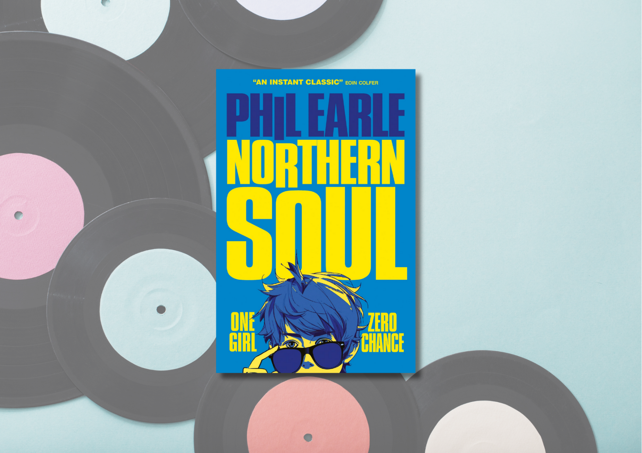

Northern Soul learning resource
Suggested learning activities for Phil Earle’s Northern Soul, focussing on Literacy and English and empathy

CfE Level Third and Fourth

Suitable for 13+


Resource created by Scottish Book Trust and EmpathyLab

scottishbooktrust.com

Scottish Book Trust is a registered company (SC184248)

and a Scottish charity (SC027669).

Contents
About this resource 2
Scottish Book Trust learning activities 3
Literacy and English activities 3
Cross-curricular activities 12
EmpathyLab learning activities 14
Further resources 19
Printable activity sheet 1: Choose a pair of shoes 20
Printable activity sheet 2: Shoe prompts 21
Printable activity sheet 3: Scripting the party scene 22
Printable activity sheet 4: Complete origami fortune teller 23
Printable activity sheet 5: Blank origami fortune teller 24

About this resource
This resource has been developed by Scottish Book Trust and EmpathyLab to support classroom use of Northern Soul by Phil Earle with a focus on literacy and English skills, cross-curricular learning, reading and writing for pleasure as well as using the text with a particular focus on developing empathy skills and an understanding of other people’s feelings and life experiences. We have also created resources for:
- Glasgow Boys by Margaret McDonald
- Little Bang by Kelly McCaughrain
- You Could Be So Pretty by Holly Bourne

Scottish Book Trust is a national charity that believes in the life-changing power of books. Our school programmes support teachers and other education professionals to put creativity, reading and books at the heart of their learning environment. To find out more about using our programmes to support reading for pleasure, see our Schools guide.
EmpathyLab is a charitable social enterprise whose mission is to raise an empathy educated generation, inspired to build a better world for everyone. Our strategy is based on scientific research showing that empathy is a learnable skill, and books are a practical, powerful tool with which to build it. By 2026 we aim to benefit one million children every year.

About Northern Soul
Northern Soul follows Marv, a fourteen-year-old whose life is about football, spending time with his best mate Jimmy, and dodging his dad (and, by extension, his dad’s terrible Crocs!) When Carly joins his class, Marv is determined to make her interested in him – soon, his musical hero, Otis Redding appears as a ghostly matchmaker. Will Marv’s attempt to find love end in success?
Northern Soul is published by Barrington Stoke, who specialise in high-quality children’s and young adult books that are designed to be dyslexia friendly. You can find out more about their approach on the Collins website. As Northern Soul is only 92 pages, you can read the text aloud in your classroom (for reference, the audiobook recording is roughly 1 hour 30 minutes long).
Please note that whilst Northern Soul does not discuss any sensitive topics, with all of our resources, we do highly recommend that you read the book before using it with your class and use your best judgement about whether teaching using this text is appropriate for the children in your class.

Scottish Book Trust learning activities

Literacy and English activities

Activity 1: Word association (before reading)
LIT 3-02a/4-02a, LIT 3-05a/4-05a
Ask pupils what words they associate with the word “soul”. You could ask them to create a mind map or ask them to call out words for you to add onto the whiteboard.
- Is it easy or difficult to define the idea of a “soul”?
- What about “soulful”?
- What does “soul” mean when placed in front of other words – e.g. “soul food”, “soul music”, “soul sister”?
Based upon these words, now show them the cover of Northern Soul.
- What do they think this book will be about?
- What clues can they find on the cover? E.g. the artwork, colours, pull quote, taglines.
- Does anyone know what “northern soul” means?

Activity 2: Judge a character by their shoes (up to page 13)
LIT 3-20a/4-20a, LIT 3-23a/4-23a, LIT 3-26a/4-26a, ENG 3-27a/4-27a,
ENG 3-31a/4-31a
Read up to page 13 (to the end of chapter two). Focus on the section where Marv describes his dad. One of the most embarrassing things that Marv’s dad does is wear Crocs!
Ask pupils to use the Printable activity sheet 1 to choose a pair of shoes. Ask them to write down all their assumptions about who they think would wear those shoes, encourage them to discuss their ideas with a partner.
Then ask them to develop a piece of writing about a character who wears these shoes, either challenging or leaning into the assumptions they made. Use the prompts on the Printable activity sheet 2 to help scaffold thinking.
You can find more creative writing activities like this on the Creative writing section of our website.

Discussion questions (up to page 18)
- What is your first impression of Marv?
- Why do you think Marv and his dad have drifted apart?
- Do you agree with Marv that things would be different if his mum still lived with him and his dad?

Activity 3: Become a music journalist (up to page 20)
LIT 3-20a/4-20a, LIT 3-24a/4-24a, LIT 3-25a/4-25a, LIT 3-26a/4-26a,
ENG 3-27a/4-27a, LIT 3-28a/4-28a, LIT 3-29a/4-29a,
Read up to page 20 (to the end of chapter four). Ask the class to focus on page 18 and 19.
- How does Marv describe listening to Otis Redding’s music?
- What adjectives does he use?
- What kind of metaphors does he use?
- Do you notice any other literary techniques?

Now ask the pupils to find a piece of music journalism. They could pick from the list below, or search for reviews of an artist or album they like. Ask them to do a close reading of the piece of music journalism.
One option is to give them different coloured pens they can use to highlight different elements of the writing, for example:
- Literary techniques – e.g. metaphor, simile, onomatopoeia
- Personal writing – the writer talking about their own reactions or feelings
- Critique of lyrics – do they quote a lyric and praise or criticise it?
- Critique of musical sound or techniques – how do they describe how the music sounds?
- Comparisons – where do they place this album or artist in comparison to other artists or genres?

Music journalism examples
- “‘She really is everything!’: how Doechii became a rap icon – and bagged a Grammy”, Shaad D'Souza for The Guardian (2025)
- “Review: Sam Fender - People Watching”, Switchthony Cardtano for The Needledrop (2025)
- “Addison Rae: Addison review – 2025’s most refreshing star revels in pop’s shallow pleasures”, Shaad D'Souza for The Guardian (2025)
- “TikTok has changed music — and the industry is hustling to catch up”, Mia Venkat for NPR (2022)
- “‘She’s one of us!’ The dizzying rise of Hannah Laing, Scottish dental nurse turned superstar doof-doof DJ”, Claire Biddles for The Guardian (2025)
Now ask your pupils to write their own piece of music journalism, using what they have learned from the close reading activity, as well as layout and presentation. They could use one of the following concepts as a prompt:
- Review just one song, going into depth on the lyrics and sound.
  - Are the lyrics well written?
  - What literary techniques do they use? (e.g. rhyme, metaphor, etc.)
  - Do you like the sound of it?
  - What other songs does this song remind you of?
  - How does listening to it make you feel? What genre or style do you think it is?

- Interview someone about their favourite musician.
  - Who is their favourite musician?
  - When did they discover them?
  - What do they like about them?
  - Have they ever seen them live?
- Listen to an album you have never listened to before and, without doing any research, write your honest opinion about it.
  - How did you choose the album?
  - Did you like it or not? Why?
  - Did it remind you of any other album or artist you’ve listened to?

If you’re interested in reading more about music, see our book list on Books for your music classroom for our top picks.

Activity 4: Magical realism (up to page 41)
LIT 3-02a/4-02a, LIT 3-04a/4-04a, LIT 3-06a/4-06a, LIT 3-09a/4-09a,
LIT 3-16a/4-16a, ENG 3-17a/4-17a, ENG 3-19a/4-19a
Read up to page 41 (to the end of chapter 6). Put pupils into two groups. Group 1 has to find evidence that Otis Redding might be real, and Group 2 has to find evidence that Otis is a figment of Marv’s imagination.
- Is Otis a traditional ghost? Why not?
- Marv’s Otis Redding is very different to the historical Otis Redding. For example, Otis Redding was from America, but this Otis Redding is northern English. Why might that be?
- Do they think there’s a correct answer?
Now use our downloadable PowerPoint on Northern Soul and magical realism. The PowerPoint introduces the concept of magical realism, offers some examples and asks pupils to think about whether Northern Soul is an example of magical realism and how the author might be using magical realism to explore ideas of first love, coming of age and masculinity.
Throughout the PowerPoint there are regular opportunities for discussion. Please feel free to edit or adapt it to suit your pupils.

Discussion questions (up to page 41)
- Why do you think Marv likes Carly?
- Do you think using chat up lines or writing a song is a good way to get to know her?
- What could Marv have done instead?

Activity 5: Otis Redding’s music (up to page 51)
LIT 3-14a/4-14a, LIT 3-16a/4-16a, ENG 3-17a/4-17a, ENG 3-19a/4-19a
Read up to page 51 (to the end of chapter 8). On page 44, Otis says ‘If I ever wanted to impress a lass, I wrote ‘em a song.’
Choose one of the following Otis Redding songs, and use the Genius website to look at their lyrics:
- “(Sittin’ On) The Dock on the Bay”
- “Try a Little Tenderness”

Ask pupils to do a close reading of the lyrics, paying attention to any metaphorical language or other techniques that Redding uses.

(Sittin’ On) The Dock on the Bay
- What do they think this song is about?
- What does the tide represent?
- What mood or feeling does this song capture?
- In one of the annotations, there’s a quote from an interview with his session band’s guitarist: ‘I said, “Otis, hold on. If a ship rolls, it will take on water and sink.” He said, “That’s what I want, Crop.” So, we let it go and worked on the rest of the song.’ Why do you think Otis wanted to keep this image? What do you think it represents?

Try a Little Tenderness
- What do they think this song is about?
- The song tells us young women ‘do get weary / Wearing that same old shaggy dress’. What do they think this means?
- What does this song say about the state of women?
- What could Marv learn from this song?

Activity 6: Carly’s point of view (up to page 59)
ENG 3-17a/4-17a, ENG 3-19a/4-19a, LIT 3-20a/4-20a, LIT 3-26a/4-26a,
ENG 3-27a/4-27a, ENG 3-31a/4-31a
Read up to page 59 (end of chapter 9). Talk about the character of Carly. Ask the pupils to discuss everything they know about her and feed back to the class. You could use some of the following prompts:
- What is Carly’s personality like?
- What does she like?
- What hobbies does she have?
- What are her dislikes?

Pupils will probably realise there’s very little detail about Carly in the narrative. Whilst Marv might think he’s in love with her, he doesn’t actually know her.
- Why does Marv know so little about Carly?
- Why do they think the author has made this choice?
- How does this tie back into the idea of magical realism that they explored in Activity 4?
Now ask them to write a passage inspired by what they have read of Northern Soul so far but from Carly’s perspective. They could rewrite one of the scenes (e.g. Marv’s chat up line in chapter 6 or Marv’s song in chapter 9) or create a backstory and character for Carly.

Discussion questions (up to page 59)
- What do they think of Marv’s song?
- How does it compare with the Otis Redding song they close read in Activity 5?

Activity 7: Don’t be that guy (up to page 71)
LIT 3-04a/4-04a, LIT 3-05a/4-05a, LIT 3-07a/4-07a, LIT 3-16a/4-16a,
HWB 3-44b/4-44b, HWB 3-45a/4-45a, HWB 3-45b/4-45b, HWB 3-46a/4-46a
Read up to page 71 (to the end of chapter 12). Watch the Authors Live on demand broadcast with Alan Bissett where he discusses his book Lads: A Guide to Respect and Consent on our website. The full broadcast is roughly 40 minutes long.
Ask the pupils:
- Considering what Alan, Nick, and the audience discuss in the broadcast, can they see how some of Otis’s advice is flawed?
- What do you think Marv would have done differently if he had this book for advice instead of Otis for advice?
It’s worth mentioning to your pupils that whilst Alan discusses harassment, Marv doesn’t harass Carly. Marv’s problem is more that he thinks he has to impress Carly, instead of trying to get to know her or having a normal conversation with her.
Revisit the text (chapters 10 to 12). Put the pupils into groups and ask them to look for Carly’s perspective again. What signs can you see that Carly either isn’t aware that Marv likes her, or doesn’t return his feelings?
Now use NSPCC’s lesson plan “Healthy relationships” (available on their website under the age group 12-14). This lesson plan contains rough timings for each activity and will ask pupils to:
- Describe a healthy relationship – you could compare this to how Otis teaches Marv to approach Carly, and the flaws in his approach
- Consider how certain beliefs about love impact relationships – you could compare this to how Marv idolises Carly but doesn’t necessarily know her (revisiting the learning from Activity 6)

Activity 8: Telling a story through song (up to page 83)
LIT 3-05a/4-05a, LIT 3-14a/4-14a, LIT 3-16a/4-16a, ENG 3-19a/4-19a,
LIT 3-25a/4-25a, LIT 3-26a/4-26a, ENG 3-27a/4-27a, ENG 3-31a/4-31a
Read up to page 83 (to the end of chapter 14). Explain to pupils that they are going to be turning one of the scenes from the last couple of chapters into a film script and, as part of this, have to find a song that matches the feeling of this scene. This will require them to both analyse the scene from Northern Soul and the song, as well as thinking about how songs can add to a scene.
Use our IntoFilm PowerPoint resource on Book reviews and trailers on film to introduce the different concepts around filming – especially different angles and shots.
Now give pupils a copy of the Printable activity sheet 3 which will ask them to track their decisions around the scene. They can choose which character (Marv or Carly) will have the main perspective, as well as how they’d like to use the books dialogues, and what camera shots they’d use.
To introduce finding the song that they would like to use, show them a clip from “A Complete Guide to Pop Music Needle Drops in Movies” by Patrick Willems on YouTube – we recommend only watching from 10:21 – 13:21 which introduces the concept of diegetic and nondiegetic music and the purpose of using an existing song in a film.
The song they find for their script should:
- Capture the feeling of the scene and the world of Northern Soul
- Match the feeling of the characters in the scene
- Match the pacing of the scene
Include time for the pupils to play a section of their song and discuss why they chose it for this scene.
As an extension, you could work with your drama department and/or technology department to turn pupil’s scripts into a short film. Our Book reviews and trailers on film resource, created with IntoFilm, will support pupils to learn about basic filming techniques, including positioning, framing and sound.
Another option is that pupils could create a film without dialogue that only uses the song they have chosen. In groups, they have to decide how to convey the emotion of the scene only with shots and music instead of dialogue.

Activity 9: What happens next (the end of the book)
ENG 3-19a/4-19a, LIT 3-22a/4-22a, ENG 3-27a/4-27a, ENG 3-31a/4-31a
Read to the end of the book. Ask pupils what they think will happen next, gathering their answers on your whiteboard.
On pages 23 and 24 you will find printable fortune teller templates. Pupils can either fill these in with eight different options of what they think could happen next or use our version with options. Now use the WikiHow guide on how to fold an origami fortune teller. There’s both a YouTube video (1 minute, 28 seconds) and an online guide.
Once complete, pupils can work in pairs to choose a possible “what happens next” for Marv and the other characters in the book. They can use this as a prompt for their own creative writing, trying to create an epilogue or an additional chapter for Northern Soul.

Cross-curricular activities

Activity 1: The life and impact of Otis Redding
SOC 3-01a, SOC 3-05a, SOC 3-16a, SOC 4-16b, SOC 4-16c, SOC 4-17a
Otis Redding was a key figure in the soul music movement, which emerged out of African American gospel (hence the name “soul”). Soul was crucial not only for Black identity and culture but also played a huge part in both civil rights and Black Power movements in the 60s and 70s.
Northern Soul was a movement in England in the 70s which centred around more upbeat Black American soul music as well as disco and breakdancing. The Northern Soul scene was predominantly working-class. Even today there is a lot of discussion about how Northern Soul created a cultural relationship between the white working class and Black people in England and America. However, others have critiqued how the perspective of people of colour are often left out of coverage of Northern Soul.
Work with your history department to look at the life of Otis Redding and his impact on music. You could look at:
- Creating a timeline of soul music and civil rights in America (see Carnegie Hall’s interactive timeline resource)
- How Northern Soul created escapism during poor working conditions during the 1970s
- Learning about another musician and their impact on a specific historical period or movement

Activity 2: Find new music for Marv
LIT 3-16a/4-16a, EXA 3-19a/4-19a
Marv falls in love with Otis Redding’s music – but what other music might he like? You could work with your music department to research other artists, albums or musical styles for Marv. You could look at:
- What other music genres or styles are similar to soul?
- What other musicians have been inspired by Otis Redding?
- How has soul impacted modern music?

The BBC has a guide to Soul music, including breakdowns of famous soul songs and a BBC Bitesize overview of the genre.

Activity 3: Compose a song
LIT 3-20a/4-20a, EXA 3-17a, EXA 4-17b, EXA 4-18a
In Activity 8 of the Literacy and English activities, the pupils create their own script for the party scene in chapters 13 and 14. Instead of asking pupils to find a song, you could work with your department to support pupils to write their own song or soundtrack for Northern Soul.

EmpathyLab learning activities

Activity 1: Listening switch activity
LIT 3-02a/4-02a, LIT 3-07a/4-07a, HWB 3-01a/4-01a, HWB 3-04a/4-04a
- Empathic communication
Read up to halfway down page 5 on chapter one, up to ‘...lost in my head.’
Marv isn’t able to tell Jimmy what he is feeling or thinking. Pretend this wasn’t the case. What would Marv say? Using EmpathyLab’s Listening switch activity, practicing using listening skills and asking good questions. Use props to get in character.

Activity 2: Dad’s turn(table)
LIT 3-02a/4-02a, LIT 3-07a/4-07a, LIT 3-26a/4-26a, HWB 3-01a/4-01a,
HWB 3-04a/4-04a
- Perspective-taking
- Building a language for emotions
Look at chapter 3 from Dad’s point of view. Retell the exchange through his eyes. What happened? Have a pair of Crocs and invite students to step into them to say what happened next, co-constructing the retelling. How did he feel at different points? After doing this together as a class or in small groups, students could either perform or write the retelling. Either way, make sure Marv’s Dad’s emotions are brought out.

Activity 3: Word art
LIT 3-05a/4-05a, LIT 3-06a/4-06a, HWB 3-01a/4-01a, HWB 3-04a/4-04a
- Building a language for emotions
‘I had no idea what all the emotions running around inside me even meant, let alone what to do with them.’ (page 18).
Draw an outline of Marv and create a word cloud of all the feelings that might be running around inside Marv. Make this as creative and “word arty” as you like. Play some Otis Reading music to accompany the activity. Record lyrics that resonate around the outside of the character outline.
Discuss what these emotions might feel like in your body. What physical sensations might accompany them?

Activity 4: Empathy characters
LIT 3-02a/4-02a, LIT 3-07a/4-07a, HWB 3-01a/4-01a, HWB 3-04a/4-04a
- Building a language for emotions
- Empathic communication

After reading Chapter 6, discuss:
- How do you think each character might be feeling? Discuss the different feelings each character has with a partner. The emotions list on the Empathy Characters resource might help you.
- Remember – they may feel many different things at once; how many emotions words can you use to describe how they feel?
- Next, stand in a circle with your group. One person stands inside the circle to represent the character they have chosen. Each person around the circle takes a turn to say something to the character. You might say words of comfort, celebration, encouragement, or reassurance. The person in the middle of the circle can respond as the character or simply listen.

Activity 5: Freeze frames/tableaux and thought tapping
LIT 3-02a/4-02a, LIT 3-07a/4-07a, HWB 3-01a/4-01a, HWB 3-04a/4-04a
- Building a language for emotions
- Perspective taking
- Prosocial behaviour

At various points throughout the story, ask pupils to arrange their faces and bodies to reflect the various characters’ feelings/reactions. You could photograph these and create a montage to retell the story (or bits of it).
With pupils in position, when you tap someone on their shoulder, they should articulate what they are thinking and feeling. You could also do this as a written exercise using thought bubbles around a photo.
This is a good opportunity to think about how we can use perspective-taking to develop a more empathic reaction. For example, if pupils verbalise unkind thoughts/reactions, this could prompt non-judgmental conversations about the reasons behind character’s behaviour, and how approaching characters in empathetic ways can change what we think of them.

Activity 6: Empathy chat (up)
LIT 3-02a/4-02a, LIT 3-07a/4-07a, LIT 3-20a/4-20a
- Empathic communication
- Perspective taking
- Prosocial attitudes

We don’t hear anything about what Carly thinks and feels in the story. What might she say about Marv and how he is approaching things? Marv is so busy trying to impress Carly that he loses sight of trying to get to know Carly or finding out anything about her. He also loses sight of being himself, trying to be someone else instead.
In pairs, small groups or mingling round the class, use the Empathy Chat questions to practice getting to know people in your class and showing them who you are. Are there other people in your life who you could use questions like these with? Students could write an alternative version of the end of chapter one when Marv meets Carly on his walk home, in which he uses empathic communication skills.

Activity 7: Empathy hero
LIT 3-02a/4-02a
- Empathic communication
- Prosocial behaviour
Read up until the end of Chapter 15. Marv doesn’t seem to have many mates other than Jimmy who is currently otherwise engaged. He seems quite isolated and a bit alone. Ask the pupils to think about what they would say to Marv if they had seen the events described in this story, including the incident at the party.

Activity 8: Empathy artists
LIT 3-15a/4-15a, EXA 2-04a, EXA 2-18a
- Building a language for emotions
- Perspective-taking
Create pieces of art or music to reflect Marv’s feelings at some of the most cringe-worthy moments in the story. Do the same for the final chapter. Discuss or write about what’s changed for Marv.

Activity 9: Lean on me
LIT 3-02a/4-02a, LIT 3-07a/4-07a, ENG 3-17a/4-17a, HWB 3-03a/4-03a,
HWB 3-08a/4-08a
- Empathic communication
- Prosocial behaviour and social action
Discuss how a lot of the plot is driven by the fact that Marv doesn’t know what to say or how to behave in the situation he finds himself in. He also doesn’t seem to know how to talk to anyone about what he is experiencing, hence turning to a dead singer reincarnated. What about Marv’s Dad? What do we know about him? What’s the relationship between him and Marv like?
Broaden the discussion into what this means for them as individuals and for each other. How reflective is this of individuals or groups in our society - not having people they can talk to or not being able to share their emotions? What are the implications of that?
Play the song “Lean on me” by Bill Withers. Explore the lyrics and discuss. What action(s) could you take to encourage people in your community to lean on each other when needed? What action(s) could you take to make sure everyone has access to information and support with healthy, positive relationships?

Activity 10: The power of music
LIT 3-02a/4-02a, LIT 3-07a/4-07a, EXA 2-19a
- Building a language for emotions
- Empathic communication
- Prosocial behaviour and social action
Music is highly emotive. Otis’ music met Marv exactly where he was at that moment in his life and seemed to connect to his experience and express what he was feeling. ‘It was like he was reading my mind’ (page 18). And at the end of the story, it facilitates an instant connection between Marv and someone else.
Choose a piece of music that has meant something special for you, or that makes you think of a particular time and place or connects you to someone else. Share it with your class and, if you want to, explain what meaning or memories it has for you. Have conversations with people in your family and community and see if they have any songs or pieces of music that are particularly significant or meaningful for them.

Further resources

Scottish Book Trust
- For more learning resources see the Learning resources section of the Scottish Book Trust website.
- We also have Teen book discussion guides which you can use for class discussion or to form a book group.
- To find out more about reading and empathy, see our webinar series Connecting empathy and reading in schools in partnership with Empathy Lab, Maisie Chan, the University of Strathclyde and Vanessa Thomson

Empathy Lab
Visit our website www.empathylab.uk for more information about how we support schools to raise an empathy-educated generation, including
- Read for Empathy collections and guides
- EmpathyLab’s Schools Programme
- The Empathy Day Festival
- Training events

Printable activity sheet 1: Choose a pair of shoes


Printable activity sheet 2: Shoe prompts
Use these prompts to do a piece of creative writing inspired by the shoes you choose.
- Who wears these shoes? What is their name?
- What kind of outfit do they wear with these shoes?
- Where do they live?
- What kind of house do they live in?
- What job do they have?
- What is their favourite food?
- Who do they live with?
- What are their hobbies?
- What are they afraid of?
- What kind of music do they listen to?
- Do they drink coffee or tea?
- What language(s) do they speak?
- What is their favourite film?
- Where did they go on their last holiday?
- Would they prefer to go out or stay home?
- Do they have any pets?
- What is their least favourite food?
- How would their friends describe them?
- Do they drive a car or ride a bicycle?
- Would they rather go to the cinema or the theatre?
- What item(s) do they always keep in their bag?
- Are they organised or messy?
- What is their favourite app on their phone?
- What is their favourite season?
- Are they a morning person or a night owl?

Printable activity sheet 3: Scripting the party scene
Here are some key considerations when turning a scene from Northern Soul into a script. You can use this table to keep track of your decisions.
Where are you going to start this scene?
Whose scene is this? Whose perspective is this?

What are they feeling?
How can you show this with the camera angles or shots?

How can you show this with your song?

Go through each line of dialogue – what is the character feeling and how would this impact how they say their lines?

How will you establish the setting?

What song will you use? Does it match the feeling of this scene and Northern Soul in general?

Printable activity sheet 4: Complete origami fortune teller
Cut around this template on the dotted lines.

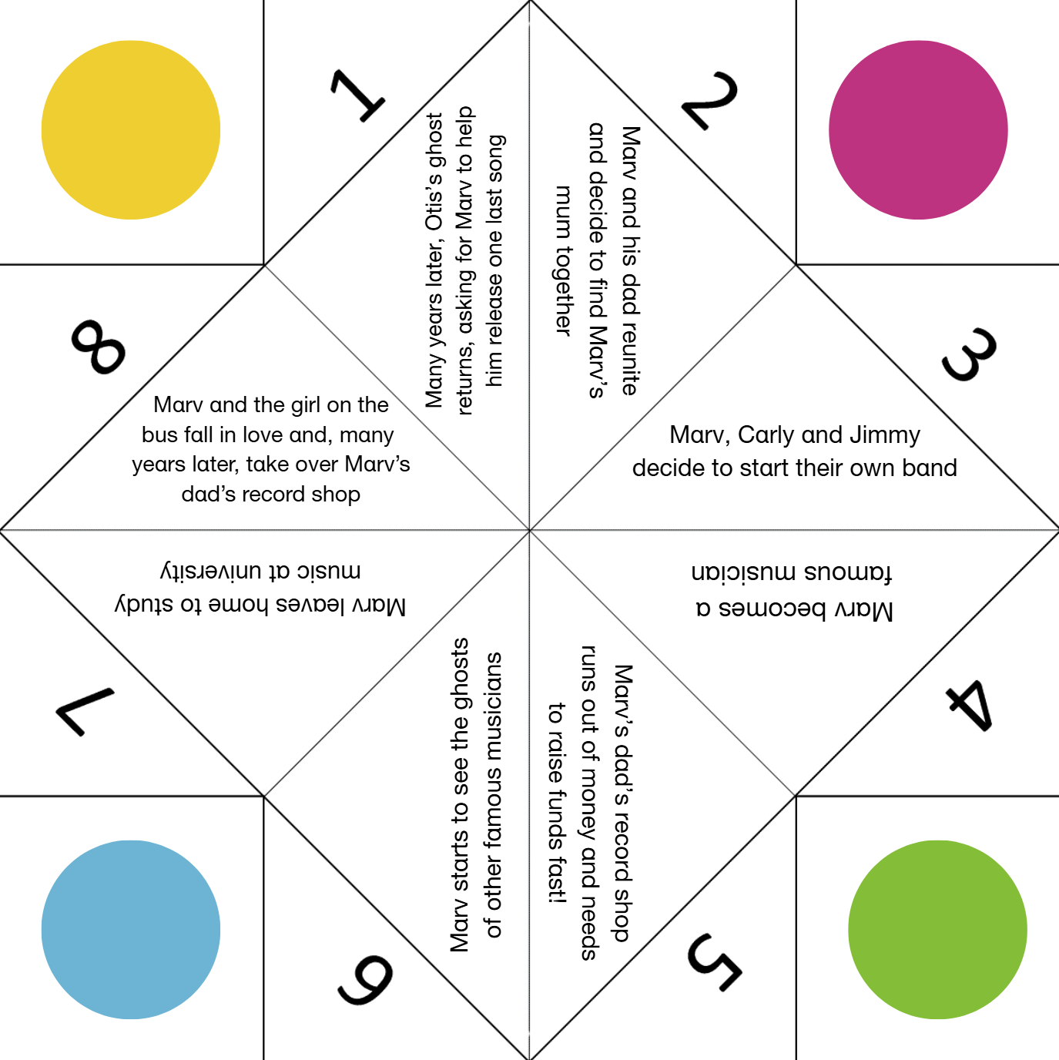

Printable activity sheet 5: Blank origami fortune teller
Come up with eight possible things that could happen to Marv, or the other characters in Northern Soul and fill in the template below. Make sure your text is the same direction as each heading!
Once you’re done, cut around the template on the dotted lines.

