
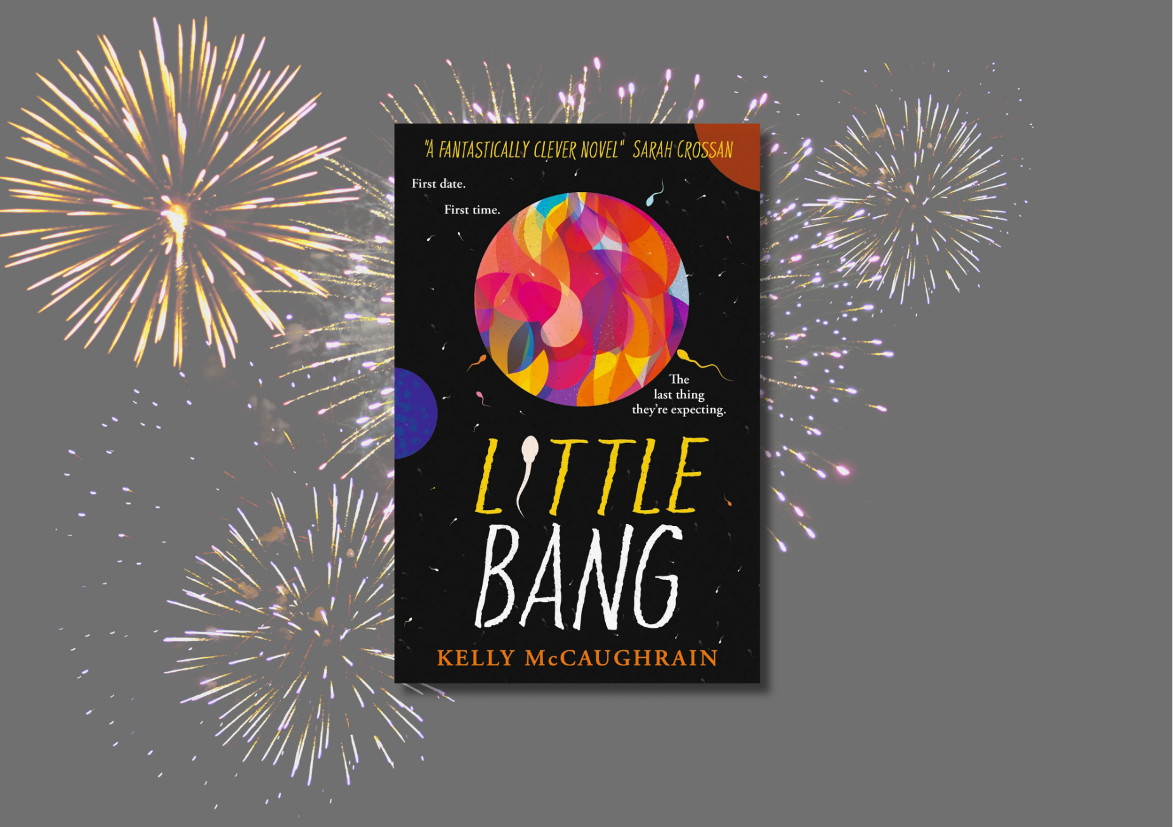

Little Bang learning resource
Suggested learning activities for Kelly McCaughrain’s Little Bang, focusing on Literacy and English and empathy

CfE Level Third and Fourth

Suitable for 13+


Resource created by Scottish Book Trust and EmpathyLab

scottishbooktrust.com

Scottish Book Trust is a registered company (SC184248)

and a Scottish charity (SC027669).

Contents
About this resource 2
Scottish Book Trust learning activities 3
English and Literacy activities 3
Cross curricular activities 14
EmpathyLab learning activities 18
Further resources 25
Printable activity sheet 1: Debate and persuasion (against) 27
Printable activity sheet 2: Debate and persuasion (for) 28
Printable activity sheet 3: Write your own song 29

About this resource
This resource has been developed by Scottish Book Trust and EmpathyLab to support classroom use of Little Bang by Kelly McCaughrain with a focus on literacy and English skills, cross-curricular learning, reading and writing for pleasure as well as using the text with a particular focus on developing empathy skills and an understanding of other people’s feelings and life experiences. We have also created resources for:
- Glasgow Boys by Margaret McDonald
- You Could Be So Pretty by Holly Bourne
- Northen Soul by Phil Earle
Scottish Book Trust is a national charity that believes in the life-changing power of books. Our school programmes support teachers and other education professionals to put creativity, reading and books at the heart of their learning environment. To find out more about using our programmes to support reading for pleasure, see our Schools guide.
EmpathyLab is a charitable social enterprise whose mission is to raise an empathy educated generation, inspired to build a better world for everyone. Our strategy is based on scientific research showing that empathy is a learnable skill, and books are a practical, powerful tool with which to build it. By 2026 we aim to benefit one million children every year.

About Little Bang
Little Bang is set in Belfast in 2018, against the background of the Irish referendum on abortion rights. It is told in the voices of teenagers Mel (15) and Sid (16). Mel finds out she’s pregnant after their first date, but, in Northern Ireland in 2018, abortion is illegal. Mel and Sid’s families have conflicting opinions on what’s best for the couple. Trying to manage their parents’ responses but also determined to do this together, Mel and Sid soon discover that pregnancy is totally different for boys and girls. When their relationship starts to fall apart under all the pressure, Mel finds herself feeling alone, trying to understand what she wants to do.
Please note that Little Bang does discuss teenage pregnancy, abortion and miscarriage. As with all of our resources, we highly recommend that you read the book before using it with your class and use your best judgement about whether teaching about this topic is appropriate for the young people in your class.

Scottish Book Trust learning activities

English and Literacy activities

Activity 1: First impressions (before reading)
LIT 3-02a/4-02a, LIT 3-04a/4-04a, LIT 3-16a/4-16a
Look at the title, cover and blurb. In pairs, ask pupils to discuss:
- What does the title and the design of the cover make them think of?
- In the blurb, there’s a short description of the main characters Mel and Sid. What parts of their character description do you think will be most significant in this story? Why?
- Did they know that abortion was illegal in Northern Ireland in 2018?
- Have they read a book about an unplanned pregnancy before?
Activity 2: Meet Sid and Mel (Chapters 1 and 2)
LIT 3-02a/4-02a, LIT 3-04a/4-04a, ENG 3-17a/4-17a
Read the first two chapters. Put the pupils into groups and ask them to discuss:
- How are Sid and Mel different?
- How do Sid and Mel’s friends see their relationship?
- In what ways are Sid and Mel’s relationships with their parents different?

Read the character descriptions from the blurb again. Ask your pupils if their first impressions of Sid and Mel match the character’s descriptions in the blurb? Do they think this is how their friends or their families would describe them, or how they would describe each other?
Ask your pupils to write a brief, two-sentence description (like the blurb) for:
- How Sid and Mel might describe themselves on New Year’s Eve 2017.
- How Sid’s mum might describe Sid and how Mel’s parents might describe Mel.
- How Sid might describe Mel and how Mel might describe Sid.
- Discuss which they think is closest to the description in the blurb? How are they different?

Discussion questions (chapters 1 to 4)
Space, the universe, the big bang, parallel universes and quantum physics are Mel’s interest and become a recurrent theme through the text. In chapters 1 to 4:
- How many references to the Big Bang or quantum physics can you find?
- Are these just in Mel’s perspective?
- Why do you think the writer chose this motif?

Activity 3: Historical fiction (chapters 3 – 4)
LIT 3-09a/4-09a, LIT 3-13a/4-13a, LIT 3-14a/4-14a
After reading chapters 3 and 4, ask your pupils to discuss:
- Do they think Little Bang is an example of historical fiction? How does it differ from other examples of historical fiction they have read?
- Little Bang was published in 2024. Why do they think the writer chose to set it in 2018 against the backdrop of the Irish referendum on abortion rights?

This activity looks at the history of abortion rights in Ireland, Northern Ireland and Scotland. Divide your pupils into groups and ask each group to research the history of abortion rights in one of these countries. Pay particular attention to rights in 2018. Ask the groups to present their findings as a visual timeline or using a method of their own choosing. You may find the author’s note on historical context on pages 299-300 of the book helpful, as well as the Further resources linked at the end of this resource.
Ask pupils to share and reflect on their findings.

Discussion questions (chapter 5 and 6)
Ask the pupils to reflect on Mel and Sid’s reactions to learning Mel is pregnant.
- What do you think Mel means when she tells Sid, ‘you’re not the one who’s pregnant.’ (page 69)?
- What do you think Sid means when he thinks, ‘aren’t I supposed to let her decide?’ (page 78)?
- ‘I don’t know anything!’ (page 73) Mel recognises that she hasn’t received any evidence-based unbiased information on abortion or unwanted pregnancies. She wants to take the morning after pill but worries about the stigma from living in a small town and being recognised in a pharmacy. You could discuss as a class how this might apply in your local area before watching the University of Bristol’s YouTube video “Emergency contraception: FAQs answered” (5 minutes, 5 seconds) which will answer questions your pupils might have about emergency contraception options.

Activity 4: Characters and conflict (chapters 7 and 8)
LIT 3-09a/4-09a, ENG 3-17a/4-17a, LIT 3-26a/4-26a, LIT 3-29a/4-29a
Read chapters 7 and 8. In these chapters, Sid and Mel tell their parents about the pregnancy. Lucille has a different reaction to Mel’s parents. The meeting between Lucille and Mel’s parents brings to light different class, family structure and religious identities and histories.
Ask your pupils to create a mind map for each of the family member’s reactions based on what we know of their characters, their beliefs, their relationship with Sid or Mel, and/or their experiences of parenting. Include Leah, Mrs Watson, Mr Watson, and Lucille in the mind map.
Below is an example of what Leah’s mind map could look like. Encourage pupils to use question marks for emotions or influences that they feel they don’t have enough information about yet.
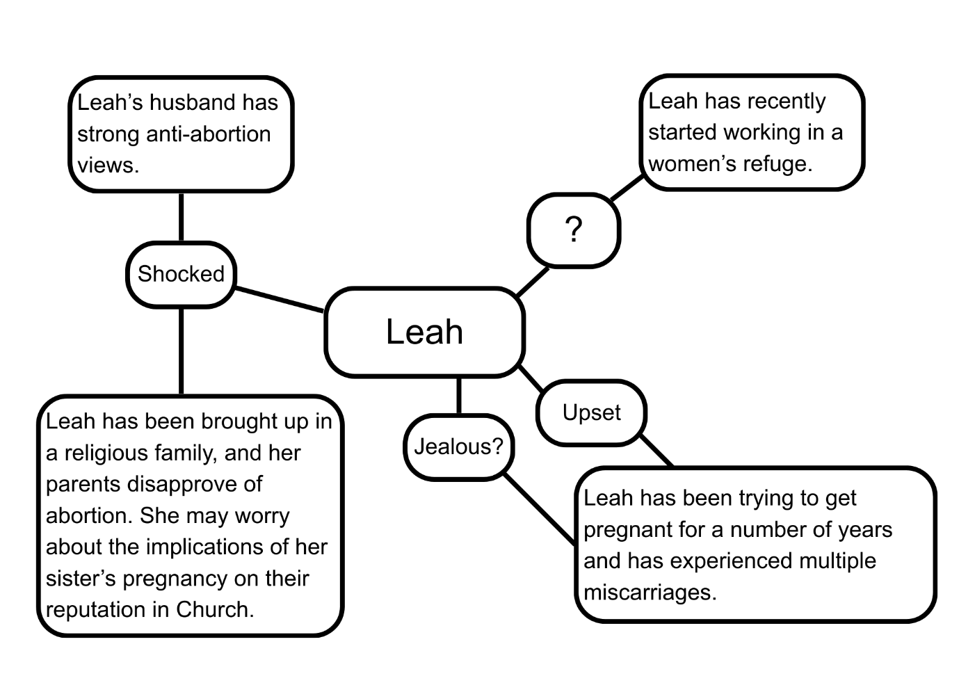
Now think about what we know of Sid and Mel’s feelings at this point and how these might have been influenced by their backgrounds and experiences to date. You could think about their:
- Aspirations
- Relationship with their parents
- Personalities
- Upbringings
In groups, take it in turn to sit in the “hot seat” as one of the main characters. Ask the person in the hot seat questions to try to understand their feelings and reactions. For example: ‘Sid, do you think your dad leaving you when you were little is making you determined to stick by Mel?’
As a group, did you have different perspectives on the characters? Was it easier to explore one of the main character’s feelings more than the other? If so, why do you think that was?

Discussion questions (chapter 9 and 10 to page 146)
- Why do you think Mel keeps her meeting with Lucille a secret from Sid?
- Why do you think Sid keeps his friendship with Cassie a secret from Mel?
- How do Sid and Mel’s choices to keep secrets from each other impact your perception of them as a couple?

Activity 5: Debate and Persuasion (p146-155)
ENG 3-03a/4-03a, LIT 3-05a/4-05a, LIT 3-08a/4-08a
Mel says that ‘debate is objective and theoretical and impersonal. But as the only pregnant person in the room, it’s kind of hard not to take it personally.’
The purpose of this activity is to encourage pupil reflection on their own personal response to the debate with the motion This house would legalise abortion in Northern Ireland as well as consider how Mel might feel. It is important to set clear expectations for this activity; encouraging everyone to be respectful of each other’s opinions and not feel they have to share anything they do not want to.
This first part of this activity is to be carried out before reading pages 146 to 155. You can do this as a whole class or in smaller groups. Divide the class into sides “for” or “against” the motion. Give each group either Printable activity sheet 1 or Printable activity sheet 2 and act out the debate formally with a speaker/s from each side presenting their points.
After each speaker, ask the pupils to write a note of how they personally responded to the points made and how they think Mel might respond in the book e.g. surprise, disbelief, discomfort.
Now read pages 146 to 155.
- How close were the pupils’ predictions for how Mel might feel?
- What resonated with them most?

Mel notes that none of the women in the video shared during the debate reflected her own experience. Now watch this spoken word poem by Leyla Josephine: “I Think She Was a She”.
In groups, ask pupils to discuss:
- Were there any similarities between the spoken word poem and arguments in the debate?
- Which did they find more persuasive?
- How might Mel have felt if she’d heard this poem?
- Do they think that ‘debate is objective and theoretical and impersonal’?
- How do you think it would feel having to argue for something you disagree with?
- Do they think any topic should be up for debate or are some things facts rather than questions? They could revisit the list of motions on pages 63-64.

Discussion questions (page 155 to chapter 13)
Read from pages 155 to the end of chapter 13 and discuss:
- Mrs Edgar and Cassie watch the abortion referendum protests on the news. To get a sense of the intensity of the protests and debate, you could share the Guardian’s photo gallery: “People go to the polls in Ireland’s abortion vote – in pictures” from 2018. Discuss how the scale of the campaigning on both sides of the referendum could impact how Mel feels. Reflect on the intersections of abortion rights with the wider inequalities and stigma that Mrs Edgar mentions.
- Read Mel’s discussion with Dr Sloan. ‘Everything is about men. That’s the definition of patriarchy and we live in a patriarchal system’ (page 169). How do you think Mel’s opinion on abortion rights is changing? What do you think has influenced this change?
- When Sid suggests they get on the list for social housing, Mel’s parents are horrified. In what ways has class prejudice impacted the relationships, assumptions and attitudes of the characters?

Activity 6: Motifs (Chapters 13 and 14)
ENG 3-17a/4-17a, LIT 3-24a/4-24a, ENG 3-27a/4-27a
‘I put my earphones in and lie under the covers in the dark, pretending I got my birthday candles wish. The same one I wish every year. That I can time-travel. Pretending it’s last November and a really cute guy just made me a playlist.’
(pages 193-4).
The purpose of this activity is to creatively explore the motif of the text. A motif is a recurring idea, theme or image that has a symbolic significance in the text. In Little Bang, references to quantum physics, time travel and parallel universes act as a motif throughout the story and the title. Discuss:
- Have you read or watched any other stories that use parallel universes?
- Why might the writer have chosen this motif?

Choose a moment from the story and think about what that scene might look like in a parallel universe if their choices were different. Sid and Mel are finding it hard to share how they are feeling with each other – what might their conversations look like if they spoke openly? Similarly, what could Mel have said to her parents at different points in the text?
For example, you could choose to rewrite the moment when Sid chooses not to tell Mel that Cassie isn’t a young kid and he hasn’t sold his guitar. Rewrite your chosen scene as a script or as text messages between the characters.
Discussion questions (pages 216 – 225)
- Sid says that ‘No one’s ever believed I can do anything before. Least of all me. But the person I most need to believe that isn’t buying it, and the more I try and convince her that I want to have this baby – that she can depend on me – the more scared she looks, and I’m starting to take it personally’ (page 216). Sid is very aware of other people’s opinions of what he is capable of throughout the story. Can you find earlier examples in the text that suggest Sid is worried that Mel doesn’t think Sid is good enough to be her boyfriend? How does this impact his understanding of Mel’s behaviour?
- “My Body, My Choice” is a feminist slogan defending an individual’s right of self-determination over their body, personal bodily autonomy and freedom of choice. Reflect on this slogan after reading the conversation between Lucille and Mel. Does it echo how Mel feels? How does Lucille respect Mel’s own decision-making?

Activity 7: Concrete poetry: So many words (Chapters 15 and 16)
LIT 3-15a/4-15a, ENG 3-27a/4-27a, LIT 3-20a/4-20a
Mel is trying to understand and stand by what she wants, though other voices interrupt her own thinking – sometimes these voices/viewpoints conflict with her decision, sometimes they bolster it. The purpose of this activity is to encourage the pupils to try to amplify Mel’s voice by using black-out poetry techniques.
Make copies of page 231 and increase the size of the text where possible. Ask pupils to circle key words that they feel amplify Mel’s feelings. Black-out the words they don’t highlight so they are left with a concrete poem. Invite pupils to share them with each other, discussing the choices they made. You could choose to extend this by asking pupils to make their own black-out poetry expressing themselves using a page from their favourite book.

Discussion questions (chapters 17 to 19)
- Read the description of the procedure and abortion clinic pages 252-257. ‘Dad thinks I’ve been through some Victorian backstreet ordeal and Mum thinks I’ve been taken advantage of by Satanists’ (page 256). Do you think Mel’s parents’ opinions would change if they knew more about the procedure and care Mel received? Do you think Mel would have acted differently if she’d known this would be the procedure and care she’d receive from the beginning?
- Why do you think we only saw Mel’s experience of the clinic as a memory? Think about the structure of the story – the author chose not to make this a climactic moment in the novel. Why? Did this surprise you?
- Mel’s schoolmates and teachers sympathise with Sid and feel Mel should have told him about the abortion. Discuss this as a class then reflect on this Reading Group question posed by the author: ‘Do you think fathers should have a legal right to know about an abortion? How would that affect pregnant people with abusive partners?’
- Mel is surprised when Matt says he doesn’t think she’s done anything wrong. He says, ‘there are loads of Christian churches that are totally pro-choice…and in some religions, you’d be taking away their [women’s] religious freedom by banning abortion’ (page 273). Invite pupils to discuss whether they were also surprised by Matt’s reaction and explore why. Introduce Faith Voices for Reproductive Justice, an initiative started by people from different Christian denominations in Northern Ireland in early 2020.

Activity 8: Character arc reflection (Chapter 19)
LIT 3-02a/4-02a, ENG 3-17a/4-17a, LIT 3-25a/4-25a, LIT 3-29a/4-29a,
Revisit the descriptors you wrote for Sid and Mel earlier on and look again at the descriptors from the blurb. Ask pupils to reflect on the descriptions they wrote previously. How do they think the characters have changed? Can they write another two-sentence character description for Sid and Mel that reflects who they are at this stage in the story?
In groups, ask pupils to again take it in turns to be Sid and Mel in the hotseat. The rest of the group should ask questions. Some examples of themes could be:
- How they feel now
- What they wish could have been different
- How they think this experience has changed them
- Their relationship with each other
Activity 9: What happens next? (after finishing the text)
ENG 3-19a/4-19a, LIT 3-20a/4-20a, LIT 3-24a/4-24a, LIT 3-26a/4-26a
After you have finished the story, ask the class ‒ what do they think happens next? Allow them some time to discuss this either as a class, or in groups. They could focus on Mel and Sid or think about changes to wider family and friend relationships.
Next, ask them to create a piece of creative writing where they add an epilogue to the story. This could be set in the immediate aftermath, or it could be in 8 years’ time when Sid and Mel have promised each other to return to their spot on the hill. What might a conversation between them look like then? Pupils could revisit their parallel universe ideas from Activity 6.
Pupils could write this in different forms, for examples: in prose, as a script, as an essay, or as a song.

Activity 10: Reading group questions (Author’s note)
LIT 3-09a/4-09a, LIT 3-16a/4-16a, LIT 3-19a/4-19a, LIT 3-26a/4-26a,
Read the author’s note and the reading group questions. Ask pupils to highlight the three questions that speak to them the most. These could be questions they are not sure how to answer, questions which reflect the impact the text had on them, or questions they feel confident they can answer. Ask them to write a paragraph explaining their choices. Once the paragraphs are complete, discuss as a class whether you could add different questions to the list.
Together, discuss ways in which you could use these questions (the reading group questions and your own) to reflect on your learning and thinking after reading this text. Suggestions might include:
- Film a book review/book show using some of the questions as interview prompts
- Put questions in a hat and, in groups, each pupil pulls one out and has two minutes to answer (with the option to pass one question)
- Write a personal essay response to one of the questions

Cross curricular activities

Activity 1: Photograph your dreams
LIT 3-02a/4-02a, EXA 3-02a/4-02a, EXA 3-03a/4-03a
Mel and Sid both have dreams for their future, symbolised by different objects in the story. Sid’s guitar is precious to him not only because it belonged to his dad, but because he dreams of being a musician. Mel continues to write and adapt her essay on the nature of time, and the planet necklace from Leah symbolises her dreams to be study Physics.
Ask pupils to discuss in pairs what their own dreams for the future look like. This could be a future 10 years away, or just next weekend. Is there an object they hold close which symbolises this future to them?
Take a photograph or a series of photographs of your chosen object demonstrating its significance to you. Encourage pupils to think about:
- Background/setting
- Size of object in frame
- Colour
- Lighting
- Texture
- Camera angle
- Focus
This could be developed into a mini exhibition, with pupils tasked with writing a bio and caption for their photograph/s.

Activity 2: Songwriting
EXA 3-17a/EXA 4-17a, EXA 4-17b, ENG 3-27a/4-27a, ENG 3-30a/4-30a
Music and songwriting are a big part of Sid’s identity and Sid writes songs for both Cassie and Mel. Work with your music department to explore the building blocks of songs including melody, lyrics, chorus, bass line and drum beat using the BBC bitesize resource on How to write a song.
Catchy songs have repeated melodies or riffs. Give pupils a copy of Printable activity sheet 3 and ask them to explore the structure of the songs, looking at the chorus and repeated lyrics.
Pupils could then either choose their favourite of Sid’s songs and work in groups to put music to the lyrics using a range of instruments or digital music technology. Or they could develop their own version of Mel’s song using the template provided as a scaffold.

Activity 3: Design your own protest
TCH 3-11a/4-11a, EXA 3-06a/4-06a, EXA 4-05a, SOC 3-16a, SOC 3-17a,
SOC 4-16b
Protests have taken place for centuries and still happen today as a way of demonstrating solidarity or demanding change. However, not all protests seek equal rights for all. Connect with the Social Studies department and explore protests that your pupils are aware of or may have taken part in. Discuss whether each one was seeking equal rights for all. Does a protest have to be public? Are all protests accessible for all? What “counts” as a protest?
In protests, placards are used as a creative and powerful tool to make one’s voice heard. Ask pupils to explore the material gathered by Glasgow Women’s Library, a museum, archive and library in the East End of Glasgow. These materials include placards, badges and leaflets supporting the Repeal the 8th campaign, demanding abortion rights for women in Ireland. They also include materials from the Save the 8th campaign. You can explore the archive materials on the eHive website.
Discuss how the graphics, slogans and colouring are used to make the messages more powerful.
Now ask pupils to reflect on something they care about using this online Tate resource as a prompt. Some examples might include climate change, disability rights, anti-racism, trans rights, or universal income. Or it could be simply a positive message or something specific that they’d like to see change in your school. Ask pupils to design and create a placard, banner or badge reflecting their key message using clear, bold graphics and a strong slogan or image.

Activity 4: Reproductive justice
SOC 3-15a/4-15a, SOC 3-16a/4-16a, SOC 3-17b, SOC 4-16b, HWB 3-46b/4-46b, HWB 3-51a/4-51a, HWB 3-47b/4-47b
‘Reproductive justice is a social justice movement rooted in the belief that individuals and communities should have the resources and power to make sustainable and liberatory decisions about their bodies, genders, sexualities, and lives… A reproductive justice framework recognizes that the fight for reproductive freedom is part of a bigger fight to dismantle systems of power and oppression.’
IPPF (International Federation of Planned Parenthood) guide on abortion messaging.
Work with your Modern Studies department to explore reproductive justice. The aim of this activity is to explore the stigma and lack of information around abortion and give your pupils the language and information which they can use to help inform others.
Read the above quote with pupils. IPPF states that abortion provision does not stand alone but is one aspect of reproductive justice. You might also like to share the definition of reproductive justice on the Alliance for Choice website.
Ask your pupils:
- Have they heard of the term reproductive justice before?
- What other aspects of reproductive justice can they think of?
- How do they think an individual’s intersecting identity might impact their access to reproductive justice?
- Did Mel have access to reproductive justice?
- What information or services do you think she should have access to? How could she access these?
- What do you think Mel would have done differently if she had the information she needed?
- What about her friends or family members – how might they have treated her differently?
You may find the US based organisations SisterSong and Spark useful for conversations about reproductive justice and marginalised communities.
Next, connect with your P.S.E department and use the IPFF resource: How to educate about abortion to plan an activity or series of activities. If you only have time for one activity, start with Activity 2: Why talk about abortion? on page 29.
Ask pupils to explore whether they think abortion provision should be discussed as part of the curriculum. Following this activity you could work with your P.S.E teacher(s) to ask pupils to either:
- Create a pamphlet providing the key information about access to abortion provision in your country/area.
- Create a poster or leaflet explaining why they think it is important to talk about abortion.

Activity 5: Design a quantum physics comic
SCN 3-20a/4-20a, SCN 3-20b/4-20b, SCN 4-06a, LIT 3-15a/4-15a, LIT 3-28a/4-28a,
‘Isaac Newton believed that time flows uniformly in one direction, like a river. But Einstein suggests that past, present and future are more like islands in a lake that we can hop between. Einstein’s time doesn’t “flow”; it just “is”…’ (page 9-10)
Mel’s dream is to go to Cambridge University to study Physics. Her essay on the nature of time references different scientists and theories. Connect with your Science department to explore some of these in more detail. Ask groups to research one of these scientists or theories:
- Isaac Newton’s theory of time: “Newtonian time”
- Einstein’s theory of relativity
- Theory of the Big Bang
- Many-worlds theory
- Schrödinger’s Cat theory
Following this research, groups could then create short comic strips illustrating each theory and share these with the class. Time travel may have come up naturally in research and discussions, so end with a debate on whether time travel research should be banned, using this BBC bitesize resource as a prompt.

EmpathyLab learning activities

Activity 1: Character profiles
ENG 3-17a/4-17a, ENG 3-19a/4-19a
- Wider vocabulary to recognise and share own and others’ feelings
- Stronger ability to imagine, understand and reflect on other people’s perspectives and feelings
Create a character profile of Sid and Mel at the start of the book, carefully reading through the first two chapters of the book for clues about how they think (including what they believe), feel and behave. Continue to add to this as you read the rest of the book. You could highlight key changes that happen to both characters as the story develops.

Activity 2: Word wall
ENG 3-19a/4-19a
- Wider vocabulary to recognise and share own and others’ feelings
Create a word wall in the shape of an image that suits the two characters, for Mel it could be a book, for Sid a guitar for example. Add words and phrases to the wall as you go through the book that reflect their characters and personalities.

Activity 3: First chat
ENG 3-19a/4-19a, LIT 3-20a/4-20a, LIT 3-24a/4-24a, LIT 3-25a/4-25a
- Wider vocabulary to recognise and share own and others’ feelings
- Stronger ability to imagine, understand and reflect on other people’s perspectives and feelings

Read pages 20-22. What do we learn about the differences between Sid and Mel in this first real interaction? Write a first-person diary entry describing this first chat for either Mel or Sid. Think about how you were feeling as you sat next to each other, starting to talk - what were you thinking about each other? How do you feel as the chat develops, are you feeling listened to? Think about your preconceived ideas of the other person, did these change as you began to get to know each other?

Activity 4: Use of words
LIT 3-25a/4-25a, LIT 3-26a/4-26a, ENG 3-27a/4-27a
- Wider vocabulary to recognise and share own and others’ feelings
- Stronger ability to imagine, understand and reflect on other people’s perspectives and feelings
On page 52, Mel says: ‘Me and Sid are counterintuitive. We’re a paradox. We’re one of the Great Unsolvable Mysteries of science.’
What do these words mean to you? Do you need to clarify their meaning? Write these short sentences in your own words as an outsider looking in at Mel and Sid.
If Sid were to write three short sentences about their relationship in his own words, what three sentences do you think he would write? Compare your sentences, are there are any similarities within the class?

Activity 5: Visual image
EXA 2-02a, EXA 2-04a, EXA 2-05a
- Stronger ability to imagine, understand and reflect on other people’s perspectives and feelings
‘I am an anarchist sir, I don’t really recognise your right to give me detention’ (page 54).
Sid says these words to Dr. Sloane as he sits on the floor rolling a cigarette. What do you think he’s feeling at this moment? What has shaped his attitude towards school and teachers? Use a visual medium of your choice to show Sid at this moment, using the style of your drawing to express what you imagine he is feeling.

Activity 6: Debate
LIT 3-02a/4-02a, LIT 3-08a/4-08a, SOC 2-15a
- Stronger empathic communication skills: deep listening and conversation
- Wider vocabulary to recognise and share own and others’ feelings
- Stronger ability to imagine, understand and reflect on other people’s perspectives and feelings
- More developed social values which turn feelings of empathy into moral actions in the home, school and community
On page 61, Mel attends her first debate club of the year. As a school do you have a debate club? Could you set up a club with interested students? What advice or guidance do you need to set up a club?
Use free online resources such as Debate topics – Noisy Classroom to hold a classroom debate on an agreed topic. As the book develops, keep a note of key topics or issues that you think would be interesting in a classroom or debate club.

Activity 7: Reality
LIT 3-20a/4-20a, LIT 3-24a/4-24a, LIT 3-26a/4-26a
- Wider vocabulary to recognise and share own and others’ feelings
Read chapter 6, pages 78 to 81. Group activity: As reality hits both Sid and Mel, emotions are running high. Make a list of everything they are feeling and expressing in these pages. Use the words you have written to write song lyrics, imagining this could be Sid’s first song.
Use the following as a starter if needed…
Too scared to think,
Too scared to tell,
Who can we turn to,
What can we do…

Activity 8: Parents
LIT 3-02a/4-02a, EXA 2-13a
- Stronger ability to imagine, understand and reflect on other people’s perspectives and feelings
Read chapter 8. In this uncomfortable, emotion-filled chapter the parents meet to discuss what has happened and what is going to happen next. Use role-play to express the feelings and emotions of the different grown-ups. Think about how you can use your body language and words to express the intensity of this situation, from the uncomfortable start to the explosive end.
Following the role-play, discuss how it felt to portray the characters. Were you comfortable being them, could you relate to them, what would you like to change in this chapter?

Activity 9: Empathy activists
LIT 3-20a/4-20a, LIT 3-24a/4-24a, LIT 3-25a/4-25a
- More developed social values which turn feelings of empathy into moral actions in the home, school and community
On page 121, Mrs Edgar tells Sid she was an activist in her younger days; what inspires you to want to take action? Consider what makes you angry, interested, curious or anxious. Write an article, develop a poster or create a leaflet to encourage others to join the cause you feel passionate about.

Activity 10: Lucille
LIT 3-02a/4-02a, ENG 3-19a/4-19a
- Stronger empathic communication skills: deep listening and conversation
- Wider vocabulary to recognise and share own and others’ feelings
- Stronger ability to imagine, understand and reflect on other people’s perspectives and feelings
We learn a lot about Lucille as the book goes on, she and Sid have a unique relationship, and she shows empathy towards Mel. Who is Lucille? Discuss with a partner your thoughts and feeling about Lucille. Do you like her and emphasise with her? Is there anything you don’t like about her?
Join up with another pair to discuss your thoughts, are they similar or different? Did your feelings about Lucille change as you read more of the story?

Activity 11: The debate
LIT 3-02a/4-02a, LIT 3-09a/4-09a
- Stronger empathic communication skills: deep listening and conversation
- Stronger ability to imagine, understand and reflect on other people’s perspectives and feelings
On page 148, the debate club discuss abortion. After hearing a few speakers, Holly stands and simply says ‘It’s. My. Body.’ and sits back down again.
Either as a class or in small groups, discuss this statement. How did you respond to Holly’s statement? Why do you think she chose to only say this?

Activity 12: Music
EXA 2-02a, EXA 2-04a, EXA 2-05a
- Stronger ability to imagine, understand and reflect on other people’s perspectives and feelings
On page 174, Sid goes to the open mic night. Once there, he starts talking to Gavin who tells him, ‘music is personal expression’. What would your form of personal expression be? Draw an image or write a paragraph to represent it. Perhaps it could be music, poetry, art, a sport, or storytelling. You could display these anonymously to celebrate the different kinds of personal expression within your class.

Activity 13: Text messages
LIT 3-20a/4-20a, LIT 3-24a/4-24a, LIT 3-26a/4-26a
- Wider vocabulary to recognise and share own and others’ feelings
- Stronger ability to imagine, understand and reflect on other people’s perspectives and feelings
Read page 193. Little Bang is told as a narrative using various styles, including the use of text messages. Mel is feeling overwhelmed by her birthday and everything that happens with Becca, Sid, and her birthday meal. Imagine you are Mel’s friend and write a text message conversation between you and Mel, including how you think Mel feels on her birthday, and what she would want to share with a friend.

Activity 14: Expression of feelings
ENG 3-19a/4-19a, LIT 3-20a/4-20a, LIT 3-24a/4-24a, LIT 3-26a/4-26a
- Wider vocabulary to recognise and share own and others’ feelings
- Stronger ability to imagine, understand and reflect on other people’s perspectives and feelings
Read page 211 to 217. Both Mel and Sid experience a lot of feelings and emotions in these few pages. A letter can be a way of expressing feelings and emotions in a way you can then choose to hide; you may choose to post the letter, or you may not, but you have written your thoughts and feelings down.
Take on the role of Mel or Sid to write a letter to the other person saying exactly how you are feeling at this time. Use words from your character profiles and word walls to help you express yourself.

Activity 15: The decision
LIT 3-18a/4-18a
- Stronger ability to imagine, understand and reflect on other people’s perspectives and feelings
Mel makes her decision to have an abortion by herself. Everyone takes Sid’s side, even the teachers who have in the past refused to help him. Does this impact your reaction to Mel’s decision? Why do you think so many people take Sid’s side? If they knew more about Mel’s experience and thoughts, would they feel differently? Take a moment to consider your thoughts on the issue (personal thoughts, not for sharing out loud or writing down). Who do you feel empathy for?

Activity 16: Character profiles
ENG 3-17a/4-17a, ENG 3-19a/4-19a
- Wider vocabulary to recognise and share own and others’ feelings
- Stronger ability to imagine, understand and reflect on other people’s perspectives and feelings
Return to your character profiles after finishing the book. Both Mel and Sid have changed through the story. To finish the profiles, consider these changes and the people they are now at the end compared to the start of the story.

Further resources

Scottish Book Trust
- For more learning resources see the Learning resources section of the Scottish Book Trust website.
- We also have Teen book discussion guides which you can use for class discussion or to form a book group.
- To find out more about reading and empathy, see our webinar series Connecting empathy and reading in schools in partnership with Empathy Lab, Maisie Chan, the University of Strathclyde and Vanessa Thomson

Empathy Lab
Visit our website www.empathylab.uk for more information about how we support schools to raise an empathy-educated generation, including
- Read for Empathy collections and guides
- EmpathyLab’s Schools Programme
- The Empathy Day Festival
- Training events

Resources and support for teaching about abortion
- International Federation of Planned Parenthood’s has a guide on “How to educate about abortion”.
- You can find out more about reproductive justice from the following organisations:
  - SisterSong
  - Spark
  - Faith Voices For Reproductive Justice
- You can find out more about the Repeal the 8th campaign from:
  - The Glasgow Women’s Library has a museum and archive collection which houses materials from the campaign
  - The BBC 3 programme “The Fight for Women’s Bodies: Ireland’s Historic Abortion Referendum” via YouTube.

Resources and support for pupils
- The NHS have a guide on abortion which includes information on what it is, why someone might have an abortion and the process of an abortion
- Samaritans have a free 24/7 helpline for anyone struggling with emotional distress
- Shout have a free 24/7 text-messaging service for young people

Printable activity sheet 1: Debate and persuasion (against)
This worksheet is to be used alongside: Activity 5: Debate and Persuasion
This house would legalise abortion in Northern Ireland.
Against:
- Pro-choice campaigners say women should be able to have abortions because they might live in poverty, or have a lack of childcare, or abusive partners. But if the government improved social care for women and children, they would be able to keep their babies.

- At the moment, sex education isn’t even standardised in Northern Irish schools. If better legislation and funding was put into contraception and sex ed for young people, unwanted pregnancies wouldn’t happen in the first place.
- I am a feminist. I believe in choice. If we want to support women we have to give them proper social care, so they have the choice to keep their babies.

- Some women have really bad lives. But actually, most abortions aren’t because of bad stuff like rape or incest or mental illness. Most of them are because of social and economic or other personal reasons and 97% of abortions in Britain are performed on healthy babies.
- One in three women will have an abortion. That number will be loads higher if it was dead easy to get one.
- Parenthood is a normal thing that men and women are designed to do. Women can be traumatised by abortion because it’s not natural. Making it hard to get an abortion actually helps women.

Printable activity sheet 2: Debate and persuasion (for)
This worksheet is to be used alongside: Activity 5: Debate and Persuasion

This house would legalise abortion in Northern Ireland.
For:
- The anti-choice lobby like to throw around emotive phrases like they’re facts when they’re not. Phrases like ‘pro-life’. What about the lives of the thirty thousand women around the world who die every year of unsafe abortions in countries where abortion is illegal. Phrases like ‘the right to life’. What about the millions of children dying of starvation and neglect around the world right now? What are we doing about their right to live?
- The only fact here is that the circumstances of every pregnancy are unique and far too complicated for some sort of blanket ban.
- Abortion is a hard enough decision to make for yourself; no one should be allowed to make it for you.
- It would be delightful if we lived in the kind of socialist utopia described by the opposition speaker but here in the real world we face all kinds of issues that make abortion necessary.
- These are extracts from interviews with women, showing why we need abortion reform:
- I’d just left an abusive marriage. I still had mental health issues when I found out I was pregnant.
- I couldn’t believe our contraception failed. I took the morning-after pill but I guess it didn’t work.
- I mean, we had four kids already and my mother has dementia. I just didn’t think I could cope.
- It’s. My. Body.

Printable activity sheet 3: Write your own song
Create your own version of Mel’s song using the original as a scaffold.

Can’t write……………………………………………………………………………………..
Can’t turn………………………………………………………………………………………
Don’t understand……………………………………………………………………………...
Don’t know……………………………………………………………………………………..

So many worlds we can choose from
But………………………………………………………………………………………………
…………………………………………………………………………………………………..
I’ll choose………………………………………………………………………………………
I’ll still choose………………………………………………………………………………….

Can’t make…………………………………………………………………………………….
Don’t know how……………………………………………………………………………….
Can’t……………………………………………………………………………………………
Never…………………………………………………………………………………………..

But there’s room for…………………………………………………………………………..
………………………………………………………………………………………………….
Cos when………………………………………………………………………………………
I’ll choose………………………………………………………………………………………
I’ll still choose………………………………………………………………………………….

And when………………………………………………………………………………………
I’ll choose………………………………………………………………………………………
I’ll still choose …………………………………………………………………………………

