
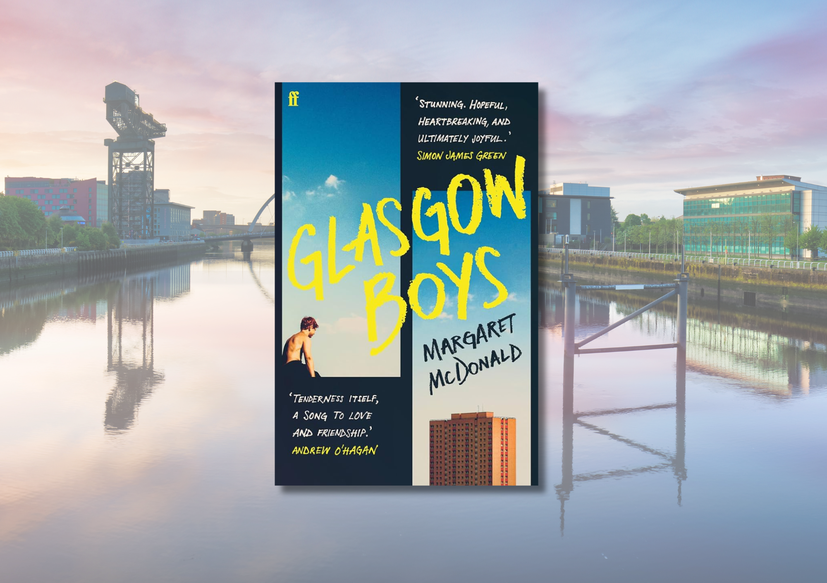

Glasgow Boys learning resource
Suggested learning activities for Margaret McDonald’s Glasgow Boys, focussing on Literacy and English and empathy

CfE Level Third and Fourth

Suitable for 13+


Resource created by Scottish Book Trust and EmpathyLab

scottishbooktrust.com

Scottish Book Trust is a registered company (SC184248)

and a Scottish charity (SC027669).

Contents
About this resource 3
Scottish Book Trust learning activities 4
English and Literacy activities 4
Cross curricular activities 14
EmpathyLab learning activities 17
Further resources 21
Printable activity sheet 1: Blurb of Glasgow Boys 22

About this resource
This resource has been developed by Scottish Book Trust and EmpathyLab to support classroom use of Glasgow Boys by Margaret McDonald with a focus on literacy and English skills, cross-curricular learning, reading and writing for pleasure as well as using the text with a particular focus on developing empathy skills and an understanding of other people’s feelings and life experiences. We have also created resources for:
- Little Bang by Kelly McCaughrain
- You Could Be So Pretty by Holly Bourne
- Northen Soul by Phil Earle
Scottish Book Trust is a national charity that believes in the life-changing power of books. Our school programmes support teachers and other education professionals to put creativity, reading and books at the heart of their learning environment. To find out more about using our programmes to support reading for pleasure, see our Schools guide.
EmpathyLab is a charitable social enterprise whose mission is to raise an empathy educated generation, inspired to build a better world for everyone. Our strategy is based on scientific research showing that empathy is a learnable skill, and books are a practical, powerful tool with which to build it. By 2026 we aim to benefit one million children every year.
About Glasgow Boys
Glasgow Boys follows two care-experienced boys: Banjo, who is attempting to navigate his last year at school, and Finlay, who has just started his nursing degree. Both are trying to make the best of their lives whilst also processing the trauma of their shared past.
Please note that Glasgow Boys does discuss trauma and abuse, as well as substance addiction, mental health and anxiety. One character also attempts suicide, though this is not directly depicted on the page. Although the book is ultimately hopeful, with all of our resources, we do highly recommend that you read the book before using it with your class and use your best judgement about whether teaching about this topic is appropriate for the young people in your class.
We also have an Authors Live broadcast with Margaret McDonald where she discusses the book in detail. This 40-minute broadcast is available on the Scottish Book Trust website and provides an excellent introduction to the book, as well as exploring Margaret McDonald’s experience as a writer.

Scottish Book Trust learning activities

English and Literacy activities

Activity 1: First impressions (before reading)
LIT 3-02a/4-02a, LIT 3-04a/4-04a, LIT 3-16a/4-16a
Look at the title and cover, but don’t read the blurb. In pairs, ask pupils to discuss:
- What do they think the book will be about?
- What genre do they think it is?
- What clues in the cover and title are they looking at?
Give them time to share their discussion with the class. Now, give the pupils a printed copy of the blurb (you can find this on page 22 of this resource).
- How close were they?
- What did they not predict?
- Is the genre different to what they predicted?
- What do they think Finlay’s storyline will be?
- What do they think Banjo’s storyline will be?
- Which character are they more interested in?

Activity 2: Banjo and Finlay (chapters 1 and 2)
LIT 3-15a/4-15a, LIT 3-16a/4-16a, ENG 3-17a/4-17a, ENG 3-19a/4-19a
Read the first two chapters. Divide pupils into two groups – one will discuss Banjo, and the other will discuss Finlay. Pupils can work in pairs or groups.
- What is your first impression of your character?
- What adjectives would you use to describe them?
- How would you describe their way of speaking?
- Are there any specific scenes, descriptions or language that shape your impression of this character?
- Can you find any key phrases or words that summarise their character?

Ask pupils to keep a note of these descriptions as they will come back to them later. Once both groups have shared, ask them to compare and contrast the two characters.
- How are they different?
- What techniques does the author use to give them distinct voices?
- What kind of language or sentence structure does she use for each character?

Discussion questions (end of chapter 5)
At the end of chapter five, it’s revealed that Banjo knows Finlay. Ask the pupils:
- How do they think they know each other?
- Has the author given us any clues so far?

Activity 3: The importance of setting (chapters 4 – 9)
ENG 3-17a/4-17a, LIT 3-18a/4-18a, ENG 3-19a/4-19a, LIT 3-26a/4-26a
In his novel Lanark, the Scottish writer Alasdair Gray had the following to say about Glasgow:
‘“Glasgow is a magnificent city,” said MacAlpine. ‘Why do we hardly ever notice that? Because nobody imagines living here. Think of Florence, Paris, London, New York, nobody visiting them for the first time as a stranger, because he’s already visited them in paintings, novels, history, books and films. But if a city hasn’t been used by an artist, not even the inhabitants live there imaginatively.”’

Ask the class:
- What other stories or books have they read that are set in Glasgow?
- What kind of stories do they associate with Glasgow?
- Did that shape their assumptions in Activity 1?

Read up to the end of chapter 9.
- How does the novel portray Glasgow? Ask pupils to note down any details about how the author describes the city and what kind of language and techniques she uses.
- How does Banjo’s relationship with his school and home life affect how he sees East Kilbride? How does this make him feel?
- How does Finlay’s personality affect how he sees Glasgow? What does he notice?

Activity 4: Writing a tour guide (chapters 4 – 9)
LIT 3-20a/4-20a, LIT 3-24a/4-24a, LIT 3-26a/4-26a
Discuss what you learned from Activity 3 about setting. Now you’re going to write about where you live. Imagine you have to give the reader a tour of your local area – where would you take them? Remember: you’re not listing the popular areas or landmarks; you’re trying to take them to places that have some significance to you.
- What are your favourite places?
- Is there somewhere you’ve always wanted to go?
- Are there any differences at different times of day? Or different seasons of the year?
- Use your senses – what do you see, hear, smell, touch, taste?

Discussion questions (end of chapter 9)
In chapter nine, Banjo is offered the job and Alena takes his photograph for a wall of employees display. Ask the pupils:
- What does the photo wall represent to Banjo?
- What word do they think Alena will give him?
- What word would they give him?

Activity 5: Memory and characterisation (chapters 10 – 15)
LIT 3-15a/4-15a, LIT 3-16a/4-16a, ENG 3-19a/4-19a
Under the blurb on the back cover is a line which reads: ‘Can Finlay and Banjo let go of the past before it drags them under?’
Look at some of the events in chapter 10 to chapter 15, for example:
- Finlay doesn’t text Akash back (chapter 10)
- Banjo’s behaviour at Kyle’s party (chapter 13)
- Finlay’s first day at work (chapter 14)
- Banjo gets angry with Paula and Henry (chapter 15, chapter 17)
Now look for evidence of how the character’s memories and experiences have shaped who they are. Why do the characters act in the way that they do? What clues do we receive from the flashbacks or their memories? Ask pupils to draw a table that shows the event and what influenced the characters to act in the way that they did.
For example:
Character | Event | Memory
Finlay  (chapter 12) | Finlay becomes anxious when his friends joke about someone dying on their nursing placement. | Finlay remembers having to look after Banjo as he went through withdrawal.
Banjo  (chapter 13) | Banjo doesn’t let Devlin look after him when he is sick at the party. | Being looked after by someone else reminds him of Finlay.

Before continuing the novel ask the pupils:
- What barriers do Finlay and Banjo face?
- How do their memories impact their relationships with the other characters around them?
- Do you think they’ll be able to move on from their past trauma?

Discussion question (end of chapter 15)
In these chapters, we start to get more of Banjo and Finlay’s memories of living with each other in a home.
- How do each character’s memories of what happened to them differ?
- Why do you think the author has included the flashbacks in the same chapter, instead of creating entirely new chapters for them?

Discussion questions (chapter 18 and 19)
In chapter 18 and 19 we see both Finlay and Banjo have extreme emotional reactions towards the loss of something – for Finlay it’s in a memory sequence where someone takes his teddy, Mr. Black, and for Banjo it’s when he’s suspended from the athletics team.
- What does Mr. Black represent for Finlay?
- What does athletics represent for Banjo?
- Compare and contrast these two motifs – Mr. Black and running – how do they highlight the differences between Finlay and Banjo? What do they have in common?

Activity 6: Relationships (chapters 16 – 20)
LIT 3-06a/4-06a, LIT 3-15a/4-15a, LIT 3-16a/4-16a, ENG 3-17a/4-17a,
ENG 3-19a/4-19a
The purpose of this activity is to understand how every relationship that a character has represents a different element of that character. Assign pupils either Banjo or Finlay and ask them to draw a mind map with their character in the centre, and every character they have a relationship with around them.
For example, Banjo’s map could look like this:
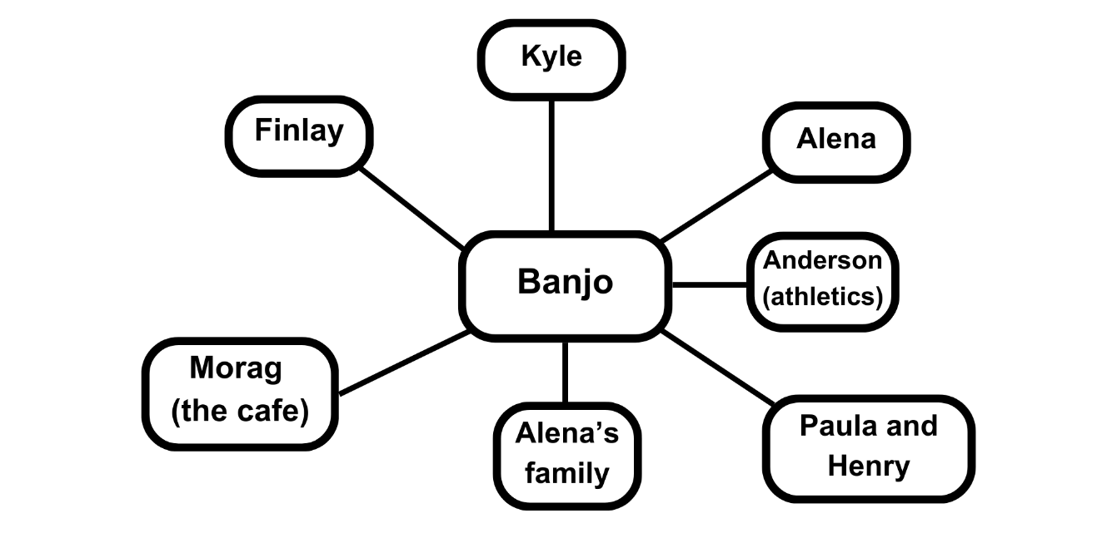
Now ask them to add more detail about what those characters each represent to the central character. This could include:
- How they make the central character feel
- What they associate them with
- What role they provide them in the story (e.g. romance, family, etc.)

For example, Banjo’s map could look like this:
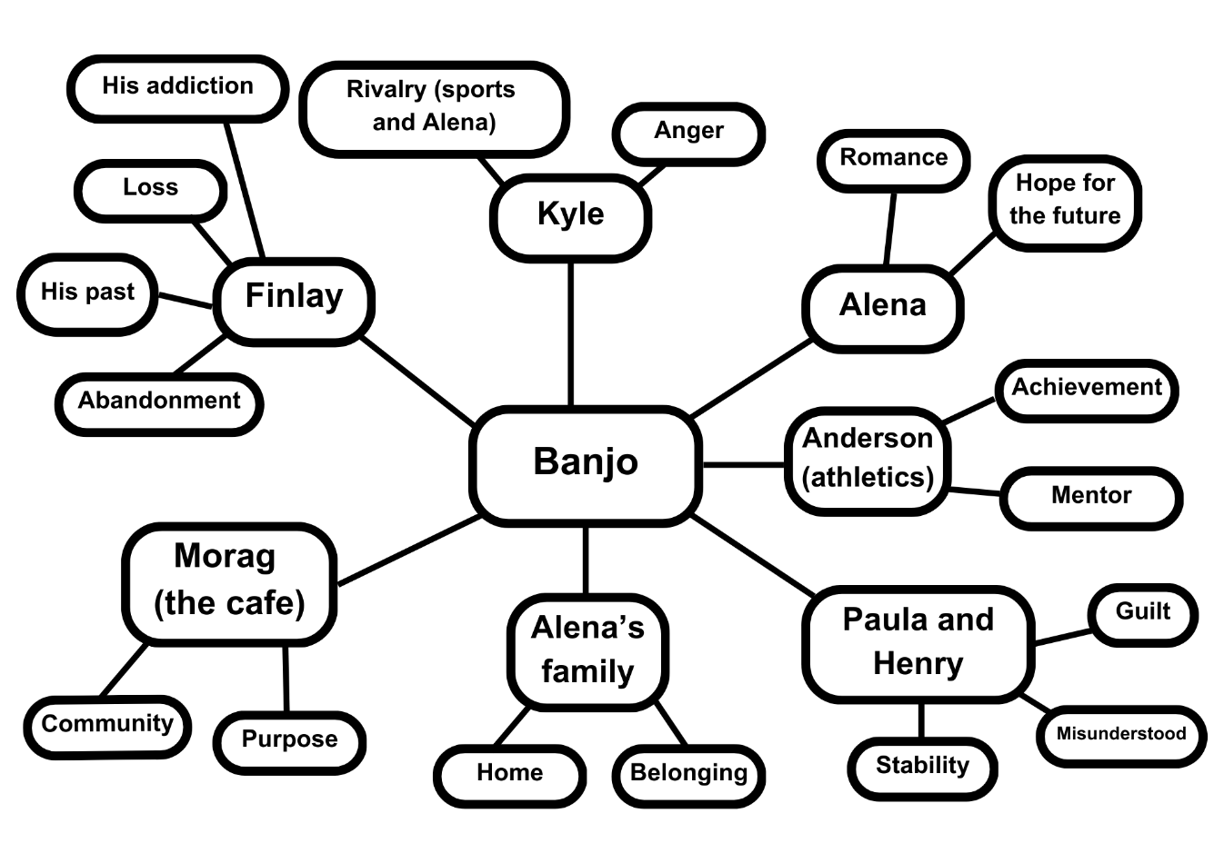
Allow the pupils time to look at each other’s mind maps.
- Do Finlay and Banjo have similar relationships in their lives?
- What do they think Banjo needs to recover from his past?
- What about Finlay? Are his needs the same?

After looking at the mind maps, ask them to pick two different relationships that the same character has, for example:
- Banjo’s relationship with his foster parents and his relationship with Alena’s family
- Finlay’s relationship with his flatmates and his relationship with Banjo

Write a paragraph comparing and contrasting these relationships, using examples from the text such as metaphor, dialogue, references to the character’s feelings, etc. For example:
- How does Alena’s family make Banjo feel at home in a way that his foster parents don’t always manage? Pupils could look at the scene where Banjo eats with Alena’s family whilst he often eats alone at home.
- Who understands Finlay better – Banjo or his flatmates? Pupils could look at how Banjo shares his care experience and the scene where Banjo retrieves Mr. Black.
- They could also look at how Finlay feels when he comes out for the first time to his flatmates and connects with them over watching a film.

Discussion questions (end of chapter 20)
Ask the pupils why they think Banjo and Finlay no longer keep in contact.
- Why do you think they no longer keep in contact?
- What clues are there in previous chapters?
- Do you think they argued or drifted apart? Are there any clues about how their relationship ended?

Discussion questions (end of chapter 25)
Revisit and recap your last discussion about why Finlay and Banjo are no longer friends.
- Did anyone correctly predict why Banjo and Finlay are no longer in contact?
- Was anyone surprised by what happened?
Think back to Finlay’s chapters.
- How did Banjo’s behaviour in the chapter 25 flashback impact Finlay?
- Are there any chapters where this impact is especially clear?

Activity 7: Stage a scene (chapters 21 – 28)
ENG 3-17a/4-17a, LIT 3-20a/4-20a, LIT 3-24a/4-24a, LIT 3-26a/4-26a
Ask pupils to choose a key chapter or scene from the book and think about how they would adapt it for stage or screen. Some good examples could include:
- Finlay’s emotional reaction to Akash’s house (chapter 22)
- The flashback where Finlay gets a foster placement (chapter 23)
- Banjo sees Finlay in the hospital (chapter 25)
- Banjo confronts Finlay after going through his phone (chapter 25)
- Finlay and Akash’s conversation (chapter 28)

Use our article on Five tips for writing an adaptation by screenwriter Douglas Dougan for advice and turn the scene into a script. Ask pupils to make sure their script contains:
- The scene’s setting – their script should set the scene before getting into the dialogue.
- Stage directions – how should someone act or move around in this scene? What are they feeling? How will they convey this?
- If it’s for screen – what should a camera focus on? What kind of shots would you use?
- Even if they’re only looking at one scene, think about how they can capture the feeling and themes of the novel overall.

Activity 8: Revisiting your notes (chapters 29 – 31)
LIT 3-15a/4-15a, LIT 3-16a/4-16a, ENG 3-19a/4-19a
Revisit either the list of assumptions pupils wrote about Banjo and Finlay from Activity 2 or the tables from Activity 5 and mind maps of relationships from Activity 6.

Revisiting assumptions (Activity 2)
Ask pupils to read through their descriptions about Finlay and Banjo before they had read the rest of the novel. Has anything changed? Were there any key moments or scenes that changed their thoughts? Now, ask them to write a new description of each character.

Revisiting character relationships (Activity 5 and 6)
Ask the pupils to look over their tables about the impact of memory, as well as the mind maps and notes where they contrasted the different relationships. Knowing what they do now, ask them to think about Banjo’s relationship with Alena and Finlay’s relationship with Akash.
- How have these relationships, across the course of the narrative, helped them heal from their past trauma?
- What do these relationships offer them that they need? Be specific here: what adjectives would they use?

Activity 9: Themes (after finishing the novel)
LIT 3-16a/4-16a, ENG 3-17a/4-17a, ENG 3-19a/4-19a
There are different ways of exploring a text. These include:
- Plot: what happens in the story?
- Character: who are the characters? What are they like?
- Themes: what are the ideas the novel explores?
Working in groups, ask your pupils to present a five-minute talk on one of the key themes in Glasgow Boys. They can come up with this themselves, or you can assign them a theme that they have to find evidence for:
- Class
- Community
- Friendship
- Hope and recovery
- Identity and language
- Masculinity
- Memory and trauma
- Sexuality

Activity 10: What happens next?
ENG 3-19a/4-19a, LIT 3-20a/4-20a, LIT 3-24a/4-24a, LIT 3-26a/4-26a
Ask the class – what do they think happens next? Allow them some time to discuss this either as a class, or in groups.
Next, ask them to create a piece of creative writing where they add an epilogue to the story. It can be prose in the style of another chapter, a poem or they could use the script writing they learned in Activity 7. If pupils are stuck, they can use one of the following prompts:
- Write an epilogue from another character’s point of view (e.g. Akash, Alena)
- Write a scene set 5, 10, 15 or 20 years in the future. Where do you imagine Banjo and Finlay are now?
- Write from the point of view of the city

Cross curricular activities

Activity 1: Create a playlist
LIT 3-15a/4-15a, EXA 3-17a/4-18a, ENG 3-19a/4-19a
Finlay and Banjo both have distinctive voices. Make a playlist for each character, thinking about how you capture their different personalities and styles. You can either imagine what kind of music they would listen to or try and think about what styles or genres capture their personalities.
You could extend this activity by composing a piece in response to Glasgow Boys, whether trying to capture the feeling of one of the narrators or soundtracking a specific chapter or scene.

Activity 2: Dramatise a scene
ENG 3-17a/4-17a, LIT 3-20a/4-20a, LIT 3-24a/4-24a, LIT 3-26a/4-26a,
EXA 3-12a/4-12a, EXA 4-13a, EXA 3-14a, EXA 3-15a/4-15a
If you completed Activity 7: Stage a scene, why not work with your drama department to stage some of the scripts you have written? Ask your pupils to think about how they will embody the different characters. For example:
- How does each character speak?
- How does each character move?
- What are they feeling in this scene? How can you express this?
Activity 3: Design a new cover
ENG 3-19a/4-19a, EXA 3-06a/4-06a, EXA 3-07a/4-07a
Work with your art department to design a new cover for Glasgow Boys. Before starting, ask the pupils to develop a brief for the project, including what they think is key to capturing on the cover – e.g. the book’s genre, the main characters, the city of Glasgow, or any of the key themes you discussed in Activity 8.
Research comparable genres and titles, for example, other Scottish or contemporary or young adult novels. Visit your local library to look at book covers. You could also explore the following resources:
- “The art of book cover design” by Penguin Random House on YouTube (2 minutes, 35 seconds)
- “How book covers are designed” article from Penguin Books
- Look at the book covers in some of our Book Discovery Guides or on our Book lists

Activity 4: Expand the glossary
LIT 3-26a/4-26a, MLAN 3-08a, MLAN 3-11a, MLAN 3-11b, HWB 3-12a/4-12a
Glasgow Boys uses Scots throughout and has a Scots glossary at the end. Some of the characters also have relationships with other languages – Alena’s family are Greek, Akash speaks Punjabi, Finlay feels alienated from his Polish heritage because he doesn’t know any Polish.
Look through the glossary together. Are any of the terms new to your pupils? Or do you use different words and phrases in your local area?
Ask pupils to design a survey for pupils and school staff about the languages that they speak. Then, expand the Scots glossary at the end of the book. You could look at translating the words into other languages or adding in words that are important to the people in your school in their languages. Your glossary could take the form of a schoolbook, display or you could create a video.

Activity 5: LGBTQ+ rights
ENG 3-19a/4-19a, SOC 2-17a/4-17a, SOC 3-16a, SOC 3-17b, HWB 3-09a/4-09a
One of the themes in the novel is sexuality. Both Finlay and Akash have experiences with coming out – Finlay comes out to his flatmates and Akash says he’s not yet out to his parents. Discuss:
- Why do you think Finlay is nervous about coming out?
- What are some reasons someone may not come out?
You could talk about how, even though there may not be any clues about why Akash is not out to his parents, there a lot of different reasons why someone may not be out as LGBTQ+. This could include a fear of discrimination but also it could be to do with still deciding terms that fit them or being a more private person.
Watch Amnesty International’s video LGBTI Rights Explained (4 minutes, 44 seconds). Put pupils in groups and assign them each one of the following Universal Declaration of Human Rights:
- Article 3 – right to life and live safely
- Article 16 – freedom to marry and to have a family
- Article 19 – freedom of opinion and expression
- Article 23 – right to work, equal pay and protection against unemployment as well as the right to form and join trade unions

As a class, ask them to feed back
- What kinds of discrimination to LGBTQ+ people face both in Scotland and abroad?
- Talking about the right they have been assigned, how does discrimination against LGBTQ+ people violate that specific right?
To extend this activity, LGBT Education’s Section 28 resource can provide a good examination of how Section 28 still has impact today.
For anyone in your class who may approach you about coming out, Childline has a guide to coming out which contains advice for young people who are considering telling their families and loved ones they are LGBTQ+. Stonewall’s website also contains advice for supporting LGBTQ+ young people.
Tie it back to Glasgow Boys. Re-read chapter 25 as a class.
- Why was Banjo upset with Finlay?
- What may have made Finlay nervous to tell Banjo he is gay?
- How did Banjo’s reaction impact Finlay?
- What helped Finlay to come out and feel safer and more supported?

Finish by discussing what you can do in your school to be rights respecting and ensure that no one experiences bullying, homophobia or discrimination. Ask pupils to write their suggestions on a post-it note, then allow them time to go around and vote on their top three by adding a tick to the post-it note. You can then discuss how to implement these in your school.

EmpathyLab learning activities

Activity 1: Meeting Banjo and Finlay
LIT 3-02a/4-02a, LIT 3-06a/4-06a, ENG 3-17a/4-17a, ENG 3-19a/4-19a
- Stronger ability to imagine, understand and reflect on other people’s perspectives and feelings

Divide the class into two. Ask one half of the class to imagine they are at school with Banjo ‒ how would they describe Banjo at the beginning of the story? Ask the other half of the class to imagine they are starting university and meeting Finlay for the first time. How would they describe Finlay when they first meet him? Ask each group to share their thoughts.

Activity 2: Create emotion maps
ENG 3-17a/4-17a, ENG 3-19a/4-19a, HWB 3-01a/4-01a
- Stronger ability to imagine, understand and reflect on other people’s perspectives and feelings
- Wider vocabulary to recognise and share own and others’ feelings
Review the key moments in the story as a class for Banjo and Finlay e.g. Banjo fighting at school, meeting Alena, starting work in the cafe, seeing Finlay again. Finlay on his first day at university worrying about being alone and his finances, meeting the other students, bumping into Akash and falling for him, seeing Banjo again, and being accepted for his work at the care home. Invite the class or groups to create emotion maps for Banjo or Finlay which identify the range of feelings experienced by the characters. Use EmpathyLab’s template to create an Emotion Map.

Activity 3: Building relationships
LIT 3-02a/4-02a, ENG 3-19a/4-19a, HWB 3-05a/4-05a, HWB 3-10a/4-10a,
HWB 3-44a/4-44a
- Stronger ability to imagine, understand and reflect on other people’s perspectives and feelings
- Stronger empathic communication skills: deep listening and conversation

Banjo and Finlay have very different personalities and yet they are friends. Why?
Divide the class into smaller groups of about 10 people.
Give half of each group cards that that say ‘Banjo is friends with Finlay because…’ and the other half cards that say ‘Finlay is friends with Banjo because…’. Give the group time to think and ask each person to write one reason on their card. Emphasise that there are no right or wrong answers and it is okay to write the same thing as someone else if that is what they think.
Then ask the group to sit in two lines of five facing each other. “Banjos” on one side, “Finlays” on the other. One person starts saying ‘I, Finlay, am friends with Banjo because…’ and gives their reason. They then pass to someone in the Banjo side who says ‘I, Banjo, am friends with Finlay because…’
When everyone has had a chance to speak, the whole group can get together to reflect on what they have said about the friendship.

Activity 4: The power of friendship
LIT 3-02a/4-02a, ENG 3-19a/4-19a, HWB 3-05a/4-05a, HWB 3-44b/4-44b
- Stronger ability to imagine, understand and reflect on other people’s perspectives and feelings
Friends and adults who care play a big part in the lives of the two main characters. Invite each person in the class to choose one of the characters in the story (other than Banjo and Finlay) and think about why they don’t give up on Banjo and Finlay, even when they sometimes push people away.
Using a hot-seating exercise, have a pupil take on the role of either Banjo or Finlay and sit on a chair. Have other pupils arrange themselves in a circle around the pupil on the chair and then take turns to speak out loud their reasons for not giving up on them. You could use the words and phrases to create a word cloud or put them on a large piece of flip-chart paper.
Hold a class discussion on what friendship means. What traits and behaviours support enduring friendship?

Activity 5: Resolving trauma
LIT 3-02a/4-02a, ENG 3-19a/4-19a, HWB 3-06a/4-06a
- Stronger ability to imagine, understand and reflect on other people’s perspectives and feelings
- Wider vocabulary to recognise and share own and others’ feelings
- Stronger empathic communication skills: deep listening and conversation
Banjo and Finlay have both experienced trauma in their lives before the story starts. During the story, they both work through some of their early experiences and find some peace. Have a group discussion about what resolves for them during the story.

Activity 6: What does the future hold?
LIT 3-15a/4-15a, ENG 3-19a/4-19a
- Stronger ability to imagine, understand and reflect on other people’s perspectives and feelings
Create a wish jar and ask each person in the class to write one wish for Finlay or Banjo after the story ends.

Activity 7: Take action
ENG 3-19a/4-19a, SOC 3-15a, SOC 3-16a/4-16a, SOC 4-16b
- More developed social values which turn feelings of empathy into moral actions in the home, school and community
Finlay and Banjo are both care experienced young people. Ask the class in small groups to discuss whether they think society does enough to support them? What could be done differently? What could we each do to make a difference?
If you have any pupils who are care-experienced in your classroom, we suggest you take care when exploring Glasgow Boys. The Promise Scotland provides an excellent resource for exploring this topic further and connects the needs of care experienced children to the U.N. Convention on the Rights of the Child.

Further resources

Scottish Book Trust
- For more learning resources see the Learning resources section of the Scottish Book Trust website.
- Watch Margaret McDonald discuss Glasgow Boys on Authors Live.
- We also have Teen book discussion guides, including a guide on Glasgow Boys, which you can use for class discussion or to form a book group.
- To find out more about reading and empathy, see our webinar series Connecting empathy and reading in schools in partnership with Empathy Lab, Maisie Chan, the University of Strathclyde and Vanessa Thomson

Empathy Lab
Visit the EmpathyLab website for more information about how we support schools to raise an empathy-educated generation, including
- Read for Empathy collections and guides
- EmpathyLab’s Schools Programme
- The Empathy Day Festival
- Training events

Printable activity sheet 1: Blurb of Glasgow Boys
Two boys can’t remember the last time they had a hug.
Meet Finlay.
He’s studying for his nursing degree at Glasgow University, against all the odds. But coming straight from care means he has no support network.
How can he write essays, find paid work and NOT fall for the beautiful boy at uni, when he’s struggling to even feed himself?
Meet Banjo.
He's trying to settle in with his new foster family and finish high school. But he can’t forget all that has happened, and his anger and fear keep boiling over.
How can he hold on to the one good person in his life, when his outbursts keep threatening his already uncertain future?
Can Finlay and Banjo let go of the past before it drags them under?
‘As if you are reading your own heart written upon the page.’ – Non Pratt

