
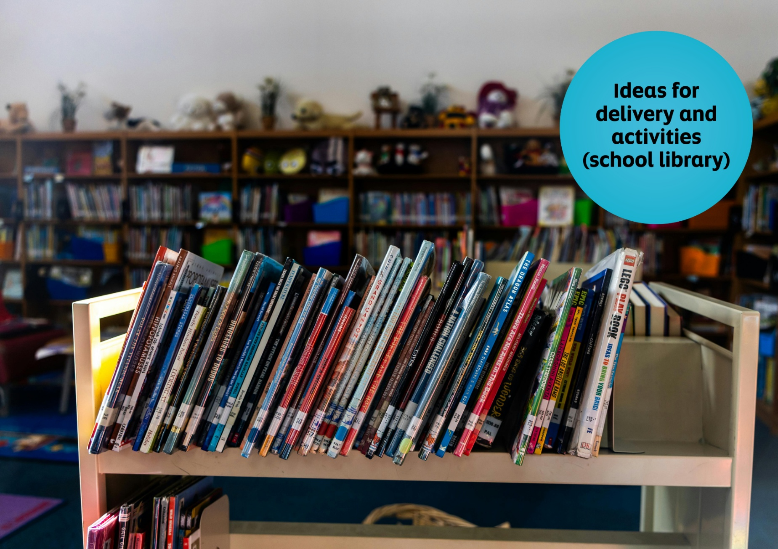

Celebrating World Book Day: school library resource
A guide to World Book Day in your school library


Resource created by Scottish Book Trust and World Book Day

scottishbooktrust.com

Scottish Book Trust is a registered company (SC184248)

and a Scottish charity (SC027669).

Contents
About this resource 2
Scottish Book Trust packages 3
Library activities for World Book Day 3
Next steps 6

About this resource
Scottish Book Trust is a national charity that believes everyone living in Scotland should have equal access to books. Our Schools programmes include book gifting, live events, our Reading Schools accreditation programme, as well as professional support, training and resources to support you to embed reading for pleasure in your school or setting.
World Book Day is a national celebration which changes lives through a love of books and reading. They are a national charity that operates in the U.K. and Ireland to promote reading for pleasure, offering every child and young person the opportunity to have a book of their own. World Book Day 2026 is Thursday 5 March.
We have partnered with World Book Day to adapt their resources for Scottish schools and libraries and help you celebrate World Book Day 2026! On the Scottish Book Trust website, you can find all of the resources including:
- Celebrating World Book Day: early years resource
- Celebrating World Book Day: primary resource
- Celebrating World Book Day: secondary resource
- Celebrating World Book Day: school library resource
- Celebrating World Book Day: home educator resource
You can also find our designated World Book Day webpage on the Scottish Book Trust website, which gathers activities, articles, videos, and more resources that have been handpicked to help you further explore reading for pleasure and the World Book Day £1 titles!
This resource, created in partnership with World Book Day, contains advice and ideas for celebrating World Book Day in your school library. Throughout, we’ve highlighted Scottish Book Trust resources you can use as part of your celebration, or to deliver further opportunities to read for pleasure.

Scottish Book Trust packages
On the Scottish Book Trust website, we’ve created a World Book Day page which gathers activities, articles, videos and more resources to help you celebrate World Book Day. For example, if your pupils have enjoyed Bunny vs Monkey: Total Chaos, you can watch our Authors Live broadcast with Jamie Smart where you can learn to draw both Bunny and Monkey. You can also find fun activities like learning how to make a mini book, creating story sticks or creating book trailers.

Library activities for World Book Day

Activity 1: Library tours
Give each class a tour of the library, during which they can choose a book to borrow or sign up for a library card.

Activity 2: Authors Live
You could set up your library to screen Authors Live on demand broadcasts throughout the day. Why not put pupils in charge of who to watch? You’ll find some of the World Book Day authors in there, including World Book Day authors such as A.F. Steadman and Jamie Smart, as well as world class authors such as Elle McNicoll, Joseph Coelho, Kiran Millwood Hargrave, Nadia Shireen and more!

Activity 3: Three books I like
Invite teaching staff to select three books they’ve enjoyed to display in their classroom. This could spark book talk in the classroom and encourage pupils to visit the library to borrow books.

Activity 4: Whose book is this?
Compile a quiz where students have to match the shelfie (a photo of a bookshelf) or favourite book to the correct member of staff.

Activity 5: Make your own photo booth
Set up a makeshift photo booth, using a cardboard box as a frame, and invite students to have their photos taken with their chosen book or magazine. You can collect props to match different types of books.

Activity 6: Design your own bookmarks or shelf shouters
Invite students to create a bookmark or shelf shouter to recommend a book to someone else! You could also use World Book Day’s printable activity sheet to play a game of Book recommendation bingo as a warm up activity.

Activity 7: Hide and seek books
Ask pupils to write a paragraph on a topic of your choosing and challenge them to hide as many book titles as they can in the text.

Activity 8: Dream reading spaces
Ask pupils to design their ideal reading space, including all the accessories needed for a good reading session.

Activity 9: Audio samples
Select snippets of audiobooks that might appeal to your students’ interests. Ask them to try 10 different titles for five minutes each. Are there any they’d spend another 5 – or 10 – minutes with?

Activity 10: Book speed dating
This is a great activity for allowing pupils to sample a variety of different books in a short space of time, and to help you get an indication of the books that pupils enjoy reading. Set out a few different book stations and ask pupils to pick a book and spend a few minutes reading, before moving onto the next station. Pupils jot down their first impressions of the book as they go, and whether they would like to keep reading. This activity was taken from our Running reading groups and events resource where you can find more activities!

Activity 11: Book Jenga
Transform a game of Jenga into an incredible (and fun!) tool for Book Talk. Book Jenga was a game brought to the attention of Scottish Book Trust by secondary school librarian Deena Wren, winner of our Scottish Book Trust Learning Professional Award.
All you will need to create Book Jenga is a set of Jenga blocks, a biro or fine liner pen, and your chosen questions! You play Book Jenga by building your tower and taking it in turns to pull out a block and answer the question on it. You can play either by answering the question yourself, or by asking everyone in the group to answer the question before moving on to the next one. The used block is then placed on top of the tower. Gradually the tower builds and becomes less stable. As with all Jenga, the aim is not to topple the tower. The game ends when the tower falls!
To find this full activity see our Running reading groups and events resource which also contains suggested questions you can use.

Activity 12: Make a mini book!
Use our guide to create your own mini book – it’s up to you what you put in it! It could be a new book journal to keep track of your favourite books, a sequel to your favourite story, somewhere to keep your favourite jokes or a World Book Day inspired poem.

Activity 13: Create your own World Book Day inspired hat
A big party needs a party hat! Use our printable template to create your own hat by cutting it out and either drawing, colouring or collaging.

Next steps
Promoting reading for pleasure in your school is important all year, not just on World Book Day! For more support to build a reading culture in your school see:
- Our World Book Day section of the Scottish Book Trust website gathers activities, articles, videos and further resources to further extend reading for pleasure and World Book Day’s £1 titles
- Our Schools guide contains more information on the programmes, CLPL and resources from Scottish Book Trust created to support teachers, educators and librarians in schools
- Our Running reading groups and events resource suggests easy and fun activities you can run in your library to help the pupils in your school start talking about, and engaging with, books.
- Our teen discussion guides have been designed for you to run a book group for secondary pupils with a wide range of contemporary teen titles, including authors such as Keith Gray, Maisie Chan, Brian Conaghan, Elle McNicoll, Dean Atta, Patrice Lawrence and more!
- World Book Day’s Resources Hub contains lots more reading for pleasure ideas, resources for World Book Day and all year round!

