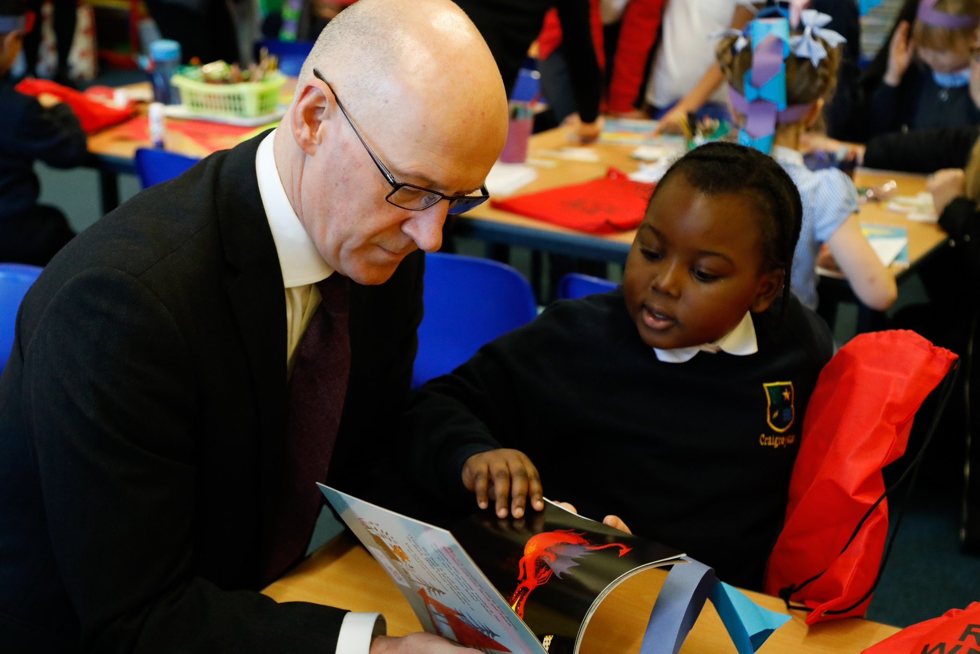

Bag gifting at Neilston Primary School
Age 5-7

CFE Levels First to Second

Resource created by Ainslie McCabe

scottishbooktrust.com

/scottishbktrust

@scottishbktrust

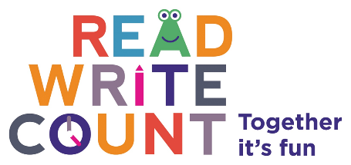

Introduction
Teachers are busy. We are under pressure with the day to day planning for different abilities, marking jotters, updating wall displays, all while attending after school meetings and trying to ensure our lessons are varied and stimulating. So, when new initiatives come along it is no wonder we sometimes sigh and mutter ‘not another thing!?’
This is how I felt at first when I was given a box of bags and told to do something with them. Once I had a look in the bag however, I realised this was something I didn’t want to send home to be lost under a bed. I want to outline some ideas for how these bags can be used to enhance what we are already doing as part of our day to day practice and tick off some wee extras too…
Forward Planning
As a school we have been working on interdisciplinary learning and the Read, Write, Count bags provided an excellent opportunity to cluster Experiences and Outcomes together to create an engaging learning experience as well as a valuable home link.
I planned my reading skills around the Read, Write, Count bags. We developed a range of strategies to help us before and as we read, and created a help video about these strategies for our parents and carers.
The finale of our learning was inviting the parents and carers in for a reading workshop and the gifting of the bags.
Building up to the gifting of the bags
I really wanted to raise the profile of reading in my classroom and the gifting of the bags was the perfect hook. We started with looking at the library area of the classroom. We added tents, as suggested by the children, and set aside time in the day for children to choose a book to read for pleasure. We allowed the children to take home a book of their choice to share with their parents and let parents know that we would invite them in for a workshop on ways for them to help us read at home.
To build up skills which could be used with any story, including those in our bags, we used Aliens Love Underpants to focus on a range of reading skills such as looking at picture clues, predicting, asking and answering questions and discussing characterisation. We acted out the story using puppets in our puppet theatre. The activities led into some of the suggested tasks for parents in the guide. The children were then confident enough to explain some of these ideas in a help video. We linked what we had been learning in maths. After learning about money, children applied their money handling skills to pay for tickets to enter the puppet theatre.

Planning the gifting of the bags as a workshop for parents
One of our School Improvement Plan priorities this year has been parental engagement. As a school we are good at involving parents and carers in class assemblies and meet the teacher events. We were eager to build on this to provide more opportunities for engagement to enable parents and carers to be joint partners in their children’s learning.
When planning our reading workshop, I considered how to make it as worthwhile as possible. Below are some tips that may be helpful in planning your own workshop or gifting event.
Time
We timed our event at 2:30pm, 45 minutes before parents and carers would be collecting their children at the end of the day. We gave plenty of notice in case parents needed time off work. Nearly all children are collected by a relative at the end of the day so we chose this time as we knew there would be someone available to come.
Siblings
We made sure that parents and carers knew it was OK for siblings to come and enjoy the fun too. Parents have mentioned childcare concerns in the past.
Children leading the workshop
Parents and carers are their children’s first teacher. They are the people who first read to their child and tell them stories. I was very aware that I didn’t want to stand up and preach to, or patronise parents and carers. I did however want to be able to suggest ideas for extending their children’s learning at home. I decided to allow the children to present the afternoon. They had little parts to say and we played a video to demonstrate the different ways that parents can help.
Video clip (made app on iPad)
I was considering how to reach parents and carers in an inclusive way. In the past I had sent home a sheet full of ideas. As teachers we know how often things mysteriously vanish on the way home, but parents and carers are also juggling their own jobs, dinners, keeping a house etc. without rummaging through their child’s bag. The letter also assumes all parents and carers can read. As a school we have had success in using Twitter as a method of communicating, so I felt a video clip would have success in reaching the most parents and carers, even those who cannot or will not attend a school event. The video clip was successful for a number of reasons:
- It was posted on the school website, Twitter page and YouTube channel which meant parents who were unable to attend, get time off work, or those who don’t have the confidence to attend school events, could access it.
- The children explained each of the strategies which meant parents wouldn’t feel patronised. Moreover, parents are more likely to watch a video of their children and the children were super excited to show it off!
- The book for parents has excellent ideas. The video demonstrated these ideas in action. This means parents who are too busy to sit and look through the book, or parents who are illiterate, could access the ideas.
After all the build-up in class, the children were so excited when the gifting afternoon finally came. They stood up at the front of the class and gave some information before we watched the clip. Children then sat with their parent or carer to finally open their bag and try out some of the new ideas. Look at how much fun we had!
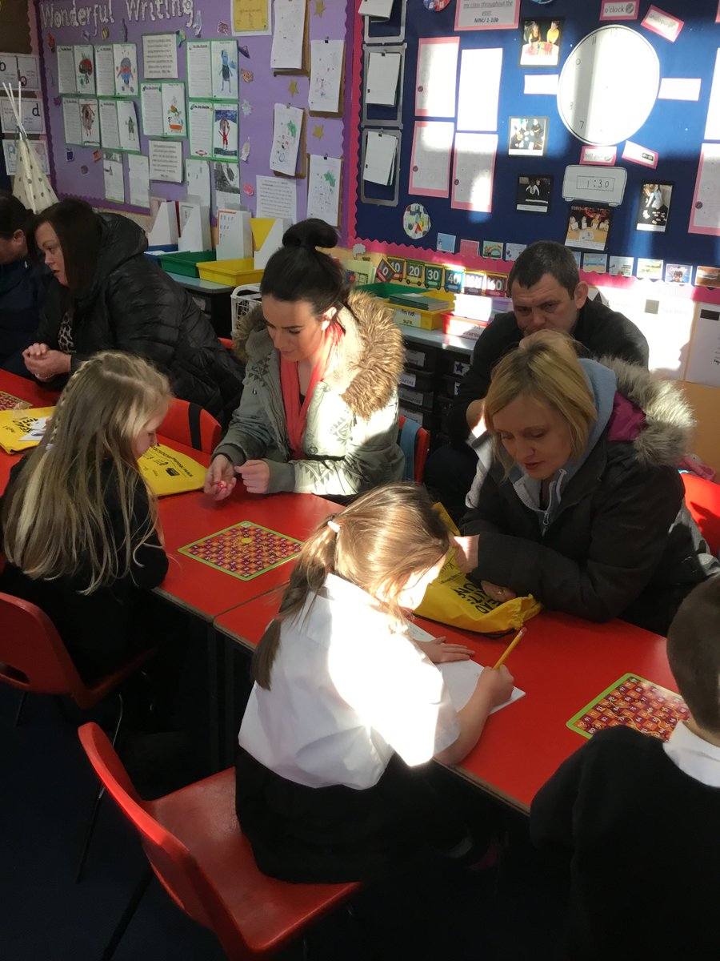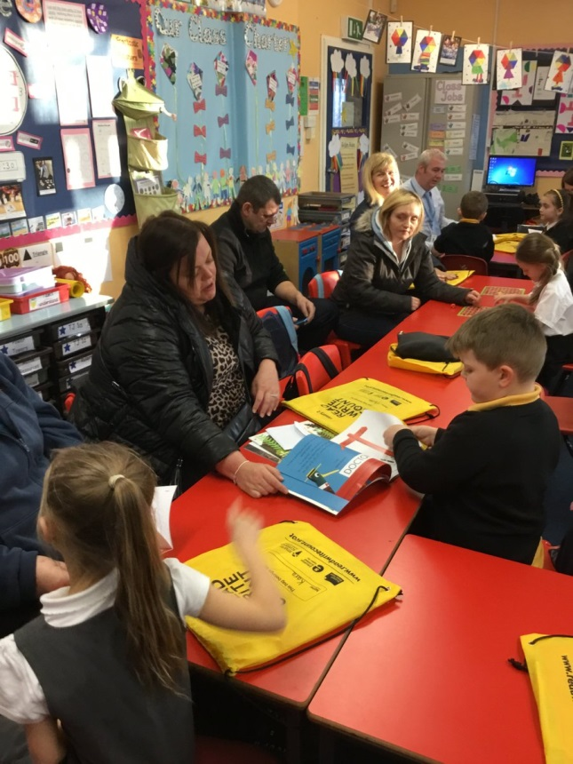
Evaluation
I used Microsoft Forms to gather feedback from parents and carers. They scanned a QR code which took them straight to my questionnaire which they completed on the iPad.
Responses were positive with 100% of parents who completed the questionnaire saying they found the afternoon ‘very helpful’.
Parents expressed a positive response to the opportunity to work alongside their children and ‘try out’ activities.
“I think it is a great idea to have parents in to enjoy learning together.”
“I would like more interactive events.”
Building on our success
Building on this success we established new spelling homework with a similar video to support it. The video was posted online and gave parents active suggestions of ways they could help their child learn their spelling words. To build on the maths resources included in the Read, Write Count bags and further support home learning, we also introduced home link bags for maths. A colleague on a maths cluster group worked with P2 to create bags with a range of resources which can be loaned out on a weekly basis (Wednesday to Wednesday to allow parents to enjoy playing with their children at the weekend). A launch afternoon was held where parents were invited to try out the resources.

