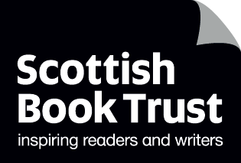
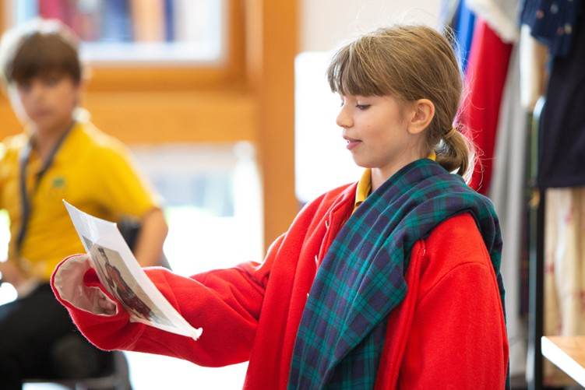

Using books to support your National Trust for Scotland visit
Suggestions for classroom texts and activities to extend learning from a visit to National Trust for Scotland places

CfE Second Level
Age 8-12


Resource created by Scottish Book Trust and The National Trust for Scotland

scottishbooktrust.com

Scottish Book Trust is a registered company (SC184248)

and a Scottish charity (SC027669).

Contents
About Scottish Book Trust / About the National Trust for Scotland 2
About this resource 3
Why use books to support a school visit to a National Trust for Scotland place? 3
Visiting National Trust for Scotland places 4
The Battle of Bannockburn 5
Culloden 7
Culzean Castle & Country Park 8
Falkland Palace 10
Glencoe 11
Mackintosh at the Willow 13
North East Ranger Service 15
Robert Burns Birthplace Museum 17
Further resources 19

About Scottish Book Trust / About the National Trust for Scotland
Scottish Book Trust is a national charity that believes in the life-changing power of books. Our school programmes support teachers and other education professionals to put creativity, reading and books at the heart of their learning environment.
The National Trust for Scotland (The Trust) is an independent charity that protects, cares for, and shares our country’s magnificent natural and human heritage. We’re the largest Scottish membership organisation, a leader in conserving and promoting the nation's treasured places and collections so that they can be enjoyed by present and future generations.

About this resource
This resource includes suggestions of texts you can use to further the learning from visiting one of the National Trust for Scotland’s places. You can use these texts before or after your visit. Each text suggestion also includes links to learn more about the places via the National Trust for Scotland’s website, as well as links to Curriculum for Excellence.
The Trust places included in this resource are:
- The Battle of Bannockburn, Stirling
- Culloden, Inverness
- Culzean Castle & Country Park, Maybole
- Falkland Palace & Garden, Fife
- Glencoe National Nature Reserve, Ballachulish
- Mackintosh at the Willow, Glasgow
- North East Ranger Service, various across Angus and Aberdeenshire
- Robert Burns Birthplace Museum, Alloway

How to purchase the books
If you would like to purchase any of the books mentioned in this resource, you can:
- Use Scottish Book Trust’s Bookshop.org list - a percentage of these sales goes to Scottish Book Trust.
- To support the National Trust for Scotland, you can also use their online shop.

Why use books to support a school visit to a National Trust for Scotland place?
These books have been carefully chosen by the Scottish Book Trust and the National Trust to tie in with the history, nature, and themes you can explore during a school visit with the National Trust for Scotland. With direct links to Experiences and Outcomes across Curriculum for Excellence, these stories, characters, and in-class activities provide an opportunity for your class to delve deeper, before or after your school’s visit to a Trust place, enriching the overall experience with a more intimate, personal perspective. Whether running with unicorns in Glencoe or discovering Robert Burns’s early life as a farmer, these books will encourage interest in, and empathy for, some of Scotland’s most beloved natural, cultural, and historic places.

Visiting National Trust for Scotland places
School visits with the National Trust for Scotland are a great way to deliver Curriculum for Excellence through hands-on experiences, encouraging discovery and exploration in inspiring heritage places.
Information on school visits, including tours, opening hours and availability, is available from individual places. Visit our website to view all the places currently offering school visit experiences: Places for school visits | National Trust for Scotland Or explore our places by theme and topic here: Topics and themes | National Trust for Scotland
Travel Subsidies
Thanks to generous support from the Scottish Government, The National Trust are able to offer a transport subsidy to schools wishing to visit The Battle of Bannockburn, Culloden or Robert Burns Birthplace Museum. The subsidy covers 75% of transport costs, up to a maximum of £300. Find out more here: Learning Visits | Historic Environment Scotland.

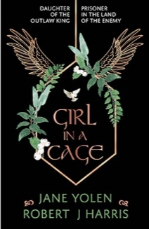
The Battle of Bannockburn

Girl in a Cage by Jane Yolen and Robert J. Harris
LIT 2-04a, LIT 2-07a, LIT 2-08a, LIT 2-14a, LIT 2-16a, ENG 2-19a,
SOC 2-01a, SOC 2-03a, SOC 2-06a
Marjorie Bruce, daughter of Robert the Bruce, has just become a princess after her father is crowned the new King of Scotland. However, the King of England, the fearsome Edward Longshanks, captures Marjorie and keeps her prisoner in a wooden cage where everyone in the town can taunt her.
This novel offers an insight into life in Scotland during the Scottish Wars of Independence before – and after – the battle of Bannockburn in 1314. It also provides a perspective from the women in Robert the Bruce’s life and explores the far-reaching consequences of war.
In your classroom, why not explore:
- Fact-check the book – there is some debate whether Marjorie Bruce was really suspended in a cage! You could discuss the difference between non-fiction and historical fiction.
- You could also explore the life of Marjorie Bruce and other the lives of other women from the Scottish Wars of Independence – see the National Trust for Scotland’s website, and BBC Bitesize for resources to support you
- See the National Trust for Scotland’s Bannockburn learning resources, including their Battlepedia quizzes!
- Read about the Marjorie Bruce Cairn in Paisley and the later life of Marjorie Bruce (see Renfrewshire Council’s resource and map).
- Other resources like Siege of Caerlaverock resources created in collaboration by author Barbara Henderson with Historic Environment Scotland: Resources – Cranachan Publishing
  - These include a suite of Historic Environment Scotland resources that introduce you to life in medieval Scotland. You could research what people like Marjorie Bruce would have eaten, or different games that people played!
  - Also with the Historic Environment Scotland resources, imagine you were alive during Scottish Wars of Independence and design your own family or clan’s coat of arms! What animals, mottos, objects or images are important to you or your family? Share your ideas or design with the class!

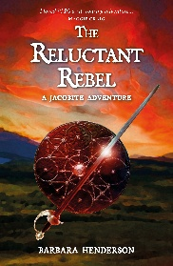
Culloden

The Reluctant Rebel by Barbara Henderson
LIT 2-04a, LIT 2-07a, LIT 2-08a, LIT 2-14a, LIT 2-16a, ENG 2-19a,
SOC 2-01a, SOC 2-02a, SOC 2-03a, SOC 2-06a, SOC 2-14a, TCH 2-02a
Archie MacDonald is thirteen years old and part of the Jacobite Cause. However, in the wake of his father’s death he’s been losing faith. After witnessing their clan’s defeat at the Battle of Culloden, Archie and his cousin Meg decide to flee in search of safety. What they don’t expect is that soon the life of the fugitive Prince Charles Edward Stuart will now depend on them.
We love how this novel offers a page-turning firsthand look at the Jacobites and explores how families and loved ones were torn apart by the conflict. Reading this book, before or after your visit to Culloden, can offer an emotional dimension to pupils’ learning.
In your classroom, why not explore:
- Barbara Henderson’s learning resources for The Reluctant Rebel created in collaboration with the National Trust for Scotland can be found on her website.
  - Before you read, you could create a timeline of the Jacobites. As you read, you can map the key events of the plot onto your timeline! There is a printable activity sheet in Barbara’s resource pack to support this.
  - This resource also contains regular discussion questions, allowing you to develop pupils’ understanding as they’re reading.
  - There are also longer classroom activities including a reenactment, creating a white cockade, and baking your own beremeal Bannocks!
- See the National Trust for Scotland’s Culloden learning resources for teachers, including a Culloden family tree and myth-busting!
- Use the National Museum of Scotland’s photographs of the Jacobite clothing in their collection – you could explore why tartan was so important to the Jacobite rebellion. Talk about the clothes the different characters in The Reluctant Rebel wear and design your own Jacobite-inspired outfit!

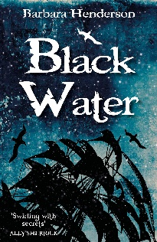
Culzean Castle & Country Park

Black Water by Barbara Henderson
LIT 2-04a, LIT 2-07a, LIT 2-08a, LIT 2-14a, LIT 2-16a, ENG 2-19a,
SOC 2-02a, SOC 2-03a, SOC 2-06a, EXA 2-13a, ENG 2-17a
Black Water is a fast-paced historical novel following Henry, a thirteen-year-old Excise apprentice in 1790s Dumfries. He and his father are responsible for tackling smugglers – but when a smuggling schooner is nearby, they discover they need more help, in the form of a newly recruited officer, a poet called Robert Burns.
After you’ve learned about Culzean Castle’s history of smuggling, this short and readable novel will help bring that theme to life, while also bringing in cross-curricular links with Robert Burns’s poems and songs. The book itself is under 100 pages, making it perfect for reading aloud in your class or, as we’ve linked below, turning into a playscript!
In your classroom, why not explore:
- Barbara Henderson’s learning resources for Black Water can be found on her website.
  - Before you read, Watch the book trailer for Black Water on Cranachan Publishing’s YouTube channel (50 seconds). What do you think this book will be about? What clues can you spot?
  - This resource also contains regular discussion questions, allowing you to develop pupils’ understanding as they’re reading.
  - There is also a playscript of the book, allowing you to dramatize the story as a class!
  - Once you’ve read the book, you could use Scottish Book Trust’s resource to and create your own book trailer for Black Water.
- Listen to Robert Burns’s song ‘The Deil’s Awa Wi the Exciseman’ on the Scots Language Centre website.
- On the National Trust for Scotland’s article about smuggling at Culzean, you can learn about how ghost stories may have kept unwanted visitors away from the caves! Why not try creating your own spooky stories in the classroom? Use your best persuasion skills to scare someone away from visiting your hidden treasure!
Scipio Kennedy
Culzean Castle was also home to Scipio Kennedy, who was forcibly transported from West Africa as a young boy of five or six and enslaved. In 1700, Scipio was sold to Captain Andrew Douglas of Mains and later taken to Scotland. After likely living as a personal servant to the Captain’s daughter, Jean, and moving around different houses, Scipio arrived in Ayrshire in 1710 when Jean’s husband inherited Culzean.
In 1725, when Scipio was around thirty years old, he was granted manumission (legally freed from forced and unpaid servitude). However, he continued to work for the Kennedy’s for another 19 years, marrying a local woman and having a family of his own.
Below we have linked some resources you could use to explore the life of Scipio Kennedy, as well as Scotland’s history of colonialism and involvement in the transatlantic slave trade.
- Exploring Culzean Castle: The Life of Scipio Kennedy (Part 1)
- Scottish Book Trust resource: Exploring climate change and colonialism with What Starts Here Stops Here has been created to help upper primary and lower secondary pupils explore the connections between climate change and colonialism in their area
- Museum of British Colonialism
- National Library of Scotland’s resources on Frederick Douglas
- ‘Our Bondage and Our Freedom’ – map of where Frederick Douglas campaigned against slavery.
- Legacies of British Slavery map from the University College of London – shows slaveowners and where they lived in the U.K.

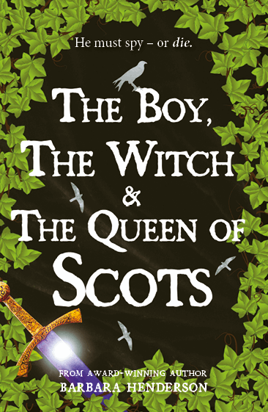
Falkland Palace

The Boy, the Witch and the Queen of Scots by Barbara Henderson
LIT 2-04a, LIT 2-07a, LIT 2-08a, LIT 2-14a, LIT 2-16a, ENG 2-19a,
SOC 2-01a, SOC 2-02a, SOC 2-03a, SOC 2-06a, SOC 2-14a, TCH 2-02a
Based upon true events from 1561-62, this novel follows Alexander, a 12-year-old boy training to be a falconer at a castle in Huntly. When he’s sent to Edinburgh, to the court of Mary Queen of Scots, he encounters a new world of secrets and treachery.
This is a gripping story full of court intrigue and spying! It also offers a different perspective on Mary Queen of Scots, including a timeline of her life at the end of the story. Falkland Palace was a beloved retreat and hunting lodge where Mary Queen of Scots enjoyed falconry (just like Alexander, the book’s protagonist), hunting and tennis. The Boy, the Witch and the Queen of Scots depicts Mary as a teenager, showing her life before her execution.
In your classroom, why not explore:
- Barbara Henderson’s learning resources for The Boy, the Witch and the Queen of Scots can be found on her website.
  - Before you read, create a timeline of the life of Mary Queen of Scots – there is a printable activity sheet in Barabara’s resource to support this.
  - This resource also contains regular discussion questions, allowing you to develop pupils’ understanding as they’re reading.
  - There are also longer classroom activities including shadow puppetry, learning about birds of prey and listening to 16th century choirsong!
- Use the National Trust for Scotland’s follow-up pack for Falkland Palace to help pupils compare their lives to the lives of people living in the 16th century, including creating your own scent pouches and designing a 16th century palace.

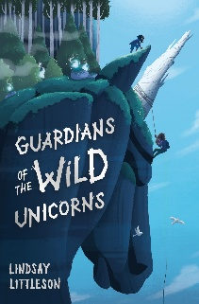
Glencoe

Guardians of the Wild Unicorns by Lindsay Littleson
LIT 2-04a, LIT 2-07a, LIT 2-08a, LIT 2-14a, LIT 2-16a, ENG 2-19a,
SCN 2-01a, SCN 2-02a
Lewis wants to be anywhere else than on his school’s residential trip to the Highlands of Scotland. Everything is damp and cold – that is, until he sees a mythical creature galloping across the bleak moorland. But unicorns aren’t real… are they?
Before or after your visit to Glencoe, dive into this fun and fantastical novel with environmental themes. We think this book is perfect for encouraging pupils to use their imaginations to explore the outdoors, learn more about Scotland’s folklore and start building the foundations of considering their role in protecting Scotland’s environment.
In your classroom, why not explore:
- Learn about how the National Trust for Scotland is working to protect Glencoe’s local wildlife. Ask pupils to create posters or deliver an assembly about ways they can protect your local environment.
- Create a classroom quiz containing some of the birds, animals and other wildlife that you might be able to find at Glencoe, as well as some other Scottish animals and mythical creatures. Ask pupils to sort into groups what they think they might find at Glencoe and what they think doesn’t live there.
  - If you have already visited Glencoe, you could ask pupils to reflect on what they learned – or even saw! – during their visit.
  - If you haven’t yet visited Glencoe, you could ask pupils to make a bingo card of birds, animals and wildlife they might spot whilst visiting Glencoe.
- Use Scottish Book Trust’s Scottish myths and legends learning resource to learn about the difference between a myth and a legend, as well as the origin of Scottish mythical creatures including selkies, wulvers and the Loch Ness monsters.
- Some of Scotland’s famous mythical creatures using Folklore Scotland’s interactive map – see what mythical creatures are tied to your area! You could also ask pupils if they have any other stories they can bring in from home.
- Create your own mythical creature – you could create a hybrid of two of your favourite animals, or create your own unique creature inspired by your local area!

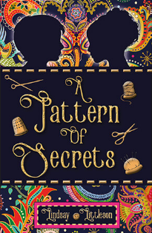
Mackintosh at the Willow

A Pattern of Secrets by Lindsay Littleson
LIT 2-04a, LIT 2-07a, LIT 2-08a, LIT 2-14a, LIT 2-16a, ENG 2-19a,
TCH 1-04b, EXA 2-02a, EXA 2-03a, EXA 2-04a
Set in Paisley in 1876, this novel follows Jim, a 12-year-old who has recently escaped the Poorhouse. Determined to stop the same thing happening to his brother he goes in search of his only family heirloom, a Paisley patterned shawl. Interwoven to Jim’s story is Jessie’s – inspired by Jessie Rowat, an artist and embroiderer who would grow up to become one of the Glasgow Girls.
Before or after your visit to Mackintosh at the Willow, why not escape into Victorian Paisley and learn more about the Glasow Girls? At Mackintosh at the Willow, you’ll learn about Margaret Macdonald Mackintosh – both Margaret and Jessie were prominent members of The Glasgow School at the turn of the 20th century.

In your classroom, why not explore:
- Lindsay Littleson’s learning resources for A Pattern of Secrets on her website.
  - Before you read, learn about the history of Paisley pattern.
  - This resource also contains regular discussion questions, allowing you to develop pupils’ understanding as they’re reading.
- There are also longer classroom activities including developing pupil’s writing skills and researching the history of textile and fabric industries in Scotland.
- Learning resources for Mackintosh at the Willow, including a virtual tour of the last surviving tearoom designed by Charles Rennie Mackintosh and Margaret Macdonald.
- Use the National Galleries’ guide to The Glasgow Girls to learn more about the work of Margaret Macdonald Mackintosh and Jessie Rowat.
- To extend this, why not design your own pattern inspired by Mackintosh or Rowat? You could make a Glasgow Girls inspired Paisley shawl.
- To further extend your pupils’ learning experience, you could return to Mackintosh at the Willow for hands-on workshops on embroidery and bookbinding. In these sessions, pupils can learn popular Glasgow Style techniques, used by Jessie Rowat and her contemporaries. Visit the Mackintosh at the Willow Teacher Information page for contact details.

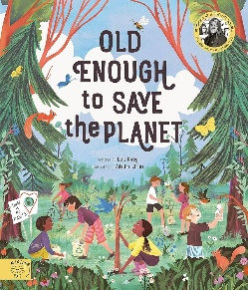
North East Ranger Service

Old Enough to Save the Planet by Loll Kirby and Adelina Lirius
LIT 2-04a, LIT 2-07a, LIT 2-08a, LIT 2-14a, LIT 2-16a, ENG 2-19a,
SCN 2-01a, SCN 2-02a, SCN 2-20a, SCN 2-20b
Each page of this book introduces the true story of a child who brought about positive environmental action in the area they live in. Meet nine-year-old Eunita from Kenya who sells seeds to help people start pollinator friendly gardens. Or read about Felix, a young boy from Germany who launched a programme to help children plant trees in their home countries.
This non-fiction book has a perfect balance of text and imagery and is great for encouraging conversations about looking after the environment, as well as themes of global citizenship and sustainable development. We especially love how this book shares the stories of real children – encouraging young readers to see themselves of capable of causing change too!
The North East Ranger Service offers school visits at a range of places across North East Scotland with some of the best examples of the wildlife and habitats in the area. Expect your class to get hands on with nature and learn about conservation in action!
To find out more about where the North East Ranger service operates, visit the National Trust for Scotland website.
In your classroom, why not explore:
- A learning resource for this book can be found on the Magic Cat Publishing website.
  - Use a map to explore the different countries that the children in the book come from. You could also show where you live on a map, as well as the National Trust Place you have visited or plan to visit.
  - Ask each pupil to choose a campaign they found particularly interesting or inspiring. They could compare this to what they learn from the North East Ranger Service.
  - Conduct a survey – the learning resource explains how to conduct a survey on recycling or traffic around your school or setting.

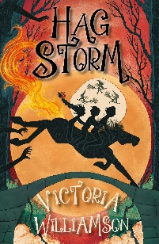
Robert Burns Birthplace Museum

Hag Storm by Victoria Williamson
LIT 2-04a, LIT 2-07a, LIT 2-08a, LIT 2-14a, LIT 2-16a, ENG 2-19a,
SOC 2-03a, SOC 2-04a, SOC 2-06a, LIT 2-07a, EXA 2-13a
1771: Robert Burns is 12 years old and spending his days working on his family’s farm instead of attending school. One day he finds a hag stone in the field, a magical stone that allows him to see a coven of witches who are hatching a plan. The bad news is – they have their sights set on Burns and his family!
We love this spooky and supernatural reinvention of Robert Burns’s poem ‘Tam o’ Shanter’. Before or after your visit to Robert Burns Birthplace Museum, why not use this novel alongside the poem to explore Burns younger years and why he earned the name of the people’s poet? We love how this novel depicts Robert Burns’s childhood in a way that is relatable to young readers, fleshing out his years working on his family’s farm, whilst also adding a fantasy twist!
During your visit to Robert Burns Birthplace Museum, be sure to ask the staff about some of the key real-life locations featured in the book like Burns Cottage or the Auld Kirk. The staff at the museum will be able to tell you more about them!
In your classroom, why not explore:
- Victoria Williamson’s learning resource for Hag Storm can be found on her website.
- Before reading – imagine what the setting of the story will be like. If you have already visited the Robert Burns Birthplace Museum, you could reflect on different words you would use to describe it. Are there any Scots words they can remember from their visit?
  - This resource also contains regular discussion questions, allowing you to develop pupils’ understanding as they’re reading.
  - There are also longer classroom activities including making your own Hallowe’en corn doll, designing a new cover for the book and exploring life on a 1770s Scottish farm!
- Use National Trust for Scotland’s teacher planners – the Being Burns planner is designed for Second Level and has been designed to support pupils with a deeper understanding of the Robert Burns Birthplace Museum and life of Robert Burns.
- Read the poem ‘Tam o’Shanter’ and learn more about its origins. You could choose a section to act out together as a class – with someone playing Tam, Meg and the different witches and warlocks!
- Use Scottish Book Trust’s resources to explore Scots with your pupils, including Using Scots in the classroom and Writing poetry in Scots
- Use Scottish Book Trust’s Celebrating Burns Night in your school article to learn our top tips for engaging with Burns and Scottish poetry all year round

Further resources
- To find out more about Scottish Book Trust’s school programmes, see our Schools guide and our Learning resources
- To find out more about the National Trust for Scotland’s school programmes, see their Schools page.

