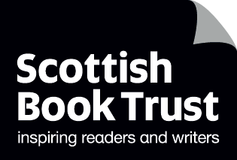
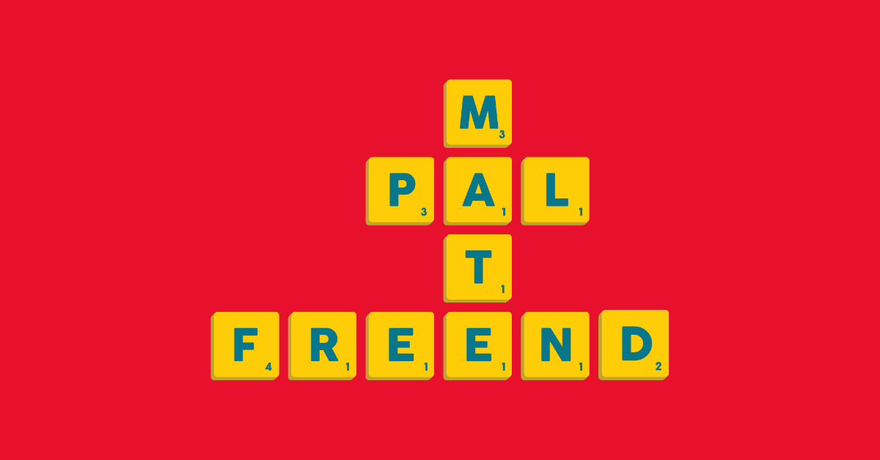

Celebrating Book Week Scotland in your school
Activities, resources and advice for celebrating Book Week Scotland in primary, secondary and additional support need schools

Age: 5–18


Suitable for: schools, libraries and additional support need settings

Resource created by Scottish Book Trust

scottishbooktrust.com

Scottish Book Trust is a registered company (SC184248)
and a Scottish charity (SC027669).

Contents
About this resource 2
Activities for all schools 4
Primary school activities 5
Secondary school activities 8
Sensory and inclusive ideas 13
Further resources 15

About this resource

What is Book Week Scotland?
Book Week Scotland is an annual celebration of books that takes place across the country. Book Week Scotland 2025 will take place from 17 – 23 November and is supported by Creative Scotland and SLIC.
This year’s theme is friendship and will contain the following strands:
- Formative friendships – remembering the friendships of our youth that helped us become who we are and set us on our path
- Friends we found in difficult moments – reflecting on those who were there for us when it mattered most
- Community friendships – the friendships we form in the causes that matter to us, whether advocating for equality or volunteering, these are the relationships that help us feel part of something bigger
- Unexpected friendships – sometimes you don’t plan to make friends with someone, it just happens – maybe you moved house, started a new job or discovered a new hobby
- Friends for life – those who have been with us through it all, the life-defining relationships that shape us
This resource includes:
- Resources you can engage with this Book Week Scotland
- Further activities for exploring Book Week Scotland’s themes in primary, secondary and/or with children with additional support needs (ASN)
- Ideas for using our Authors Live on Demand catalogue

Why should you celebrate Book Week Scotland in your school or setting?
By taking part in Book Week Scotland, your school can be part of a national event. This is a great way to demonstrate to your pupils that reading is a valuable activity and worth spending their time on. For some children, engaging with an author – whether watching an Authors Live broadcast or going to an event, can make a huge difference in their motivation to read. Book Week Scotland also celebrates all forms of reading – so even if pupils are earlier on in their reading journey, there’s still a way for them to engage.

What can I do after Book Week Scotland?
Books are for life, not just for Book Week Scotland! Explore our Scottish Book Trust schools guide to find out how you can embed reading for pleasure in your school or setting all year round.
If you’re taking part in Reading Schools, you can use this resource to support delivery of the following key areas:
- 1.3.2 – School environment
- 1.3.3 – National events and celebrations
- 2.2.1 – Regular opportunities to read for pleasure
- 2.2.2 – Interdisciplinary book projects
- 2.3.5 – Access to authors

Activities for all schools

Activity 1: Reading map
Add your school to the interactive reading map (please note, this link will not be live until Monday 17 November). Have a look at what other schools, libraries and settings are on the map and what they’re reading!

Activity 2: Drop everything and read
There’s no better way to celebrate Book Week Scotland than to make time for pupils (and staff!) to read. Set aside time during the week where everyone – not just the pupils – can read a book or text of their choice. You could sound a bell or alarm to signify when that starts or display a countdown on your classroom board.
Make sure that you join in too. By reading when your pupils do, you’re demonstrating that reading is worth spending your time on. It’s also worth remembering you may be one of the only adults that a child or young person sees reading, so you play an incredibly important part as a role model!

Activity 3: Watch Authors Live
Authors Live is a series of world class children’s author and illustrator events brought directly to your classroom, library or home for free, live on the web. Each broadcast is roughly 40 minutes and comes with a quick tie-in activity to help extend pupils’ learning. Here are our top picks on the theme of friendship!

Primary
- Nadia Shireen
- Mark Bradley
- Rachel Bright and Jim Field

Secondary
- Patrice Lawrence
- Elle McNicoll
- Brian Conaghan

Primary school activities

Gifting the Bookbug P1 Family Bag and Read Write Count bags
If your class is in P1, P2 or P3, Book Week Scotland is the perfect time to gift their Bookbug Primary 1 Family Bags or Read Write Count with the First Minister P2 or P3 bag. These bags contain books and resources that are theirs to take home.
We recommend holding a gifting event or party where families can come and learn about the bags and their contents and gain confidence in using them at home. Our website contains learning resources to explore the books and resources in the bags, as well as recordings of the books being read aloud. You can find those, and more about how to gift the bags, on the Bookbug or Read Write Count section of our website. There are also symbolised resources for the Bookbug P1 Family Bag and sensory and inclusive activities for Read Write Count on the P2 bag webpage and P3 bag webpage.

Activity 1: Share a story with a friend
LIT 2-01a, ENG 2-03a, LIT 2-04a, LIT 2-10a, LIT 2-11a, LIT 2-16a,
HWB 1-14a/2-14a
Whether friends are old are new, you can use our paired reading toolkit to connect pupils across your school. You could:
- Ask older pupils (P5-P7s) to read the Bookbug P1 Family Bag books or Read Write Count with the First Minister books to the P1-P3s
- Ask pupils to create class displays or book boxes of their favourite books about friendship
- Ask pupils to “recommend a book to a friend” – write their review of a book on a piece of paper and put it in one of the books in your school. If someone else reads that book, they have to add their notes about the book (and so on!)

Activity 2: Write a Scrabble poem
LIT 1-20a/2-20a, LIT 1-21a/2-12a, LIT 1-23a/2-23a, LIT 1-26a/2-26a
Inspired by this year’s Book Week Scotland artwork – why not try writing a poem with Scrabble? If you don’t have a Scrabble set, ask your pupils to create letter tiles by writing out letters of the alphabet and cutting them into squares (bear in mind, you’ll need more of certain letters such as “a”, “e”, “s”, etc.)
Now, ask pupils to play around with the letters, seeing what words they can – the goal is to try and find some words that can interact. Here’s an example of what your poem could look like:
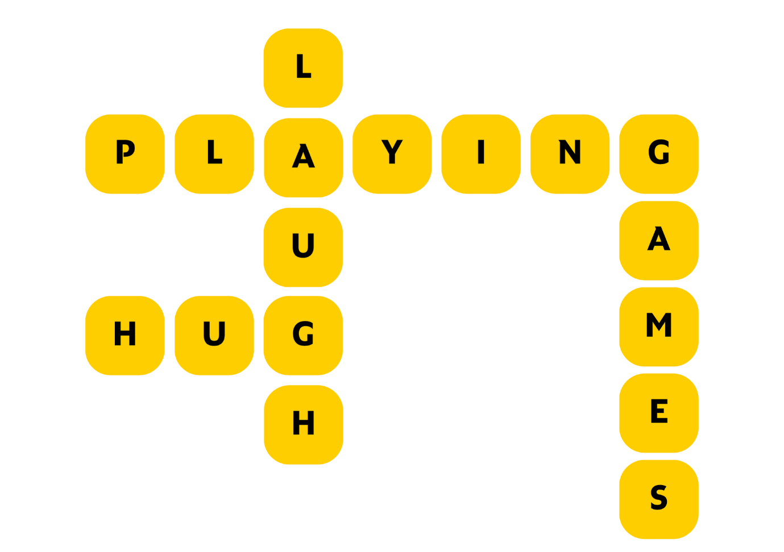

Pupils can work together in groups, or on their own. What’s the biggest poem they can make?

Activity 3: Create a friendship display
LIT 1-14a/2-14a, LIT 1-16a/2-16a, ENG 1-19a/2-19a, HWB 1-05a/2-05a,
HWB 1-14a/2-14a, HWB 1-44a
Books are a great way to learn about friendship. This includes:
- Thinking about what traits a good friend should have, e.g. caring, kind, fun
- Learning about how to be a good friend, e.g. apologising when you do something wrong, helping a friend feel better when they are sad
- Exploring how to make a new friend, or make someone new to your school feel welcome

Ask your pupils to look at the books in your classroom, school or library. You could create a display of all the books that explore friendship in one way or another. Ask the pupils – what do they think they can learn from these books?

Activity 4: Learn about animal friendships
LIT 1-01a/2-01a, LIT 1-04a/2-04a, LIT 1-06a/2-06a, LIT 1-14a/2-14a,
LIT 1-15a/2-15a, HWB 1-05a/2-05a, HWB 1-44a/2-44b, SCN 1-02a/2-02a
One of this year’s Read Write Count titles is The Ballad of Cactus Joe by Lily Murray and Clive McFarland, which will be gifted to every P2 as part of their Read Write Count with the First Minister P2 bag.
You can watch The Ballad of Cactus Joe being read aloud on our website (6 minutes, 11 seconds). It follows a very grumpy cactus called Cactus Joe, who is the leanest, meanest prickle machine in the whole of the desert.
Why not look up all of the different birds and animals that live on Cactus Joe? Are there any other examples of these kinds of friendships in nature? Why do animals, birds or plants work together like this? Research as a class and write your own fact files about your favourite animal friendships.
You could use:
- The non-fiction section at the end of The Ballad of Cactus Joe
- Newsround’s report: “Cute animals: How sweet are these furry friendships?”

You could extend this activity by asking pupils to write about, or deliver a short talk on, what animal they would like to be friends with and why.

Activity 5: Discover your new book friends!
LIT 1-01a/2-01a, LIT 1-02a/2-02a, LIT 1-05a/2-05a, LIT 1-11a/2-11a,
HWB 1-14a/2-14a
Download the Book Personality Quiz from the Reading Schools website – on the same webpage you’ll also find some other fun activities including a treasure hunt and an escape room, which you could also use during Book Week Scotland.
The quiz asks pupils to ask a series of questions, hopefully matching them up with some books they might like to explore. This is a great way to introduce the concept of genre to young children – and help them connect to other pupils who may enjoy similar stories! You could also prompt a discussion about how it’s okay to like, or not like, certain types of stories or books, and that everyone will have their own identity as a reader. You could also extend this activity by visiting your local, or school, library and asking for a recommendation based on the result of the quiz.

Secondary school activities
As part of Book Week Scotland, comics artists Tom Humberstone and Candice Purwin have created comic adaptations of two of the pieces from the Scotland's Stories Friendship book. These will be added to the Book Week Scotland section of the website during the week, so make sure to check in! You could also explore creating your own comic adaptations using our How to write a comic book scene resource.

Activity 1: Use our Scotland’s Stories prompts
LIT 3-20a/4-20a, LIT 3-25a/4-25a, LIT 3-26a/4-26a, ENG 3-27a/4-27a,
ENG 3-31a/4-31a
Scotland’s Stories is an annual writing project which aims to encourage all types of people to share their experiences. This year the theme was friendship. Though the submissions are now closed, you can still use the writing prompts on our website, which are the same as Book Week Scotland’s strands.

Activity 2: Creative writing with this year’s Pitch It! writers
LIT 3-04a/4-04a, LIT 3-07a/4-07a, LIT 3-20a/4-20a, LIT 3-25a/4-25a,
LIT 3-26a/4-26a, ENG 3-27a/4-27a, ENG 3-31a/4-31a
Pitch It! allows communities to bring a bestselling author to them. This year’s Pitch It! writers are:
- Hannah Lavery, poet and playwright
- Kirsty Logan, short story writer, novelist and memoirist
- Anbara Salam, novelist and essayist

Explore poetry with Hannah Lavery
Using the Scottish Poetry Library’s website, read and then listen to the audio clip of Hannah Lavery’s poem “Flying Bats”. Discuss the poem as a class:
- What did they notice when listening to the poem that they didn’t when they read it?
- What ideas or images stand out to them?
- What do they think the poem is about?
- What do they think the bats represent?
- How does the poet create a specific mood or feeling? What language does she use?

In Hannah Lavery’s poem, the bats represent feeling unstable claiming somewhere as your own in the face of being challenged. Just as the audience in the poem assume the poet isn’t from Scotland, the bats make her feel uneasy when she walks through the woods near her house. Ask pupils to choose an animal and create a mind map of all the words they associate with that animal. They can then use this as the basis of creating a poem, or piece, that uses an animal as a metaphor.
You could extend this activity by using our Performance poetry learning resource.

Dive into horror with Kirsty Logan
Pupils may be familiar with Kirsty Logan’s short story, “Things My Wife and I Found Hidden in Our House” which is an SQA set text at National 5 level. The story is available to read online via The Dark Magazine. If you are exploring this text, you can use our downloadable discussion guide for discussion questions, creative writing prompts and suggestions of what books pupils might like to read next.
You could also use Kirsty Logan’s articles on the Scottish Book Trust website to prompt creative writing:
- “How to write horror stories”
- “Five things: creating an atmosphere in your writing”

On our website, you can find a series of creative writing lesson PowerPoints created by Brian Conaghan. Use the second lesson (“Writing style”) and Kirsty Logan’s articles to support pupils to experiment with tone.
- What will the central scary idea of their story be?
- What techniques or language could they use to create an eerie or uncomfortable tone?
- What should they leave to the imagination and what should they reveal?
- What techniques can they use to play with the pacing of their story?

Visit the past with Anbara Salam
Anbara Salam’s writing includes historical fiction. You can find out more about her writing process in an article she wrote for Female First: “10 Things I’d Like My Readers to Know About Me”.
We have an article on our website, “Use objects to inspire historical fiction writing”, which uses resources from The International Slavery Museum to inspire historical fiction writing. You could also use the following museum’s online collections:
- National Museum of Scotland
- National Library of Scotland
- Grampian Transport Museum
- The Museum of Scottish Lighthouses
- V&A Dundee

Ask pupils to choose an object and write down answers to the following questions:
- What is this object? Where did it come from? What does it do?
- What is it made of?
- What would it feel like if they held it? Or what kind of sounds would it make?
- Who owned it?
- How was it used?

They can then use their notes to inspire a piece of creative writing, for example:
- A poem or scene from the point of view of the object
- A story about how the owner bought, acquired or stole the object
- A story or scene about someone seeing the object in the museum and what it means to them

Activity 3: Revisit your class books
LIT 3-08a/2-08a, LIT 3-16a/4-16a, LIT 3-18a/4-18a
Book Week Scotland is a great opportunity to visit your local library or bookshop, but
you can also revisit the books in your classroom or school. Here are some activities
you can do with your books that hopefully also create new social connections within your school.

Book tasting
Pull out all the books from the shelves and lay them on a table. Give pupils time to look through all the books and talk with each other about what they’d like to read. This is a great activity to do alongside your Story Decks, allowing pupils to connect the cards to the covers or blurbs of books.

First lines
Pick some first lines from books and either read them aloud or display them on your whiteboard. Ask pupils to rate the first line of novels from one to five; five being ‘I would read on’, and one being ‘I would put this book down and move onto something else’. Make sure you include a variety of genres and reading levels to help you get a better indication of pupils’ preferences. Use the pupil response as a guide for reading recommendations.

Come up with categories
Putting your pupils in charge of how your books are organised will make them more
likely to pick one up! Books don’t have to be organised in any set way – they could
explore genres, or themes like “superheroes”, “magical stories”, etc. You could also
use your Story Deck cards – allowing pupils to sort books so that they match the feeling of the different cards.

Play Book Jenga
Transform a game of Jenga into an incredible (and fun!) tool for Book Talk. Book Jenga was a game brought to the attention of Scottish Book Trust by secondary school librarian Deena Wren, winner of our Scottish Book Trust Learning Professional Award. See our “Running reading groups and events” resource for the full rules and ideas for questions you can write on your Jenga bricks.

Activity 5: Interview a reader
LIT 3-09a/4-09a, LIT 3-10a/4-10a
This activity could be a great way to connect with your wider community during Book Week Scotland, as well as helping pupils access some reading role models.
Ask pupils to interview a reader. This could be staff member (not just teachers!), someone in their community, e.g. from a club, a school visitor, a family member or another pupil. Put them in charge of coming up with the questions, or use our My Life as a Reader resource on the Reading Schools website.
Pupils could share their interviews through an assembly, display, school book or short film - see our resource on filmmaking in class.

Sensory and inclusive ideas
Gifting the Bookbug P1 Family Bag and Read Write Count bags
You can also explore this year’s Read Write Count books with sensory and inclusive activities. There are also symbolised resources for the Bookbug P1 Family Bag and sensory and inclusive activities for Read Write Count on the P2 bag webpage and P3 bag webpage.
To run an inclusive and sensory gifting event, invite the families to the school to receive the bags. You can introduce each book and resource to the adults and children and explore them together. This helps parents or families feel more confident using the books and resources with the children and adapting them for their children’s needs. You can also share our Turning a book into a sensory story resource with them so they can think about using sound, touch or texture to engage with the books.

Activity 1: Create your own sensory story about friendship
Use our Turning picture books into sensory stories resource to plan out your own storytelling session with your pupils. Why not use a picture book about friendship as the basis of your sensory story? You could use our book list, Great books for sensory storytelling or 14 books that celebrate friendship for inspiration.

Activity 2: Songs and rhymes
You can use the Bookbug Song and Rhyme Library to listen to songs that link into this year’s theme:
- “Five Fat Peas” – also available in Makaton
- “If You’re Happy and You Know It” – also available in Makaton
- “Five Little Ducks”
- “See How I’m Bouncing”
- “The Hello Song”

Each link will take you to the Bookbug Song and Rhyme Library which has ideas for how to engage with each song and rhyme. Some children might like to learn the songs or come up with their own actions.

Activity 3: Reading my way
Our articles on Reading and being autistic, Reading with dyslexia and Reading and ADHD could inspire you to have conversations about reading with the children you work with.
- Look through the articles and share some top tips – you could create a display, or a book of tips you can put in your class, school or local library
- Ask pupils to share their own tips for other pupils – you could create a class book or display
- Ask pupils about how they like to read – are there some changes you can make to your school environment? (e.g. more cosy reading spaces, more comfy chairs?)
- You could host a Book tasting, where you look at some of the books in your class or library, laying them out on a table and asking pupils to respond. It’s okay to like, or not like, the look of specific books!

Activity 4: Share a sensory experience with a friend
What sensory experiences feel good to you? Think about smells, tastes, textures or sounds. Some people love the smell of cut grass, or the feeling of holding a big cup of tea. What do your pupils like? You may be able to ask them or know from experiences you’ve shared together in the past. See Starcatchers’ Sensory Wow! resource – if possible, you could work in groups, allowing pupils to share their favourite experiences with each other, taking it in turns to share their favourite sensory experience.

Activity 5: Create a class cookbook
Stories and food are both great for sharing together. You could create your own cookbook as a class, or school, then hold an event where you share some of the recipes and some stories together – potentially with family members or people from your community! This may be an exciting reading experience for pupils who are not as interested in fiction or stories.
What will your cookbook look like? It could:
- Consider pupils who may have food aversions or restrictions
- Contain detailed instructions that pupils can follow step-by-step
- Use photographs of the pupils in the kitchen in your school, so they know what pieces of equipment or utensils look like
- It could also be audio or video – if pupils might prefer listening to instructions instead of reading them, or sharing them by speaking instead of writing

Further resources
- Learn more about Book Week Scotland via our website
- Explore stories submitted from people all over Scotland on the Book Week Scotland: Your Stories webpage
- Find out about Scottish Book Trust’s Schools Programmes which you can use to support reading and a love of stories in your class or school throughout the year
- Find more resources for your school in the Scottish Book Trust Learning resources section of our website
- For more about gifting the bags, Bookbug Primary 1 Family Bag webpage or Read Write Count section of our website

