
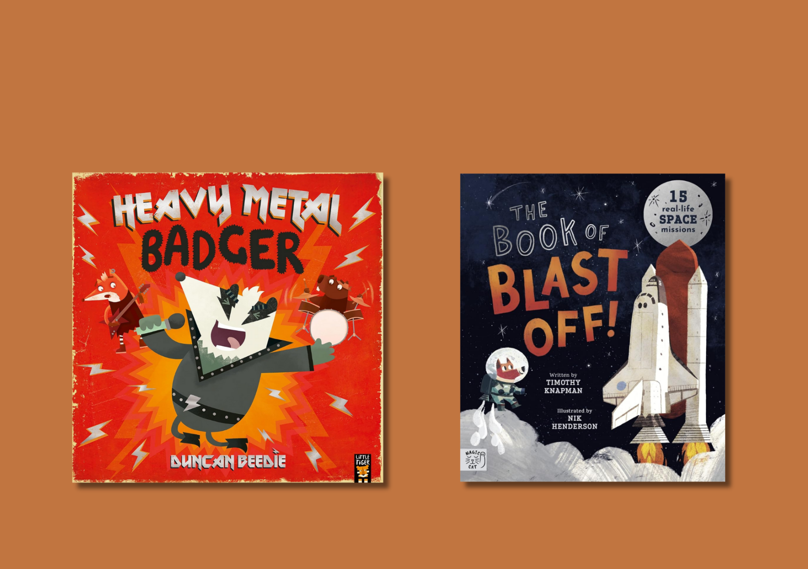

Read Write Count: P3 inclusive activities
Activities for the Read Write Count with the First Minister P3 bag designed for children with additional support needs

Resource created by Ailie Finlay


scottishbooktrust.com

Scottish Book Trust is a registered company (SC184248)
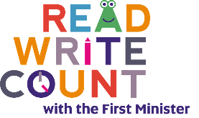
and a Scottish charity (SC027669).

Contents
About this resource 2
Heavy Metal Badger activities 3
The Book of Blast Off! activities 4
Galactic Fantastic cards activities 7
Mindfulness cards activities 8
Story Cards activities 8
Search and See cards activities 9
Meteors and Rockets board game activities 10
Clock face activities 10
Further resources 10

About this resource
The aim of this resource is to make the items in the Read Write Count P3 bag accessible to all. The activities can be used with pupils with a variety of needs, including additional support needs, English as an additional language or those who are disengaged from or struggle with reading.
These activities are flexible and we encourage you to adapt them, whether in school, community groups or at home. Some ideas have been specifically designed for children at home – if you work in a school or setting, you can send these home as possible home activities for families!
For more sensory storytelling activities, see our Getting started with sensory stories or Make your own sensory story resources on the Disability and neurodiversity section of the Scottish Book Trust website. You can also find more of Ailie Finlay’s work on the Flotsam and Jetsam and My Kind of Book websites.

Heavy Metal Badger activities

Activity 1: Role-play story
Have fun role-playing a simpler version of the story as you look at the pictures in the book. One of you could be the badger and the other the woodpecker, Mrs Smythe, the ant bandmaster, the choirmaster and the cheering crowds. You could make the noises of the different instruments that badger plays – but it is probably more fun to just bang on pots and pans!
Try making up a simple version of the story – something like this:
Badger was noisy! (Bang on the pots and pans)
‘Sssh!’ said woodpecker. (Say ‘ssh’ – the banging stops)
Badger was noisy! (Bang on the pots and pans)
‘Sssh!’ said Mrs Smythe. (Say ‘ssh’ – the banging stops)
Repeat for ant bandmaster and choirmaster… but the choirmaster adds:
‘Keep trying!’
Finish with:
Badger was noisy! (Lot of banging on the pots and pans)
And everyone cheered! (Everyone cheers!)

Activity 2: Short and simple musical story
At certain times, for example bedtime, a simpler and calmer version of this story might suit your pupils (and you!) better. Try telling a very short musical version of the story. You could look online for free audio clips of music to fit each of the scenes – or simple hum, whistle and tap out the different styles of music.
For this calm version you might want to leave out all of Badger’s musical interruptions and instead look at the book with the class, pointing out the different characters, whilst re-telling a very simple version of the story something like this:
The birds like this kind of music. (Play an audio clip of bird song or make some bird song noises)
Badger likes this kind of music. (Play an audio clip of drumming or tap on your knees)
Mrs Smythe likes this kind of music. (Classical music or sing/hum!)
The ants like this kind of music. (Marching band music – or whistle/hum.)
The church choir likes this kind of music. (Church choir music or sing/hum.)
Badger really likes this kind of music. (Rock music or sing/hum.)
You could finish your musical version of the story with:
[Pupil’s name/this class] really likes this kind of music. (Play an audio clip of some music your pupil, or class, likes – or sing their favourite song.)

Activity 3: Puff, puff
The badger has so much puff that when he plays the recorder a bird gets blown up in the air. Tear a tiny piece from the sheet of tissue paper (in the board game), put it on your flat hand and see how far you and the pupils can blow it. See who can blow a tissue paper scrap the furthest!

Activity 4: Musical squiggles
Show the class the grey squiggles on the page where the badger is trying out for the band. Play some music and draw “squiggles” to the music. Change to a different type of music and see if your musical squiggles come out different. Can you tell which music you were listening to by looking at the squiggles?

The Book of Blast Off! activities

Activity 1: Sensory space stories
Tell a short space story using props and objects. Try basing this story on one section of the book. The aim is to have fun rather than to attempt to be scientifically accurate! For example:
Landing on the moon space story
Use a pillow for the moon and a ball or box (from your recycling) for the Eagle. Count down and blast off your rocket. Cover the pupil(s) with a blanket for a minute to recreate the darkness of space. Try using fairy lights or a torch while you are under there to make the stars.
Then throw some bunched-up socks (with a tail!) around the room for comets. You could add in a meteor shower – tear tissue paper (or anything similar) into tiny pieces and let these float down over the pupil(s)!
Maybe you meet an alien teddy bear on your journey! The moon also has extreme temperature swings - you could let the pupil(s) feel a cold pack from the freezer and something safe and warm to contrast (such as a hand warmer if you have one – used under supervision).
Then using a pair of wellies – one on each hand – stomp these together to make the noise of the first steps on the moon. (Very inaccurate – but fun!) Wave a pillowcase or a tea towel as a flag. Give a big cheer at the end!

Activity 2: Living room space journey
This idea has been written for families at home, or in a comfier setting – therefore, it may not be suitable for all classroom settings.
Put three or four cushions on the floor and give each cushion the name of a planet. Start on the couch, or chair, then count down together and then blast off and fly through space – round the room! Let the pupil(s)/your child decide which cushion planet to land on. Sit together on the cushion and then read the page in the book about the planet you have landed on. Then blast off and visit another planet! This game can be as long or as short as you both find enjoyable – it’s fine if the pupil(s)/your child only wants to visit one planet!

Activity 3: Blast off – again and again
Try this if your pupils love repetition. Turn to the “blast off” page in the book. Gather together some soft toys or use boxes from the recycling box as “rockets”. Read the text to the pupils from ‘Quick…’ then countdown together and blast the teddy or box into “space”. Then go back and read it again and blast off the next teddy or box! Keep on repeating! You could play this outdoors as well.

Activity 4: “If You’re Happy and You Know It” (Space version)
Instead of reading the text of the story try singing a version of this classic song as you look at the pictures with your child. You can listen to the tune via the Bookbug Song and Rhyme Library.
If you're the moon and you know it, go round the Earth (“Draw” a circle with your finger in the air or draw a circle on the back the pupil’s hand)
If you're the moon and you know it, go round the Earth
If you're the moon and you know it
And you really want to show it
If you’re the moon and you know it, go round the Earth
If you're the Hubble and you know it, take a photo (Mime taking a photo and make a “click” sound or gently touch your child’s nose and say “click”).
If you're the Hubble and you know it, take a photo
If you're the Hubble and you know it
And you really want to show it
If you're Hubble and you know it, take a photo
If you're Jupiter and you know it, give a swirl (Make a swirling motion with your hands, moving them this way and that. Alternatively, you could “draw” a swirling line with your index finger on the back of your pupil’s hands and arm)
If you're Jupiter and you know it, give a swirl
If you're Jupiter and you know it
And you really want to show it
If you're Jupiter and you know it, give a swirl.
If you're a comet and you know it, shout ‘Whoo-eee!’ (Say ‘whoo-ee’ whilst “drawing” the arc of a comet in the air with your finger. Or you could draw this long line from your pupil’s hand right up their arm)
If you're a comet and you know it, shout ‘Whoo-eee!’
If you're a comet and you know it
And you really want to show it
If you're a comet and you know it, shout ‘Whoo-eee!’

Galactic Fantastic cards activities

Activity 1: Alien bedtime story
This is a good bedtime activity – when your child is lying in bed “draw” (with your index finger) on their back. First “draw” one of the aliens from the Galactic cards and then tell your child a very simple story using the facts from the cards – for example:
This is Luna. (With your index finger “draw” the outline of Luna the alien on your child’s back)
Luna digs are long long tunnel. (Draw a wiggly line on your child’s back)
She lies down at the end of the tunnel, falls asleep and dreams about the stars. (Draw some stars on your child’s back)

Activity 2: Soup for the aliens
Make some goop soup for the aliens. This can get a bit messy – but children usually love the unusual texture. Mix together a cup of cornflour and a cup of water to make some alien soup to play with. Food colouring could also be added if you like – you could match the colour of the goop to the colour of the aliens on the cards!

Activity 3: Scribble aliens
Ask pupil(s) to draw a scribble on a piece of paper. Then try to turn this scribble into an alien – you could try to turn it into one of the aliens on the Galactic cards or just make one up.

Mindfulness cards activities
Activity 1: Breathing shapes
Try “drawing” the breathing shapes with your finger on the back of your pupil’s hand as you practise breathing deeply. Alternatively, you could draw larger versions of the shapes on paper for your pupils to trace with their fingers. Or maybe you could make the shapes out of playdough together.

Activity 2: Head, shoulders, knees and toes!
If for whatever reason it is not possible for your pupils to do the yoga poses on the cards, you could try using this classic rhyme instead to help them with their awareness of their own body. Sit or lie next to the pupil. Gently pat each part of their body as you chant or sing it.
Head, shoulders, knees and toes, knees and toes
Head, shoulders, knees and toes, knees and toes
And eyes and ears and mouth and nose
Head, shoulders, knees and toes, knees and toes.
This can be done with lots of fun and energy during the day, or slowly and calmly at bedtime. You can listen to the tune via the Bookbug Song and Rhyme Library.

Story Cards activities

Activity 1: A story about me
We all love to hear stories about ourselves! Try making up a simple story about your pupils using the story cards and prompts. Choose a setting and tell them a tale about their journey to that place. Then choose a character or an item and tell them how that character or item helped them. Keeping it short is fine – many children prefer short stories.
Your story might be even more fun if you use some objects or add in some funny noises. You could:
- Use an ice pack for the snowy mountain forest
- Tell the story in the dark for the far away planet
- Make some ghost noises for the haunted house
- Dive under the blankets for an under the sea story
- Make some monkey chattering and strange bird noises for the jungle

Activity 2: Mime a character
Lay the character cards face up in front of you. Try taking it in turns to mime being one of the characters – the other person tries to guess who you are. You could do this for the setting cards as well by miming being in the setting.

Search and See cards activities

Activity 1: Search and See I-Spy
One person chooses a word from the Search and See cards and the others search for something in the room that matches that word. For example, if the word is “bumpy” they could point to some Lego. If the word is “bright” they could point to the lamp. You could play this outdoors as well.

Activity 2: Search and See sensory fun
Use the words on the Search and See cards as a prompt to help you gather together a few objects in one category for you and your pupils to explore together. For example, you could gather together some loud objects: musical toys, pots and pans to crash and bang, a box of Lego to shake. What noises can you make? How loud can you be?
Or you could gather together some smelly objects: soap, coffee, cinnamon… Which smells do you like? Do any of the smells remind you of a particular person or place? Careful with spices as these will hurt if they accidentally get into your pupil’s eyes.

Meteors and Rockets board game activities

Activity 1: Space race
Some children may prefer a simpler version of this game. Draw a path of twenty squares or circles that leads to one of the planets in the space picture. Number the squares. Then race each other using just one of the dice and the counters. First to the planet wins! If your pupils do not enjoy winning and losing games, then play as a team.

Clock face activities

Activity 1: Day and night
If your pupils are not ready for telling the time yet, then try this simple day and night activity instead. Divide a blank sheet of paper into two. Draw the sun in one half and the moon in the other half. Then take it in turns to draw things that happen in the day and things that happen at night. School, park, swimming and so on could be in the day-time section. Bedtime stories, sleeping, dreaming could be in the night-time section. You could add in animals to the night-time picture to make it more interesting – owls, foxes, cats…
Alternatively, you could divide the paper in four: morning, afternoon, evening and night.
Further resources
- For further resources to support children with additional support needs, see the Disability and Neurodiversity section of our website including our Make your own sensory story resource, created by Ailie Finlay.
- For further resources to support use of the Read Write, Count bags see the Read Write Count section of our website or our Home Activities Hub.
- You can find more of Ailie Finlay’s work on the Flotsam and Jetsam and My Kind of Book websites.

