
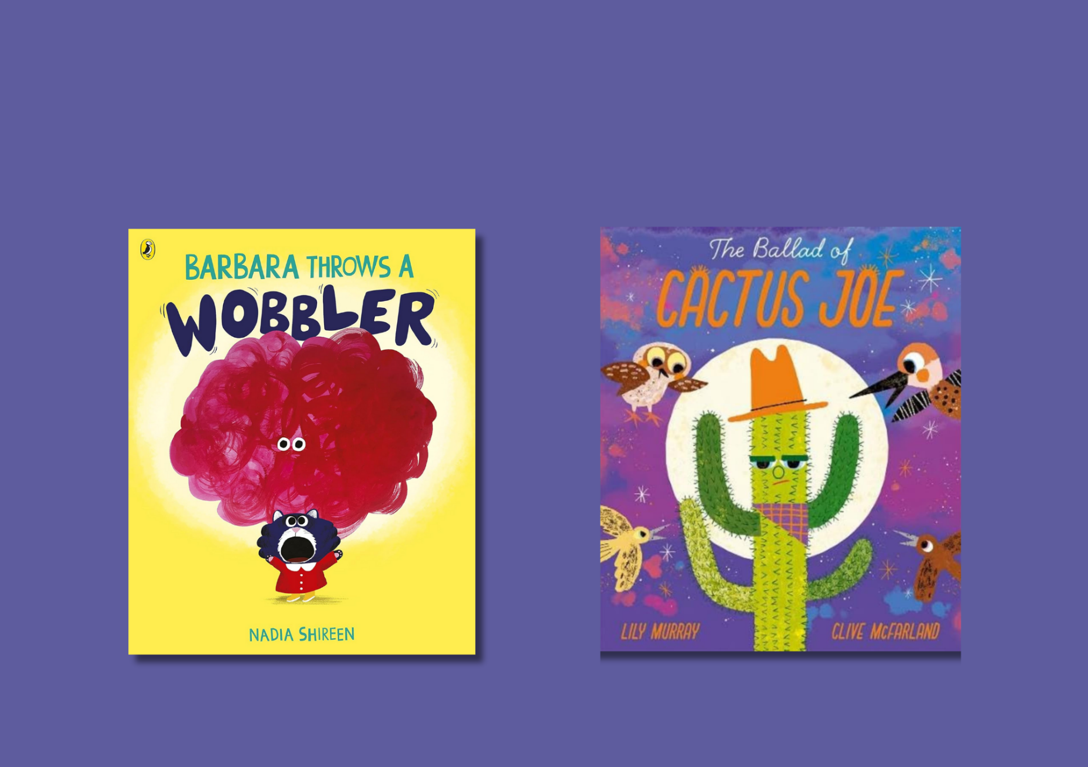

Read Write Count: P2 inclusive activities
Activities for the Read Write Count with the First Minister P2 bag designed for children with additional support needs

Resource created by Ailie Finlay


scottishbooktrust.com

Scottish Book Trust is a registered company (SC184248)
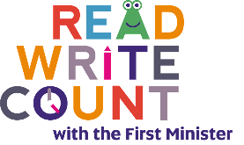
and a Scottish charity (SC027669).

Contents
About this resource 2
Barbara Throws a Wobbler activities 2
The Ballad of Cactus Joe activities 5
Domino cards activities 7
Act it Out cards activities 8
Talk it Out cards activities 9
Binoculars activities 9
Further resources 10

About this resource
The aim of this resource is to make the items in the Read Write Count P2 bag accessible to all. The activities can be used with pupils with a variety of needs, including additional support needs, English as an additional language or those who are disengaged from or struggle with reading.
These activities are flexible and we encourage you to adapt them, whether in school, community groups or at home. Some ideas have been specifically designed for children at home – if you work in a school or setting, you can send these home as possible home activities for families!
For more sensory storytelling activities, see our Getting started with sensory stories or Make your own sensory story resources on the Disability and neurodiversity section of the Scottish Book Trust website. You can also find more of Ailie Finlay’s work on the Flotsam and Jetsam and My Kind of Book websites.

Barbara Throws a Wobbler activities

Activity 1: Make a playdough wobbler
Make “wobblers” out of the playdough using the BBC Good Food recipe. You could add red food colouring if you like. Pupils might like to make the wobbler get bigger and bigger and then smaller again as you read the story together.
If your pupils enjoy this, you could make some more mood shapes out of playdough. Copy the mood shapes at the end of the book - or make up your own.

Activity 2: Short and simple
Some children might find it tricky to think of their moods as a “thing” like a wobbler. Try this if your pupils would enjoy a simpler version of the story.
Start telling the story from the page with the dropped ice cream and finish at the page after the “pop”. Re-tell it in words that your class usually uses and describe what is happening in the pictures, something like this:
Barbara dropped her ice cream.
She felt angry.
She shouted.
She shouted louder.
She wanted to be alone.
She lay on the ground and cried.
She didn’t know what to do.
She thought of all the things that had made her angry.
Then she took some deep breaths. (Pause to take some breaths)
…and at last she felt better.
“Pop!” went her angry feelings and she didn’t feel angry anymore.
Now she wanted to be with her friends.

Activity 3: Ice cream drop
Look at the page in the book where the ice cream falls to the ground, then try using anything you have to hand to re-create this scene. For example, you could use some wooden blocks. Put one block on your flat open hand: ‘this is the cone.’ Balance a couple more blocks on top: ‘these are the scoops of ice cream.’
Mime carrying the “cone” carefully - and then drop the “scoops” to the ground. Play this balancing game with pupils – maybe adding more scoops to see who can balance the most on their hand while they walk. Cushions would also be fun to use for this game – then you can jump in the “scoops of ice cream” when they fall!
The pupils might enjoy it if you fall to the ground in a pretend over-the-top tantrum when you drop your “ice cream”. Encourage them to help you calm down by taking some deep breaths!

Activity 4: Back of the hand story
Look at the first park scene picture with your class and try telling the story of this picture whilst you “draw” the actions on children’s arms and hand with your index finger.
We’re going to the park.
We’re going to have some fun. (Draw a long winding path down their arm)
We’re going to do some…
Swinging! (Draw a back and forward motion with your index finger on the back of their hand)
We’re going to the park.
We’re going to have some fun. (Draw a long path again)
We’re going to do some…
Sandcastle patting! (Gentle pat)
We’re going to the park.
We’re going to have some fun. (Draw a long path again)
We’re going to do some…
Waddling! (Using your hands alternately make a ‘waddle, waddle’ action on the back of their hand)
Carry on repeating with:
- Bubble blowing! (Draw some bubbles)
- Sliding! (Draw a long fast sliding motion down their arm)

And so on! Alternatively, you could act out the actions together as you tell this little park story.

The Ballad of Cactus Joe activities

Activity 1: Make a sensory setting
Try adding in one or two of the following to set the scene in the desert:
- Warmth: something warm – and safe – to touch (such as a hand warmer used under supervision)
- Quiet: say ‘Ssh!’ and listen to the quiet together.
- A breeze: Use a fan or a piece of card.
- Cactus Joe: something spiky such as a scrubbing brush
- The sandy desert: some sand or sandpaper
- Desert rocks: pebbles
- Soft clouds: cotton wool (not accurate – but fun!)

Activity 2: Short and simple
If your class enjoy stories with fewer words, try re-telling a very simple version of the story while you look at the pictures with them, something like this:
Cactus Joe lived alone in the desert.
But one day, a woodpecker came along, and he said: ‘Can I live with you Joe?’
‘Okay,’ said Joe.
Cactus Joe and the woodpecker lived in the desert.
Until one day an owl came along and he said: ‘Can I live with you Joe?’
‘Okay,’ said Joe.
Cactus Joe, the woodpecker and the owl lived together in the desert.
Repeat for Hawk and for all the birds, until…
‘No!’ said Joe. ‘Go away!’
But then Cactus Joe felt lonely….and called all the birds back home…
…and then Cactus Joe began to flower. And everyone was happy. Hurray!
The children might enjoy it if you include Cactus Joe’s song in this short version of the story as well. Cactus Joe’s song can be sung to the tune of “Twinkle, Twinkle, Little Star”.

Activity 3: Cactus Joe – without the birds!
Try looking at the book together and telling the story of the animals in the book instead of the birds. There are animals in lots of the pictures. You could tell a simple story something like this:
Cactus Joe lived in the desert and along came a…. snake!
Cactus Joe lived in the desert and along came some… insects!
Cactus Joe lived in the desert and along came some… bats!
And so on. You could use noises, actions or objects to make this version more fun. Here are some suggestions:
- Snake: Say: ‘Ssssss’. Action: make a snake shape, or “draw” this with your index finger on the pupil’s arm. Make a snake by stuffing a sock with other socks and tying it shut.
- Insects: Make a high-pitched hum.
- Bats: Make a flapping action with your arms or flap a piece of fabric (tea towel or similar).
- Spider: Tickle the palm of the pupil’s hand.
- Tortoise: Say: ‘plod, plod, plod, plod.’ As you say this slap your hands on your knees making slow plodding movements or tap the pupil’s knees gently in the same way.
- Wood rat: Use a short length of string with a knot in the end to make the rat’s tail. Make a “scurrying” noise by running your fingers on the top of a table. “Scurry” your fingers up and down their child’s arm.

Activity 4: Pick and mix story
Rather than reading the book from cover to cover let the pupils pick a few pages from the book in any order. Use the wording and suggestions above or make up your own words and actions for the animals in the picture they have chosen. You could add in noises and actions for the birds as well:
- Woodpecker: Knock lightly and fast on a table or wall
- Owl: Hoot like an owl
- Hawk: Put your arms out to make a gliding action
- Flock of birds: Lots of tweeting, flapping etc.

Domino cards activities
If your class would enjoy simpler dominoes cut some rectangles from paper or card and put just one, two or three dots on each.

Activity 1: Make a tower
If you have some building blocks you could try this game. Start with some of the domino cards in a face down pile. Take it in turns to pick up the top card – at each turn you have to add the same number of blocks to your tower as dots on the domino. Until the whole thing comes crashing down!

Activity 2: How many people live here?
On the blank sheet in your booklet draw the outlines of four or five houses – a box with a triangle on top is fine! Ask the pupils to give you a domino and to choose one of the houses – then you draw the right number of stick men in the house to match the dots on the domino. You can either take turn about or just let them be in charge while you do the drawing!
If your class has a cuddly toys, Lego figures or something similar you could use these instead of drawing. Put cushions out on the floor (or use pieces of scrap paper) – each cushion is a “home”. Pick a domino for each home and then collect the right number of toys and put them on the cushion. Maybe some of the toys move house! One person switches the domino cards around and then the other has to re-arrange the toys to match.

Activity 3: Dots or no dots?
Lay some of the dominos out face down on the floor (including the one with no dots). Take it in turns to pick up a domino. Ask: ‘dots or no dots?’ Whoever picks up the no dots domino is the winner. You can play varieties of this with one dot, two dots etc.

Act it Out cards activities

Activity 1: Perfect day
Using the activity cards try choosing three activities that would make their perfect day. You could also choose a character to take with you on this perfect day.
Activity 2: Animal hide and seek
Choose an animal card and hide. Quietly make the sound of the animal on the card every so often while the pupils look for you. Once they have found you let them guess which animal you were imitating. Switch roles!

Talk it Out cards activities

Activity 1: This or that
Try selecting two choices to make things simpler when using these cards. For example, for the Describe your perfect day card you might say: ‘Tell me about a place you’d like to visit. Would you like to visit a football match or a museum?’ or ‘Which animal would you like to be? Would you rather be a lion or an elephant?’

Activity 2: I’ll tell you a nice thing I saw you do…
Turn this Talk it Out question around and tell your pupils about something nice that you saw them doing.
If they find it tricky to express themselves in words you could try this with some of the other Talk it Out questions as well, for example: ‘I’ll tell you about a brave thing I saw you do…’
For questions that involve expressing an opinion you could express it like this:
‘I think your favourite song might be…’
‘I think maybe your favourite part of this week was…’
Then see if they agree or not!

Binoculars activities

Activity 1: What can we hear in the distance?
The binoculars help us to see into the distance. Can you hear things that are far away as well? Have a listen – what can you hear that is far away and where do you think the sound might be coming from?
Or try making a “magical ear trumpet” - this can just be a cardboard tube! Hold the ear trumpet to your ear and make up a story about what you can see/hear. ‘I can hear aliens dancing on a far-away planet’ or ‘I can hear Granny in London making a cup of tea in the kitchen.’

Activity 2: Bird sounds
The binoculars help us to identify birds by sight… if your pupils find sounds are more interesting, try the bird song identifier on the RSPB website. There is much less bird song in the winter months, but you can almost always hear a robin!
Further resources
- For further resources to support children with additional support needs, see the Disability and Neurodiversity section of our website including our Make your own sensory story resource, created by Ailie Finlay.
- For further resources to support use of the Read Write, Count bags see the Read Write Count section of our website or our Home Activities Hub.
- You can find more of Ailie Finlay’s work on the Flotsam and Jetsam and My Kind of Book websites.

