

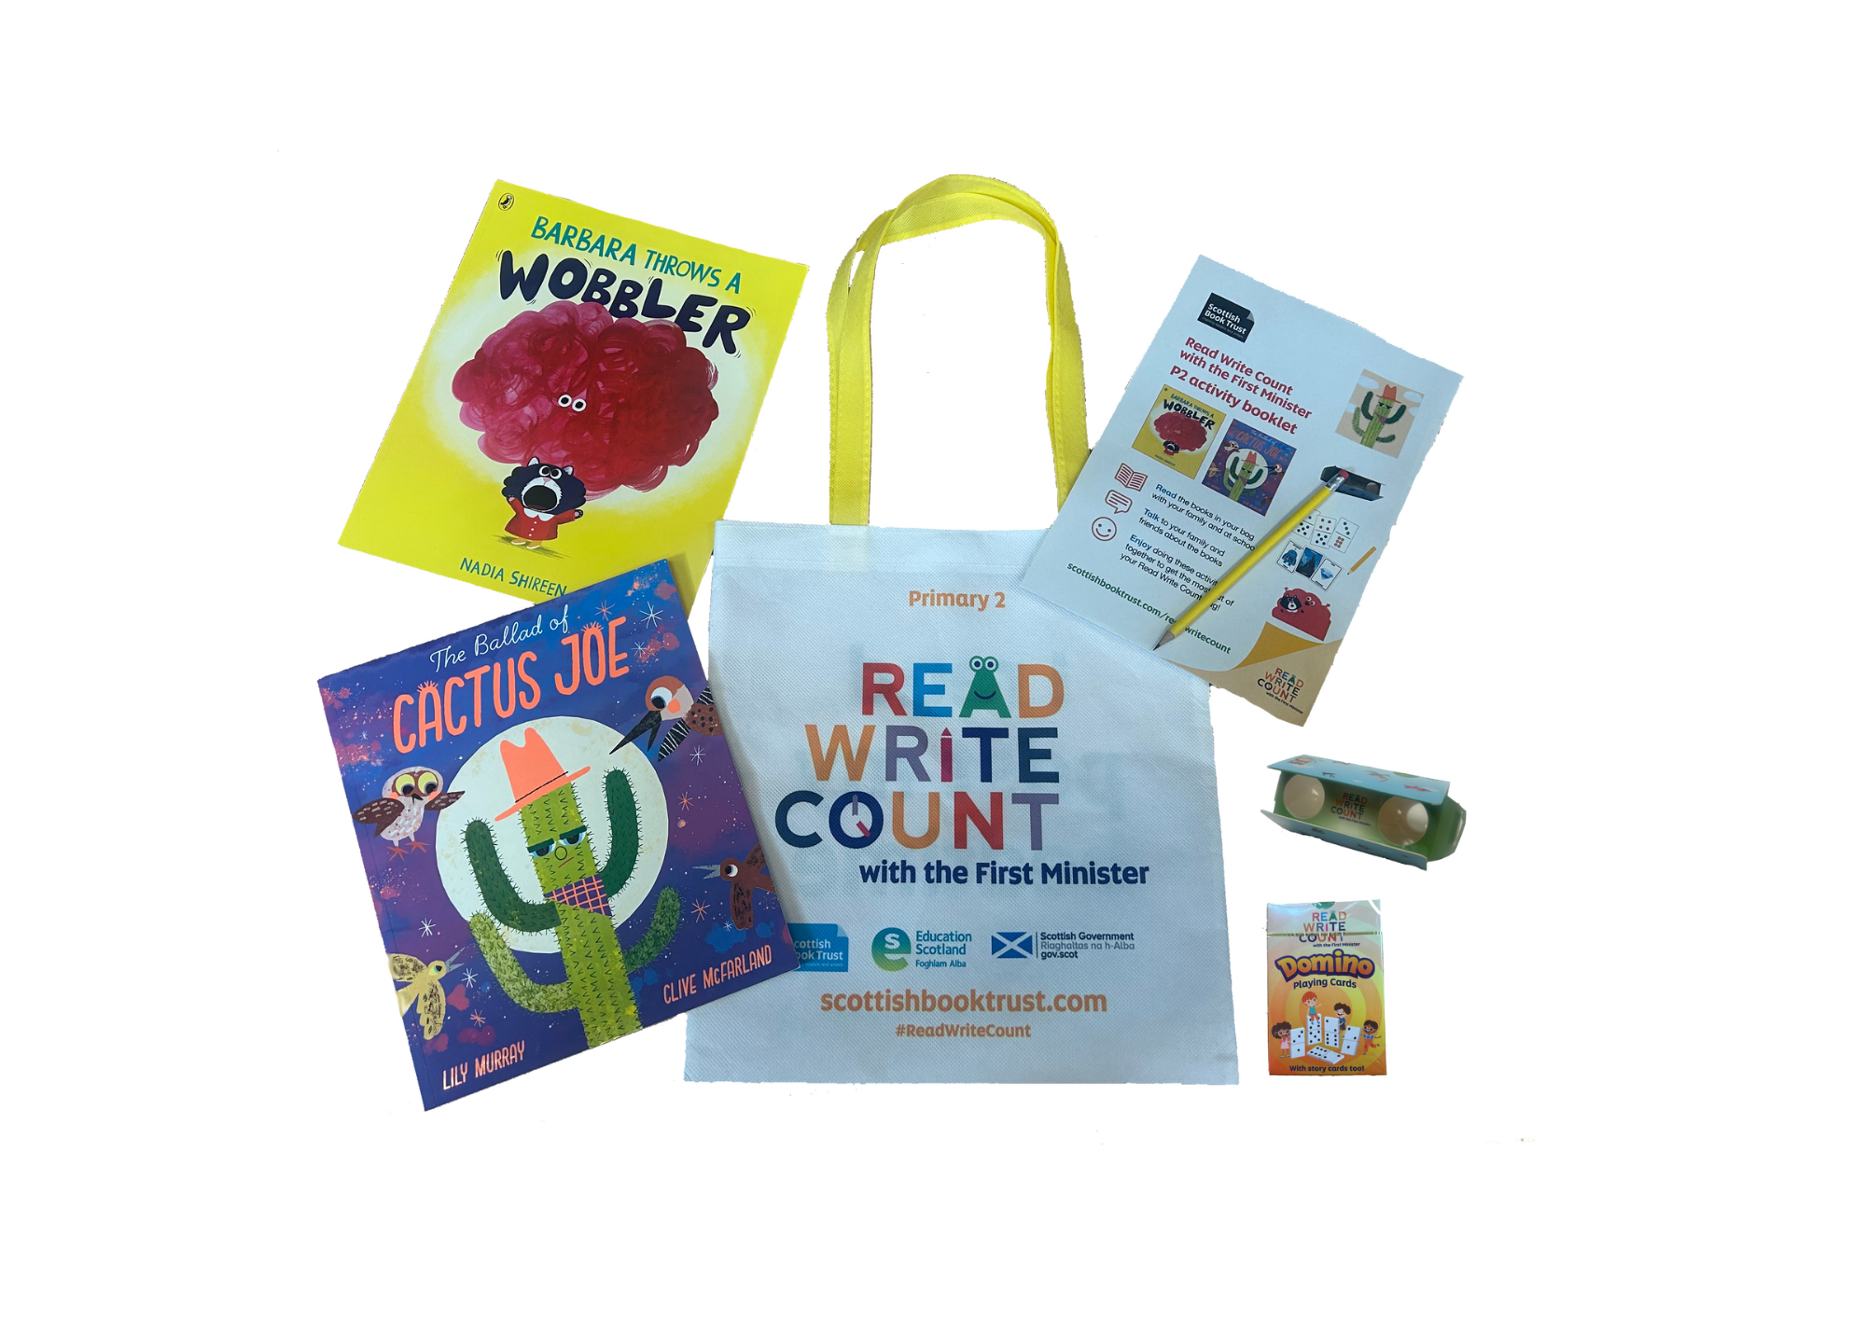

Read Write Count with the First Minister: P2 worksheetsPrintable worksheets you can use to explore your Read Write Count P2 bag



scottishbooktrust.com



Scottish Book Trust is a registered company (SC184248)

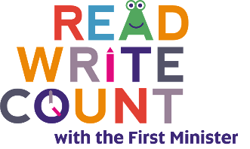and a Scottish charity (SC027669).

## Contents

About this resource 2

Further resources 2

Activity sheet 1: Design your own wobbler! 3

Activity sheet 2: Design your own mood! 4

Activity sheet 3: Cactus colouring 5

Activity sheet 4: Collage this cactus 6

Activity sheet 5: How to make a new hat for Cactus Joe 7

Activity sheet 6: Design your own Story Cards 9

Activity sheet 7: Binoculars record sheet 10

Activity sheet 8: Binocular bingo 11

## About this resource

Print these activity sheets at home to explore your Read Write Count P2 bag together! Will you draw your own mood like Barbara’s wobbler, make a new hat for Cactus Joe or design your own story cards for your card deck?

## Further resources

* Find out more about Read Write Count on the Read Write Count [section of the Scottish Book Trust website](https://www.scottishbooktrust.com/reading-and-stories/read-write-count)
* Find more activities, ideas and inspiration for reading and playing together at home on our [Home Activities Hub](https://www.scottishbooktrust.com/home-activities)

## Activity sheet 1: Design your own wobbler!

Colour in, collage and decorate your very own wobbler.

## Activity sheet 2: Design your own mood!

On the last page of the book, you can see what some different moods might look like. Use the boxes below to design your own moods. One might be a nice mood or feeling like “happy” or “giggly” and one might be a not so nice mood like “cross” or “sad”.

My mood is called:

My mood is called:

## Activity sheet 3: Cactus colouring

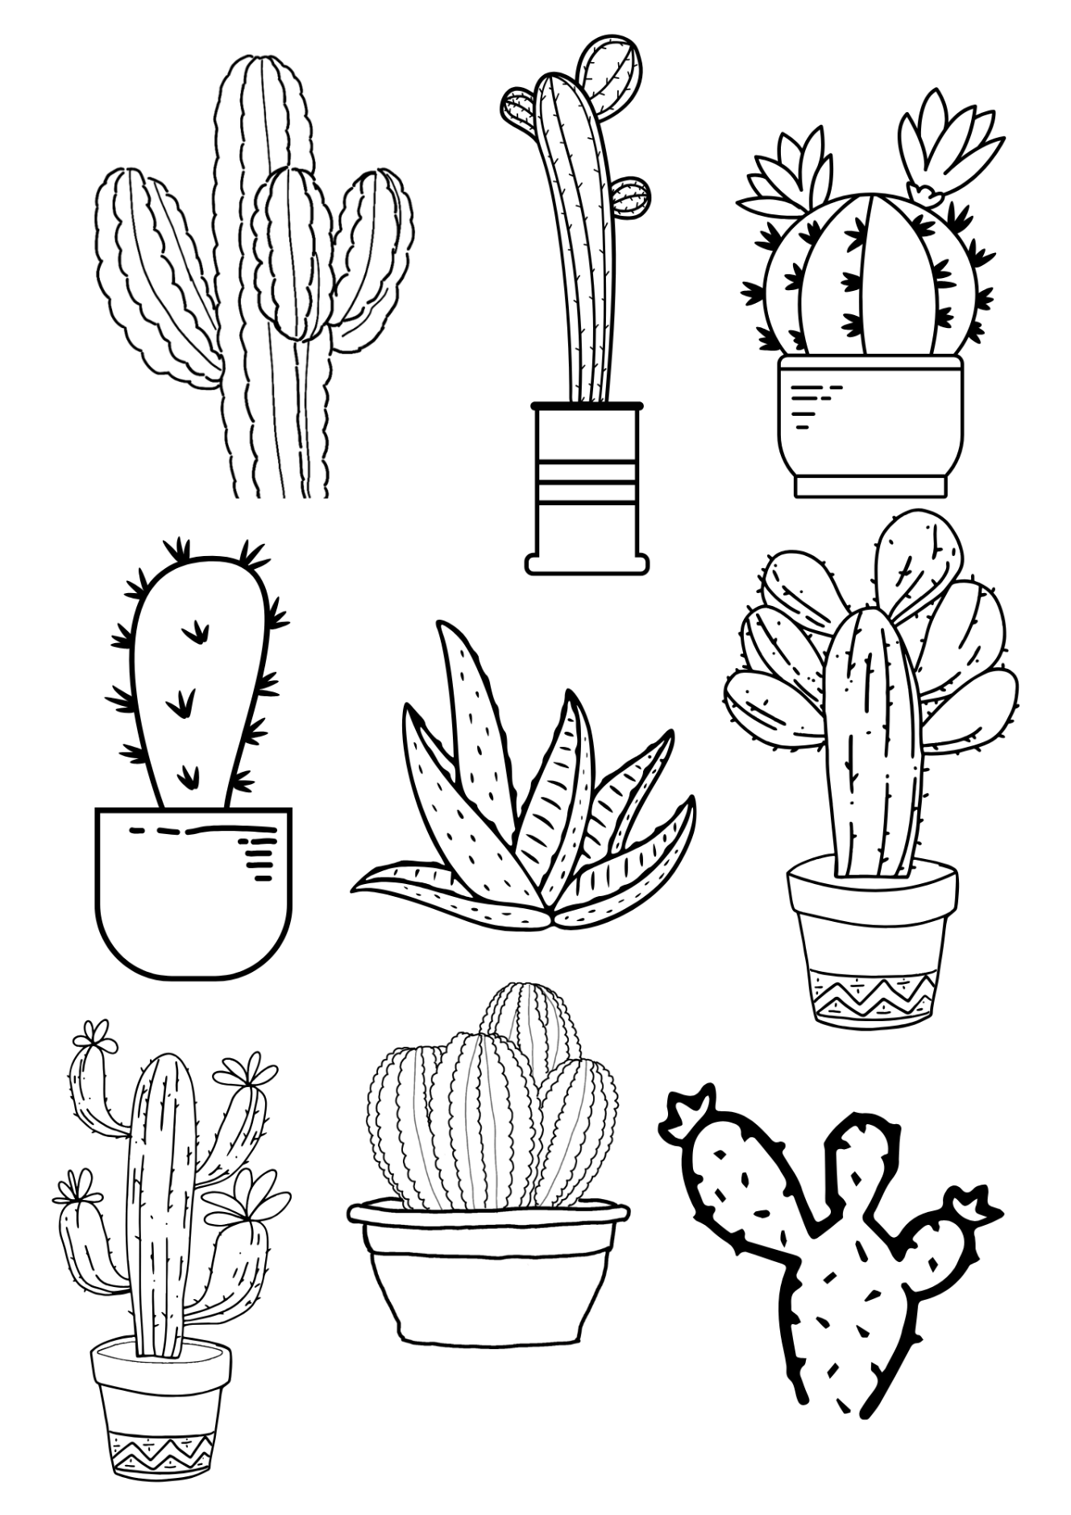Colour in these cactuses!

## Printable 4: Outline of a cactusActivity sheet 4: Collage this cactus

Colour in, collage and decorate your very own cactus.

## 

## Activity sheet 5: How to make a new hat for Cactus Joe

Follow this guide to create your own origami hat for Cactus Joe! Top tip: colour in or draw on your paper before you fold it. Or, wait until your hat is complete and use stickers to decorate it!

|  |  |
| --- | --- |
| Printable 6: Step 1  **Step 1:** Start with a normal A4 piece of paper | Printable 6: Step 2  **Step 2:**  Fold your piece of paper in half lengthways |
| Printable 6: Step 3  **Step 3:**  Unfold your piece of paper. | Printable 6: Step 4  **Step 4:** Now fold your piece of paper in half from top to bottom. |
| Printable 6: Step 5  **Step 5:**  Fold the right corner to the line down the centre, so it makes a triangle. | Printable 6: Step 6  **Step 6:**  Now fold the left corner to the line down the centre, so it makes a triangle. |
| Printable 6: Step 7  **Step 7:** Fold the bottom flap up along the base of the triangle. | Printable 6: Step 8  **Step 8:**  Turn the paper over |
| Printable 6: Step 9  **Step 9:** Fold up the bottom flap along the base of the triangle. | Printable 6: Step 10  **Step 10**  Your hat is now ready to wear, decorate or be given to a friendly cactus! |

## Activity sheet 6: Design your own Story Cards

Use the templates below to create your own Story Cards. What character, object or setting would you like to hear a story about?

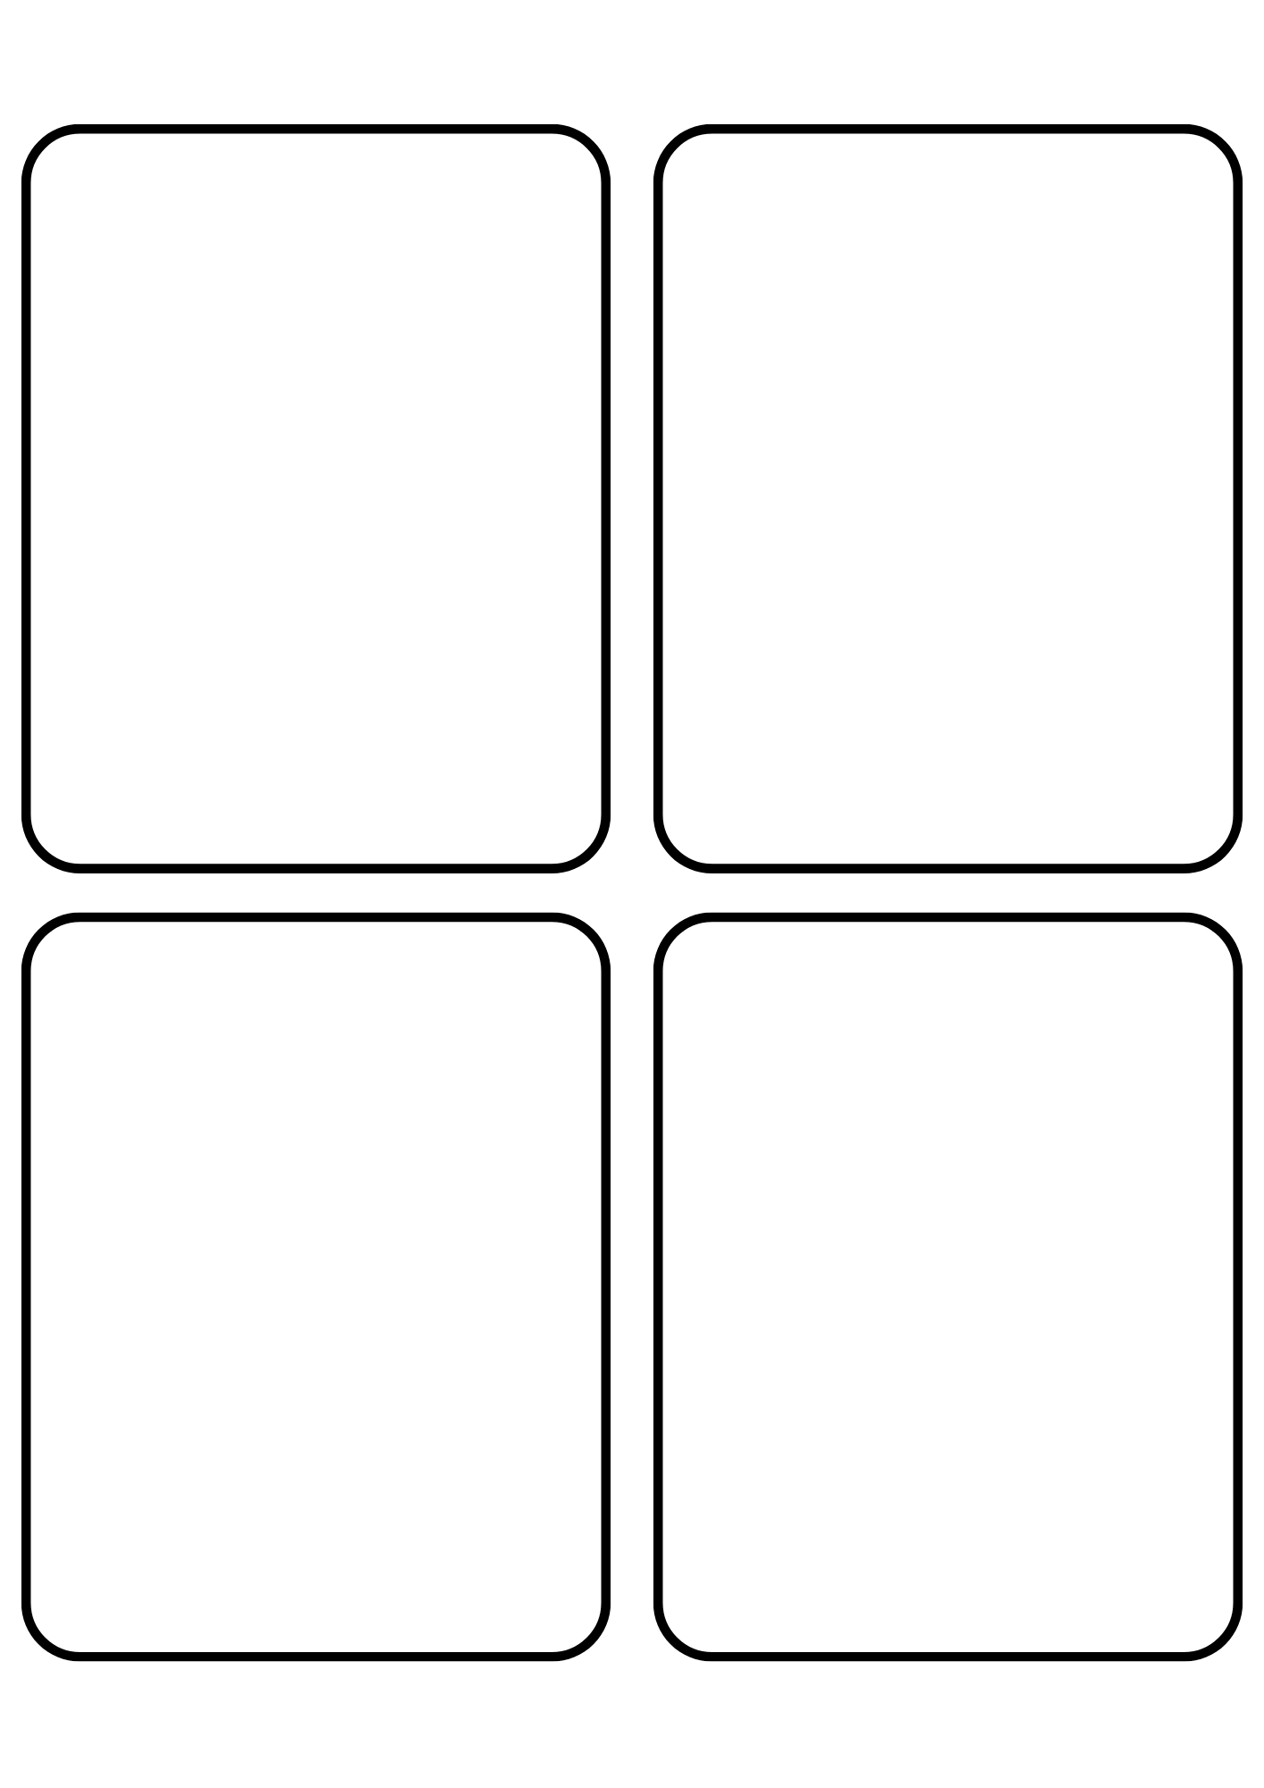

## Activity sheet 7: Binoculars record sheet

Using your binoculars explore the environment around you and make a list of some of the birds and/or animals you see. Using tally marks record how many of each you can find. Count your tally marks and write the number.

|  |  |  |
| --- | --- | --- |
| Animal/bird | Tally Marks | Number |
|  |  |  |
|  |  |  |
|  |  |  |
|  |  |  |
|  |  |  |
|  |  |  |

Which animal/bird did you see the highest number of?

Which animal/bird did you see the least number of?

## Activity sheet 8: Binocular bingo

Draw one thing in each square that you would like to spy through your binoculars. You could draw things in the sky, animals, plants, buildings near you, and even your neighbour’s pets! Then take your binoculars on a walk and see if you can find everything you drew! Did you see anything more than once?

|  |  |  |
| --- | --- | --- |
|  |  |  |
|  |  |  |
|  |  |  |
|  |  |  |