

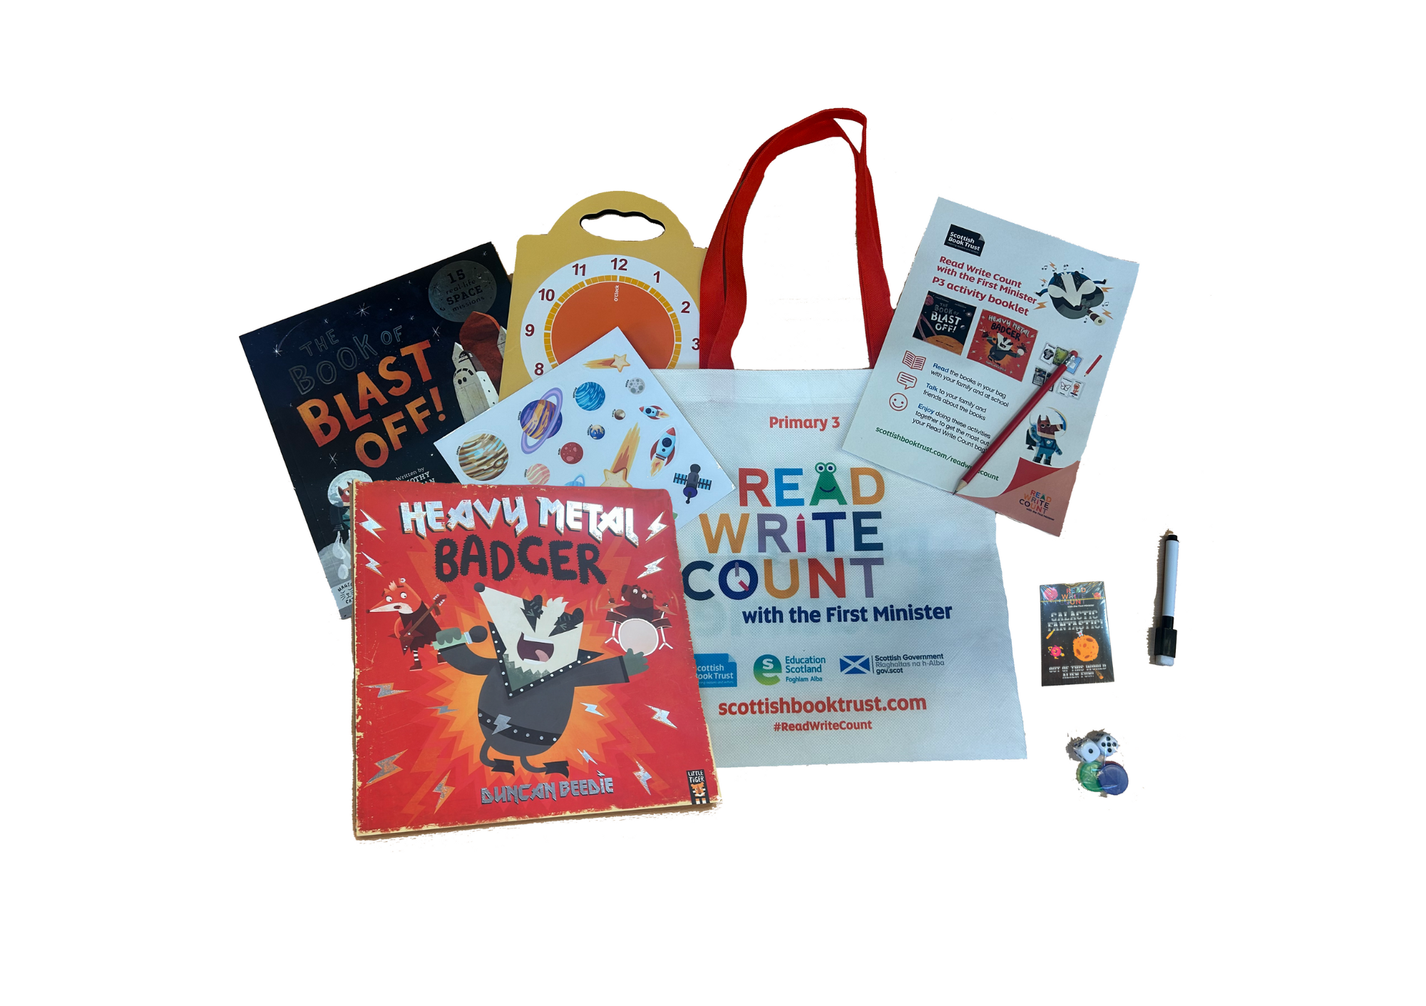

Read Write Count with the First Minister: P3 worksheetsPrintable worksheets you can use to explore your Read Write Count P3 bag



scottishbooktrust.com



Scottish Book Trust is a registered company (SC184248)

and a Scottish charity (SC027669).

## Contents

About this resource 4

Further resources 4

Activity sheet 1: Design an outfit for Badger! 5

Activity sheet 2: Create a poster for a music concert 6

Activity sheet 3: Create a ticket for a music concert 7

Activity sheet 4: What’s inside your space station? 8

Activity sheet 5: My space suitcase! 9

Activity sheet 6: Create your own Galactic Fantastic card 10

Activity sheet 7: Design your own Story Cards 11

Activity sheet 8: Create your own puppets 12

## About this resource

Print these activity sheets at home to explore your Read Write Count P3 bag together! Will you design a new outfit for Heavy Metal Badger, create your own space station or make a new Galactic Fantastic alien?

## Further resources

* Find out more about Read Write Count on the Read Write Count [section of the Scottish Book Trust website](https://www.scottishbooktrust.com/reading-and-stories/read-write-count)
* Find more activities, ideas and inspiration for reading and playing together at home on our [Home Activities Hub](https://www.scottishbooktrust.com/home-activities)

## Activity sheet 1: Design an outfit for Badger!

Badger needs some great clothes for his heavy metal show. Design a brilliant outfit for him by gluing on some scraps of coloured paper, fabric, stickers, card, sticky gems or anything else you can find.

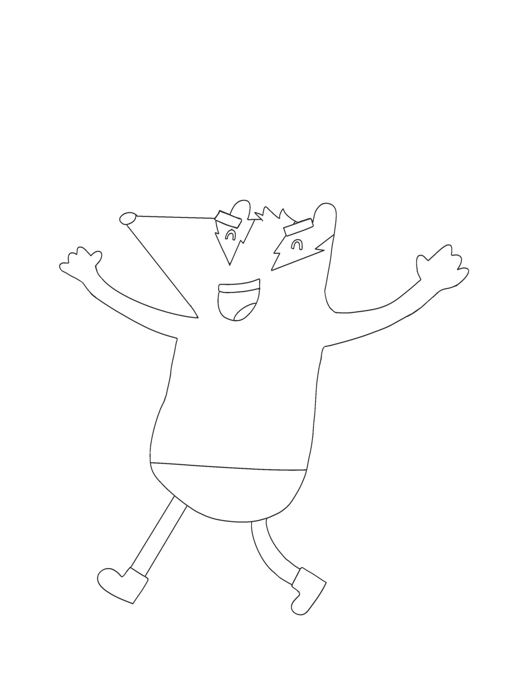

## Activity sheet 2: Create a poster for a music concert

Use the space below to draw a poster for a music concert. What information should your poster include so people can come to your concert?

|  |
| --- |
|  |

## Activity sheet 3: Create a ticket for a music concert

Imagine you’re attending a concert. What band are you seeing? Where are you seeing them? How much did the ticket cost? Once you’ve included all the information you need, colour in your ticket and cut it out.

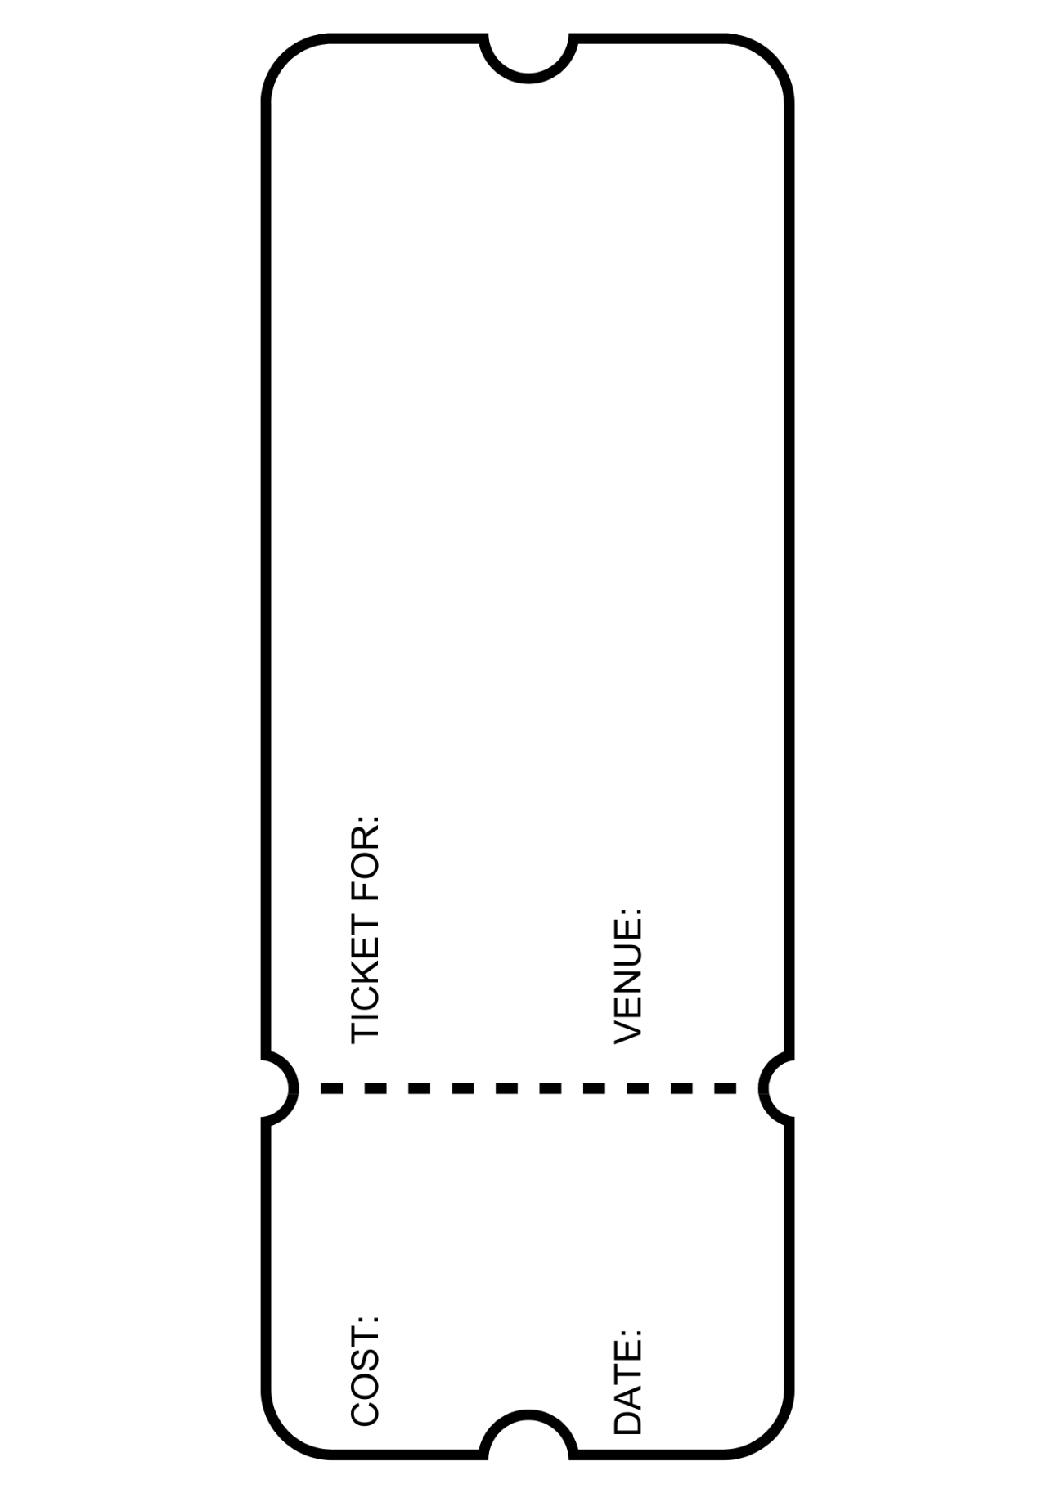

## Printable activity sheet 5: an outline of a satelitteActivity sheet 4: What’s inside your space station?

This space station is all yours. What do you want to do with it?

Add people, equipment and experiments into the different rooms, and label them so everyone knows what is happening.

Activity sheet 5: My space suitcase!Imagine you are an astronaut getting ready to go into space. Draw everything you would pack inside your suitcase. What are the five things you would definitely take with you?

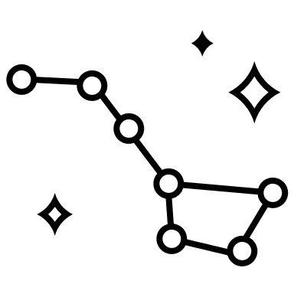

|  |
| --- |
| I would take… |
| 1. |
| 2. |
| 3. |
| 4. |
| 5. |



## Activity sheet 6: Create your own Galactic Fantastic card

Use the template below to design your own alien inspired by your Galactic Fantastic cards!

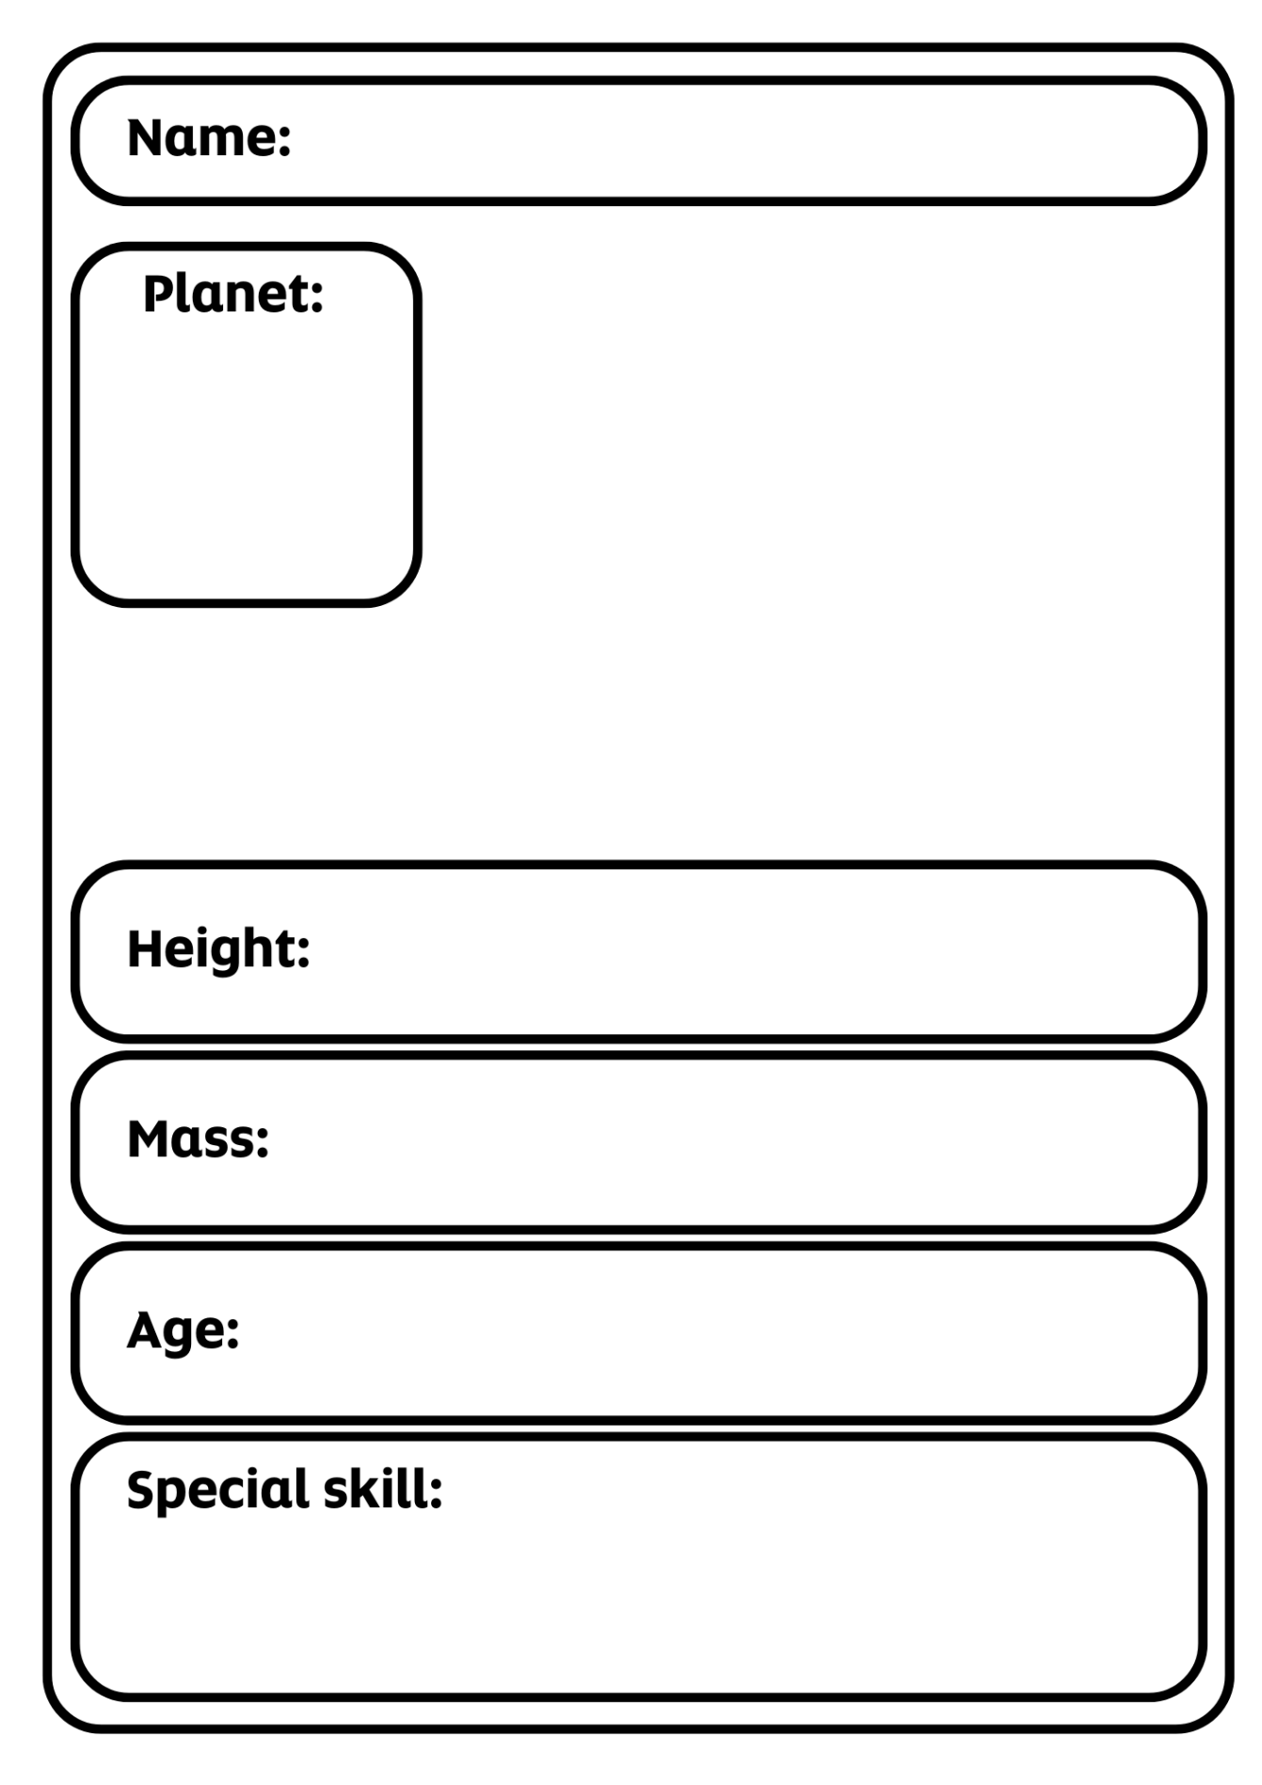

## Activity sheet 7: Design your own Story Cards

Use the templates below to create your own Story Cards. What character, object or setting would you like to hear a story about?

## Printable activity sheet 10: blank story cards for pupils to fill in

## Activity sheet 8: Create your own puppets

Colour in then cut out the characters below. Stick them to straws or sticks to make your own puppets. You can then use the space scene on your fold out board game as a backdrop to create your own play!

