

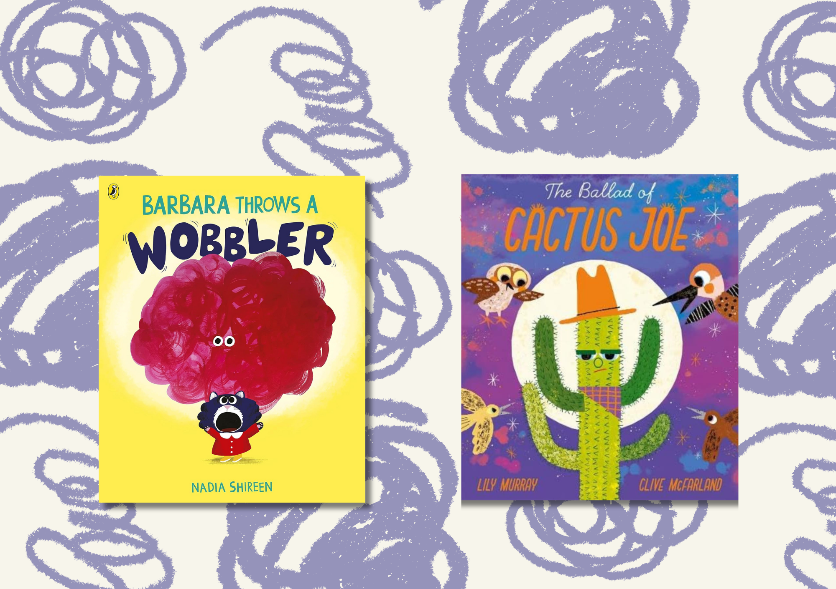

# Read Write Count library pack: P2 bag

A library session for the Read Write Count P2 bag including songs, crafts, worksheets and printables

scottishbooktrust.com



Scottish Book Trust is a registered company (SC184248)

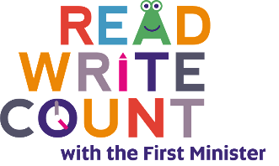and a Scottish charity (SC027669).

## Contents

About this resource 2

Read Write Count gifting 4

Welcome to the session 4

Reading the books 4

Songs and rhymes 5

Craft activity 5

Goodbye and finding books to take home 6

Printable 1: What to read after your Read Write Count books 7

Printable 2: Design your own wobbler! 8

Printable 3: Design your own mood! 9

Printable 4: Decorate this cactus! 10

Printable 5: Cactus colouring 11

Printable 6: How to make a new hat for Cactus Joe 12

## About this resource

Every year, we gift Read Write Count with the First Minister bags to every P2 and P3 child in Scotland. Each bag contains books and educational games and resources. These bags are designed to support families to read, learn and bond together at home.  
  
We’ve put together a library session for each of this year’s Read Write Count bags so you can run interactive family sessions. These can be adapted to suit the duration of storytelling sessions in your library.  
  
Each session includes:

* Reading the book together
* Choices of songs to sing together
* Choices for a main activity or arts and crafts
* Suggestions to help families find their next read

In this resource we’ve included suggested songs, activities as well as some printables you can use as part of your session.

Whilst Read, Write, Count gifts bags to children in P2 and P3, you can keep these sessions open to all families and they don’t rely upon the families having prior knowledge of the books. The contents of this year’s bags are as follows:

### P2

* *Barbara Throws a Wobbler* by Nadia Shireen
* *The Ballad of Cactus Joe* by Lily Murray and Clive McFarland
* Folding binoculars
* A deck of cards with Dominoes, Story Cards and Talk it Out conversation prompts and Act it Out acting prompts
* An activity booklet and pencil

### P3

* *Heavy Metal Badger* by Duncan Beedie
* *The Book of Blast Off* by Timothy Knapman and Nik Henderson
* A tri-fold board game with counters, dice and a dry wipe pen
* A deck of cards with Galactic Fantastic card game, story prompts and mindfulness cards
* An activity booklet and pencil

Every year, we create two surveys in order to gather feedback from both [**learning professionals**](https://www.surveymonkey.com/r/9D333DZ)and [**families at home**](https://www.surveymonkey.com/r/9DGDVZV). Please do fill these in, letting us know what you think of the Read Write Count bags and resources, and encourage families at home to do the same. Anyone who fills in either survey will be entered into a prize draw to win a Read Write Count superbox filled with books and numeracy games.

## Read Write Count gifting

As part of Read Write Count, we encourage schools to host a gifting event to generate excitement about the bags and help parents or families feel confident reading the books and using the resources at home. The bags arrive in schools around September or October, and we encourage schools to gift them during [Book Week Scotland](https://www.scottishbooktrust.com/book-week-scotland) in November. You can reach out to any local schools to invite them to host the gifting event in the library, where families can also find more books to borrow and sign up for a library card if they don’t have one already. To find out more about gifting events, visit the [Read Write Count section of our website](https://www.scottishbooktrust.com/reading-and-stories/read-write-count).

## Welcome to the session

Welcome everyone to the session, saying hello to all the adults and children in turn. You could use [“The Hello Song”](https://www.scottishbooktrust.com/songs-and-rhymes/the-hello-song-audio) from the Bookbug Song and Rhyme Library or Bookbug app to warm the group up.

## Reading the books

Read *Barbara Throws a Wobbler* aloud to the group, making sure everyone can see the pages and hear you. Allow the children to stop and ask questions or take time to look at the illustrations. Towards the end of the book, there’s a page that shows the park again, where there’s lots of hidden wobblers. Ask the children to help you find them all. Why do they think these potential wobblers might happen?  
  
Now, read through *The Ballad of Cactus Joe*. Can the children do their best Cactus Joe impression? See the Songs and rhymes section for our top tips on singing Cactus Joe’s song!

## Songs and rhymes

For singing together, you could choose between:

* [“If You’re Happy and You Know It”](https://www.scottishbooktrust.com/songs-and-rhymes/if-youre-happy-and-you-know-it-audio) – change the verses to fit the different moods in *Barbara Throws a Wobbler*
* “The Ballad of Cactus Joe” – the song in the book fits perfectly to the tune of [“Twinkle Twinkle, Little Star”](https://www.scottishbooktrust.com/songs-and-rhymes/twinkle-twinkle-little-star-audio)

### If You’re Happy and You Know It

Available via [Bookbug Song and Rhyme Library](https://www.scottishbooktrust.com/songs-and-rhymes/what-do-you-see)  
If you’re happy and you know it, clap your hands  
If you’re happy and you know it, clap your hands  
If you’re happy and you know it,  
And you really want to show it  
If you’re happy and you know it, clap your hands  
  
Singing ay ay yippy yippy ay  
Singing ay ay yippy yippy ay  
Singing ay ay yippy, ay ay yippy  
Aye ay yippy yippy ay  
  
If you’re nervous and you know it, hide your face…  
If you’re angry and you know it, stamp your feet…  
If you’re silly and you know it, jump about…

## Craft activity

### Option 1: Create your own wobbler

Use our printable activity sheet on page 8 to create your own wobbler! You can colour or use collage to explore different textures. Children can take them home, or you can use them to make a display in your library.

### Option 2: Make a new hat for Cactus Joe

Use our printable activity sheet on page 12 and 13 to learn how to make an origami hat – all you need is A4 paper. Children can colour it in or decorate it!

### Bonus colouring in

In this pack, we’ve also included some themed colouring in sheets – see page 9, 10 and 11.

## Goodbye and finding books to take home

At the end of your sessions, you can explore some books similar to *Barbara Throws a Wobbler* and *The Ballad of Cactus Joe* in theme or topic. Explain to the children they can borrow them and take them home. See page 7 for a printable where children can note down any books they’d like to borrow. We’ve included some books we think readers might enjoy next – but feel free to edit this!

## Printable 1: What to read after your Read Write Count books

If you enjoyed *Barbara Throws a Wobbler* by Nadia Shireen, we think you might like:

* *Geoffrey Gets the Jitters* by Nadia Shireen
* *The Eyebrows of Doom* by Steve Smallman and Miguel Ordóñez
* *My Big Shouting Day* by Rebecca Patterson

If you enjoyed *The Ballad of Cactus Joe* by Lily Murray and Clive McFarland, we think you might like:

* *Steve, Terror of the Seas* by Megan Brewis
* *The Oak Tree* by Julia Donaldson and Victoria Sandøy
* *My Dad is a Tree* by Jon Agee

And here’s space for you, your librarian, or your family to write down some books you might like:

|  |
| --- |
|  |

## Printable 2: Design your own wobbler!

Colour in, collage and decorate your very own wobbler.

## Printable 3: Design your own mood!

On the last page of the book you can see what some different moods might look like. Use the boxes below to design your own moods. One might be a nice mood or feeling like ‘happy’ or ‘giggly’ and one might be a not so nice mood like ‘cross’ or ‘sad’.

My mood is called:

My mood is called:

## Printable 4: Decorate this cactus!

Colour in, collage and decorate your very own cactus.



## 

## Printable 5: Cactus colouring

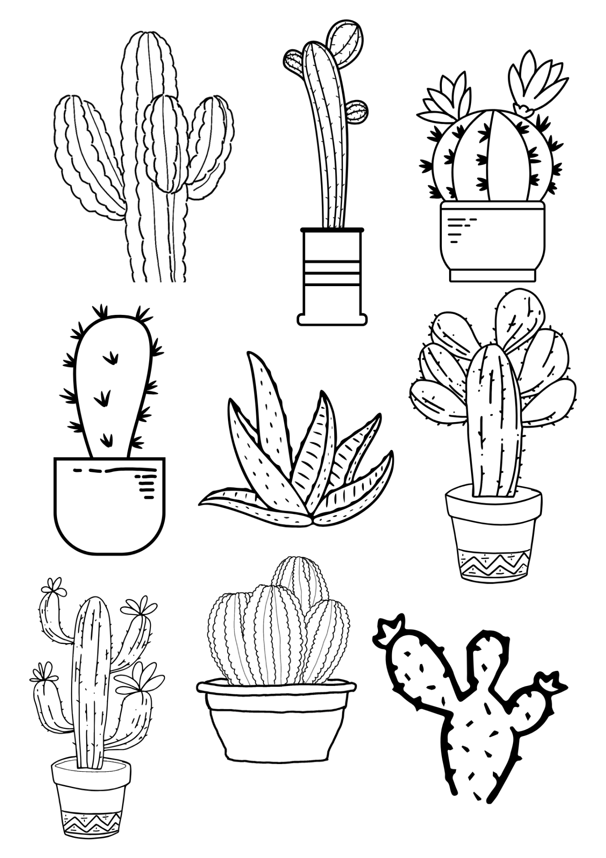Colour in these cactuses!

## 

## Printable 6: How to make a new hat for Cactus Joe

Follow this guide to create your own origami hat for Cactus Joe! Top tip: colour in or draw on your paper before you fold it. Or, wait until your hat is complete and use stickers to decorate it!

|  |  |
| --- | --- |
| Printable 6: Step 1  **Step 1:** Start with a normal A4 piece of paper | Printable 6: Step 2  **Step 2:**  Fold your piece of paper in half lengthways |
| Printable 6: Step 3  **Step 3:**  Unfold your piece of paper. | Printable 6: Step 4  **Step 4:** Now fold your piece of paper in half from top to bottom. |
| Printable 6: Step 5  **Step 5:**  Fold the right corner to the line down the centre, so it makes a triangle. | Printable 6: Step 6  **Step 6:**  Now fold the left corner to the line down the centre, so it makes a triangle. |
| Printable 6: Step 7  **Step 7:** Fold the bottom flap up along the base of the triangle. | Printable 6: Step 8  **Step 8:**  Turn the paper over |
| Printable 6: Step 9  **Step 9:** Fold up the bottom flap along the base of the triangle. | Printable 6: Step 10  **Step 10**  Your hat is now ready to wear, decorate or be given to a friendly cactus! |