

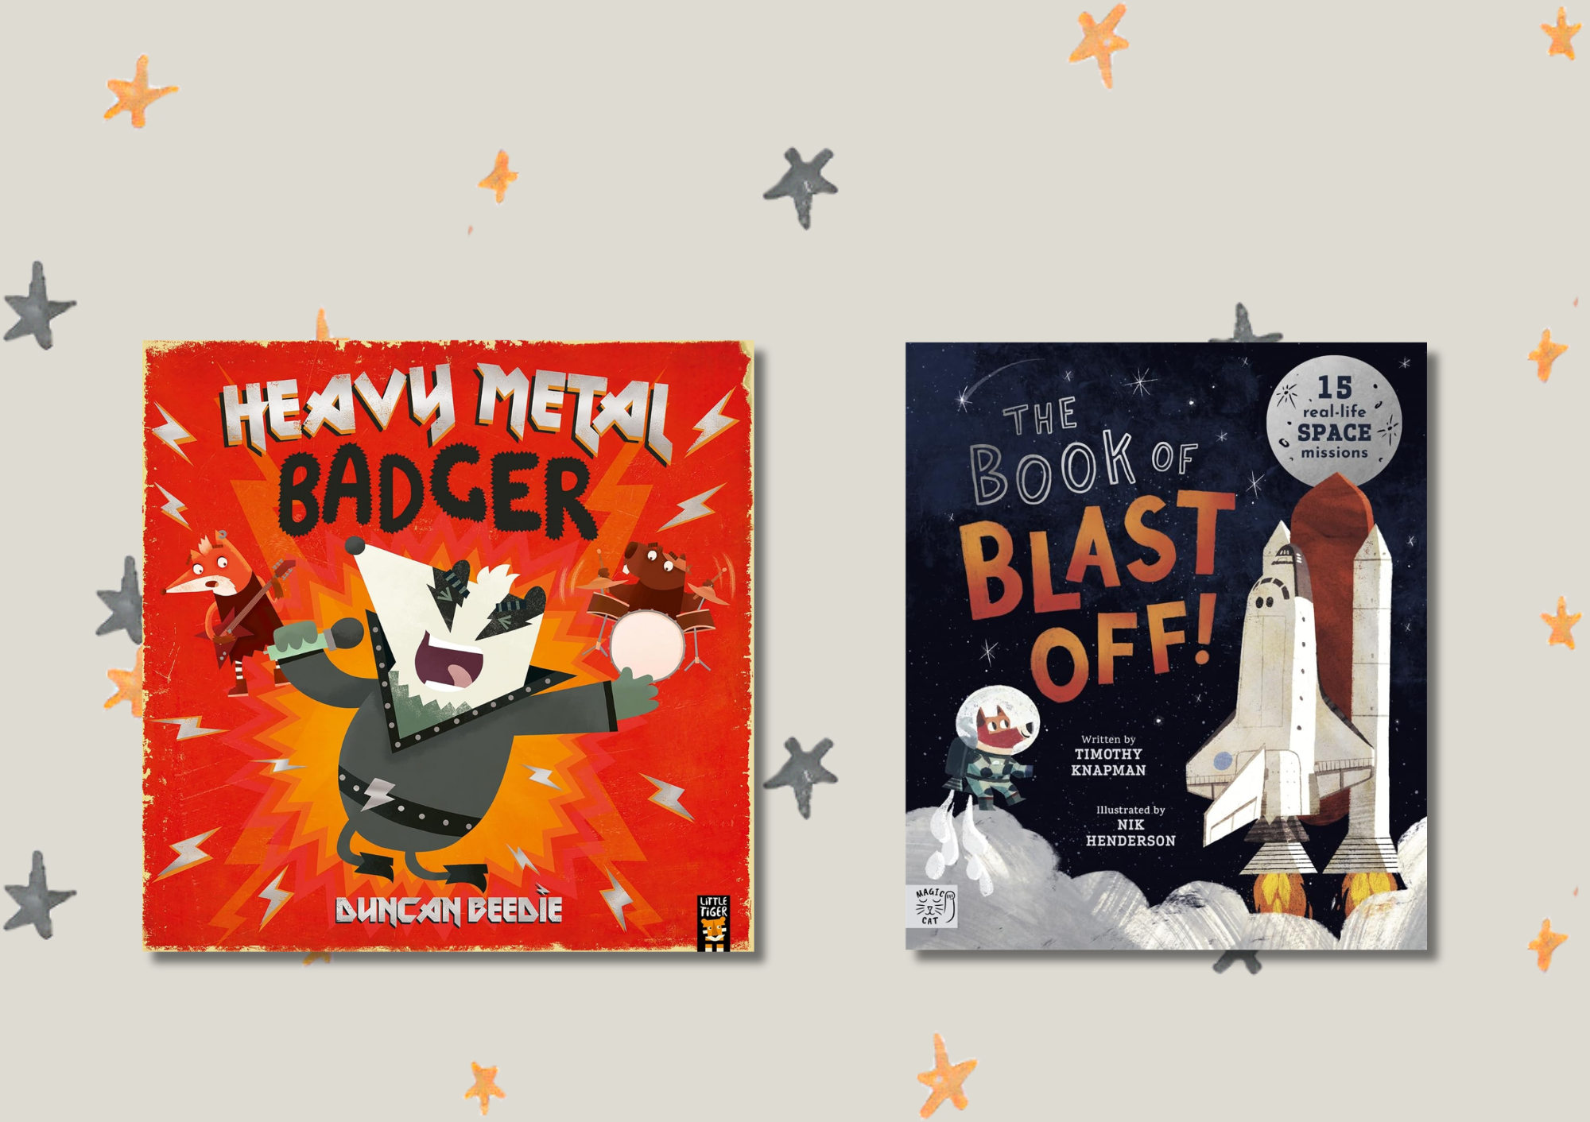

# Read Write Count library pack: P3 bag

A library session for the Read Write Count P3 bag including songs, crafts, worksheets and printables

scottishbooktrust.com



Scottish Book Trust is a registered company (SC184248)

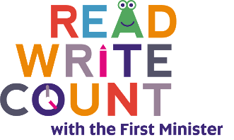and a Scottish charity (SC027669).

## Contents

About this resource 2

Read Write Count gifting 4

Welcome to the session 4

Reading the books 4

Songs and rhymes 5

Craft activity 6

Goodbye and finding books to take home 7

Printable 1: What to read after your Read Write Count books 8

Printable 2: Design a concert ticket 9

Printable 3: Design a music studio 10

Printable 4: Pack your space suitcase! 11

Printable 5: Space colouring 12

Printable 6: Design your own rocket 14

## About this resource

Every year, we gift Read Write Count with the First Minister bags to every P2 and P3 child in Scotland. Each bag contains books and educational games and resources. These bags are designed to support families to read, learn and bond together at home.  
  
We’ve put together a library session for each of this year’s Read Write Count bags so you can run interactive family sessions. These can be adapted to suit the duration of storytelling sessions in your library.  
  
Each session includes:

* Reading the book together
* Choices of songs to sing together
* Choices for a main activity or arts and crafts
* Suggestions to help families find their next read

In this resource we’ve included suggested songs, activities as well as some printables you can use as part of your session.

Whilst Read, Write, Count gifts bags to children in P2 and P3, you can keep these sessions open to all families and they don’t rely upon the families having prior knowledge of the books. The contents of this year’s bags are as follows:

### P2

* *Barbara Throws a Wobbler* by Nadia Shireen
* *The Ballad of Cactus Joe* by Lily Murray and Clive McFarland
* Folding binoculars
* A deck of cards with Dominoes, Story Cards and Talk it Out conversation prompts and Act it Out acting prompts
* An activity booklet and pencil

### P3

* *Heavy Metal Badger* by Duncan Beedie
* *The Book of Blast Off* by Timothy Knapman and Nik Henderson
* A tri-fold board game with counters, dice and a dry wipe pen
* A deck of cards with Galactic Fantastic card game, story prompts and mindfulness cards
* An activity booklet and pencil
* A deck of cards which includes Galactic Fantastic, Story Cards and Prompts, Search and See and Mindfulness cards

Every year, we create two surveys in order to gather feedback from both [**learning professionals**](https://www.surveymonkey.com/r/9D333DZ)and [**families at home**](https://www.surveymonkey.com/r/9DGDVZV). Please do fill these in, letting us know what you think of the Read Write Count bags and resources, and encourage families at home to do the same. Anyone who fills in either survey will be entered into a prize draw to win a Read Write Count superbox filled with books and numeracy games.

## Read Write Count gifting

As part of Read Write Count, we encourage schools to host a gifting event to generate excitement about the bags and help parents or families feel confident reading the books and using the resources at home. The bags arrive in schools around September or October, and we encourage schools to gift them during [Book Week Scotland](https://www.scottishbooktrust.com/book-week-scotland) in November. You can reach out to any local schools to invite them to host the gifting event in the library, where families can also find more books to borrow and sign up for a library card if they don’t have one already. To find out more about gifting events, visit the [Read Write Count section of our website](https://www.scottishbooktrust.com/reading-and-stories/read-write-count).

## Welcome to the session

Welcome everyone to the session, saying hello to all the adults and children in turn. You could use [“The Hello Song”](https://www.scottishbooktrust.com/songs-and-rhymes/the-hello-song-audio) from the Bookbug Song and Rhyme Library or Bookbug app to warm the group up.

## Reading the books

Read *Heavy Metal Badger* aloud to the group, making sure everyone can see the pages and hear you. Allow the children to stop and ask questions or take time to look at the illustrations. Parents or other adults might enjoy noticing all the little details – including the funny band names!  
  
Now, read through *The Book of Blast Off*. There’s a rhyming narrative that runs throughout, but you can also point out the labelled parts of the different spaceships.

## Songs and rhymes

For singing together, you could choose between:

* “What Shall We Do with a Noisy Badger” – to the tune of [“What Shall We Do With the Grumpy Pirate?”](https://www.scottishbooktrust.com/songs-and-rhymes/what-shall-we-do-with-the-grumpy-pirate)
* [“Zoom, Zoom, Zoom”](https://www.scottishbooktrust.com/songs-and-rhymes/zoom-zoom-zoom) – take it in turns for the children to count down from 5 to

### What Shall We Do with a Noisy Badger?

Tune available [via Bookbug Song and Rhyme Library](https://www.scottishbooktrust.com/songs-and-rhymes/what-shall-we-do-with-the-grumpy-pirate)  
  
What shall we do with a noisy badger?  
What shall we do with a noisy badger?  
What shall we do with a noisy badger?  
Early in the morning  
  
Strum, strum, play the guitar  
Strum, strum, play the guitar  
Strum, strum, play the guitar  
Early in the morning

Bang, bang, bang the drums,  
Bang, bang, bang the drums,  
Bang, bang, bang the drums,  
Early in the morning  
  
Shout, shout, shout out loud,  
Shout, shout, shout out loud,  
Shout, shout, shout out loud  
Early in the morning  
  
Dance, dance, dance to the song  
Dance, dance, dance to the song  
Dance, dance, dance to the song  
Early in the morning  
  
Join a band and make some music  
Join a band and make some music  
Join a band and make some music  
Early in the morning

### Zoom, Zoom, Zoom

Available via [Bookbug Song and Rhyme Library](https://www.scottishbooktrust.com/songs-and-rhymes/zoom-zoom-zoom-audio)  
  
Zoom, zoom, zoom,  
We’re going to the moon!  
Zoom, zoom, zoom,  
We’ll be there very soon.  
  
If you want to take a trip,  
Climb on board my rocket ship.  
Zoom, zoom, zoom,  
We’re going to the moon!  
  
5-4-3-2-1-BLAST OFF!

## Craft activity

### Option 1: Create your rock and roll posters

In this activity pack, you’ll find printables to design your own concert ticket and a music studio for Badger! You could also create posters for your library, encouraging people to visit, e.g. “Our library rocks!” or “Reading rocks!”

### Option 2: Create straw rockets

You will need:

* Paper
* Straws
* Cellotape
* Scissors
* Pens, pencils or crayons

Use [NASA’s guide](https://www.jpl.nasa.gov/edu/resources/project/make-a-straw-rocket/) to make your own flying rockets, using paper and straws! You can also find a printable to support this activity on page 13.

### Bonus colouring in

In this pack, we’ve also included some themed colouring in sheets – see page 11 and 12.

Goodbye and finding books to take home   
At the end of your sessions, you can explore some books that are similar to *Heavy Metal Badger* or *The Book of Blast Off* in theme or topic. Explain to the children they can borrow them and take them home. See page 8 for a printable where children can note down any books they’d like to borrow. We’ve included some books we think readers might enjoy next – but feel free to edit this!

## Printable 1: What to read after your Read Write Count books

If you enjoyed *Heavy Metal Badger* by Duncan Beedie, we think you might like:

* *Frida the Rock-and-Roll Moth* by Kimm Hillyard
* *LOUD!* by Rose Robbins
* *Here Comes Frankie!* by Tim Hopgood

If you enjoyed *The Book of Blast Off* by Timothy Knapman and Nik Henderson

* *Look Up!* by Nathan Bryon and Dapo Adeola
* *Rocketmole* by Matt Carr
* *The Skies Above My Eyes* by Charlotte Guillan and Yuval Zommer

And here’s space for you, your librarian, or your family to write down some books you might like:

|  |
| --- |
|  |

## Printable 2: Design a concert ticket

Imagine you’re attending a concert. What band are you seeing? Where are you seeing them? How much did the ticket cost? Once you’re included all the information, decorate or colour in your ticket and cut it out.

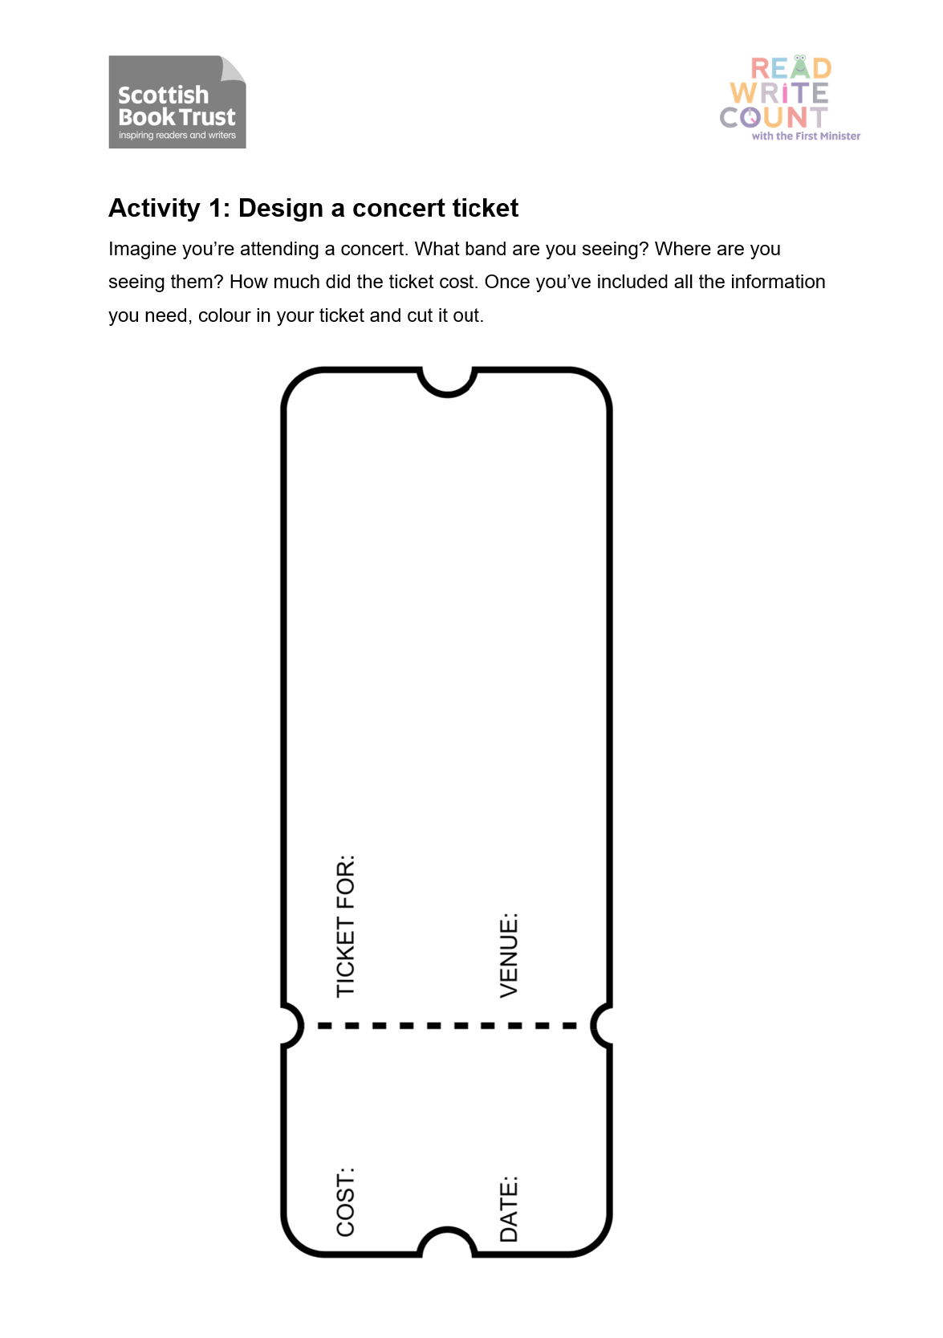

## Printable 3: Design a music studio

In the blank room below, design a new music studio for Badger. Think about which instruments to include. What type of equipment will badger need for rehearsing? Colour/decorate your studio to make it ‘Rock ‘n’ Roll’.

|  |
| --- |
|  |

Printable 4: Pack your own suitcase!  
Imagine you are an astronaut getting ready to go into space. Draw everything you would pack inside your suitcase. What are the five things you would definitely take with you?



|  |
| --- |
| I would take… |
| 1. |
| 2. |
| 3. |
| 4. |
| 5. |



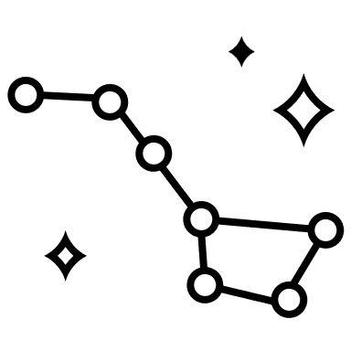

## Printable 5: Space colouring

Colour in these aliens, astronauts, planets and meteors!

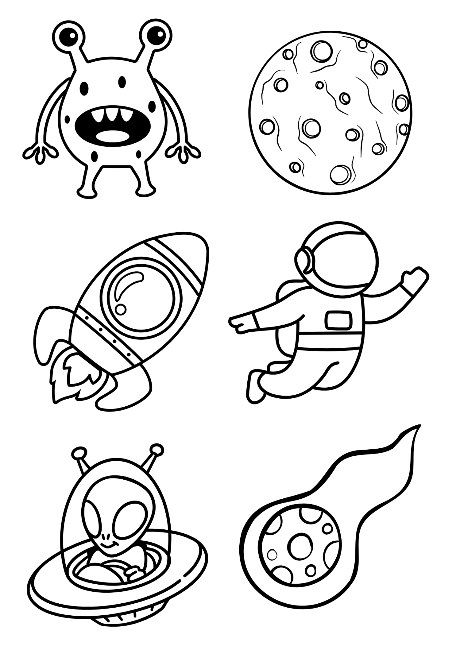

## Printable 6: Design your own rocket

To design your own rocket ship you might like to follow this video example from [Arts and Crafts Kingdom](https://www.youtube.com/watch?v=VOaSdyzrv8g)’s.

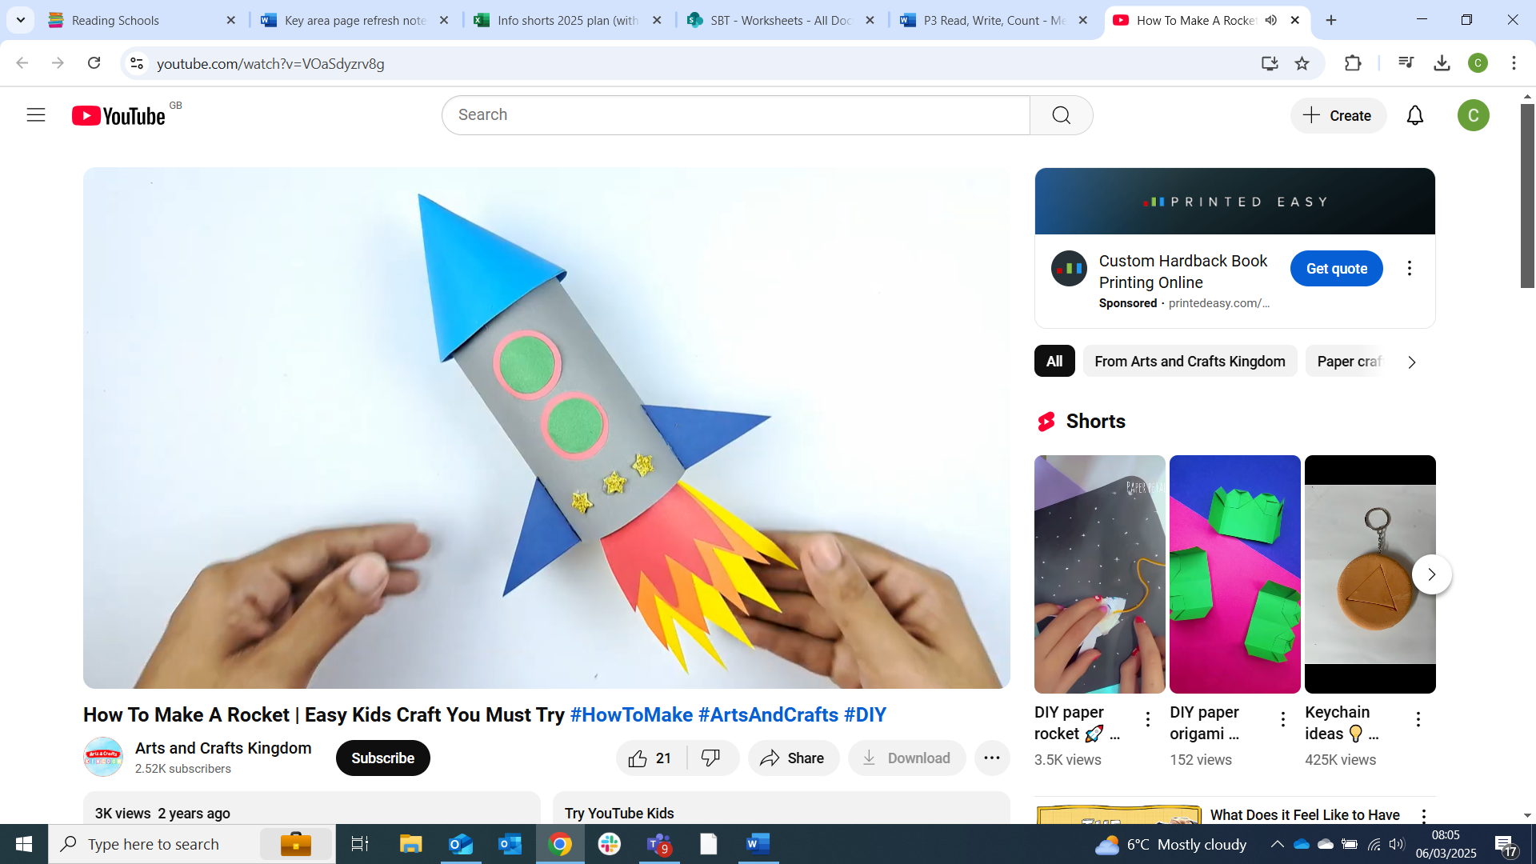

### Materials you’ll need

* Inside tube from kitchen roll
* Paper
* Colouring pencils
* Scissors
* Glue

Once you have seen how to create a rocket you can think about your own design to make it look good.

* What colour would you like it to be?
* What will you decorate it with?
* Which 2D and 3D shapes will be needed to create your rocket?
* Will it have a logo or a name on the side?