

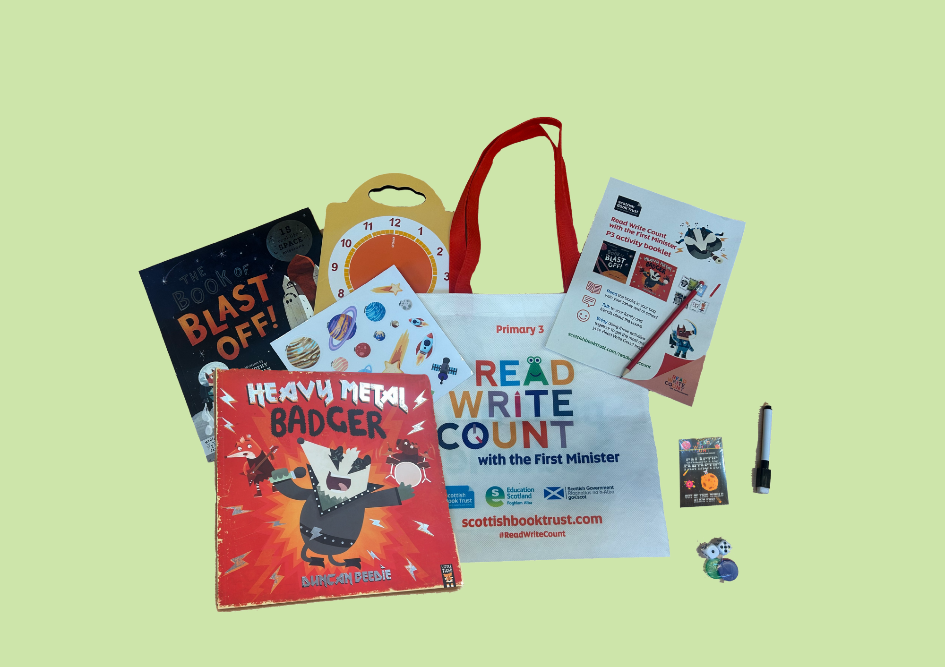

# Read Write Count with the First Minister: P3 teacher pack

Resources to support the Read Write Count P3 bag including guidance on the bags, cross-curricular classroom activities and printable activity sheets

## Resource created by Scottish Book Trust



scottishbooktrust.com



Scottish Book Trust is a registered company (SC184248)

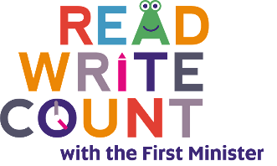and a Scottish charity (SC027669).

## Contents

About this resource 2

Teacher letter 4

Suggested learning activities for *Heavy Metal Badger* by Duncan Beedie 8

Suggested learning activities for *The Book of Blast Off* by Timothy Knapman and Nik Henderson 9

Suggested learning opportunities for P3 cards and board games and dice 10

Activity sheet 1: Design an outfit for Badger! 15

Activity sheet 2: Create a poster for a music concert 16

Activity sheet 3: Create a ticket for a music concert 17

Activity sheet 4: Design a music studio 18

Activity sheet 5: What’s inside your space station? 19

Activity sheet 6: My space suitcase! 20

Activity sheet 7: Create a space mnemonic! 21

Activity sheet 8: Build your own rocket ship! 22

Activity sheet 9: Create your own Galactic Fantastic card 23

Activity sheet 10: Design your own Story Cards 24

Activity sheet 11: Alien beetle drive 25

Activity sheet 12: Create your own puppets 26

Further resources 27

## About this resource

Through [Read Write Count with the First Minister](https://www.scottishbooktrust.com/reading-and-stories/read-write-count), every child in Primary 2 and 3 receives a free bag with books, educational games and writing materials that change on a yearly basis. Read Write Count with the First Minister also provides advice and support for learning professionals and families through training events and online resources.

In this resource, you’ll find the following:

* A teacher letter, which introduces the bags and how you can make the most of them with your pupils and their families
* Cross-curricular classroom activities for each of the books and items in the P3 bags
* Printable activity sheets
* More information on the other Read Write Count resources available

Please feel free to adapt these activities to suit the needs and contexts of the children you work with.  
  
Every year, we create two surveys in order to gather feedback from both [**learning professionals**](https://www.surveymonkey.com/r/9D333DZ)and [**families at home**](https://www.surveymonkey.com/r/9DGDVZV). Please do fill these in, letting us know what you think of the Read Write Count bags and resources, and encourage families at home to do the same. Anyone who fills in either survey will be entered into a prize draw to win a Read Write Count superbox filled with books and numeracy games.

## Teacher letter

This teacher letter has been designed to provide you with an introduction to the programme. Please feel free to email or print this to circulate it with your colleagues.

Read Write Count with the First Minister Bags are coming to your school!  
Write Count with the First Minister bags will be delivered to your school for every Primary 2 and Primary 3 pupil this term. These are fantastic bags filled with books and resources to inspire a lifelong love of reading, writing and counting.  
  
These bags are gifted by Scottish Book Trust through the Scottish Government’s Read Write Count campaign, and give you a great opportunity to build relationships with parents and strengthen links between home and school learning.

Read Write Count gifting

**Step one**: Plan your family event! Watch our webinar on [Gifting the Read Write Count bags](https://www.scottishbooktrust.com/learning-resources/webinar-gifting-primary-1-3-bag) to find out more about how to gift the Read Write Count bags to families without a large event. To book a bespoke online or in-person session, you can also contact: [readwritecount@scottishbooktrust.com](mailto:readwritecount@scottishbooktrust.com)**Step two**: Your school will receive the Primary 2 and Primary 3 Read Write Count bags in September or October. Count them when they arrive and get in touch with [your local Read Write Count contact](https://www.scottishbooktrust.com/reading-and-stories/read-write-count/contacts) if you have any issues with delivery, have too many bags, or need additional bags.  
  
**Step three**: Get stuck into some fun creative learning with our free downloadable [Learning resources](https://www.scottishbooktrust.com/reading-and-stories/read-write-count). There are cross-curricular classroom activities, quick activity sheets, video recordings of the books being read and lots more. You could get older pupils involved by including them in family events!  
  
**Step four:** Give the bags out to your families. If possible, do this during [Book Week -Scotland](https://www.scottishbooktrust.com/book-week-scotland), our national celebration of books and reading (17 - 23 November 2025)! Don’t worry if this date isn’t possible – just be sure to give families tips on how to explore the bags with the children and enjoy all the contents as a family. You can also find lots of great activities and videos for families to enjoy on our [Home Activities Hub](https://www.scottishbooktrust.com/home-activities).

Inside this year’s bags…

This year’s P2 bag contains:

* *Barbara Throws a Wobbler* by Nadia Shireen
* *The Ballad of Cactus Joe* by Lily Murray and Clive McFarland
* Folding binoculars
* A deck of cards with Dominoes, Story Cards and Talk it Out conversation prompts and Act it Out acting prompts
* An activity booklet and pencil

This year’s P3 bags contains:

* *Heavy Metal Badger* by Duncan Beedie
* *The Book of Blast Off* by Timothy Knapman and Nik Henderson
* A tri-fold board game with counters, dice and a dry wipe pen
* A deck of cards with Galactic Fantastic card game, story prompts and mindfulness cards
* An activity booklet and pencil

Our Gaelic packs also include Gaelic copies of both books as well as a translated copy of the Activity Booklet.

How to make the most of your bags  
**Resources**  
We have a full set of learning resources created in collaboration with Education Scotland for each Read Write Count bag which includes: cross-curricular classroom activities linked to Curriculum for Excellence, printable worksheets, video readalongs and much more.  
  
**Webinars**On our website, you can find webinars which introduce the Read Write Count with the First Minister bags and give top tips for making the most of them in your classroom.

* [Webinar: Making the most of the Primary 2 bag](https://www.scottishbooktrust.com/learning-resources/making-the-most-of-the-primary-2-bag)
* [Webinar: Making the most of the Primary 3 bag](https://www.scottishbooktrust.com/learning-resources/making-the-most-of-the-primary-3-bag)
* [Webinar: Gifting the Read Write Count bags](https://www.scottishbooktrust.com/learning-resources/webinar-gifting-primary-1-3-bag)

**CLPL sessions**We’ll be holding online CLPL for learning professionals that offers support with the Read Write Count with the First Minister bags, including how to use them to promote parental engagement. There will also be the opportunity to attend webinars that explore the accompanying resources for Primary 1-3 teachers.   
  
Our current CLPL dates are as follows:

* **Thursday 28 August, 16.30 – 17.30**: [Read Write Count with the First Minister for Public Libraries](https://www.eventbrite.co.uk/e/read-write-count-with-the-first-minister-for-public-libraries-tickets-1408663653909?aff=ebdsoporgprofile&_gl=1*1a5b9ba*_up*MQ..*_ga*MzQxMzg4NDIzLjE3NTUwNzQzNDY.*_ga_TQVES5V6SH*czE3NTUwNzQzNDYkbzEkZzAkdDE3NTUwNzQzNDYkajYwJGwwJGgw)
* **Tuesday 30 September, 16:00 – 17:00**: [Running a Paired Reading Project: Read Write Count with the First Minister](https://www.eventbrite.co.uk/e/running-a-paired-reading-project-read-write-count-with-the-first-minister-tickets-1408671206499?aff=ebdsoporgprofile&_gl=1*dksua0*_up*MQ..*_ga*MzQxMzg4NDIzLjE3NTUwNzQzNDY.*_ga_TQVES5V6SH*czE3NTUwNzQzNDYkbzEkZzAkdDE3NTUwNzQzNDYkajYwJGwwJGgw)

There will be other CLPL sessions throughout the year. Please see [our EventBrite listings](https://www.eventbrite.co.uk/o/scottish-book-trust-10921342975) for the most up-to-date information.

In addition, we offer bespoke training in-person and online. We can link with your authority on sessions, parental engagement workshops or making the most of your bags. To request a session in your school or area, contact: [readwritecount@scottishbooktrust.com](mailto:readwritecount@scottishbooktrust.com)   
  
On our website, you can also find [our full list of CLPL on offer](https://www.scottishbooktrust.com/learning-and-resources/clpl-for-learning-professionals) and details on how to offer.

## Suggested learning activities for *Heavy Metal Badger* by Duncan Beedie

#### Mathematics and numeracy

* Make the entrance into your classroom the entrance into a woodland concert. Choose a band manager to check whether their classmates have enough money to buy a ticket. Remind the ticket-buyers to make sure they’ve been given the right change! You can also find a printable activity sheet to design your own ticket in this teacher pack. **(MNU 1-09a, EXA 1-04a, EXA 1-12a)**
* Listen to a piece of music and try to count the number of different instruments. Ask the pupils questions about which instrument came first, second, third and so on.   
  **(MNU 0-20a/1-20a)**
* Talk about some different types of music. What are your classes’ favourite songs, artists or music genres? How could you gather and display this information? You might like to make a graph or chart. **(MNU 1-20b,   
  MTH 1-21a)**

#### Sciences

* How would you light a stage at a musical performance? Create a diorama of the stage and use simple component to make a series circuit attached to a light. How does the electrical circuit work? See [Virtual Club’s How to Design a Diorama video](https://www.youtube.com/watch?v=-Loj-YoSbfw) (3 minutes, 1 second) for ideas! **(SCN 1-09a)**
* Create your own guitar using a container and elastic bands. Discover how the   
    
  pitch of the sound changes when you use thicker or thinner elastic bands. **(SCN 1-11a, TCH 1-09a)**

#### Technology

* Explore using different technologies like [the Garage Band app](https://apps.apple.com/us/app/garageband/id408709785) to create your own music. Can you make something that you think sounds like Badger’s band? **(TCH 1-01a)**
* Badger wears a very rock ‘n’ roll outfit. Use our printable activity sheet and some textiles or scraps to design your own costumes for his next performance. **(TCH 1-04b)**

#### Literacy and English

* Imagine you’re making a band with your friends, but you need one more person to join. Write a flyer making it clear who you are looking for, what skills they should have, and why they should join your band! **(LIT 1-28a, EXA 1-04a)**
* Can you find the onomatopoeic words in the story – the words that show the sounds Badger is making? Experiment with reading these aloud in different fun ways. Can you make up some of your own? **(LIT 1-14a)**
* Rewrite the story in your own words. What kind of band would your favourite animal join? What instrument would they play? **(LIT 1-26a)**

#### Modern languages

* Can you learn a song or rhyme in the language you’re learning? How would Badger sing them? **(MLAN 1-05a)**

#### Health and wellbeing

* Badger doesn't fit in with some of the bands and groups but finds somewhere he enjoys making music! Discuss how we are all different and have our own strengths. **(HWB 1-47a)**

#### Social studies

* Use [Dig It Scotland’s guide historical musical instruments](https://www.digitscotland.com/unearthing-scotlands-musical-past-through-archaeology/) to learn how people in the past made music! Why did people make these instruments? How have archaeologists preserved them?   
  **(SOC 1-02a, SOC 1-04a)**
* Badger visits lots of different places –a music school, a church, a studio and a music festival. Go for a walk in your local area, then create a map of some of the different shops and services in your local area. **(SOC 1-07a)**

#### Religious and moral education

* Badger goes to a church. Look at what places of worship there are in your local area and why they are important to believers of different religions. What kind of ceremonies do they hold there?   
  **(RME 1-06a)**

#### Art

* Want to be in a band but don’t have any instruments? Why not make your own? You can upcycle paper cups and

cardboards boxes into a drum and a guitar! **(EXA 1-02a)**

* Design an eye-catching poster for Badger’s band’s performance. What colours and materials will you use to make it stand out? What fonts and colours capture the feeling of Badger’s band? Remember to include important information for attendees! **(EXA 1-03a, EXA 1-04a)**
* Use our printable activity sheet to create your own ticket to a music festival. Make sure you include the cost, venue and name of the band! **(EXA 1-04a)**

#### Music

* Badger tries to play with a choir and a brass band, but it doesn’t feel right – Badger loves heavy metal rock! Listen to examples of all three music groups or genres and talk about how they make you feel. Which is your favourite?   
  **(EXA 1-19a)**
* Run an open mic or music performance for parents and families to come along to. You could combine this with your [Read Write Count gifting](https://www.scottishbooktrust.com/learning-resources/primary-1-3-bag-gifting)! **(EXA 1-01a, EXA 1-17a)**

#### Dance

* Write different musical instruments on pieces of paper and take turns pulling them out a bag. Pretend you’re playing that musical instrument to your friends and see how quickly they can guess which one it is! **(EXA 1-12a)**

## Suggested learning activities for *The Book of Blast Off* by Timothy Knapman and Nik Henderson

#### Mathematics and numeracy

* How many digits and number words can you find in the book? Which is the smallest? Which is the largest? Can you put them into order? **(MNU 1-02a)**
* Rock samples are collected from space and investigated by scientists. Imagine you're part of a team of scientists investigating Earth. Go on a walk to collect pieces of rock and other natural materials. Can you think of a way that you could sort the items that you have found? Which item do you think is heaviest? Use scales to see if you were correct. **(MNU 1-11a, MNU 1-20b)**
* Create a database of all the Space missions detailed in the book - include the name of each mission, the dates and the names of crew members.   
  **(MTH 1-20b)**

#### Sciences

* Start your own space journal where you record the different formations of the moon over the course of a month. You could use the bingo square of your fold out board game to draw what the moon looks like every night! How does it change shape? **(SCN 1-06a)**
* Make [a baking soda rocket and experiment](https://www.science-sparks.com/baking-soda-rocket/) to see how far it shoots off the ground! What happens if you change the amount of vinegar or baking soda? **(SCN 1-07a)**

#### Technology

* Explore [the amazing photos that have been taken by the Hubble telescope](https://esahubble.org/images/). Which one is your favourite? Can you find photos showing the Hubble being built? **(TCH 1-01a)**
* Find out all you can about space junk using [BBC Teach’s guide to space exploration](https://www.bbc.co.uk/teach/class-clips-video/articles/zgvdh4j). Imagine it floating all around us in space! Talk about the importance of recycling in space and on Earth and make a recycled artwork showing our solar system. **(TCH 1-07a)**

#### Literacy and English

* Use our printable activity sheet to create your own funny mnemonic to remember the order of the planets in our solar system. **(LIT 1-05a)**
* Choose an astronaut from the story and talk about some interview questions that you would ask them.  
  **(LIT 1-07a)**
* Choose your favourite astronaut from the book and imagine you’re them and it’s your first day in space. Write a diary entry describing how you feel and what you can see. **(LIT 1-26a)**

#### Modern languages

* 3, 2, 1 blast off! Practice counting down from ten in the language you’re learning. **(MLAN 1-08b)**

#### Health and wellbeing

* Use the [BBC Bitesize Ask an astronaut resource](https://www.bbc.co.uk/bitesize/topics/zjmqkmn/articles/z822hv4) to learn from Tim Peake about what it’s like being an astronaut! Discuss some of the other jobs there are in space. Would you like to go to space?   
  **(HWB 1-20a)**
* Astronauts have to be really fit so they can do space walks. Try out some NASA astronaut training exercises on [NASA STEM’s YouTube channel](https://www.youtube.com/playlist?list=PLTUZypZ67cdsQCpAUbfsRN1f01y7tpBk1)!   
  **(HWB 1-22a)**

#### Social studies

* Choose one of the space missions in the book and write a newspaper article which reports on what happened.   
  **(LIT 1-26a, SOC 1-03a)**
* One of the space probes in the book is named after Galileo Galilei, a 16th century astronomer. Use [the Britanica Kids guide](https://kids.britannica.com/kids/article/Galileo/351402) to learn about Galileo’s life and his impact on scientific discovery today. **(SOC 1-06a)**
* Space missions such as Apollo 11 relied on the work of “human computers” such as [Katherine Johnson](https://kids.britannica.com/kids/article/Katherine-Johnson/628677), [Dorothy Vaughan](https://kids.britannica.com/kids/article/Dorothy-Vaughan/628679) and [Mary Jackson](https://kids.britannica.com/kids/article/Mary-Jackson/628686) who received little recognition due to their gender and race. Use the [Kids National Geographic guide](https://education.nationalgeographic.org/resource/women-nasa/) to prepare a talk on the importance these women and their discoveries. **(SOC 1-01a, SOC 1-06a, TCH 1-01a, LIT 1-10a)**

#### Art

* Look at some of the suits the astronauts wear in the book. Design your own dream spacesuit. Make sure you label all the different parts! **(EXA 1-02a,   
  EXA 1-04a)**
* All the planets in our solar system look different. Can you use playdough to create their distinctive patterns and colours, or you could try painting salt dough spheres. Research which planets should be the biggest! **(EXA 1-04a)**

#### Music

* Lots of films are set in space. Listen to some famous soundtracks, close your eyes, and imagine you're shooting upwards towards the stars! How do they make you feel? **(EXA 1-19a)**

### **Drama**

* Pretend you are newsreaders presenting one of the stories in the book on the news. Can you film your own news story? What key facts do you need to include? **(EXA 1-13a)**

### **Dance**

* What do you think it would feel like to move in space? Make a dance showing how a daily routine (like brushing your teeth or getting dressed) might look like when you’re floating inside a space station. **(EXA 1-09a)**

## Suggested learning opportunities for P3 cards and board games and dice

#### 

#### Galactic Fantastic cards Mathematics and numeracy

* How a game of Galactic Fantastic in pairs or a small group. See inside the pack for the instructions or [watch the video on our website](https://www.scottishbooktrust.com/learning-resources/p3-how-to-use-your-deck-of-cards)! **(MNU 1-02a)**
* Come up with your own game to play with the Galactic Fantastic cards.   
  **(MNU 1-02a)**
* Use our printable activity sheet to make your own card for the Galactic Fantastic pack by creating an alien and its length, mass, lifespan, and a special skill. What planet does it live on? What makes it unique? **(MNU 1-02a)**
* Pick a card at random. Now, use chalk to mark on the ground how long you think that length is. Use a tape measure to check how close you were!   
  **(MTH 1-11a, MNU 1-11b)**
* Play Guess Who with a partner using two sets of cards. Each of you choose an alien and the other person asks yes or no questions like “Do they weigh more than 5kg?”. Whoever guesses correctly first is the winner! **(MNU 1-15a)**
* Have everyone in the class pick a Galactic Fantastic card. Now, ask them to line up in order of length from longest to shortest. The only catch is – you can’t show anyone your card! Figure out where you need to be by asking your classmates “less than” or “greater than” or “equal to” questions to try and identify the correct order of the sequence.   
  **(MTH 1-15a)**

#### Sciences

* The Galactic Fantastic aliens live on all kinds of different planets! Look up the planets in our solar system, as well as the sun and the moon. Create a poster about their patterns and movements. **(SCN 1-06a)**
* Choose one of the planets and read its descriptions. Write down what you think you think it would smell, taste, and sound like if you were there.   
  **(SCN 1-12b)**
* Use [the NASA website](https://www.nasa.gov/learning-resources/nasa-kids-club/) to learn about the most up-to-date news in space! Create a newspaper article reporting on a news story about recent scientific discovery. **(SCN 1-20a)**

#### Technology

* Choose one of the planets in our solar system and research it using a computer or device. What does it look like? How far away is it from Earth? **(TCH 1-01a)**

#### Literacy and English

* Choose an alien that you think should have a higher special skill score. Have a debate and try to persuade your classmates around to your way of thinking. You could share your opinion of why it should be higher, answer questions and share your ideas to win them over. **(LIT 1-09a)**
* Choose a random object from your classroom (e.g., a pencil) and design an alien that is the same length and mass – you can use a measuring tape to help you! Now, create a new Galactic Fantastic card for your creature, deciding on a name, lifespan, and its special skill. **(LIT 1-28a, MNU 1-11a)**

#### Health and wellbeing

* All the cards show the aliens’ special skills. Have a think about what your special skill is. Is there something you’re good at – whether a hobby, interest or being kind to other people?   
  **(HWB 1-05a)**

#### Art

* Pick one of the aliens and draw your own version of them to create your own fact file. You can use the information on the card as well as using other sources to create more information or fun facts about them! **(EXA 1-04a, LIT 1-06a)**
* Choose one of the planets and draw your own version of it. What shops, landmarks or places to visit would it have? **(EXA 1-03a)**

#### Drama

* Working in small groups, ask the children to each choose an alien from the cards. Take it in turns to act out the alien’s special skill whilst the rest of the group guess the alien. **(EXA 1-12a)**

**Story cards**

**Mathematics and numeracy**

* Choose one of the settings from the story cards and design a map of this on a grid template. Ask your classmates to describe or find different parts of your map using the coordinates. **(MTH 1-18a)**

**Sciences**

* Using the cards create a scenario – e.g., a knight needs to deliver a special potion to the bear, but the potion needs to be kept cold. Investigate what materials or properties you’d need to solve your problem. **(SCN 1-15a)**

**Technology**

* Use [Book Creator](https://bookcreator.com), [Storyboard That](https://www.storyboardthat.com/) or a similar app to make a digital version of a story you have written, including adding pictures. **(TCH 1-01a)**
* Use digital software to find sound effects or music that matches the genre of one of the setting cards. **(TCH 1-01a,   
  TCH 1-02a)**

#### Literacy and English

* Read a story to the class and ask them to guess what genre it is as they listen. What clues did they pick up on? What genre do you think *Heavy Metal Badger* or *The Book of Blast Off* is? **(LIT 1-04a)**
* Choose the haunted house or ghost card, then work in a pair to make up a short story to tell. Think about how you can use pace, gestures, expressions, emphasis on certain words and word choice to make it sound mysterious or scary! Swap your stories with another pair. **(ENG 1-03a)**
* Sort the cards into different genres together as a class by asking questions like “What kind of book would an astronaut be in?” Ask the pupils what their favourite genre to read is. Make a poster about it, featuring their favourite stories in the genre and what they like about it. **(LIT 1-04a, LIT 1-11a)**
* Choose two or three of the story cards and see if you can think of a super sentence involving the pictures and words on the card, as well as using some adjectives to describe them.   
  **(LIT 1-06a)**
* Select three story cards then work in groups to create a story around the object, setting and character. Share all the stories with the class. What do they have in common? How are they different? Discuss how everyone has a different imagination and will create different stories! **(LIT 1-20a)**
* In groups, create a six-picture storyboard. Draw the images in the squares then write short captions underneath to explain what is happening. **(LIT 1-26a)**

#### Health and wellbeing

* Choose two character cards and write a story about how they became friends, thinking about what qualities are helpful for making friends! **(HWB 1-44a)**

#### Social studies

* As a group, pick a period of history that could be an interesting setting for a story. Learn about it as a class using historical evidence, then practise describing or writing about it so you're ready to use it in stories. **(SOC 1-04a)**

#### Art

* Use our printable activity sheet to design your own character, setting or object card based on a favourite animal or story. **(EXA 1-03a)**

#### Drama

* Use the cards to inspire a piece of role play. Give everyone a character by asking them to draw a card, then draw another card for setting, and lastly an item card is something they have to work together to find!   
  **(EXA 1-12a)**

#### Music

* What would the soundtrack be for different genres? Pull a card and experiment with different music technologies or instruments!   
  **(EXA 1-17a)**

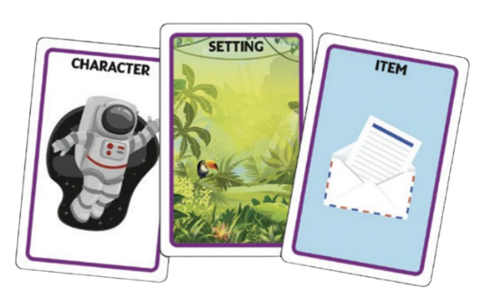

### **Search and See cards**

**Mathematics and numeracy**

* Pick one of the words on the card. How many things around you fit the description? How could you keep track of how many things you find? You might like to use tally marks or a table.   
  **(MNU 1-20b)**

**Sciences**

* Look at the words on the cards together as a class. Ask which sense you would need to find out if something fit each word? For example: can you see something is bumpy or do you need to touch it? Is it always easy to know if something is heavy just by looking at it?   
  **(SCN 1-12b)**

#### Literacy and English

* Look through *Heavy Metal Badger* or *The Book of Blast Off*. Try and find things that fit the word on the cards, for example: something big, something small, something loud, something quiet and so on. **(LIT 1-07a, LIT 1-14a)**
* In pairs, take it in turns picking an object that the other person has to guess. Use the words on the card to describe it: is it big or small? Flat or bumpy? Heavy or light? **(LIT 1-07a)**
* Create your own comic book strip using some of the words like Ooh! Eek! Yuck! Wow! You could look at examples of sound effects in comic books in your classroom or online. **(LIT 1-20a,   
  LIT 1-26a)**
* Pull a random Search and See card and choose one of the words. Write down some things that word could describe - for example, cold could describe ice cream, snow, winter or a fridge!   
  **(LIT 1-21a)**

#### Social studies

* Go for a walk in your local area, taking your cards with you. Use your cards as a scavenger hunt and see what you can find for each word! **(SOC 1-14a)**

### 

### **Mindfulness and yoga cards**

#### Health and wellbeing

* Read how to use the mindfulness breathing shape cards together. Discuss with your class why taking notice of your breathing helps you calm down and regulate your feelings. **(HWB 1-02a,   
  HWB 1-15a)**
* Create your own calm cards to add to your deck. Cutting out some pieces of paper that are the same size as the other cards and write some of your favourite things or people that make you feel happy, relaxed or calm on them. You can share these with the other people in your class or use this card for suggestions of things you can do, or people you can talk to, when you feel stressed or upset. **(HWB 1-06a,**   
  **LIT 1-24a)**
* Try some of the yoga pose cards. Can you create a sequence where you move between different poses?  
  **(HWB 1-21a)**

#### Religious and moral education

* Yoga is a form of prayer and meditation which helps Hindu connect with their Gods. Learn more about other Hindu beliefs and practices by watching this [BBC video](https://www.bbc.co.uk/bitesize/guides/z793rwx/video) following Vandana, a young Hindu living in London (7 minutes, 11 seconds). **(RME 1-04b, RME 1-06a)**
* Use the [Britannica Kids guide](https://kids.britannica.com/kids/article/yoga/390264) to learn about the history of yoga and Hinduism. Why do Hindus practice yoga? How does it tie into their beliefs?   
  **(RME 1-06a)**

#### Music

* Listen to some calm or relaxing music as you try different yoga poses. How does the music make you feel? How does it change the poses or moving between them? You could extend this activity by learning more about some of the musical instruments and styles from India, where Hinduism originates from. **(EXA 1-19a)**

#### Dance

* Create a dance that incorporates some of the different yoga poses.   
  **(EXA 1-08a, EXA 1-09a)**

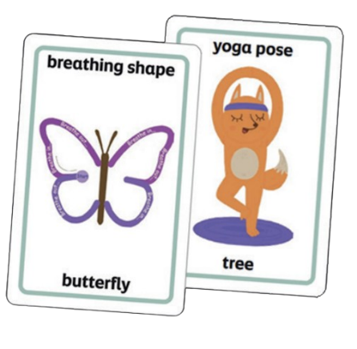

### **Board game: Meteors and rockets**

**Mathematics and numeracy**

* Have a go at playing the game. It is similar to Snakes and Ladders, but you travel up a rocket and down a meteor– each player starts at zero (earth) and the first one to reach 99 (the moon) wins. **(MNU 1-02a)**

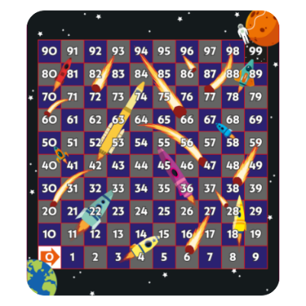

### **Board game: Dotted grid**

**Mathematics and numeracy**

* Estimate how many squares you could draw on your dot board, then have a go at drawing them and see how accurate you were. What happens if you increase the size of the squares? **(MNU 1-01a)**
* Practise drawing different shapes on your dot board then use them to create a tiling pattern. Can you name the shapes and their properties?   
  **(MTH 1-16b)**
* Draw a shape on your dot board and see if you can spot any lines of symmetry. Use a ruler to draw them in and count how many you find.   
  **(MTH 1-19a)**
* Draw a maze and challenge a classmate to find their way through it and ask them to describe their journey as they go. You could include some dead ends to make it harder! **(MTH 1-17a)**

#### Art

* Draw a rocket by joining up different dots using a ruler or straight edge. Does your rocket have a heat shield?   
  **(EXA 1-05a)**
* Use the board to draw a floor plan of a music studio for the *Heavy Metal Badger*, marking out spaces for different instruments. **(EXA 1-06a)**

### **Board game: Clock face**

**Mathematics and numeracy**

* In pairs, write a time on the clock (either on the hour or half past) and keep it hidden. Take it in turns to guess what the time is by giving hints such as “it’s after lunch but before we finish school”. **(MNU 1-10c, MTH 1-15a)**
* The opening of *The Book of Blast Off* is at night, where it’s totally dark. Keep a record of what time is gets dark where you live. Compare this across different seasons. **(MNU 1-10c, SCN 1-06a)**

#### Health and wellbeing

* Use the clock to talk about everyday routines, for example, what time you might brush your teeth. **(HWB 1-33a,**   
  **HWB 1-15a)**

#### Social studies

* Use digital technology to research a clock from history. It could be a clocktower in your local area, the[Millenium clock tower in the National Museum of Scotland](https://sharmanka.com/millennium-clock-tower/) or the [Balmoral clock tower that is never on time](https://www.bbc.co.uk/travel/article/20180913-scotlands-clock-thats-almost-never-on-time). Why are these clocks important?   
  **(SOC 1-02a, MTH 1-12a)**
* Show the children in your class some of [different ways we have kept time in the past](https://www.bbc.co.uk/programmes/articles/2Jzg3WT8LJMLFJGYKSzWXzp/nine-quick-facts-about-the-history-of-timekeeping) – from the human alarm clocks who used to wake people up to sundials! Ask them to discuss how the clocks we have today compare to the ways we kept time in the past. **(SOC 1-04a)**

### **Board game: Bingo square**

**Mathematics and numeracy**

* Use your stickers, or make tokens, to play a game of Connect Four or Noughts and Crosses. **(MNU 0-02a, MTH 0-13a)**
* Use the [University of Cambridge’s video](https://nrich.maths.org/games/dotty-six-two) (29 seconds) to learn how to play a game of Dotty Six with your bingo square and dice. **(MNU 1-03a)**
* Play bingo using number relationships. Ask the pupils to pick numbers from an example list. Then call numbers out by their relationships. For example: “cross out any numbers that are less than four” or “cross out any numbers that are greater than twenty”. First to get a full house wins! **(MTH 1-15a)**

**Sciences**

* Play animal bingo! Ask the pupils to pick sixteen animals from an example list. Then, call out the animals by what group they are in. For example: “cross out any animals that can fly” or “cross out any animals that live in the jungle”. First to get a full house wins! **(SCN 1-01a)**
* Use each square to draw the shape of the moon each night. How does it change over time? **(SCN 1-06a)**

#### Modern languages

* Play a game of bingo in the language you are learning. Call out the numbers, or phrases, in the language you’re learning and have pupils cross them out as they hear them. **(MLAN 1-01c)**

#### Art

* Create your own art gallery by treating each square as a different frame hanging on a wall. Draw a picture in each square! **(EXA 1-03a)**
* In each square, draw an item you’d like to take with you into space!  
  **(EXA 1-04a, EXA 1-05a)**

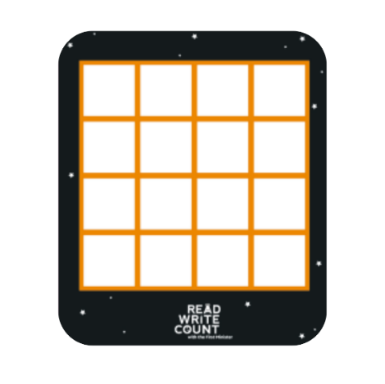

### **Board game: Outer space scenes and stickers**

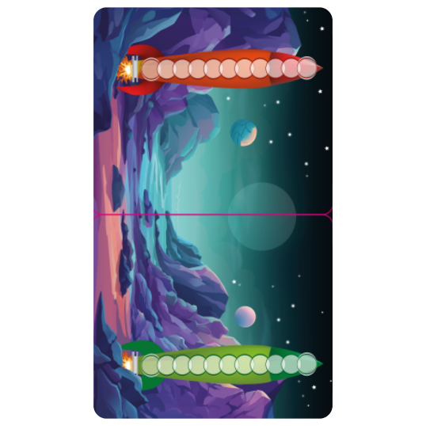**Mathematics and numeracy**

* In pairs, play a counting game with the rockets. Take it in turns rolling the dice and move your counter up that number of spaces. If you roll over the number you need to reach the final circle, you have to move back down the rocket. The goal is to land exactly on the top circle on the rocket! **(MNU 0-03a/1-03a)**

**Technology**

* Use digital technology to research your planet stickers. What order do they go in? **(TCH 1-01a)**

**Literacy and English**

* Choose the Galactic Fantastic aliens that you think would live on the planet in the space scene. Have a debate and try to persuade your classmates around to your way of thinking. You could share your opinion of why you think they would like to live there, answer questions and share your ideas to win them over.   
  **(LIT 1-09a)**

**Art**

* Draw a different face in each window of the rocket! **(EXA 1-03a)**
* Use our colouring in sheet to create your own puppets and use your space scene as the backdrop for a play. You could also use our resource to [create a stop motion animation](https://www.scottishbooktrust.com/learning-resources/create-your-own-stop-motion-animation)! **(EXA 1-02a,   
  EXA 1-06a)**

### **Board game: Dice and counters**

**Mathematics and numeracy**

* Find all of the totals that can be made by adding the numbers on two dice.   
  **(MNU 1-02a, MNU 1-03a)**
* Choose a target number between 5 and 20. See how many times you need to throw the dice to reach your target number, adding the numbers on as you go. **(MNU 1-03a)**
* Play in pairs. The aim is to be the first to reach 100. The first player rolls all 3 dice and adds up the numbers and then continues to roll until they roll a 6 which ends their turn and passes play to the other player. **(MNU 1-03a)**
* Roll the dice. Imagine that the number that you roll is how many pounds you have. What could you buy? Would you get any change? **(MNU 1-09a)**
* Roll a dice. Imagine that the number that you roll is a time (either AM or PM). How many hours is that away? What would you normally do at that time?   
  **(MNU 1-10a)**
* With a friend, roll the dice then race each other to find that number in *The Book of Blast Off!* Who is quickest? You could use a stopwatch to time yourselves! **(MNU 1-10c)**
* Take it in turns to roll the dice. Use tally marks to record how often you roll each number. **(MNU 1-20b)**

**Literacy and English**

* Make up your own game using the dice and write down the instructions so you can play it at home. **(LIT 1-28a,   
  LIT 1-29a)**

**Modern languages**

* Learn to count to 10 in another language. Use your dice as prompts to shout out the numbers as a class and gain confidence when the numbers are out of sequence. **(MLAN 1-05b)**

**Health and wellbeing**

* Working in teams, agree an action for each number e.g., jump, hop, step forward, star jump. Use the dice to make a sequence and practise linking the steps together. **(HWB 1-21a)**

**Social studies**

* Investigate the history of dice – what country do they come from? How were they used? Compare old dice to yours. How are they different? What is the same? **(SOC 1-04a)**

**Art**

* Use your dice to play a game of [Beetle](https://cdn.buglife.org.uk/2019/12/Beetle-drive-game-rules.pdf)drive. See our activity sheet for full instructions. Each dice roll decides what part of the beetle you get to draw. First to complete their beetle drawing wins! **(EXA 1-04a)**

## Activity sheet 1: Design an outfit for Badger!

Badger needs some great clothes for his heavy metal show. Design a brilliant outfit for him by gluing on some scraps of coloured paper, fabric, stickers, card, sticky gems or anything else you can find.

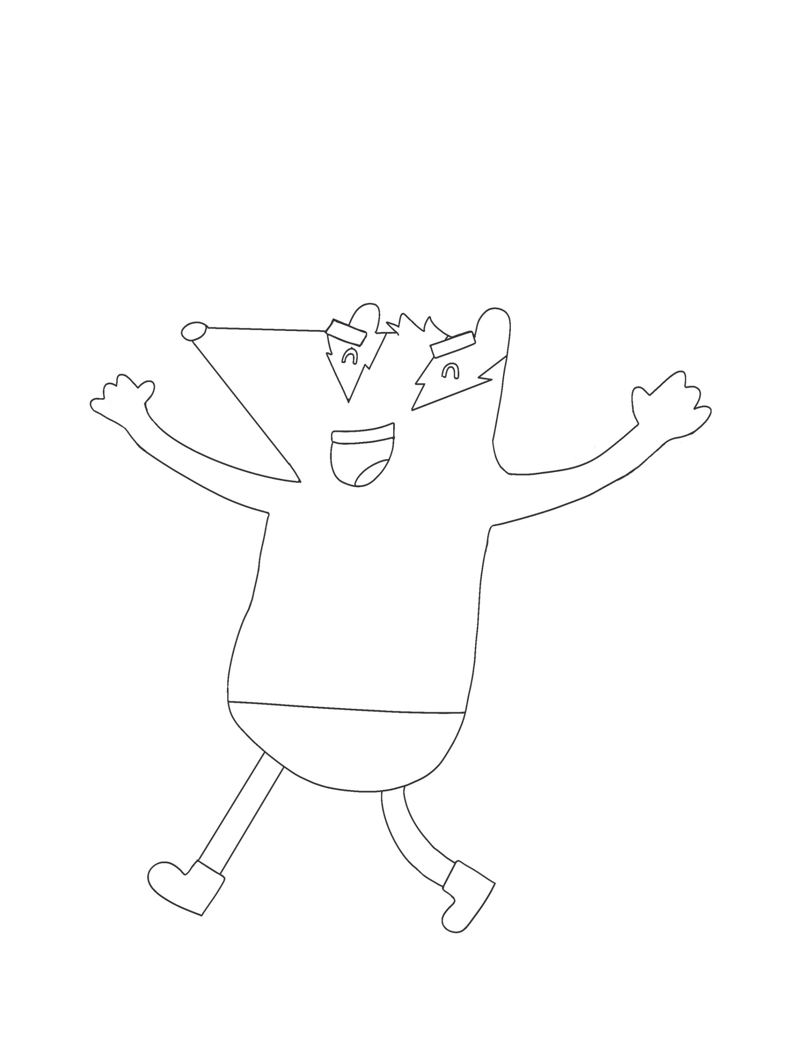

## Activity sheet 2: Create a poster for a music concert

Use the space below to draw a poster for a music concert. What information should your poster include so people can come to your concert?

|  |
| --- |
|  |

## Activity sheet 3: Create a ticket for a music concert

Imagine you’re attending a concert. What band are you seeing? Where are you seeing them? How much did the ticket cost? Once you’ve included all the information you need, colour in your ticket and cut it out.

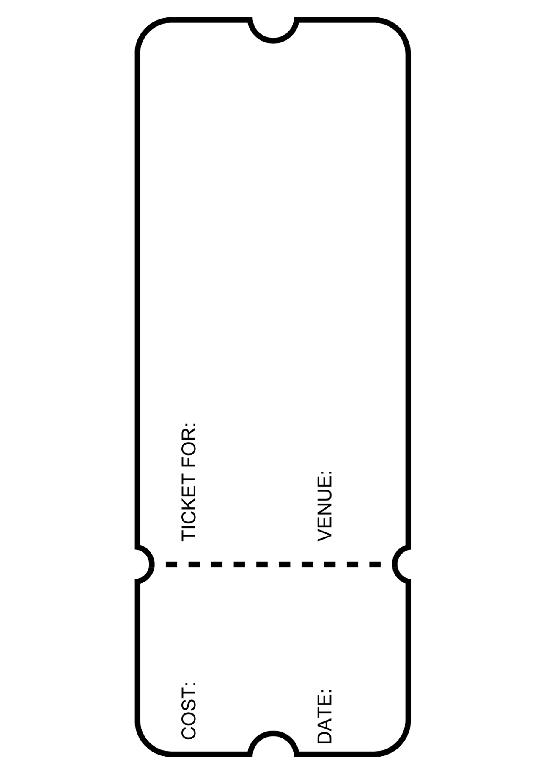

## Activity sheet 4: Design a music studio

In the blank room below, design a new music studio for Badger. Think about which instruments to include. What type of equipment will badger need for rehearsing? Colour/decorate your studio to make it ‘Rock ‘n’ Roll’.

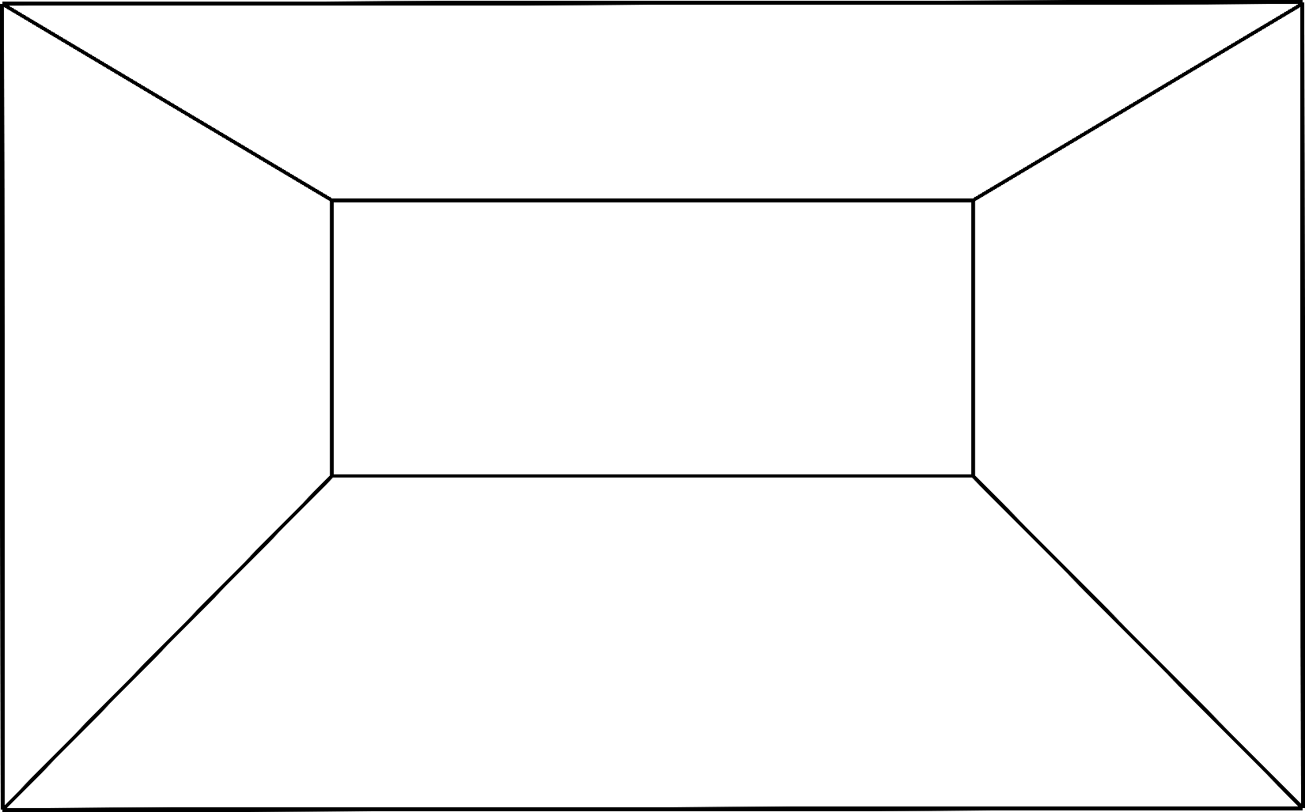

## Printable activity sheet 5: an outline of a satelitteActivity sheet 5: What’s inside your space station?

This space station is all yours. What do you want to do with it?

Add people, equipment and experiments into the different rooms, and label them so everyone knows what is happening.

Activity sheet 6: My space suitcase!Imagine you are an astronaut getting ready to go into space. Draw everything you would pack inside your suitcase. What are the five things you would definitely take with you?

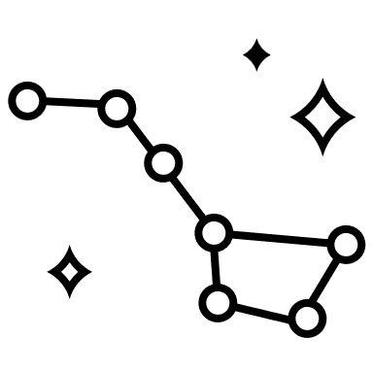

|  |
| --- |
| I would take… |
| 1. |
| 2. |
| 3. |
| 4. |
| 5. |



## Activity sheet 7: Create a space mnemonic!

A “mnemonic” is a series of words that helps you remember something. To remember the order of the planets, come up with a word that starts with each letter.

|  |  |  |
| --- | --- | --- |
| **M**  (Mercury) | My | Word that begins with “M”: |
| **V**  (Venus) | Violet | Word that begins with “V”: |
| **E** (Earth) | Emu | Word that begins with “E”: |
| **M** (Mars) | Munched | Word that begins with “M”: |
| **J** (Jupiter) | Jam | Word that begins with “J”: |
| **S** (Saturn) | Sandwiches | Word that begins with “S”: |
| **U** (Uranus) | Until | Word that begins with “U”: |
| **N** (Neptune) | Nightfall | Word that begins with “N”: |

## Activity sheet 8: Build your own rocket ship!

To design your own rocket ship you might like to follow this video example from [Arts and Crafts Kingdom](https://www.youtube.com/watch?v=VOaSdyzrv8g)’s.

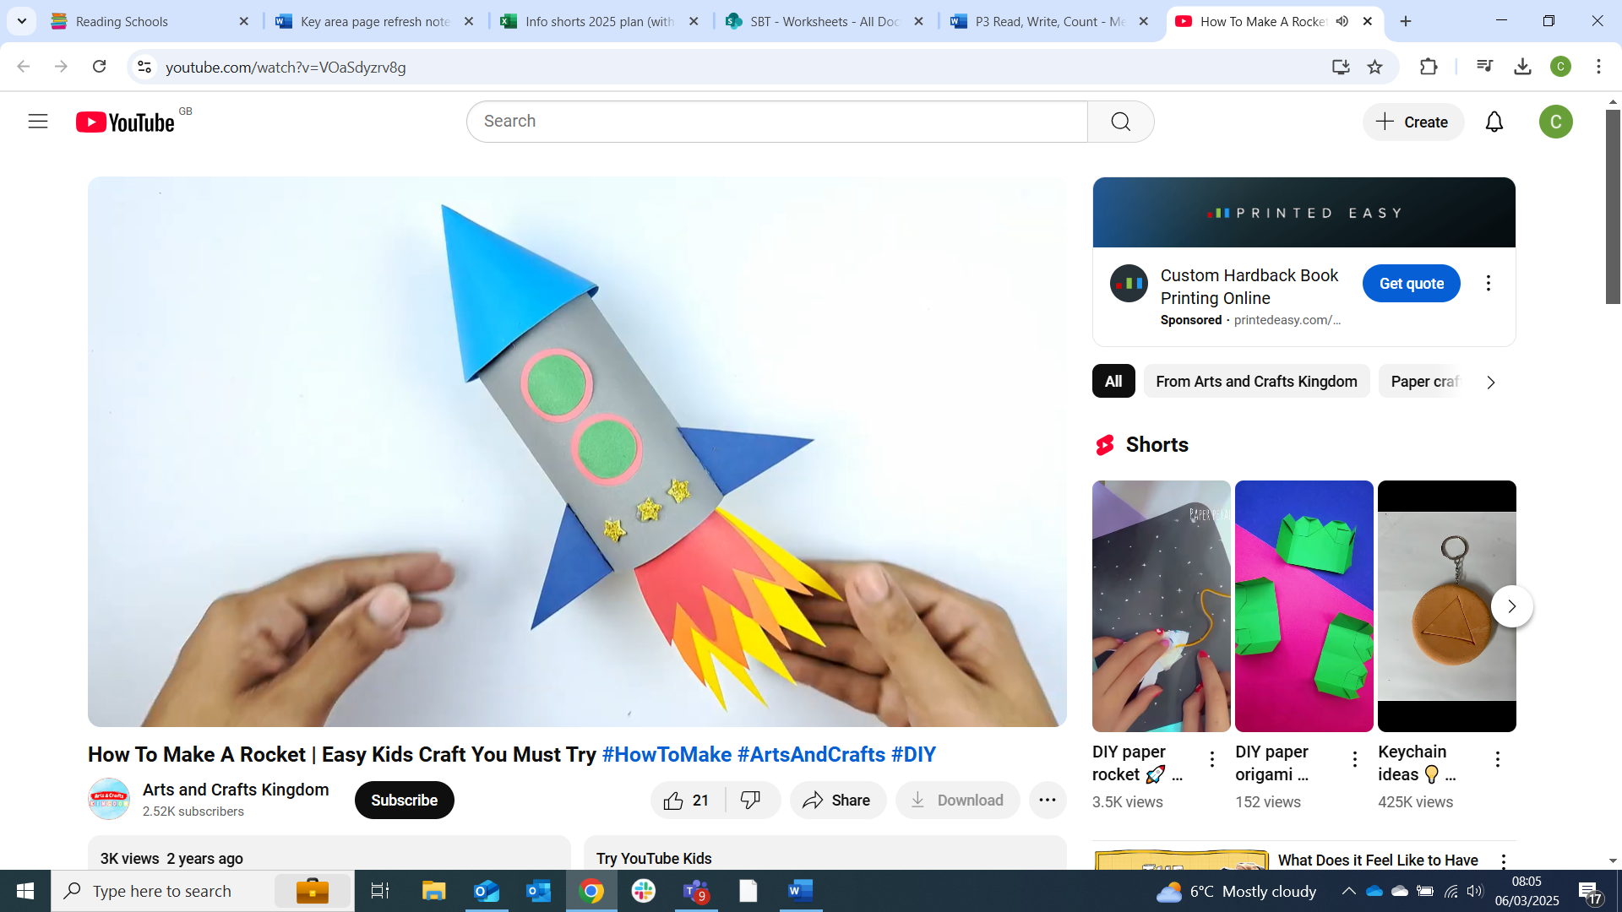

### Materials you’ll need

* Inside tube from kitchen roll
* Paper
* Colouring pencils
* Scissors
* Glue

Once you have seen how to create a rocket you can think about your own design to make it look good.

* What colour would you like it to be?
* What will you decorate it with?
* Which 2D and 3D shapes will be needed to create your rocket?
* Will it have a logo or a name on the side?

## Activity sheet 9: Create your own Galactic Fantastic card

Use the template below to design your own alien inspired by your Galactic Fantastic cards!

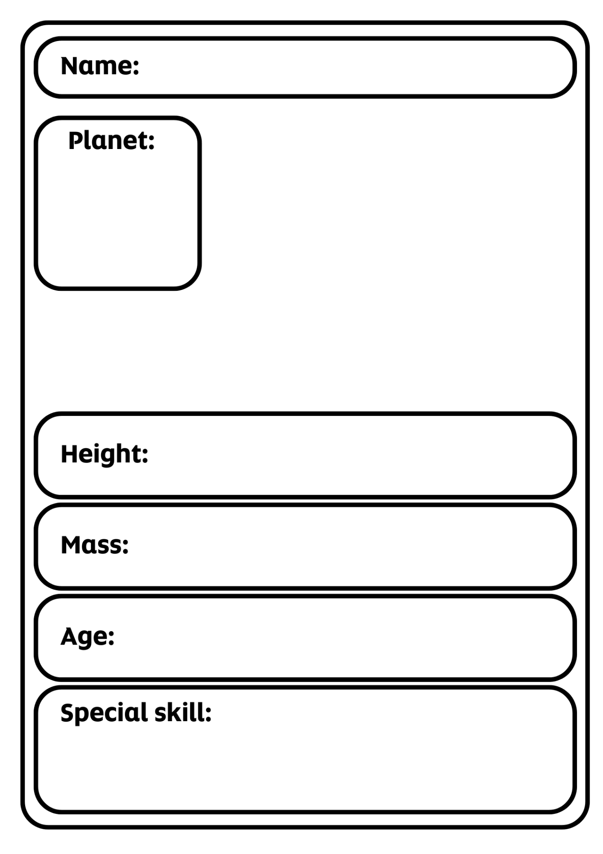

## Activity sheet 10: Design your own Story Cards

Use the templates below to create your own Story Cards. What character, object or setting would you like to hear a story about?

## Printable activity sheet 10: blank story cards for pupils to fill in

## Activity sheet 11: Alien beetle drive

Have some fun creating your own alien by rolling the dice and adding different parts to your alien using the numbers you roll.

This game can be played with two or more players, and before you begin you will need:

* 1 x dice
* Paper (for each player)
* Pencils (for each player)

All players take it in turns to roll the dice and the first person to finish their alien wins.   
  
All players must first roll a 6 to draw the body and start their alien. You must have a body before you can begin. Once you have rolled a 6 and drawn your alien body you can start to add other parts.   
  
You must also have a head before you can add any eyes and a mouth.

1. Roll a one to add a mouth (1 mouth)
2. Roll a two to add an arm (2 arms)
3. Roll a three to add an eye (3 eyes)
4. Roll a four to add a leg (4 legs)
5. Roll a five to add a head (1 head)
6. Roll a six to create a body (1 body)

The winner is the first player to complete an alien with all the required parts. When finished, why not colour in your alien and add some extra details.

## Activity sheet 12: Create your own puppets

Colour in then cut out the characters below. Stick them to straws or sticks to make your own puppets. You can then use the space scene on your fold out board game as a backdrop to create your own play!

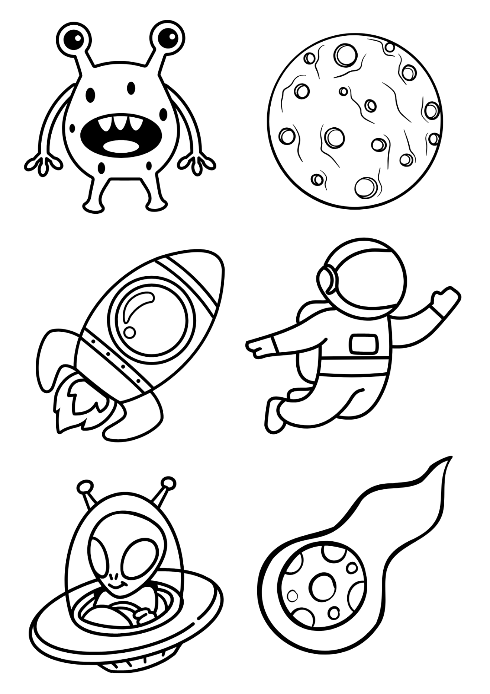

## Further resources

Help and support  
To find out more about Read Write Count, visit our [About Read Write Count webpage](https://www.scottishbooktrust.com/reading-and-stories/about-read-write-count), our find your local contact with our information on [How to get Read Write Count bags](https://www.scottishbooktrust.com/reading-and-stories/read-write-count/contacts)

Teacher resources  
Find further teacher resources on the [Read Write Count section of the Scottish Book Trust website](https://www.scottishbooktrust.com/reading-and-stories/read-write-count), including:

* [Our P2 bag teacher pack](https://www.scottishbooktrust.com/learning-resources/read-write-count-for-p2)
* Our webinars on [Making the most of the P2 bag](https://www.scottishbooktrust.com/learning-resources/making-the-most-of-the-primary-2-bag) and [Making the most of the P3 bag](https://www.scottishbooktrust.com/learning-resources/making-the-most-of-the-primary-3-bag)

Further resources will be added later, including inclusive resources designed for children with additional support needs. Keep checking back on the [Read Write Count section of our website](https://www.scottishbooktrust.com/reading-and-stories/read-write-count) to see when these are available!

### Family resources

* Our [Home Activities Hub](https://www.scottishbooktrust.com/home-activities) contains resources, activities and top tips for families at home
* Our [Read Write Count Home Challenges](https://www.scottishbooktrust.com/articles/read-write-count-at-home) are fun activities designed to help them further explore the bag