

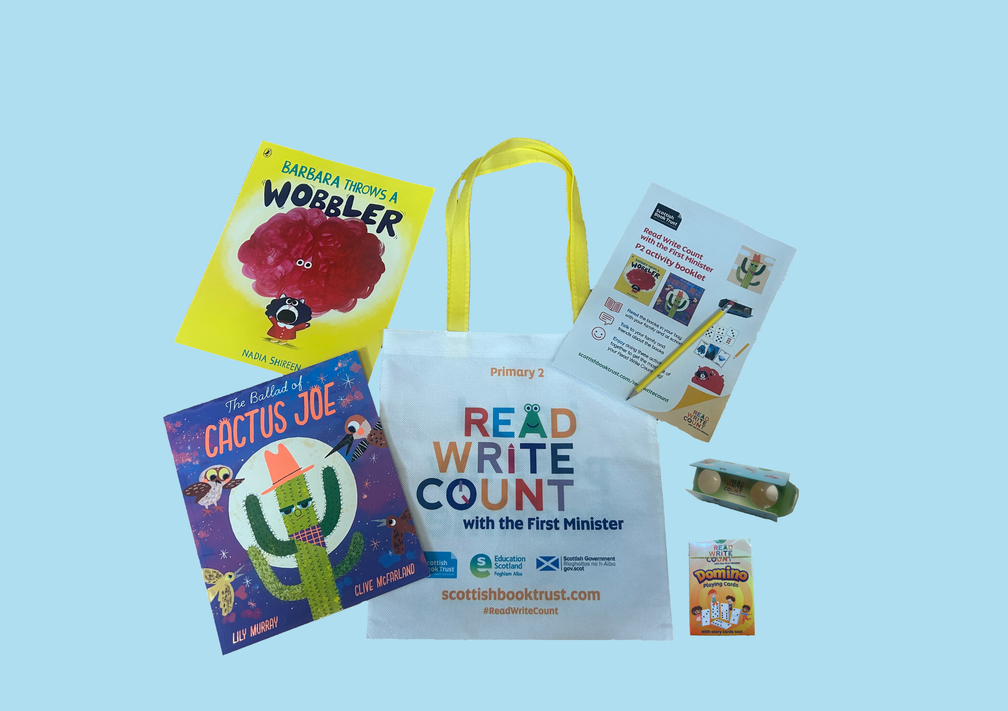

# Read Write Count with the First Minister: P2 teacher pack

Resources to support the Read Write Count P2 bag including guidance on the bags, cross-curricular classroom activities and printable activity sheets

## Resource created by Scottish Book Trust

## Decorative image

scottishbooktrust.com

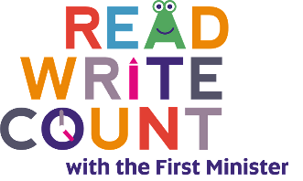

Scottish Book Trust is a registered company (SC184248)

and a Scottish charity (SC027669).

## Contents

About this resource 2

Teacher letter 4

Suggested learning opportunities for *Barbara Throws a Wobbler* by Nadia Shireen 8

Suggested learning opportunities for *The Ballad of Cactus Joe* by Lily Murray and Clive McFarland 9

Suggested learning opportunities for P2 cards and binoculars 10

Activity sheet 1: Measure record sheet 14

Activity sheet 2: Design your own wobbler! 15

Activity sheet 3: Design your own mood! 16

Activity sheet 4: Collage this cactus 17

Activity sheet 5: How to make a new hat for Cactus Joe 18

Activity sheet 6: What makes a good friend? 20

Activity sheet 7: Design your own Story Cards 21

Activity sheet 8: Binoculars record sheet 22

Activity sheet 9: Birds to watch 23

Activity sheet 10: Binocular bingo (blank template) 24

Activity sheet 11: Binocular bingo (filled template) 25

Activity sheet 12: Binocular bingo (fill in the gaps) 26

Further resources 27

## About this resource

Through [Read Write Count with the First Minister](https://www.scottishbooktrust.com/reading-and-stories/read-write-count), every child in Primary 2 and 3 receives a free bag with books, educational games and writing materials that change on a yearly basis. Read Write Count with the First Minister also provides advice and support for learning professionals and families through training events and online resources.

In this resource, you’ll find the following:

* A teacher letter, which introduces the bags and how you can make the most of them with your pupils and their families
* Cross-curricular classroom activities for each of the books and items in the P2 bags
* Printable activity sheets
* More information on the other Read Write Count resources available

Please feel free to adapt these activities to suit the needs and contexts of the children you work with.  
  
Every year, we create two surveys in order to gather feedback from both [**learning professionals**](https://www.surveymonkey.com/r/9D333DZ)and [**families at home**](https://www.surveymonkey.com/r/9DGDVZV). Please do fill these in, letting us know what you think of the Read Write Count bags and resources, and encourage families at home to do the same. Anyone who fills in either survey will be entered into a prize draw to win a Read Write Count superbox filled with books and numeracy games.

## Teacher letter

This teacher letter has been designed to provide you with an introduction to the programme. Please feel free to email or print this to circulate it with your colleagues.

Read Write Count with the First Minister Bags are coming to your school!  
Write Count with the First Minister bags will be delivered to your school for every Primary 2 and Primary 3 pupil this term. These are fantastic bags filled with books and resources to inspire a lifelong love of reading, writing and counting.  
  
These bags are gifted by Scottish Book Trust through the Scottish Government’s Read Write Count campaign, and give you a great opportunity to build relationships with parents and strengthen links between home and school learning.

Read Write Count gifting

**Step one**: Plan your family event! Watch our webinar on [Gifting the Read Write Count bags](https://www.scottishbooktrust.com/learning-resources/webinar-gifting-primary-1-3-bag) to find out more about how to gift the Read Write Count bags to families without a large event. To book a bespoke online or in-person session, you can also contact: [readwritecount@scottishbooktrust.com](mailto:readwritecount@scottishbooktrust.com)**Step two**: Your school will receive the Primary 2 and Primary 3 Read Write Count bags in September or October. Count them when they arrive and get in touch with [your local Read Write Count contact](https://www.scottishbooktrust.com/reading-and-stories/read-write-count/contacts) if you have any issues with delivery, have too many bags, or need additional bags.  
  
**Step three**: Get stuck into some fun creative learning with our free downloadable [Learning resources](https://www.scottishbooktrust.com/reading-and-stories/read-write-count). There are cross-curricular classroom activities, quick activity sheets, video recordings of the books being read and lots more. You could get older pupils involved by including them in family events!  
  
**Step four:** Give the bags out to your families. If possible, do this during [Book Week -Scotland](https://www.scottishbooktrust.com/book-week-scotland), our national celebration of books and reading (17 - 23 November 2025)! Don’t worry if this date isn’t possible – just be sure to give families tips on how to explore the bags with the children and enjoy all the contents as a family. You can also find lots of great activities and videos for families to enjoy on our [Home Activities Hub](https://www.scottishbooktrust.com/home-activities).

Inside this year’s bags…

This year’s P2 bag contains:

* *Barbara Throws a Wobbler* by Nadia Shireen
* *The Ballad of Cactus Joe* by Lily Murray and Clive McFarland
* Folding binoculars
* A deck of cards with Dominoes, Story Cards and Talk it Out conversation prompts and Act it Out acting prompts
* An activity booklet and pencil

This year’s P3 bags contains:

* *Heavy Metal Badger* by Duncan Beedie
* *The Book of Blast Off* by Timothy Knapman and Nik Henderson
* A tri-fold board game with counters, dice and a dry wipe pen
* A deck of cards with Galactic Fantastic card game, story prompts and mindfulness cards
* An activity booklet and pencil

Our Gaelic packs also include Gaelic copies of both books as well as a translated copy of the Activity Booklet.

How to make the most of your bags  
**Resources**  
We have a full set of learning resources created in collaboration with Education Scotland for each Read Write Count bag which includes: cross-curricular classroom activities linked to Curriculum for Excellence, printable worksheets, video readalongs and much more.  
  
**Webinars**On our website, you can find webinars which introduce the Read Write Count with the First Minister bags and give top tips for making the most of them in your classroom.

* [Webinar: Making the most of the Primary 2 bag](https://www.scottishbooktrust.com/learning-resources/making-the-most-of-the-primary-2-bag)
* [Webinar: Making the most of the Primary 3 bag](https://www.scottishbooktrust.com/learning-resources/making-the-most-of-the-primary-3-bag)
* [Webinar: Gifting the Read Write Count bags](https://www.scottishbooktrust.com/learning-resources/webinar-gifting-primary-1-3-bag)

**CLPL sessions**We’ll be holding online CLPL for learning professionals that offers support with the Read Write Count with the First Minister bags, including how to use them to promote parental engagement. There will also be the opportunity to attend webinars that explore the accompanying resources for Primary 1-3 teachers.   
  
Our current CLPL dates are as follows:

* **Thursday 28 August, 16.30 – 17.30**: [Read Write Count with the First Minister for Public Libraries](https://www.eventbrite.co.uk/e/read-write-count-with-the-first-minister-for-public-libraries-tickets-1408663653909?aff=ebdsoporgprofile&_gl=1*1a5b9ba*_up*MQ..*_ga*MzQxMzg4NDIzLjE3NTUwNzQzNDY.*_ga_TQVES5V6SH*czE3NTUwNzQzNDYkbzEkZzAkdDE3NTUwNzQzNDYkajYwJGwwJGgw)
* **Tuesday 30 September, 16:00 – 17:00**: [Running a Paired Reading Project: Read Write Count with the First Minister](https://www.eventbrite.co.uk/e/running-a-paired-reading-project-read-write-count-with-the-first-minister-tickets-1408671206499?aff=ebdsoporgprofile&_gl=1*dksua0*_up*MQ..*_ga*MzQxMzg4NDIzLjE3NTUwNzQzNDY.*_ga_TQVES5V6SH*czE3NTUwNzQzNDYkbzEkZzAkdDE3NTUwNzQzNDYkajYwJGwwJGgw)

There will be other CLPL sessions throughout the year. Please see [our EventBrite listings](https://www.eventbrite.co.uk/o/scottish-book-trust-10921342975) for the most up-to-date information.

In addition, we offer bespoke training in-person and online. We can link with your authority on sessions, parental engagement workshops or making the most of your bags. To request a session in your school or area, contact: [readwritecount@scottishbooktrust.com](mailto:readwritecount@scottishbooktrust.com)   
  
On our website, you can also find [our full list of CLPL on offer](https://www.scottishbooktrust.com/learning-and-resources/clpl-for-learning-professionals) and details on how to offer.

## Suggested learning opportunities for *Barbara Throws a Wobbler* by Nadia Shireen

#### Mathematics and numeracy

* Barbara’s wobbler gets bigger than her! Draw or make your own wobbler outside using chalk. Estimate how long it is, then measure it. How close was your estimation? Is it much bigger than you? **(MNU 1-11a)**
* Which moods or feelings do your friends have the most? Design a quiz to find out and use tally marks to record their answers. **(MNU 1-20b)**

#### Sciences

* Barbara squashes her wobbler to make it smaller. Find out what happens when you squash, twist or stretch different materials. Do you think they will change shape?   
  **(SCN 1-07a, MNU 1-20a,   
  MNU 1-20b)**
* Barbara's wobbler looks a bit like jelly! Why not experiment with making jelly in your classroom? Do you know why the jelly dissolves in water? **(SCN 1-16a,   
  TCH 1-04a)**

#### Technology

* Make a squishy wobbler out of clay or dough. Then [use our resource to create a stop motion animation](https://www.scottishbooktrust.com/learning-resources/create-your-own-stop-motion-animation) showing Barbara's wobbler getting bigger and bigger. Every time you take a photo, add more clay or dough onto your wobbler! Watch your animation back and see it grow!   
  **(TCH 1-01a)**
* Use [Starcatchers guide to create a squishy feelings ball](https://starcatchers.org.uk/work/wee-inspirations/squishy-feelings/) with a balloon. Discuss which materials you could put in it to make a stress ball. You could draw a different emotion on it and talk about how a stress ball can help you when you’re feeling upset or nervous. **(TCH 1-10a, HWB 1-02a)**

#### Literacy and English

* There’s a lot of different onomatopoeia in the story. Explore onomatopoeia together then see how many you can find in the book! In pairs, try and come up with as many onomatopoeias as you can. You could use these to create a classroom display. **(LIT 1-09a, ENG 1-12a,   
  LIT 1-14a)**
* The author uses lots of *italics*, **bold** and CAPITAL letters in the story. Can you find them and talk about how they change the way you read the story? **(ENG 1-12a)**
* Look at the pages that show the park. Working in pairs, write speech bubbles and thought bubbles for the different characters. What are the characters thinking and/or saying? Discuss what might help the characters with how they’re feeling. **(LIT 1-25a, LIT 1-26a)**

#### Health and wellbeing

* Make a corner of your classroom into a Wobbler Squisher space for all learners to use when they need to. Discuss what would be useful to put in there to help “unmake” bad moods. As it’s used, talk about how it has helped and what has helped the most. You could tie this into Technologies by asking pupils to help plan and design the Wobbler Squisher space. **(HWB 1-02a, TCH 1-11a)**
* Design a breathing shape inspired by a wobbler or different mood. You can trace these with your finger as you breathe in and out to slow down your breathing and help you feel more relaxed. **(HWB 1-02a, EXA 1-03a)**
* Look closely at what’s happening in the park at the end of the story. Discuss whether you think there will be more wobblers that day. How might that make the animals feel? What could they do to shrink their wobblers? **(HWB 1-02a,   
  HWB 1-04a, LIT 1-07a)**

#### Social studies

* In the book, Barbara plays at the park. Do you have a park or green space near you? How far away is it? Talk about some of your favourite things to do when you play outside. **(SOC 1-07a, LIT 1-09a)**
* Design your own park, thinking about what people might need to be able to play safely and have fun. **(SOC 1-16a,   
  SOC 1-20a, HWB 1-16a, EXA 1-05a)**

#### Art

* In the story, the Wobbler grows bigger and bigger. As a class, challenge yourselves to create the biggest wobbler you can in the playground – you could use loose parts, leaves, or other natural materials. **(EXA 1-02a)**
* Paint your own moods inspired by the useful guide at the end of the book. They could be other bad moods, or you could think about what a good mood looks like. What colour should it be? What shape? Will you need a thin paintbrush for making neat lines or a straw for blowing paint all around? See our printable worksheet for more inspiration! **(EXA 1-02a)**

#### Music

* Using your body or instruments, create the soundtrack for when Barbara steps on a crack. What does her walking sound like? How could you show the moment when she steps on the crack?   
  **(EXA 1-17a)**
* What do you think different moods sound like? Explore instruments or your voice to create your own piece of music or soundscape for each of the moods in the book or other feelings. **(EXA 1-18a)**

#### Drama

* Taking it in turns, pull an emotion from a hat or use your Act It Out cards. Act out that emotion and have everyone else guess what emotion you are embodying. **(EXA 1-13a)**

#### Dance

* Create a dance sequence built on your drama representations of the moods in the book and accompany this with the instruments you have selected to portray the moods. Use travel, turn, jump, gesture, pause and fall to help you express the moods through dance.   
  **(EXA 1-08a, EXA 1-17a, EXA 1-18a)**

## Suggested learning opportunities for *The Ballad of Cactus Joe* by Lily Murray and Clive McFarland

#### Mathematics and numeracy

* Can you count how many different animals show up in the book? Create a chart that shows their different heights or lengths. **(MNU 1-20b)**
* Saguaro cacti can grow over 40 feet or 12 metres tall! How tall do you think you are? Work with a friend to measure your height and see how close your estimation was. How tall is your teacher or grown-up? **(MNU 1-11a)**
* Can you find cacti like the birds in the book? Run your own Cactus Scavenger Hunt by hiding images of cacti in different locations around school. You could also add signs to help pupils find trickier cacti by following directional language. **(MTH 1-17a)**

#### Sciences

* Research some of the animals and plants that live in the desert and create a diagram to show their food chain. How do they rely upon each other for food? **(SCN 1-02a)**
* Cacti don't need as much water as some other plants to live because they live in the desert. Why not try caring for a cactus as well as some different plants, and compare how much water they each need? If you would prefer a non-spiky plant, succulents also come from the desert! **(SCN 1-03a)**
* What kind of birds live in your playground or your local area? Use our worksheet to keep a tally of what kind of birds you see and sort them into different groups. **(SCN 1-01a,  
  MNU 1-20b)**

#### Technology

* Use digital technology to look up what birds eat. Now design a menu they could order from at a bird café!   
  **(TCH 1-01a, LIT 1-25a)**
* When birds build a nest, they use different materials. Why not explore using natural materials to build your own nest. How will you make sure your nest holds together? **(TCH 1-09a)**

#### Literacy and English

* Read the story together. Then ask the class what they think happens next. Then, write down or draw the next part of the story. **(LIT 1-09a, LIT 1-26a)**
* Have a go at writing your own ballad poem. It should be 4 lines long, and the second and last line should rhyme. You could use a rhyming dictionary to help you! **(ENG 1-31a)**
* Imagine this story was set somewhere else - for example, under the sea, in the jungle or in the Arctic. Research what plants or birds or animals might you find? What kind of song would they sing? **(LIT 1-14a, ENG 1-31a)**

#### Health and wellbeing

* Cactus Joe was grumpy at first, but by the end of the story, he made friends with all the different types of birds. Use our worksheet to write the qualities that make you a good friend. **(HWB 1-05a, HWB 1-44a)**
* Cactus Joe told the birds to leave him alone. Talk about how you can tell someone if you need some personal space. **(HWB 1-45b)**

#### Social studies

* The birds each use Cactus Joe for a home in different ways. Talk about some of the different types of housing in your area. How might these homes, meet the needs of different people who might live in them? **(SOC 1-11a)**
* Cactus Joe lives in the Sonoran Desert. Can you find it on a virtual map? Compare the colour of the desert with the colour of Scotland – why do you think look different? Are there other places on the map that are the same colour? **(SOC 1-12b, TCH 1-02a)**
* Go for a walk and see what plants you find. Did you see any cacti? Compare the plants you have seen to cacti. Explore how cacti have adapted to growing in the desert. How have other desert creatures adapted? **(SOC 1-13b)**

#### Art

* Create your own night sky picture by colouring in a sheet of paper with crayons, then using different tools to scrape off the wax to make stars. See [Mr. Otter Art Studio](http://www.youtube.com/watch?v=y5rbd-iKJ-4) for an example of what this looks like (7 minutes, 20 seconds). **(EXA 1-02a)**
* Use different mark-making tools and experiment blending different shades of green on big pieces of paper or card. Then cut out body and branch shapes to make a collage of your own Cactus Joe. **(EXA 1-03a)**
* Cactus Joe’s hat fits him perfectly. Can you design and make a perfect hat for a plant in your classroom or your playground? What materials will you need? How will you make it the right size? See our activity sheet to learn how to make an origami hat! **(EXA 1-06a, TCH 1-09a, TCH 1-10a)**

#### Music

* Have a go at singing Cactus Joe’s song. Try it fast and slow, quiet and loud. Can you change the rhythm? Can you add actions? Write another verse of his song and sing it together. **(EXA 1-17a)**

#### Drama

* Look up the different birds that nest on Cactus Joe and listen to their birdcall. What would their voice sound like? Come up with your own voices for each bird and take it in turns reading the lines of each of the birds. **(EXA 1-13a,   
  TCH 1-01a)**

## Suggested learning opportunities for P2 cards and binoculars

#### Dominoes Mathematics and numeracy

* Use [the video on our website](https://www.scottishbooktrust.com/learning-resources/p2-how-to-use-your-deck-of-cards) to learn how to play a game of dominoes!   
  **(MNU 1-02a)**
* Find all of the totals that can be made by adding the numbers on two cards.   
  **(MNU 1-02a, MNU 1-03a)**
* Create your own set of domino cards by choosing animals or objects to draw. Draw that number of animals or objects on each card. For example: two cats on the 2, or seven pineapples on the 7. **(MNU 1-02a, EXA 1-06a)**
* Write down the numbers 0-12. As you turn over the cards count the domino spots to work out what your card totals to and tick it off your list of numbers. Which numbers are the trickiest to find? Which number do you find the most of? **(MNU 1-03a)**
* Place the domino cards face down. Have one person pick a card. Everyone has to guess the total amount of spots by asking yes or no questions, for example, "Is it an odd number?", "Is the total more than 5?" etc. **(MNU 1-03a)**
* Pull a random card. Imagine that the number on it is how many pounds you have. What could you buy? Would you get any change? **(MNU 1-09a)**
* Pull a random card. Imagine that the number on it is a time (either AM or PM). How many hours is that away? What would you normally do at that time? **(MNU 1-10a)**

#### Technology

* If you have domino blocks, create your own domino run! How far can you make it run? Can you involve other objects as barriers? If you don’t have dominoes, you could explore building a house of cards. **(TCH 1-09a)**

#### Literacy and English

* Make up your own game using the cards and write down the instructions so you can play it at home. **(LIT 1-28a,   
  LIT 1-29a)**

#### Modern languages

* Learn to count to 10 in another language. Use the cards as prompts to shout out the numbers as a class and gain confidence when the numbers are out of sequence. **(MLAN 1-05b)**

#### Health and wellbeing

* Working in teams, agree an action for each number e.g., jump, hop, step forward, star jump. Use the cards to make a sequence and practise linking the steps together. **(HWB 1-21a)**

#### Social studies

* Investigate the history of dominos, how the game was created and what country it was from. Compare old Domino sets (made of ivory) to the ones on your cards. How are they different? What is the same? **(SOC 1-04a)**

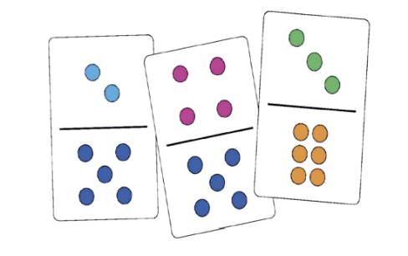

#### Story cards Mathematics and numeracy

* Choose one of the settings from the story cards and design a map of this on the grid template. Ask your classmates to describe or find different parts of your map using the coordinates. **(MTH 1-18a)**

#### Sciences

* Using the cards create a scenario – e.g. a knight needs to deliver a special potion to the bear, but the potion needs to be kept cold. Investigate what materials or properties you’d need to solve your problem. **(SCN 1-15a)**

#### Technology

* Use [Book Creator](https://bookcreator.com) or [Storyboard That](https://www.storyboardthat.com/) to make a digital version of a story you have written, including adding pictures. **(TCH 1-01a)**
* Use digital software to find sound effects or music that matches the genre of one of the setting cards**. (TCH 1-01a,   
  TCH 1-02a)**

## Literacy and English

* Read a story to the class and ask them to guess what genre it is as they listen. What clues did they pick up on?   
  **(LIT 1-04a)**
* Sort the cards into different genres together as a class by asking questions like “What kind of book would an astronaut be in?” Ask the pupils what their favourite genre to read is. Make a poster about it, featuring their favourite stories in the genre and what they like about it. **(LIT 1-04a, LIT 1-11a)**
* Choose two or three of the story cards and see if you can think of a super sentence involving the pictures and words on the card, as well as using some adjectives to describe them.   
  **(LIT 1-06a)**
* Create an oral story around the class. The first child chooses a story card, shows everyone the picture then starts the story by introducing the character, setting or item. The next child chooses a new card and continues the story. Keep telling the story until the cards are finished, or everyone has had a turn.   
  **(ENG 1-03a, LIT 1-07a)**
* Select three story cards then work in groups to create a story around the object, setting and character. Share all of the stories with the class and notice how different they are. **(LIT 1-20a)**
* In groups, create a six-picture storyboard. Draw the images in the squares then write short captions underneath to explain what is happening. **(LIT 1-26a)**

**Health and wellbeing**

* Choose two character cards and write a story about how they became friends, thinking about what qualities are helpful for making friends! **(HWB 1-44a)**

**Social studies**

* As a group, pick a period of history that could be an interesting setting for a story. Learn about it as a class using historical evidence, then practise describing or writing about it so you're ready to use it in stories. **(SOC 1-04a)**

**Art**

* Design your own character, setting or object card based on a favourite animal or story. **(EXA 1-03a)**

**Drama**

* Use the cards to inspire a piece of role play. Give everyone a character by asking them to draw a card, then draw another card for setting, and lastly an item card is something they have to work together to find!   
  **(EXA 1-12a)**

**Music**

* 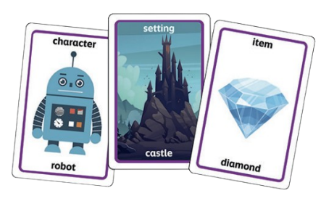What would the soundtrack be for different genres? Pull a card and experiment with different music technologies or instruments!   
  **(EXA 1-17a)**

**Talk It Out**

**Sciences**

* Use the “What can we see if we look out of the window together” card to prompt a discussion. What do you think you’d be able to smell? What do you think you’d be able to hear? What is easier to see? What is more difficult to see? **(SCN 1-12b)**

**Technology**

* Design a structure using your cards. Work as a class to try out different arrangements to find the most stable**. (TCH 1-12a)**

**Literacy and English**

* Choose a character from your favourite book and imagine how they might answer the questions. Write down your replies and then read them aloud in a group. Can your group guess who your character is? You can make it harder by not mentioning names or specific places, so your group has to be creative in asking questions? **(LIT 1-09a)**
* Practise using the cards in pairs, choosing one to discuss and taking time to listen to each other's answers and talk together about your responses. **(LIT 1-09a)**
* Use the card "if you were an animal what would you be and why" as inspiration for a piece of writing - you could create your ideas as a comic strip, letter or diary entry, whatever you choose. **(LIT 1-20a)**

**Health and wellbeing**

* The cards could be used in a Circle Time activity to encourage discussion and build confidence in a group**.   
  (HWB 1-01a)**
* Use the "what makes you happy" card to start a discussion on what happiness feels like and when you feel it. You could create a mural or display in your class to remind you when you're having a hard day. **(HWB 1-01a)**

**Social studies**

* Talk about the card "what is one cool thing that happened today" - how different might our answers be if we lived at a different time in history? Find out about daily life in a different historical period and write a few sentences from the point of view of someone living in that time to answer the question. **(SOC 1-04a)**
* Talk about the card “What can we see if we look out of the window together?”. How might that be different if you lived in a different period of history? Can you spot anything that wouldn’t be there in the past? **(SOC 1-04a)**
* Talk about the card "tell me an example of when you were a good friend" - what does it mean to be a good friend? How can we think about the needs of our friends and those around us, and how these can be different from our own? **(SOC 1-16a)**

**Art**

* Get each of the pupils to pick a card and use it as a basis for an art activity. Compile all of the drawings and create a book of their thoughts and feelings. **(EXA 1-05a)**

**Dance**

* Talk about the card "if you could choose a superpower what would it be?" as a class. Use some of the suggested superpowers to inspire a dance that you can create together**. (EXA 1-09a)**

#### Act It Out Mathematics and numeracy

* Take 12 of the cards and practise sharing them equally between 2, 3 and 4 people. If you have more people, do they get less cards? Discuss the fairest way to split the cards. **(MNU 1-07b)**

#### Sciences

* Sort the cards into living and non-living things. Are there any other groups you can sort them into? **(SCN 1-01a)**

#### Technology

* Film members of your class acting out some of the cards and use the video to make a quiz for other classes to try! **(TCH 1-01a)**

#### Literacy and English

* Take turns to pick a card and describe it to the class or group, thinking about your choice of words and using gestures to help them to guess. **(ENG 1-03a)**
* Are there any cards that link to *Barbara Throws a Wobbler* or *The Ballad of Cactus Joe*? Choose three cards and explain your reasoning. **(ENG 1-17a)**
* Make a word bank for the cards, talking about what each item is, how to spell the word and practising any tricky words. **(LIT 1-21a)**

#### Health and wellbeing

* Choose two character cards and write a story about how they became friends, thinking about what qualities are helpful for making friends! **(HWB 1-44a)**

#### Art

* Pick a category and draw a new image of your choice to accompany the set. **(EXA 1-05a)**
* Share the card you’ve designed with the class. Act it out and see if anyone can guess what your card is!  
  **(EXA 1-01a, EXA 1-12a)**

#### Drama

* Play Act it Out as a class. Challenge the pupils to only use sounds rather than actions to describe the card they've chosen. **(EXA 1-12a)**

### **Binoculars**

#### Mathematics and numeracy

* Ask a friend to write a secret message on a piece of paper. See how far away they have to walk until you can't read it any more through your binoculars. Can you estimate how far away they are? **(MNU 1-11a)**
* How many different shapes can you find using your binoculars? Keep a list of the different shapes you find in your playground or on your way to school! **(MTH 1-16a)**
* Use your binoculars to look for different birds or animals. Use our printable activity sheet to keep a track of what you see. You could create a chart to show your findings. **(MNU 1-20b)**

#### Sciences

* Use the [RSPB’s learning resources](https://www.rspb.org.uk/whats-happening/get-ready-for-big-schools-birdwatch/resources) to learn about the different kinds of birds you might be able to see with your binoculars. Can you sort them into different groups? You can also find a printable activity sheet in this pack which helps you identify common birds in Scotland. **(SCN 1-01a)**
* Use binoculars to explore the night sky. Look at how the moon changes; can they find when the moon matches the one in the book? **(SCN 1-06a)**
* Use digital technology to learn about animals that have binocular vision. What does binocular vision mean? How does it help humans and other animals respond to the world around them? **(SCN 1-12b, TCH 1-01a)**

#### Technology

* Research what binoculars used to look like in the past. What do you think they’ll look like in the future? Create your own model! **(TCH 1-01a, TCH 1-09a)**

#### Literacy and English

* Imagine you're a detective and you have to use your binoculars to search for clues! Write a short story or poem about how your binoculars help you solve the case of something that’s gone missing. Why not pull a random Story Card to decide what the missing item is?   
  **(ENG 1-31a)**
* Use your binoculars to look at treetops or the sky and imagine what a bird sees. Create a diary entry from your day in the life as a bird. **(LIT 1-28a, LIT 1-29a)**
* Come up with a list of things you want to try and see with your binoculars and write them down. **(LIT 1-28a, LIT 1-29a)**

#### Social studies

* Use the [Cool Kids Facts article](https://www.coolkidfacts.com/telescopes/)to learn about different tools that have been used throughout history to help people see things that are far away! In pairs, talk about what you might see if you used your binoculars in a different period of history. What would be different? **(SOC 1-04a)**

#### Art

* Use your binoculars to look at different plants in your local area. Can you create a piece of art inspired by the detailed patterns that you see? **(EXA 1-03a)**

Activity sheet 1: Measure record sheetBarbara throws a wobbler! Can you track different items that you through? Gather a collection of soft objects, such as soft toys, balls or beanbags. Make sure you have a large space indoors or outdoors so that you can throw each item as far as you can.   
  
Stand on the same spot to throw each item and throw each soft article as far as you can. Using your measuring tape measure the distance between your starting point and the point at which each item landed. Record your findings below.

|  |  |
| --- | --- |
| **Write the name of your item or sketch it here** | **Measurement in cm** |
|  |  |
|  |  |
|  |  |
|  |  |
|  |  |

Which item travelled furthest?  
  
Why do you think this might be?

## Activity sheet 2: Design your own wobbler!

Colour in, collage and decorate your very own wobbler.

## Activity sheet 3: Design your own mood!

On the last page of the book, you can see what some different moods might look like. Use the boxes below to design your own moods. One might be a nice mood or feeling like “happy” or “giggly” and one might be a not so nice mood like “cross” or “sad”.

My mood is called:

My mood is called:

## Printable 4: Outline of a cactusActivity sheet 4: Collage this cactus

Colour in, collage and decorate your very own cactus.

## Activity sheet 5: How to make a new hat for Cactus Joe

Follow this guide to create your own origami hat for Cactus Joe! Top tip: colour in or draw on your paper before you fold it. Or, wait until your hat is complete and use stickers to decorate it!

|  |  |
| --- | --- |
| Printable 6: Step 1  **Step 1:** Start with a normal A4 piece of paper | Printable 6: Step 2  **Step 2:**  Fold your piece of paper in half lengthways |
| Printable 6: Step 3  **Step 3:**  Unfold your piece of paper. | Printable 6: Step 4  **Step 4:** Now fold your piece of paper in half from top to bottom. |
| Printable 6: Step 5  **Step 5:**  Fold the right corner to the line down the centre, so it makes a triangle. | Printable 6: Step 6  **Step 6:**  Now fold the left corner to the line down the centre, so it makes a triangle. |
| Printable 6: Step 7  **Step 7:** Fold the bottom flap up along the base of the triangle. | Printable 6: Step 8  **Step 8:**  Turn the paper over |
| Printable 6: Step 9  **Step 9:** Fold up the bottom flap along the base of the triangle. | Printable 6: Step 10  **Step 10**  Your hat is now ready to wear, decorate or be given to a friendly cactus! |

## Activity sheet 6: What makes a good friend?

Cactus Joe was a good friend to others. What do you think makes a good friend? Write some of your ideas in the clouds below.You could colour in your picture and give it as a gift to one of your friends.

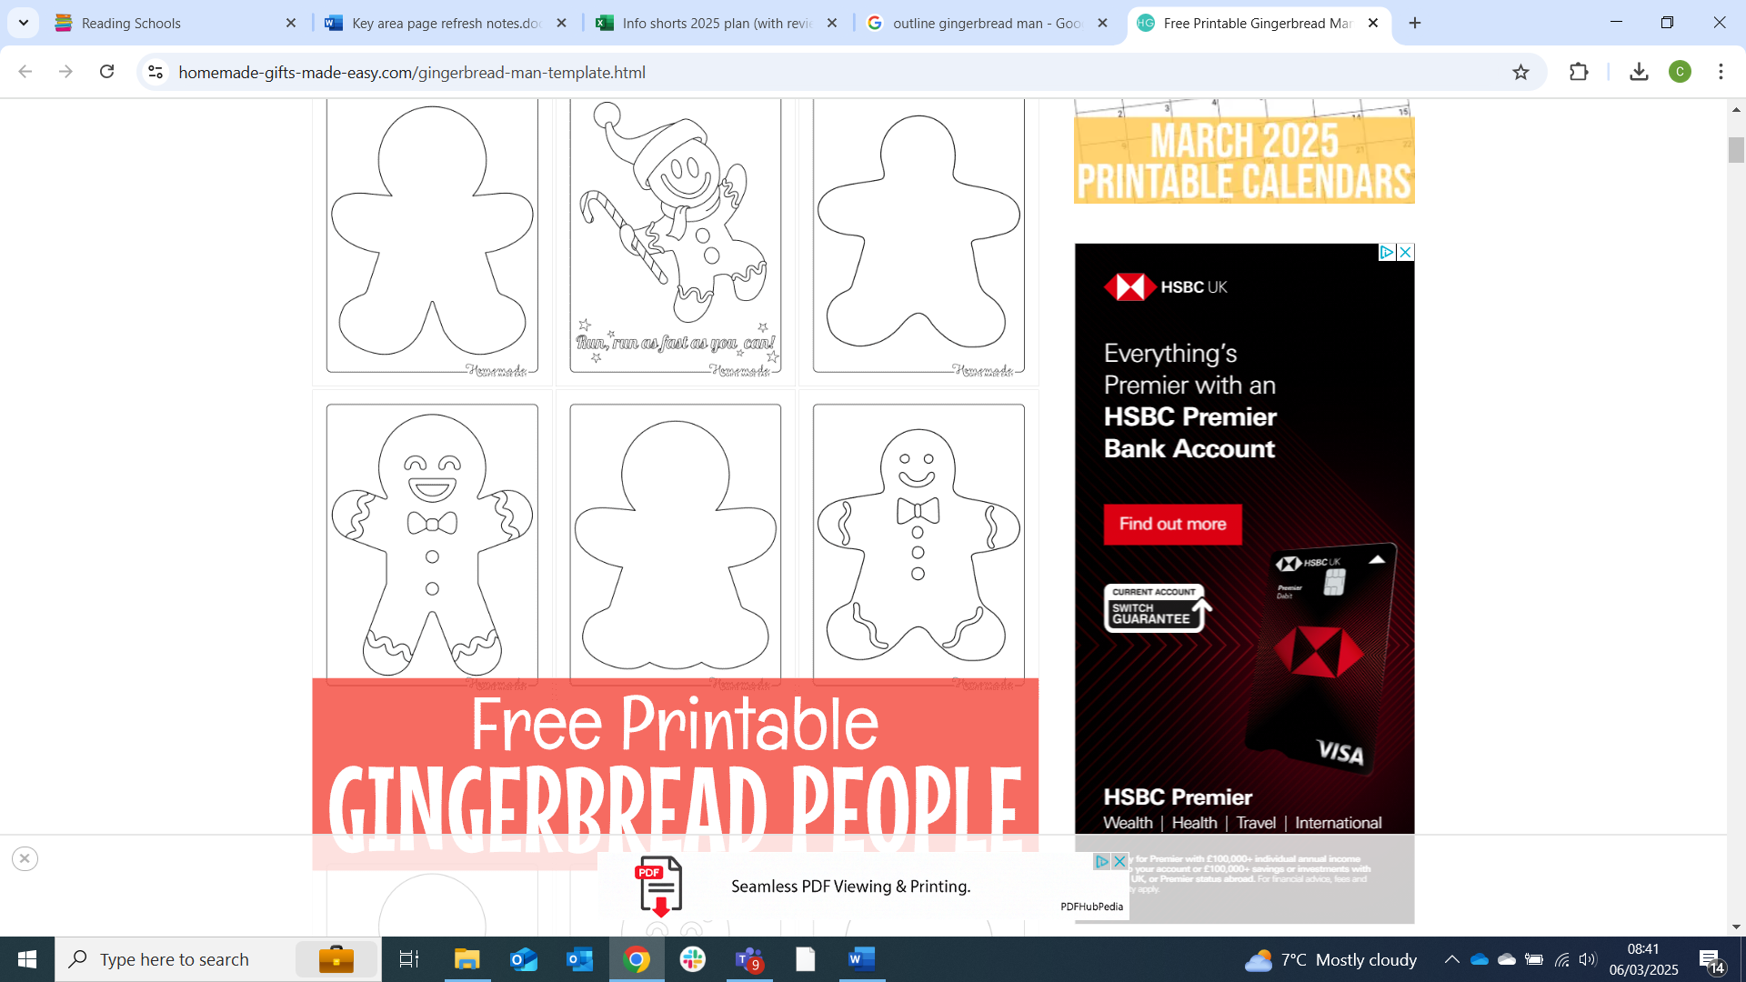

## Activity sheet 7: Design your own Story Cards

Use the templates below to create your own Story Cards. What character, object or setting would you like to hear a story about?

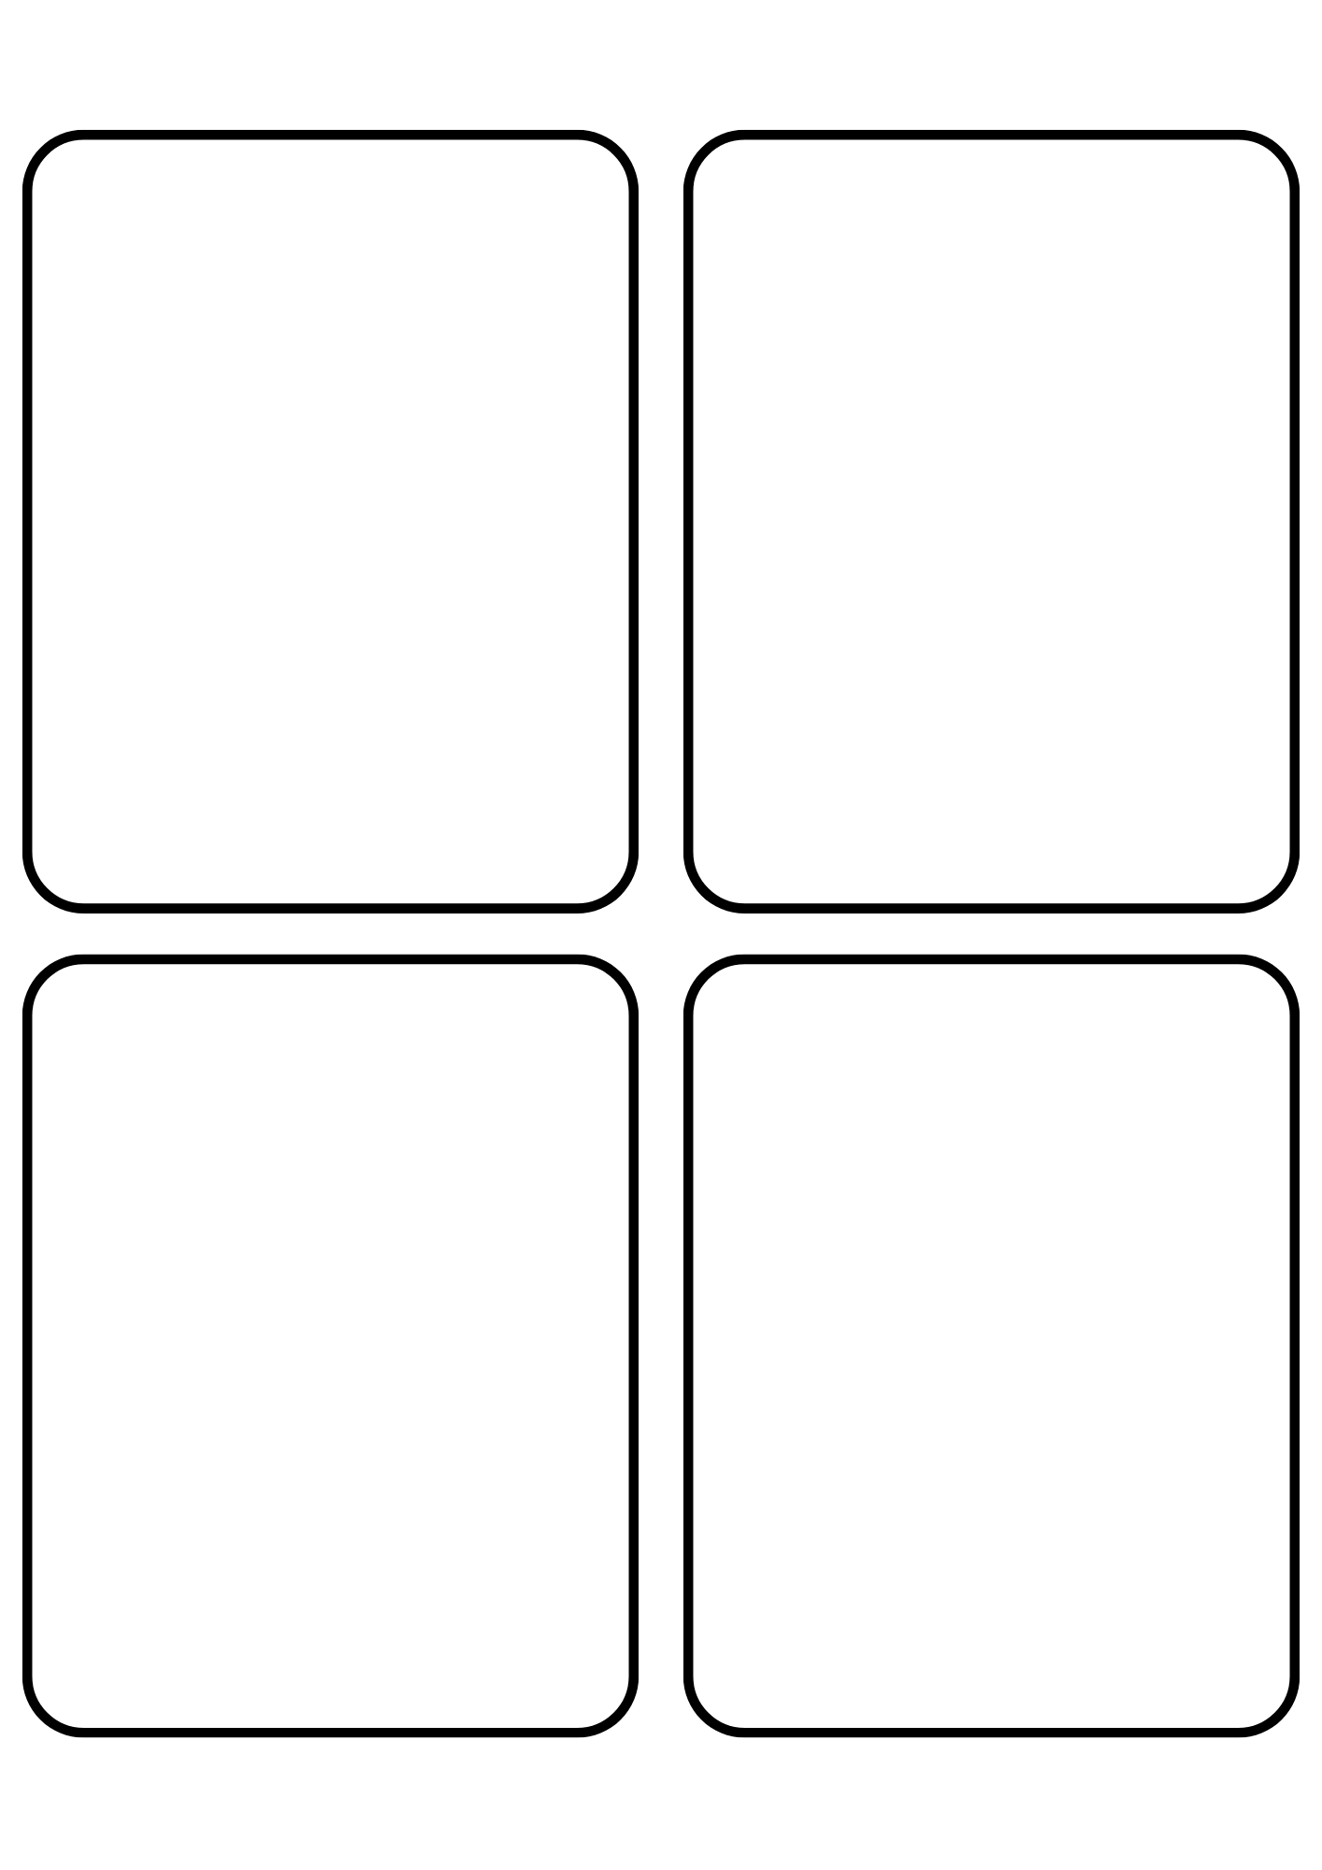

## Activity sheet 8: Binoculars record sheet

Using your binoculars explore the environment around you and make a list of some of the birds and/or animals you see. Using tally marks record how many of each you can find. Count your tally marks and write the number.

|  |  |  |
| --- | --- | --- |
| Animal/bird | Tally Marks | Number |
|  |  |  |
|  |  |  |
|  |  |  |
|  |  |  |
|  |  |  |
|  |  |  |

Which animal/bird did you see the highest number of?

Which animal/bird did you see the least number of?

## Activity sheet 9: Birds to watch

Use the RSPB website to find the name for all these birds. Once you’ve written each bird’s name under their picture, you can use this as a guide when you go birdwatching!

|  |  |
| --- | --- |
| A photograph of a crow | A photograph of a robin |
| A photograph of a jackdaw | A photograph of a blue tit |
| A photograph of a blackbird | A photograph of a house sparrow |
| A photograph of a pigeon | A photograph of a seagull |

## Activity sheet 10: Binocular bingo (blank template)

Draw one thing in each square that you would like to spy through your binoculars. You could draw things in the sky, animals, plants, buildings near you, and even your neighbour’s pets! Then take your binoculars on a walk and see if you can find everything you drew! Did you see anything more than once?

|  |  |  |
| --- | --- | --- |
|  |  |  |
|  |  |  |
|  |  |  |
|  |  |  |

## Activity sheet 11: Binocular bingo (filled template)

Take your binoculars on a walk and see if you can find everything in our scavenger hunt. Colour in each picture once you have seen it.

|  |  |  |
| --- | --- | --- |
| Moon and stars outline  **Moon** | Acorn outline  **Acorn** | Sparrow outline  **Bird** |
| Squirrel outline  **Squirrel** | Spider web outline  **Cobweb** | Cat outline  **Cat** |
| Cloud outline  **Cloud** | Animal footprints outline  **Animal tracks** | Aeroplane outline  **Aeroplane** |
| Dog outline  **Dog** | Building outline  **Tallest building** | Rose outline  **Flower** |

## Activity sheet 12: Binocular bingo (fill in the gaps)

Take your binoculars on a walk and see if you can find everything in our scavenger hunt. Colour in each picture once you have seen it. Draw what else you see in the blank spaces!

|  |  |  |
| --- | --- | --- |
| Moon and stars outline  **Moon** | Acorn outline  **Acorn** | Sparrow outline  **Bird** |
| Squirrel outline  **Squirrel** | Spider web outline  **Cobweb** | **Draw your own** |
| **Draw your own** | Animal footprints outline  **Animal tracks** | Aeroplane outline  **Aeroplane** |
| Mushroom outline  **Mushroom** | Building outline  **Tallest building** | Rose outline  **Flower** |

Further resources  
Help and support  
To find out more about Read Write Count, visit our [About Read Write Count webpage](https://www.scottishbooktrust.com/reading-and-stories/about-read-write-count), our find your local contact with our information on [How to get Read Write Count bags](https://www.scottishbooktrust.com/reading-and-stories/read-write-count/contacts).

Teacher resources  
Find further teacher resources on the [Read Write Count section of the Scottish Book Trust website](https://www.scottishbooktrust.com/reading-and-stories/read-write-count), including:

* [Our P3 bag teacher pack](https://www.scottishbooktrust.com/learning-resources/read-write-count-for-p3)
* Our webinars on [Making the most of the P2 bag](https://www.scottishbooktrust.com/learning-resources/making-the-most-of-the-primary-2-bag) and [Making the most of the P3 bag](https://www.scottishbooktrust.com/learning-resources/making-the-most-of-the-primary-3-bag).

Further resources will be added later, including inclusive resources designed for children with additional support needs. Keep checking back on the [Read Write Count section of our website](https://www.scottishbooktrust.com/reading-and-stories/read-write-count) to see when these are available!

### Family resources

* Our [Home Activities Hub](https://www.scottishbooktrust.com/home-activities) contains resources, activities and top tips for families at home
* Our [Read Write Count Home Challenges](https://www.scottishbooktrust.com/articles/read-write-count-at-home) are fun activities designed to help them further explore the bag