

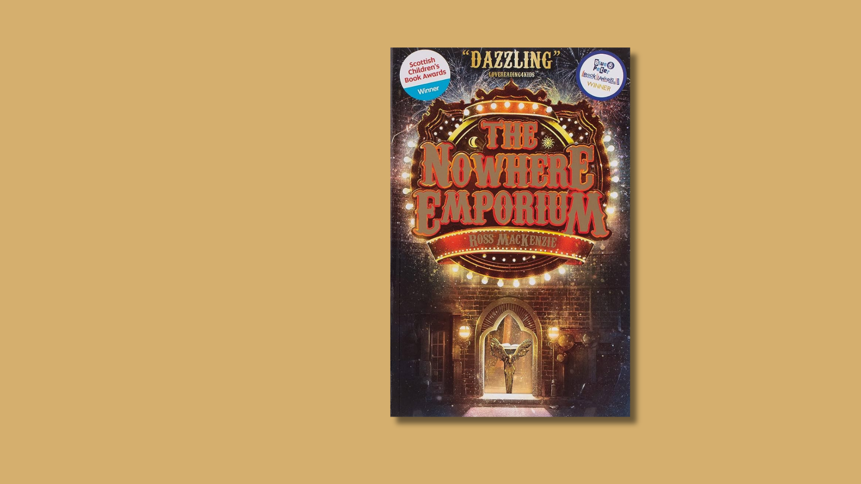

# *The Nowhere Emporium* learning activities

Activities inspired by *The Nowhere Emporium* by Ross Mackenzie

## Age 8-12

## CFE Second Level

## Resource created by Scottish Book Trust



scottishbooktrust.com



Scottish Book Trust is a registered company (SC184248)

and a Scottish charity (SC027669).

## Contents

About this resource 2

Learning activities 2

Further resources 4

## About this resource

This resource gives cross-curricular activity suggestions to accompany Ross MacKenzie’s *The Nowhere Emporium*. These activities can be used independently, or built upon to create a class project. With all our resources, we highly recommend that you **read the book before using it with your class** and use your best judgement on whether teaching about this topic is appropriate for the children you work with.  
  
If you are taking part in [Reading Schools](https://www.readingschools.scot/), the activities in this resource could support delivery of Key Area:

* 1.5.1: Access to high-quality books
* 2.2.2: Interdisciplinary book projects
* 2.3.4: Opportunities for learners to respond to what they’re reading

## Learning activities

### Activity 1: Create your own book of wonders

EXA 2-02a,EXA 2-03a, ENG 2-27a  
‘*When I have a new wonder, and I’ve thought it through carefully and decided that it is suitable, I begin to write it down. The pages are enchanted and entwined with the shop. When I have finished writing, a Wonder will appear somewhere in the corridors*.’

* Have a day at the library. Research book jackets and identify the many styles of book covers; images, calligraphy, typography. Discuss what makes a book alluring or special. Have your pupils issue one book, ask them to read this and later discuss with their peers whether they thought that the book jacket effectively reflected the story. They can upload your findings on [Padlet](https://padlet.com/).
* Now, ask your pupils to decorate a notebook of their own to make their own personal Book of Wonders. Using arts and crafts they can make it look mysterious and ancient like the magic book in the story, or they can put a modern twist on it.
* Once your pupils have finished decorating their Book of Wonders ask them to imagine a room and write a description in their book. What style would it be? What characters would live there? What does this room mean to them?

### Activity 2: Bring the room to life

TCH 2-12a, TCH 2-14a, EXA 2-02a, SCN 2-09a  
When your pupils have finished their entry in their Book of Wonders, ask them to create their imagined room by using a shoe box, arts and crafts and recycled goods.

* Ask them to measure the dimensions of their room. What size will the furniture be? What size will the characters be? What tools will you need to measure these things?
* Will it have lights? Can they make a circuit? It’s easy and all they need is 1-2 D batteries, aluminium foil, electrical tape, a small light bulb from a flashlight and enthusiastic scientists! Use [What We Do All Day guidelines for quick experiments](http://www.whatdowedoallday.com/2015/03/simple-circuit-science-project.html) for help.
* What fabrics and textiles can they use? Where are these sourced? See [First Pallette’s guide to panoramas](https://www.firstpalette.com/craft-theme/diorama.html) for inspiration.

### Activity 3: Research a city

LIT 2-14a

‘*We’re lucky. We can see New York, Cairo, and Paris…watch Kings and queen and governments come and go. We get to see everything Ellie, the whole of history-*’  
  
Have your pupils’ research one of the cities mentioned in the book:

* What century will they research?
* Has the city landscape changed over the years?
* What’s the population?
* Are there any famous locations?
* What is the city culture?
* How does it look different during seasons?

### Activity 4: Make a city snow globe

EXA 2-02a

The first entry that Daniel creates in the Book of Wonders is a room filled with empty snow globes, waiting for secrets to be added. People often collect snow globes on their travels as they usually depict a city scene and make great souvenirs.   
  
When your children have finished researching their chosen city, have them make a snow globe. It’s simple and fun and you can use a jam jar. See [Tuts Plus Design’s guide](https://crafts.tutsplus.com/tutorials/create-a-wondrous-winter-wonderland-in-a-jam-jar--craft-710) for help.

## Further resources

* For more cross-curricular book projects for Second Level, see our resources on [*A Kind of Spark*](https://www.scottishbooktrust.com/learning-resources/a-kind-of-spark), [*How to Train Your Dragon*](https://www.scottishbooktrust.com/learning-resources/how-to-train-your-dragon-learning-activities), [*Tidy*](https://www.scottishbooktrust.com/learning-resources/using-tidy-for-a-cross-curricular-book-project)or [*Who Let the Gods Out?*](https://www.scottishbooktrust.com/learning-resources/maz-evans-activity-pack)
* For more creative writing ideas see our [Creative writing activities for upper primary resource](https://www.scottishbooktrust.com/learning-resources/creative-writing-activities-for-upper-primary)