

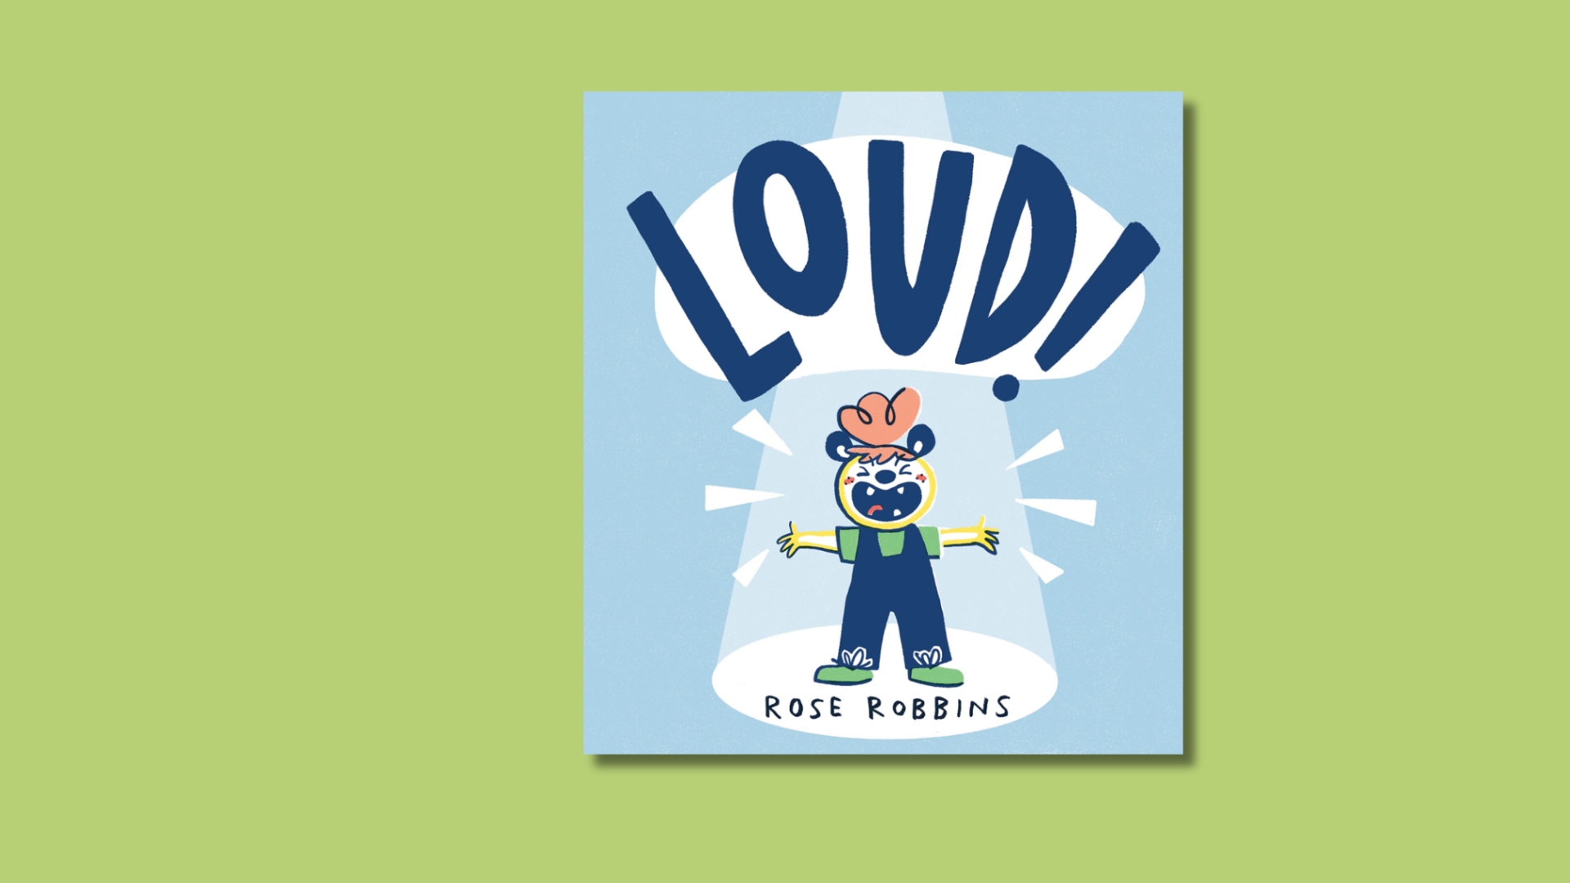

# *LOUD!* sensory storytelling

A resource to support sharing the picture book *LOUD!* as a sensory story

## Age 3-18

## CFE Levels Early to Fourth

## Resource created by Rose Robbins



scottishbooktrust.com



Scottish Book Trust is a registered company (SC184248)

and a Scottish charity (SC027669).

## Contents

How to use this resource 2

Page by page 3

Further resources 7

## How to use this resource

*LOUD!* is a picture-book full of sounds and textures, making it perfect for sensory-storytelling. Use the recommended props and actions described in this resource to bring the book to life for all ages and abilities. Feel free to adapt this guide to suit the individual needs of the children that you are working with (e.g. swapping relaxing music sound effects for a hand massage). With all our resources, we highly recommend that you **read the book before using it with your class** and use your best judgement on whether teaching about this topic is appropriate for the children you work with.

If you are taking part in [Reading Schools](https://www.readingschools.scot/), the activities in this resource could support delivery of Key Area 2.2.2: Interdisciplinary book projects.

### Props and stimuli:

* A copy of the book *LOUD!* by Rose Robbins
* Pens, pencils or crayons
* Paper stationary
* Wig or hair extensions
* Percussion instruments or noisy objects
* Cardboard box

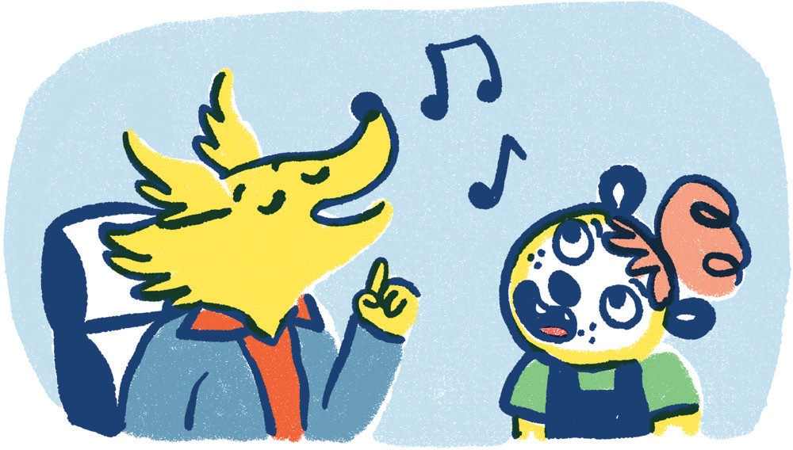

## Page by page

### Pages 1-2

It wasn’t a good day. Abigail was restless. She didn’t want to do writing.  
**Actions: Play sound effect of noisy classroom, give pupils pencils, pens, crayons and paper to handle.**

### Pages 3-4

She wanted to do scribbling… and fiddling with her hair… and fiddling with Lottie’s hair! Lottie didn’t like it but Abigail thought it was funny.  
**Actions: Let the child feel the texture of the wig/hair extensions to mimic Abigail.**

### Pages 5-6

Teacher wasn’t pleased. Abigail was taken to the calming down room.  
**Actions: Play sound effect of calm music.**

### Pages 7-8

The lady in the calming down room was kind but Abigail did not feel like talking. The next class was music. She had never been to a music class before…

### Pages 9-10

She was LATE. “There you are Abigail! Come and join us,” said Miss Butler. She didn’t seem cross at all. “Choose any instrument you like.”  
**Actions: Give the child the cardboard box with a selection of percussion instruments/noise making objects to feel and explore.**

### Page 11-12

Lina was playing the recorder. She was Brilliant! “I’ll never be as good…” thought Abigail.  
**Actions: If you have a recorder or whistle to hand, use this to mimic the playing of Lina and Abigail, alternatively you could whistle or use sound effects.**Ruby was drumming a beat all of her own. She had terrific rhythm. Abigail just couldn’t keep up.

**Actions: Using either a drum or a solid surface, mimic the drumming in the story. Encourage the children to join in.**

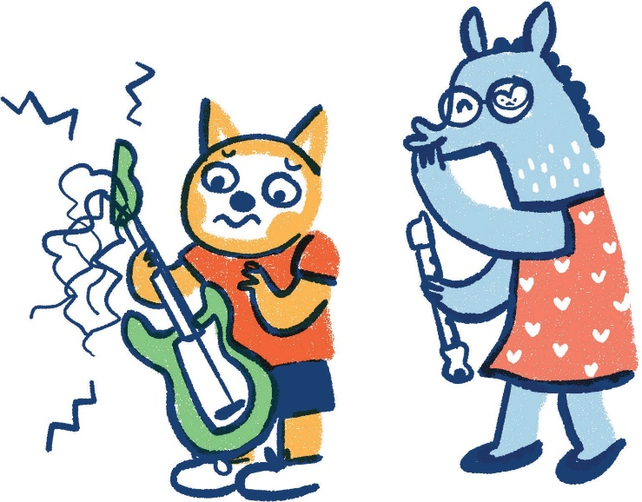

### Page 13-14

The guitar looked fun but the strings hurt Abigail’s fingers. Rex didn’t care! He played it like a pro.  
**Actions: If you have a guitar or string instrument you can use these to mimic Rex and Abigail, if not, use sound effects or carefully use elastic bands/ hair ties as strings.**Abigail wanted to join in… but she didn’t know how to.

### Page 15-16

So, she opened her mouth and SCREAMED!

**Actions: Switch off any sound effects at this point and make screaming noises (being mindful of students who may be sensitive to such sounds).**

### Page 17-18

UH-OH Miss Butler was coming over. “Back to the calming down room,” thought Abigail.  
**Actions: As Miss Butler is a wheelchair user, you could use a small, wheeled toy (you can get miniature toy wheelchairs, which would be ideal) to roll over children’s arms or across the floor/desk.**

### Page 19-20

But instead, Miss Butler smiled. “Wow, Abi!” she said. “You have such a strong voice! You’re a natural born singer.”

“Ooh! We need a singer for our band,” said Ruby. “Will you join us?” Abigail could have BURST with pride!

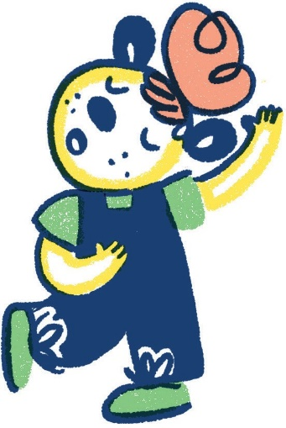

### Page 21-22

And suddenly, Abigail DID want to write. She wanted to write what she wanted to sing. Miss Butler helped her to choose the words.  
**Actions: Allow children to explore paper and pens/pencils. (This could also be the prompt for a separate song writing activity).**

### Pages 23-24

So, they started jamming and singing and this was their song…  
**Actions: Play Abigail’s song from the Scallywag website, either sound only or the animated music video. The children can sing along, or make up their own tune/words.**

### Pages 25-26

They practiced and they practiced, and they practised.  
**Actions: Encourage children to play with the percussion instruments or play to them.**

### Pages 27-28

So when it was time for the school talent show they shone like STARS  
**Actions: Everyone applauds.**

### Pages 29-30

How COOL is that?!  
**Actions: End.**

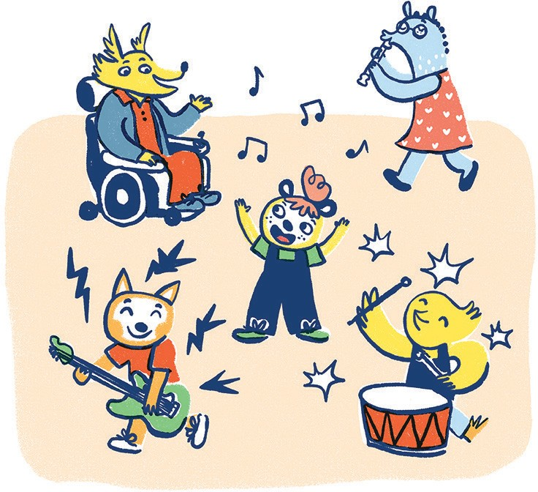

## 

## Further resources

* For more sensory resources, or resources to use with children with additional support needs, see [the Disability and Neurodiversity section of our website](https://sbtrust.sharepoint.com/sites/WebContent/Shared%20Documents/scottishbooktrust.com/topics/disability-and-neurodiversity)
* If you’re interested in creating your own sensory stories, see our [Getting started with sensory stories](https://www.scottishbooktrust.com/learning-resources/getting-started-with-sensory-stories), [Turning picture books into sensory stories](https://www.scottishbooktrust.com/learning-resources/turning-picture-books-into-sensory-stories) or [Make your own sensory story resources](https://www.scottishbooktrust.com/learning-resources/make-your-own-sensory-story)