

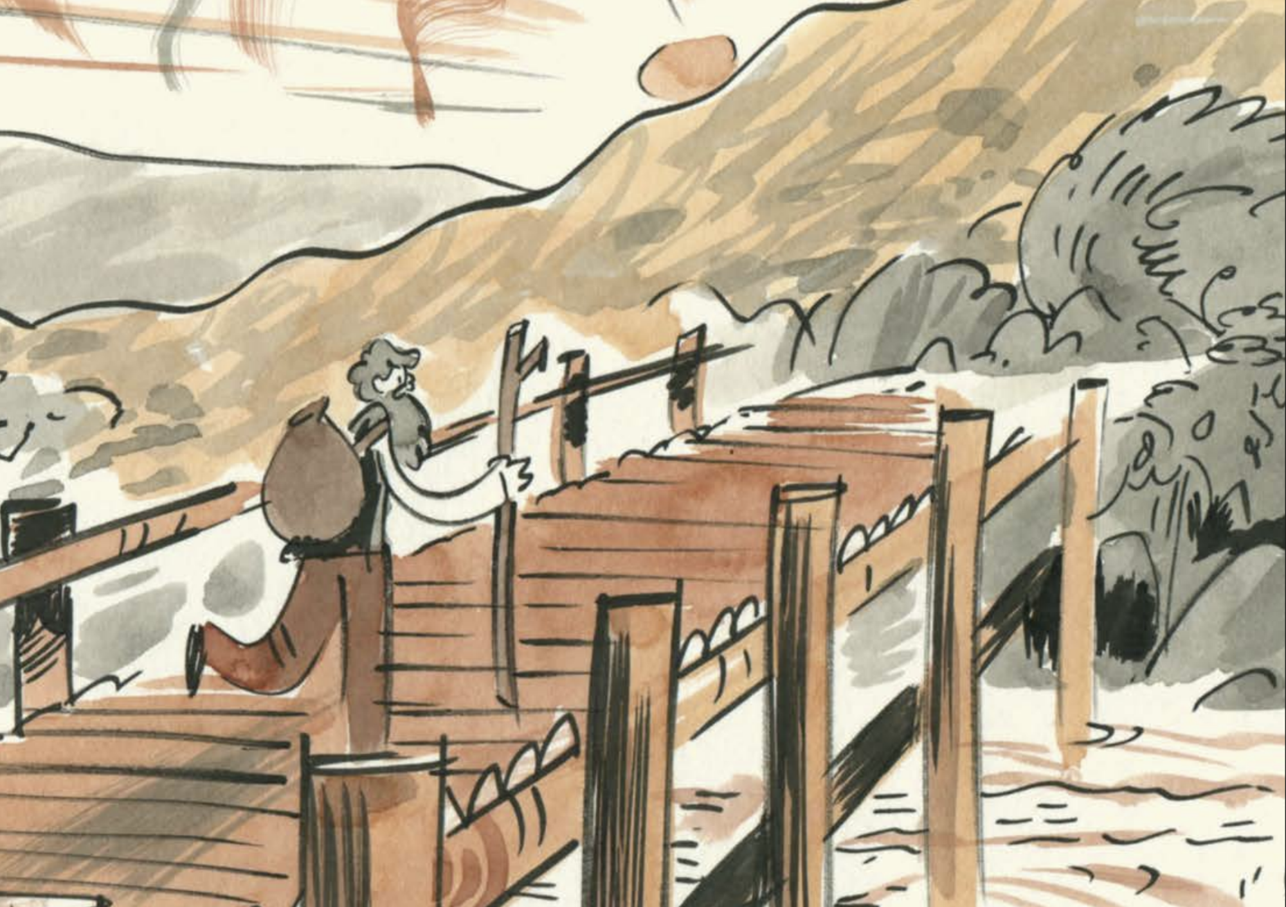

***John Muir, Earth - Planet, Universe* printable activities**

Ideas and activities for using the graphic novel *John Muir, Earth – Planet, Universe*

## Age: 9-14

## Decorative imageCFE Second and Third levels

## Resource created by Scottish Book Trust

scottishbooktrust.com



Scottish Book Trust is a registered company (SC184248)

and a Scottish charity (SC027669).

## Contents

About this resource 4

Explore birds – answers for teachers 4

Printable activity sheet 1: Explore birds 5

Printable activity sheet 2: Ancient Tree Hunt insturctions 9

Printable activity sheet 3: Ancient Tree Hunt counters 11

Printable activity sheet 4: Ancient Tree Hunt board game 12

## About this resource

In this document you can find the printable resources you can use as part of using [*John Muir, Earth – Planet, Universe*](https://www.scottishbooktrust.com/learning-resources/john-muir-earth-planet-universe)graphic novel. All of the resources are available on [the Scottish Book Trust website](https://www.scottishbooktrust.com/learning-resources/john-muir-earth-planet-universe).

## Explore birds – answers for teachers

Here are the answers to the activities on the Explore birds activity sheet  
  
Activity 1: a. Robin, b. Victorian Slender-billed Curlew, c. Gannet, d. Skylark,   
e. Puffin  
  
Activity 2: All of them!

## Printable activity sheet 1: Explore birds

The aim of this activity is to identify birdlife today and then compare your findings

to the birdlife John Muir would have experienced when he lived in Dunbar,

Scotland (from the year 1838 to 1849).

History tells us that John Muir could identify up to 71 birds from their song, nest or

egg.

1. **How many birds can you identify from the following list? Match them to their egg, nest, sound or general description.**

* Puffin
* Victorian Slender-billed Curlew
* Robin
* Gannet
* Skylark

a. *I am a plump bird with a bright orange-red breast and my face, throat and*

*cheeks are edged with grey. I have a white belly and olive-brown upper*

*parts. I sing a melodious warbling song from strategic perches, often quite*

*high up; it sounds like ‘twiddle-oo, twiddle-eedee, twiddle-oo twiddle’. I lay*

*blue eggs. What bird am I?*

I am a…

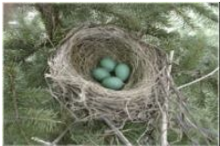b. *I am a small bird with a 77–88 cm wingspan and a long, curved, slender bill.*

*I am mainly greyish brown above, with a whitish rump and lower back. My*

*under parts are whitish, heavily streaked with dark brown. My flanks have*

*round or heart-shaped spots. The sound I make as my alarm call is a*

*fast ‘cu-ee’. What bird am I?*

I am a…

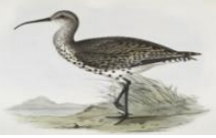

c. *I am a large black and white bird with a yellow head; long, pointed wings*

*with a wing span of up to two meters; and a long yellow bill. My huge nest is*

*made of seaweed and sticks. I eat big fish and hunt them by diving from a*

*height into the sea and pursuing my prey underwater. My eggs are large and*

*speckled. What bird am I?*

I am a…

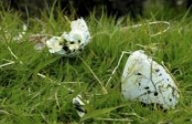

d. *My upper parts are brown with heavy black streaks. My under parts are buff*

*to white and my breast is streaked with black. My outer tail feathers are*

*white. My legs are yellowish-brown and my bill is horn-coloured. I am well*

*known for my singing. Most people hear me more than they see me. I sing*

*while I fly with a rapid ‘tweet, tweet, tweet, whistle, tweet, tweet’ sound. I lay*

*smooth, glossy eggs that are greyish-white with heavy brown and olive*

*spots. What bird am I?*

I am a…

A nest with eggs in it


e. *I have a brightly coloured beak and bright orange feet. I eat sand eels and I*

*lay my creamy white eggs in a burrow. The sound I make is a ‘growling*

*laugh’. What bird am I?*

I am a…

A white egg in a hole in the ground


1. **Which birds from the above list do you think John Muir would have seen or heard when he lived in Dunbar?**…………………………………………  
     
   …………………………………………  
     
   …………………………………………

The Royal Society for the Protection of Birds’ surveys show that some bird

species, since John Muir’s time, are in decline. For example:

The Slender-billed Curlew has disappeared from Scotland all together. So if

John Muir were alive today they would no longer be part of the 71 birds he

knew. Slender-billed Curlews are now so rare, there is thought to be fewer

than 50 adult birds left in the whole of the world!

Also in recent times the Skylark population has plummeted so that today the

population is about one-third what it was when John Muir was alive!

1. **Why do you think this has happened? What do you think you could do on your own or as a class group to help get to know and look after your local birds?**

…………………………………………  
  
…………………………………………

## Printable activity sheet 2: Ancient Tree Hunt insturctions

### Ancient Tree Hunt from Woodland Trust: Nature detectives

Get out and find all the fat, wrinkly old trees around where you live, then use the [Ancient Tree Inventory of the Woodland Trust’s website](https://ati.woodlandtrust.org.uk/) to log what you find!

#### Old

Saggy, stooped and twisted – if you spot a tree that looks like it has lots of scars and dead bits on it, it’s showing signs of age, so is probably an old tree worth telling us about.

#### Fat

We love fat trees! How fat is your tree? Is it hollow? Can you climb inside the big fat tree? Quick! Get someone to take your photo! How many people does it take to hug the tree?

#### Wrinkly

Wrinkles are great places for bugs to hide. Look around and see what you can find living in the crinkles of your old, fat tree. If you bug will stop wriggling for long enough, take its photo. Don’t forget to look up to the top of the tree – can you spot an owl or a bat? Tell everyone about who lives in your wrinkly tree. When you get home, create a tree record using the [Ancient Tree Inventory of the Woodland Trust’s website](https://ati.woodlandtrust.org.uk/).

#### Game instructions

The aim of the game is to complete the food chains in the correct order. If you are playing two-player, the winner is the one who has the most food chains. Before you start, cut out your counters and get some dice ready.

##### One player

Use the dice to move around the board and follow the instructions on the squares that you land on. You finish the game once you have moved all the animals into the tree, completing the food chains.

##### Two players

If the first player lands on a square (e.g. move the fly in), they can move that counter onto their side of the tree. If player two later lands on the same square, they can steal that counter from player one’s side and add it to their side. However, if player one already has the next creature in that food chain (spider), player two cannot take the fly, but if they land on the spider square they can take the spider from player one’s side and take it off the board, ready to be used again.

## Printable activity sheet 3: Ancient Tree Hunt counters

## The Ancient Tree game stickers and counters

## The Ancient tree board gamePrintable activity sheet 4: Ancient Tree Hunt board game