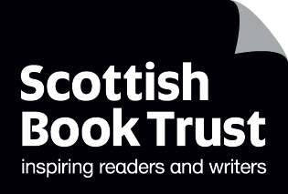
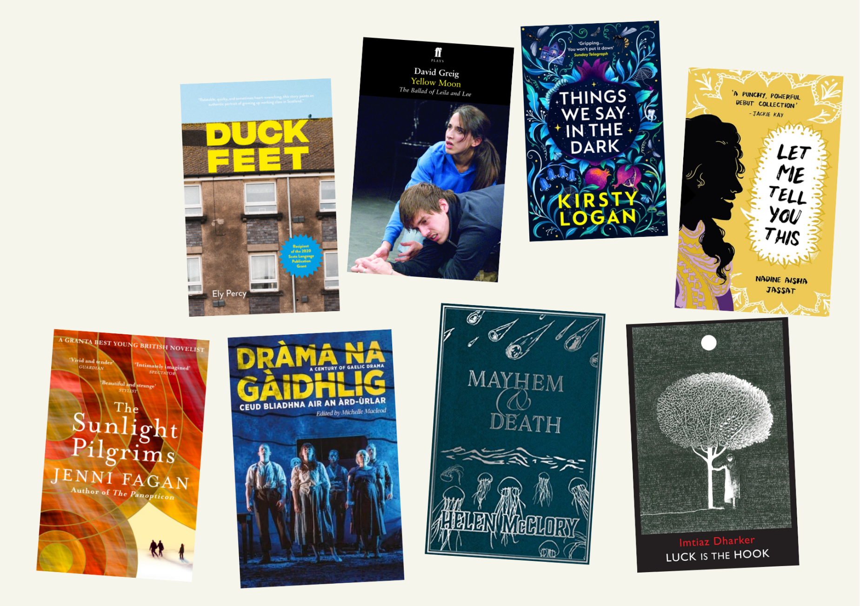

SQA set texts discussion guides
Discussion questions and creative writing prompts based on SQA National 5 and Higher texts

Resource created by Scottish Book Trust


scottishbooktrust.com

Scottish Book Trust is a registered company (SC184248)
and a Scottish charity (SC027669).

Contents
About this resource 2
Duck Feet by Ely Percy 4
Yellow Moon by David Greig 7
“Things My Wife and I Found Hidden in Our House” by Kirsty Logan 10
“Auntie” by Nadine Aisha Jassat 13
The Sunlight Pilgrims by Jenni Fagan 16
Sequamur by Donald S. Murray 19
“A Voice Spoke to Me at Night” by Helen McClory 22
Poems from Luck is the Hook by Imtiaz Dharker 25
Further resources 28

About this resource
This resource contains discussion guides for each the below texts from National 5 and Higher. Each discussion comes as a text-rich printable version and a plain text version. You can use them to introduce the National 5 or Higher texts to your class, to structure conversation and responses to the text, or to support pupils with exam revision.
A key part of Scottish Book Trust’s ethos is to promote reading and writing for pleasure. Whilst these texts have been designated as part of pupil’s study, we hope these discussion guides can help pupils use these texts as a jumping off point for reading for pleasure – whether through engaging in open discussion, responding to the text through creative writing, or using our suggestions of other texts they may enjoy.
On each discussion guide we’ve included three cards from our Story Deck which we think summarise the feeling or atmosphere of the piece. If you have Story Deck in your school or library, we encourage you to use this as an icebreaker. What do they think of the cards we’ve included? Which cards would they use?
To find out more about Story Deck, and get your packs, visit the Story Deck page on our Reading Schools website.

National 5 texts
- Duck Feet by Ely Percy (extract from novel)
- Yellow Moon by David Greig (play)
- “Things My Wife and I Found Hidden in Our House” by Kirsty Logan (short story)
- “Auntie” by Nadine Aisha Jassat (poetry)

Higher texts
- The Sunlight Pilgrims by Jenny Fagan (novel)
- Sequamur by Donald S. Murray (play)
- “A Voice Spoke to Me at Night” by Helen McClory (short story)
- “Bairn”, “Bloom”, “Letters to Glasgow”, “Send This”, “Stich” and “The Knot” by Imtiaz Dharker (poetry)

With each guide, we advise you use your best judgement on whether a specific discussion question or creative writing prompt is appropriate for the pupils you work with. Please feel free to adapt and print the plain text version. Each guide also contains recommended books that readers may enjoy if they liked the book. As with the discussion guide titles, we encourage you to use your best judgement if these are suitable for individual readers.

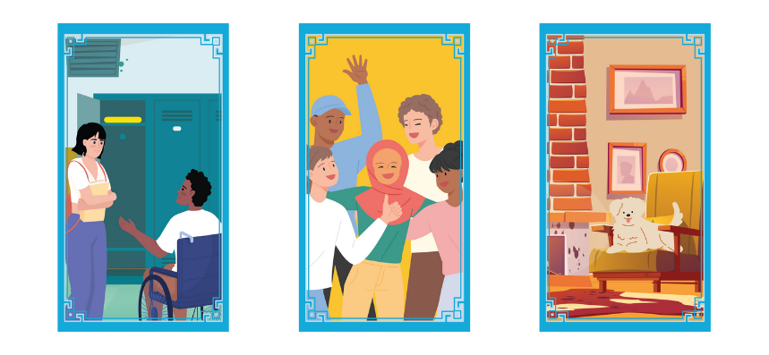
Duck Feet by Ely Percy
We’ve included three Story Deck cards we think summarise the feeling of this book.
Do you agree with our choices?
What would you pick?

Discussion questions
- Each chapter of Duck Feet is a short story. Did it feel different to reading a traditional novel? How?
- Duck Feet is set in the mid-noughties. What differences did you notice about growing up then versus now? Has anything stayed the same?
- How does the novel depict friendship? Think about Kirsty’s relationships with Harpreet and Charlene. Could you relate to any of Kirsty’s relationships?
- How do you interact with Scots in your day-to-day life? Do you speak similarly to Kirsty or did her voice feel new to you?
- To what extent do you think Kirsty is shaped by growing up working class?

Creative writing prompts
- Choose a Scot word from the book. If the word is new to you, use a Scots Language Dictionary to look it up, or find the equivalent word you may use in your area or dialect. Now, write a poem using this word. You could create an acrostic, use it in a haiku or just write in free verse inspired by this word.
Kirsty has a distinctive voice throughout each chapter. In pairs or groups, discuss what words you’d use to describe Kirsty. Think of words that you associate with her as well as adjectives. Now, use these to create a character fact file which introduces Kirsty to someone who has never read Duck Feet. Next time you do some creative writing, use this fact file format to outline who your main character is.

What to read next

Glasgow Boys by Margaret McDonald
A coming-of-age story set in Glasgow, following Finlay and Banjo as they navigate life after growing up in care.

The Climbers by Keith Gray
A searing look at teenage rivalries and life-defining friendships.

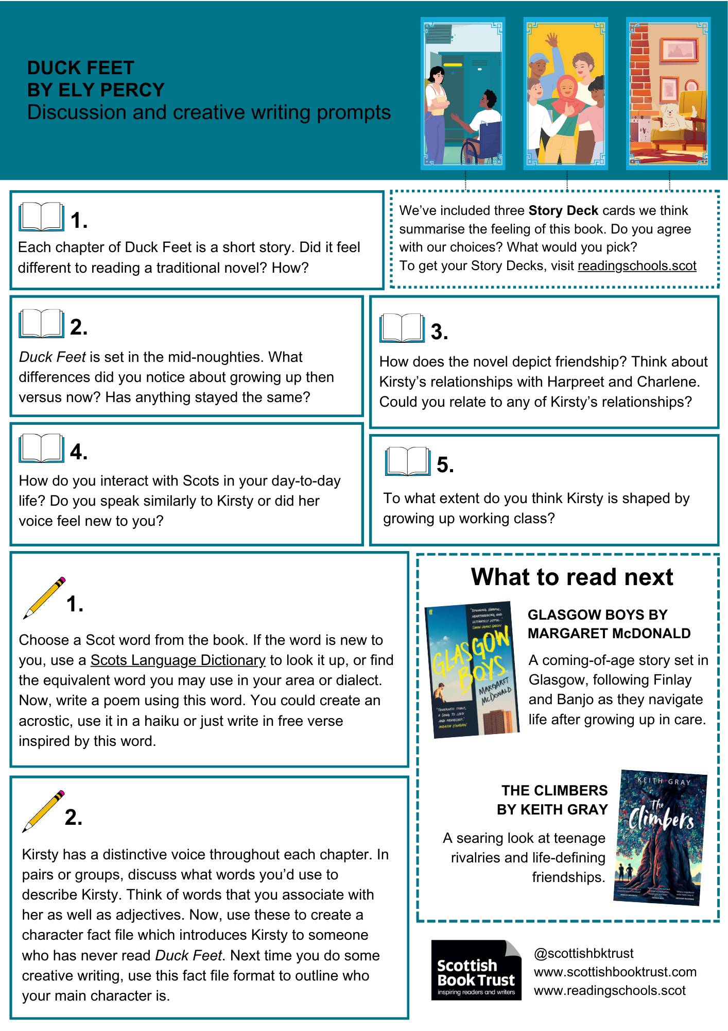

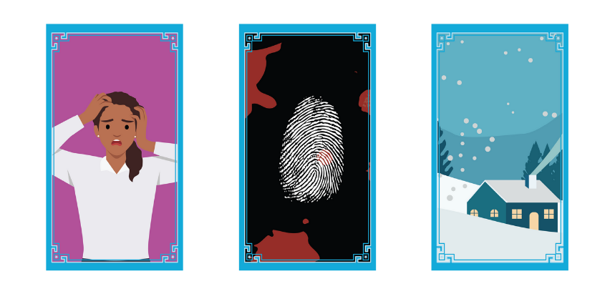
Yellow Moon by David Greig
We’ve included three Story Deck cards we think summarise the feeling of this play.
Do you agree with our choices?
What would you pick?

Discussion questions
- The play has a subtitle: “The Ballad of Leila and Lee”. Why do you think the playwright has used the word “ballad”? What does it add to the play?
- Why do you think Leila joined Lee?
- How does the play depict masculinity?
- What did you think of how the play captured Leila’s voice, even when she didn’t speak aloud?
- The play is designed to be performed in school halls without the same staging as a theatre. How do you think this would impact an audience watching the show?

Creative writing prompts
- Try and write a ballad. You can use BBC Bitesize’s guide for help! If you’re feeling confident, try using the ABCB rhyming scheme for each stanza.
- Try writing your own play, or screenplay. You can come up with your own characters and plot, or you could pick something you’ve read recently and try thinking about how you would adapt it on the stage. Make sure you think about:
- Staging – where is this set? What set or props will you use?
- Stage directions - how are the characters speaking or moving?
- Audience experience - how are the audience watching this play? Are they in a traditional theatre, or somewhere more unusual?

What to read next

Needle by Patrice Lawrence

A short and fast-paced thriller about Charlene, a young girl who goes on the run after a violent incident with her foster carer’s son.

Mary’s the Name by Ross Sayers
After Mary’s granpa is mixed up in a robbery at the bookies, the two of them go on the run to the Isle of Skye. Hilarious and heart-wrenching!

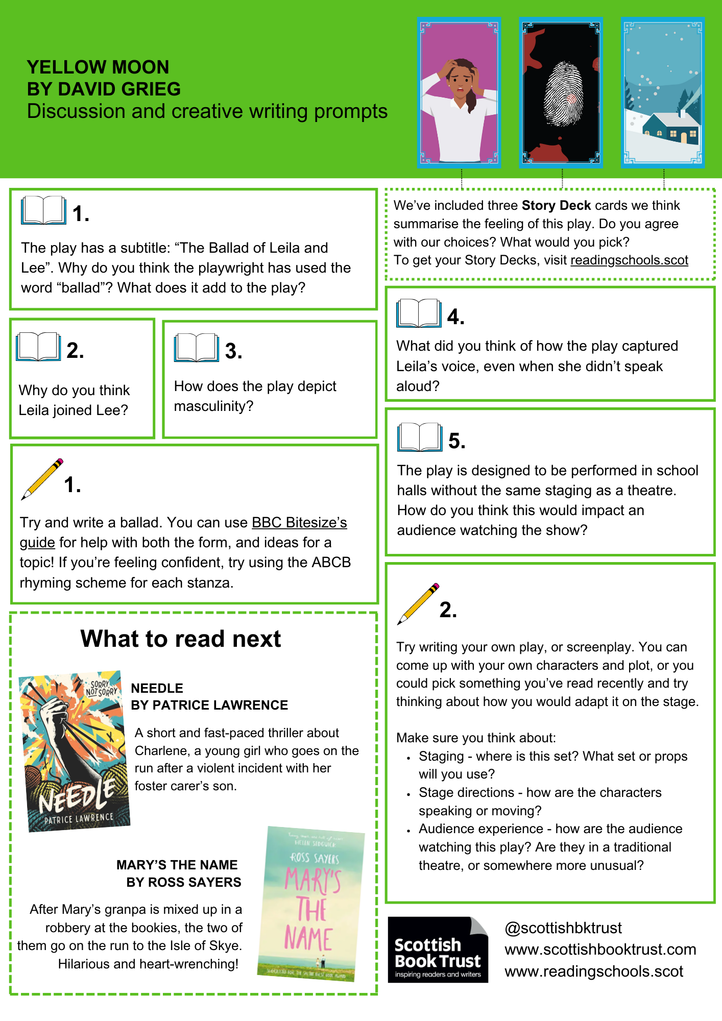

“Things My Wife and I Found Hidden in Our House” by Kirsty Logan
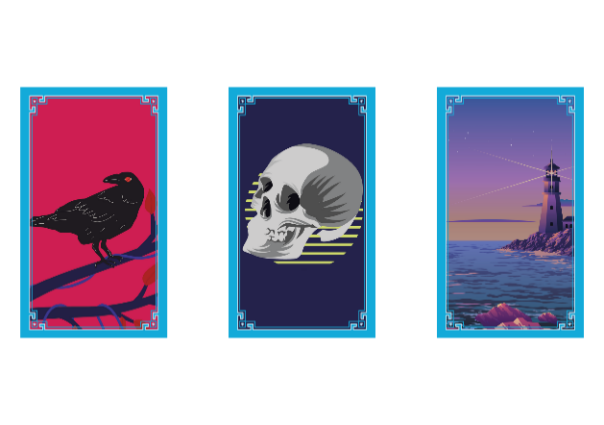
We’ve included three Story Deck cards we think summarise the feeling of this story.
Do you agree with our choices?
What would you pick?

Discussion questions
- Why do you think the author structured the story as a list? What is the importance of each object?
- How does the story create a sense of unease? What techniques stood out to you?
- Does this story fit your idea of a “haunted house” story? What is different about it?
- What did you think of the ending? What is the impact of the story ending when it does? Did you see it coming, or were you surprised?

Creative writing prompts
- Write from the perspective of an object. You could use one of the objects in the story, or use Edwin Morgan’s poem “Gasometer” for inspiration. What would your object see? How would it understand the world that it lives in?
- Research a Scottish mythical creature - you could choose one you know, like a kelpie, selkie or the Loch Ness Monster, or search for something new to you. Are there any local myths or interesting pieces of folklore in your local area? Now imagine you’ve been sent to track down this mythical creature and write a report about your encounter.

What to read next
The Gracekeepers by Kirsty Logan
Another book from the same author – this time set aboard a floating circus.
Hold Back the Tide by Melinda Salisbury
A dark story set in the Scottish Highlands. Filled with murder, betrayal and a cold and lonely loch.

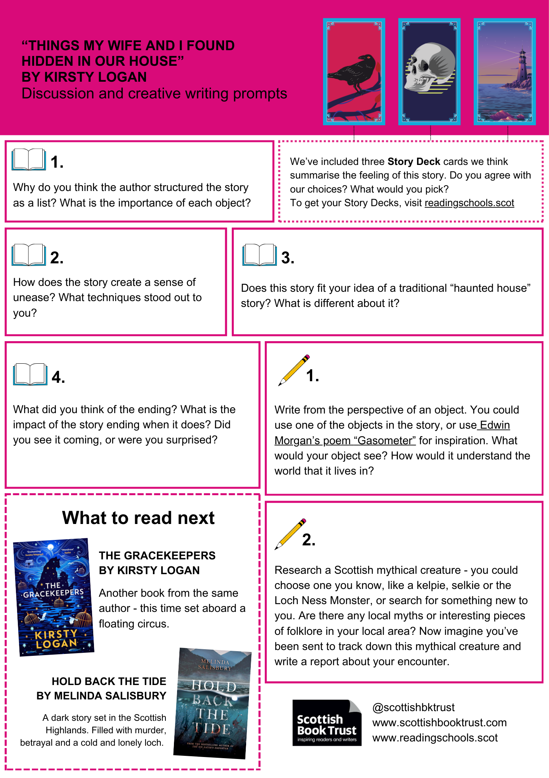

“Auntie” by Nadine Aisha Jassat
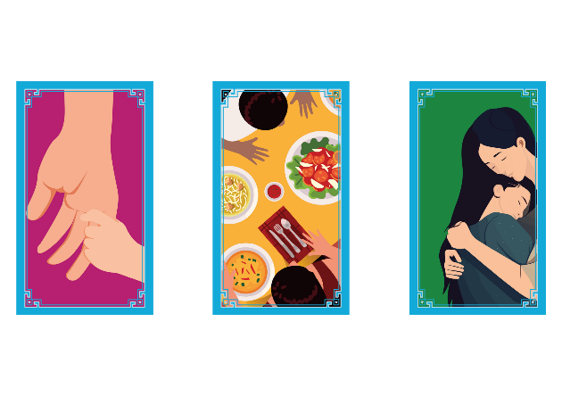
We’ve included three Story Deck cards we think summarise the feeling of this poem.
Do you agree with our choices?
What would you pick?

Top tip: you can watch Nadine Aisha Jassat talk about her writing on Authors Live!

Discussion questions
- How would you sum up this poem in one word?
- How does the writer show how they feel about their aunt? What techniques do they use?
- How does the writer create a sense of calm in the poem? What words or images do you notice?
- Which senses did you notice in the poem? How did this effect how you read it?

Creative writing prompts
- Imagine you are in charge of turning this poem into a short film and write a script. What would each shot be? What would the characters be doing? What would they say to each other?
- The poem contains references to the auntie’s cooking and her time in the kitchen. In your group, talk about the best meal you have ever eaten and where you ate it. Now, write a paragraph describing something you loved to eat and where you at it. Take some time to think over the details and set the scene. What could you see, smell and hear? What did the meal taste like? Who did you eat it with?

What to read next
Let Me Tell You This by Nadine Aisha Jassat
More poems by the same author!

The Black Flamingo by Dean Atta
A novel-in-verse about finding, and celebrating, your identity.

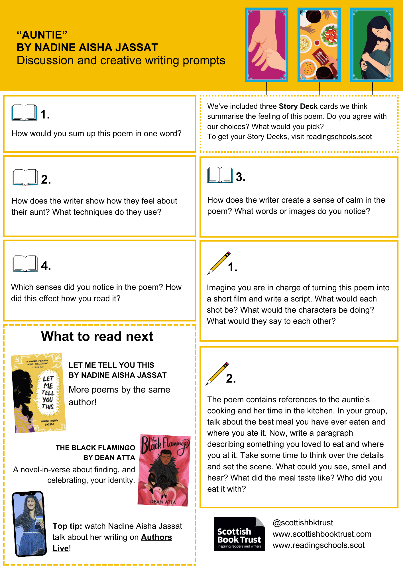

The Sunlight Pilgrims by Jenni Fagan
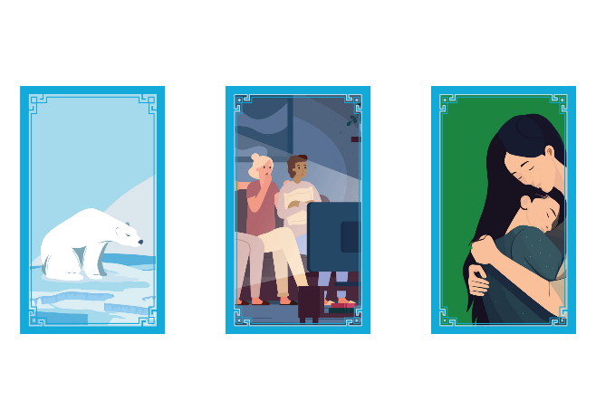
We’ve included three Story Deck cards we think summarise the feeling of this book.
Do you agree with our choices?
What would you pick?

Discussion questions
- Which point of view did you prefer – Dylan’s or Stella’s? Why?
- The novel has been described as being “set at the end of the world”. What did you think of how the novel depicted living through extreme weather? Was it realistic? Did anything surprise you?
- How were Dylan, Constance and Stella isolated from Clachan Fells?
- Do you think this novel is optimistic or pessimistic?
- The novel ends suddenly. What did you think of the ending? What do you think happened?

Creative writing prompts
- In the novel, characters stay in an Ikea to shelter from the weather. Choose a shop you have visited and imagine you had to stay overnight. Where would you sleep? What would you eat? What would you like to go snooping through?
- What do you think happened next? Write an epilogue to The Sunlight Pilgrims telling us what you think happened to Dylan, Constance, Stella and Alistair.

What to read next
The Girl Who Broke the Sea by A. Connors
Something in the dark is calling to the rig’s newest inhabitant. A cli-fi thriller about a deep-sea mining rig on the brink of discovery!

Feast of Ashes by Victoria Williamson
Set in 2123, this novel imagines life after climate disaster. When Adina accidentally destroys her eco bubble, she discovers her life isn’t what she thought it was.

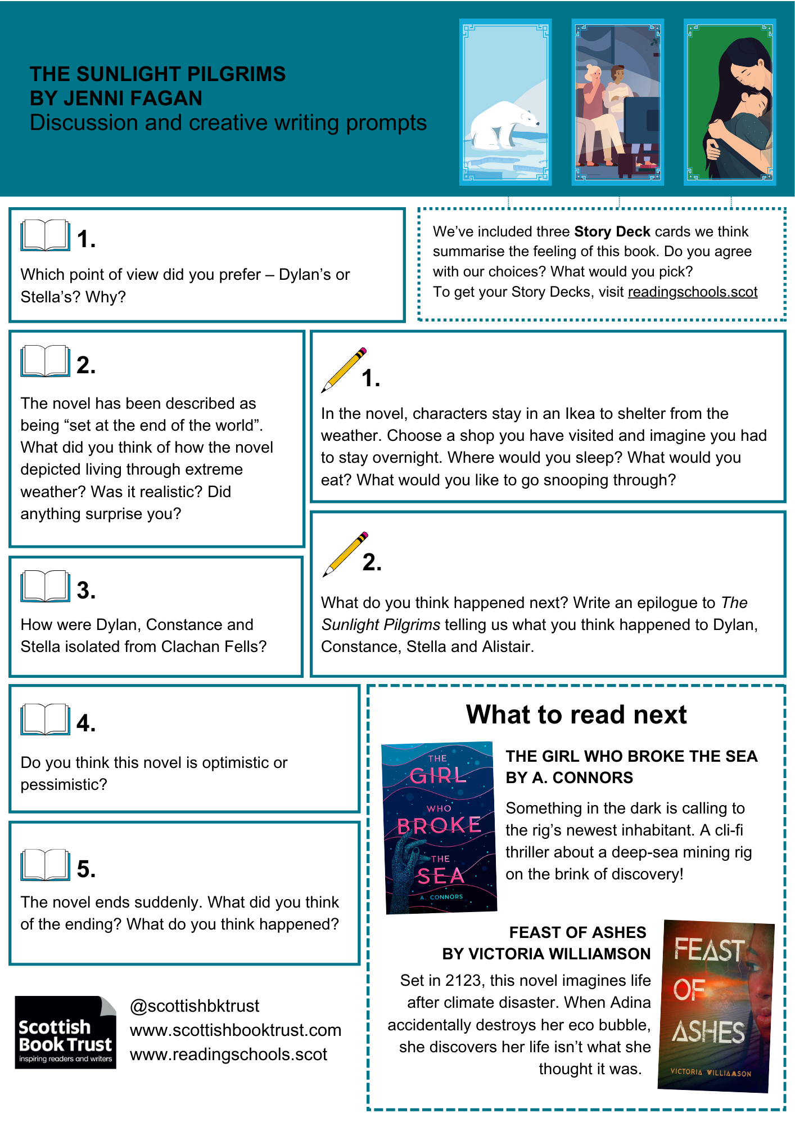

Sequamur by Donald S. Murray
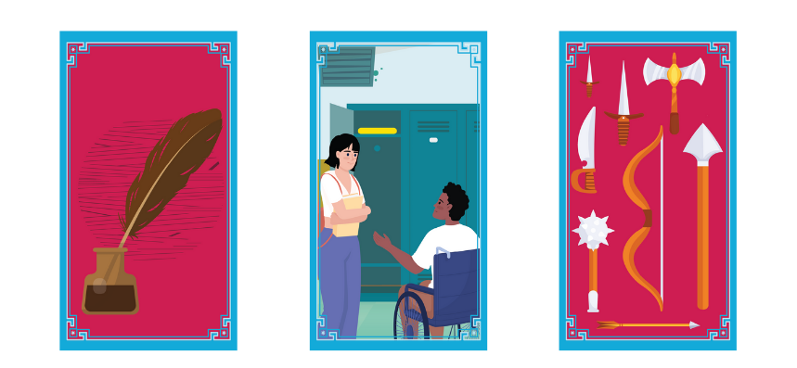
We’ve included three Story Deck cards we think summarise the feeling of this play.
Do you agree with our choices?
What would you pick?

Discussion questions
- How is war described or depicted to the young men in the play?
- What do you think is the relevance of Gibson teaching classics? How does what he teach connect to his life, both in 1914, and in the 1930s?
- Do you think there’s a difference between regret and guilt? Which do you think this play is exploring?
- How does the play depict women’s experience of World War I?
- ‘It’s the fault of those people who encouraged him. As if it were an adventure. As if it was a way of seeing the world.’ Do you agree with Jessie about who is to blame for the soldier’s experience of the war? Who, or what, else might be to blame?

Creative writing prompts
- Write from the perspective of one of the young boys in Gibson’s class. What did he think going to war was going to be like? How had it been described to him? What was his actual experience like?
- Write a letter in the style of a soldier, nurse or other worker on the front lines. What would they notice? What details would they include? What might they not include if they’re sending this letter to family? How would they convey what they’re experiencing?

What to read next
The 306: Dawn by Oliver Emanuel
Commissioned by the National Theatre of Scotland, this play is inspired by real WWI soldiers who were killed for desertion.
The Big Lie by Julie Mayhew
In a reimagined world where Nazis won WWII, two friends decide how far they’ll go to challenge an oppressive regime.

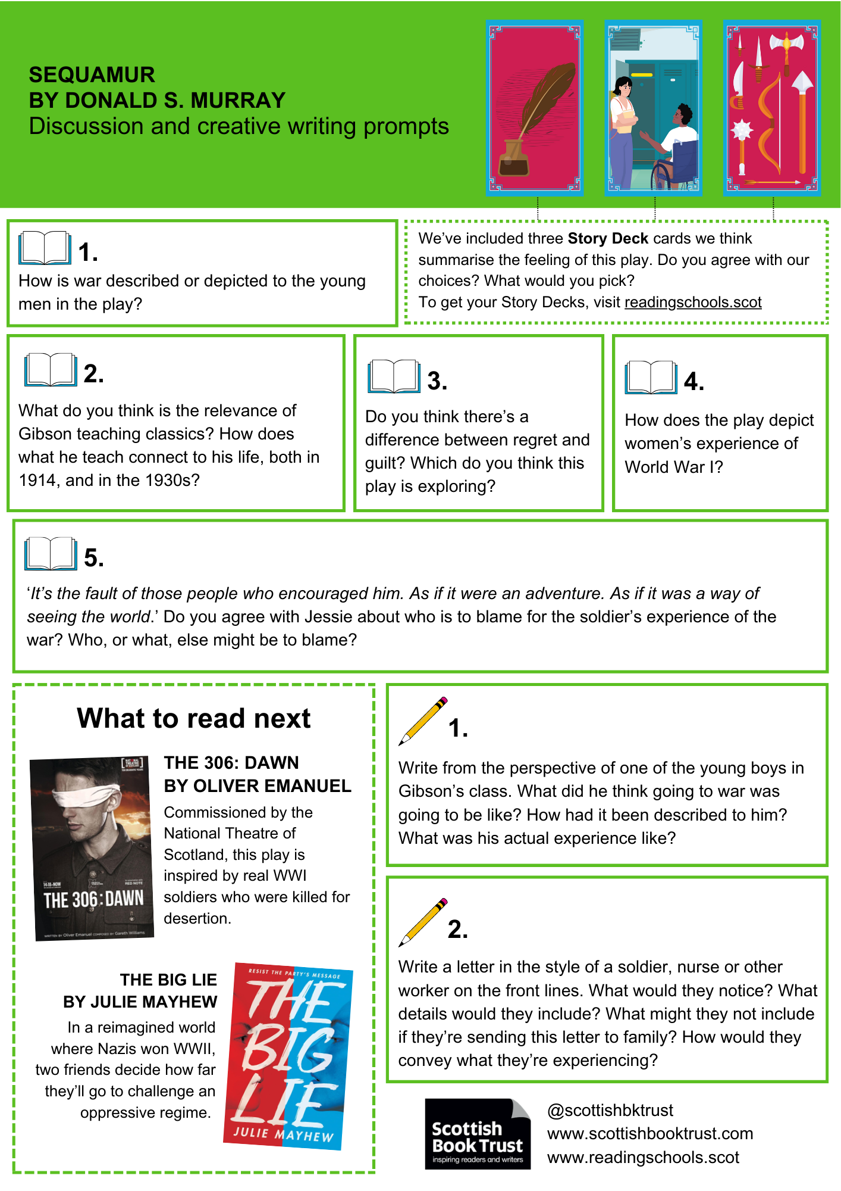

“A Voice Spoke to Me at Night” by Helen McClory
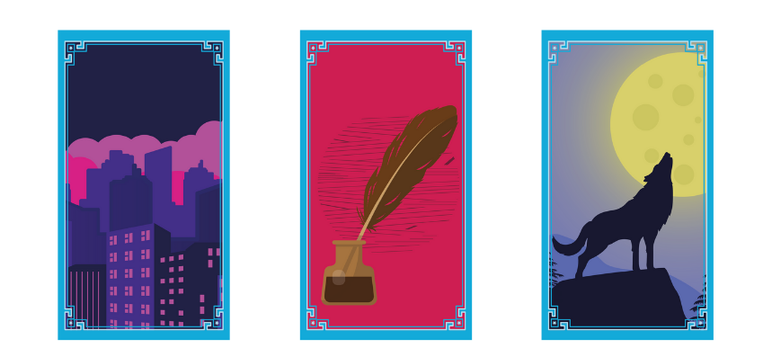
We’ve included three Story Deck cards we think summarise the feeling of this story.
Do you agree with our choices?
What would you pick?

Discussion questions
- How does the author make the familiar feel weird or discomforting?
- ‘This part of town seems to be historyless’. Do you think any place can be without a history? Does the history of a place have an impact on people living in it today?
- How does the short story capture the feeling of loneliness and isolation?
- What genre do you think this story is? Is it easy or hard to categorise?

Creative writing prompts
- Imagine you see someone in a mirror in your house. Write a short paragraph about your interaction. Who is this person, or being? When, or where, are they from? What would you tell them about your life? Would you trust them?
- Use a branching narrative to create a spooky story where it’s up to the readers what happens next. Do they investigate a scary sound in the basement or try to ignore it? Do they walk home via a scary forest or through an echoing cave? You can use Code.org’s template to map your story out.

What to read next
Us in the Before and After by Jenny Valentine
A beautiful book about grief and ghosts.
Tales from the Inner City by Shaun Tan
Unusual short stories that examine our relationship with nature and place.

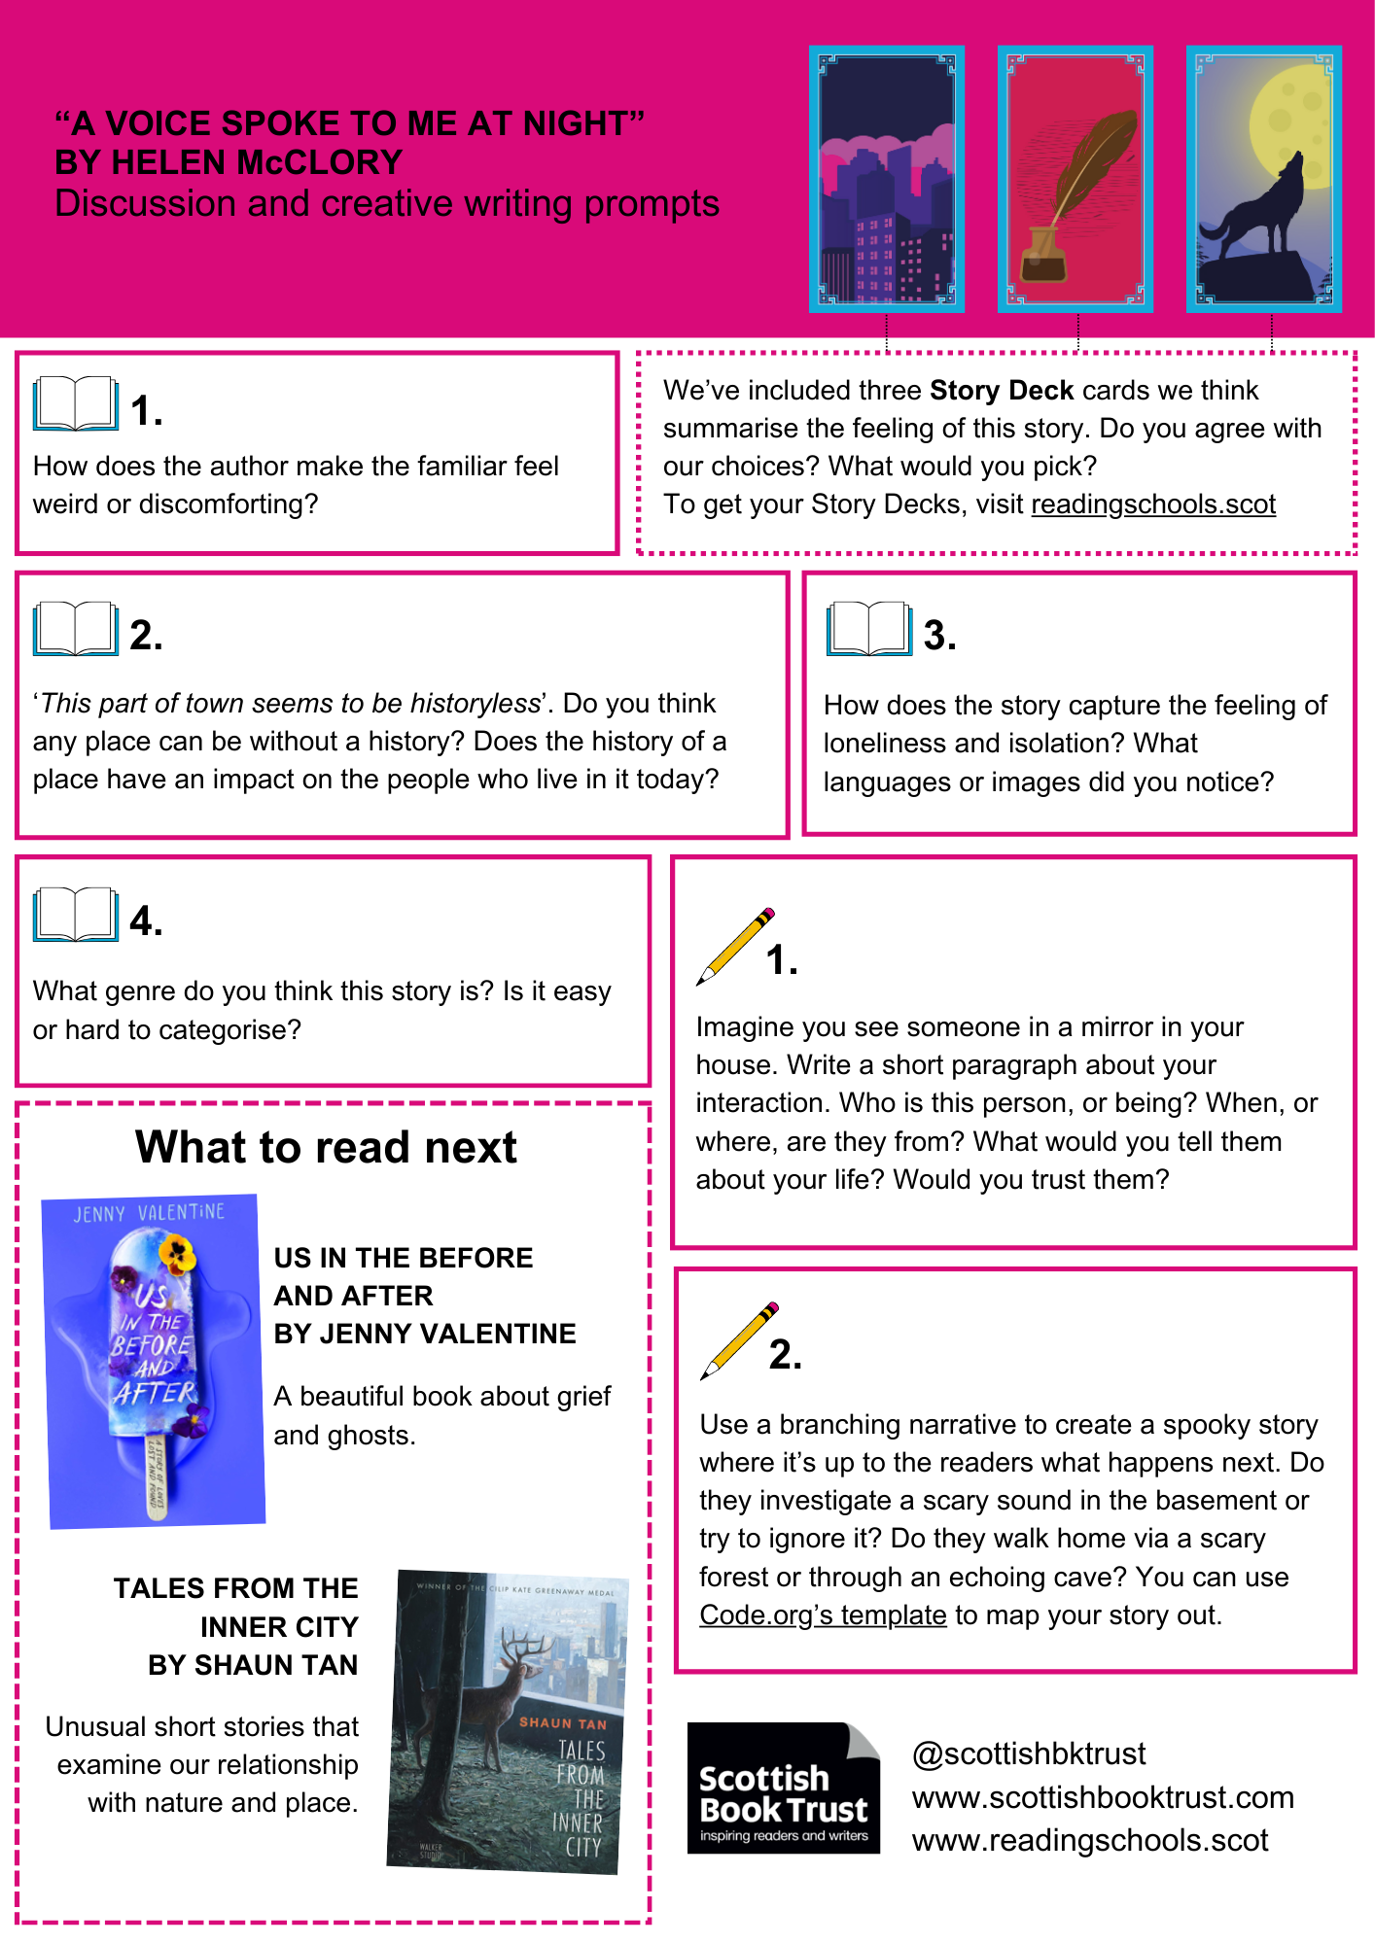

Poems from Luck is the Hook by Imtiaz Dharker
Poems included: “Bairn”, “Bloom”, “Letters to Glasgow”, “Send This”, “Stich” and “The Knot”, originally published in Luck is the Hook.
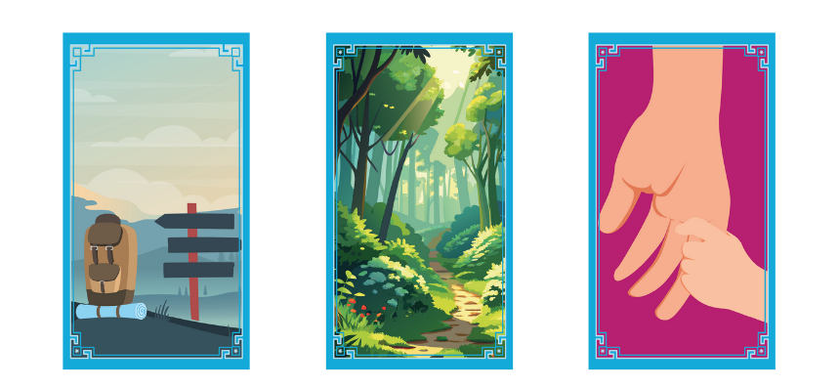
We’ve included three Story Deck cards we think summarise the feeling of these poems.
Do you agree with our choices?
What would you pick?

Discussion questions
- Which poem was your favourite?
- What do you think the poems have in common?
- ‘[...] the high, the low, the road we did not take.’ How do the poems interact with the theme of luck or chance? What images or ideas do you associate with the idea of luck? What images or ideas does the poet use?
- A few of the poems follow someone on a journey. Why do you think this image is repeated?
- What do these poems have to say about Scotland and Scottish identity?

Creative writing prompts
- Think about the idea of “luck”. You could write about a time you were lucky, a story featuring a lucky escape, or look up old superstitions around luck, such as broken mirrors or walking under ladders and use them for inspiration.
- Using “Letters to Glasgow” as inspiration, write about a journey you have taken. It could be a bus you’ve sat on a hundred times, what you see as you walk around your school, or a school trip or holiday you went on. Think about your senses – what did you see on the journey? What could you hear? Did you listen to the sound of train, or listen to music? What could you smell? How did you feel?

What to read next
Tomorrow is Beautiful, poems chosen by Sarah Crossan
Poems for hope, comfort and joy.
The Crossing by Manjeet Mann
This novel-in-verse beautifully captures two different cultures and voices.

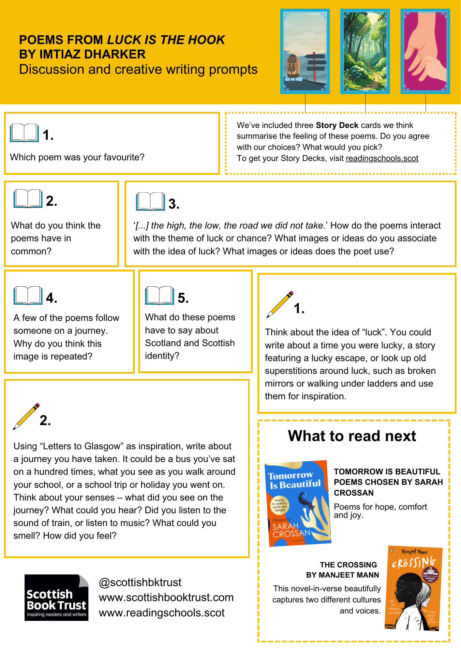

Further resources
- For more discussion guides, see our Teen book discussion guides which provide discussion questions, creative writing prompts and reading suggestions for contemporary teen titles
- For more creative writing resources, see the Creative writing for schools section of our website. You can also direct pupils to our Young Writers section where they can find advice and resources to support writing for pleasure
- For more book recommendations, see our Book Discovery Guide and Book lists
- For more activities and advice for using your Story Deck, see the Story Deck resources on our Reading Schools website

