Our learning resources for specific books

About this resource
You can search this resource for specific titles or authors. Each title is linked to the resource page on our website where you can download the activity pack for each book in different formats. You can also find all of our resources by visiting the Learning and resources section of the Scottish Book Trust website.

Second Level texts
Cover image | Title and author | Themes
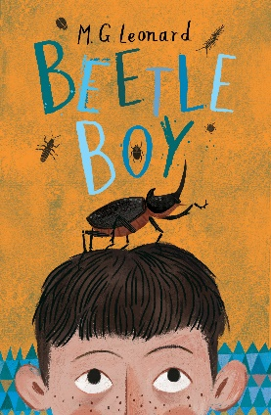 | Beetle Boy by M.G Leonard | Make a book trailer, design your own beetle-inspired jewellery and head outside to explore eco-systems and make a bug hotel using these cross-curricular activities.
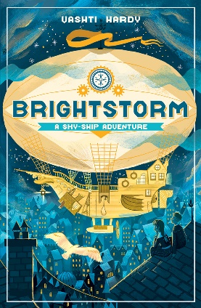 | Brightstorm by Vashti Hardy | Perfect if you’re doing a topic on polar regions, these cross-curricular activities prompt you to imagine your own polar fantasy creature, build a 3D exploration scene and write your own adventure story! This is part of our Polar learning resource.
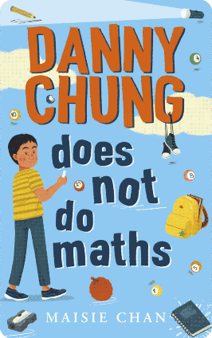 | Danny Chung does not do Maths by Maise Chan | Whilst this is a positive, funny and heartwarming story, issues of racism and discrimination are central to the book. These cross-curricular activities can be used to explore stereotypes and bullying as well as to inspire golden ratio art, role play and computer game design. This is part of our Read Woke South Ayrshire resource, which empowers learners to engage with social justice issues.
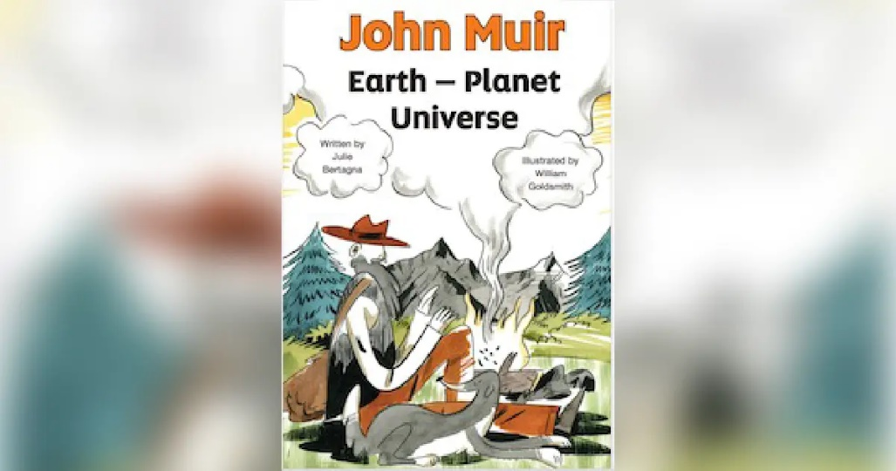 | John Muir, Earth – Planet, Universe by Julie Bertagna and William Goldsmith | This graphic novel, based on the life and adventures of John Muir, is free to download and is designed to develop a deeper understanding and awareness of the natural environment and the importance of protecting wild places. Become a nature detective, research Scottish inventors, and discover how the landscape of Scotland was created using these cross-curricular activities.
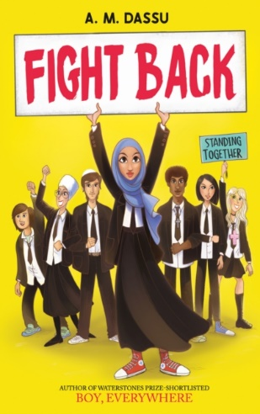 | Fight Back by A.M Dassu | Fight Back explores the importance of being free to make our own choices and decisions without prejudice. These cross-curricular activities inspire discussions about identity and what makes a good friend, and give ideas for how to get active about issues you care about. This is part of our Read Woke South Ayrshire resource, which empowers learners to engage with social justice issues.
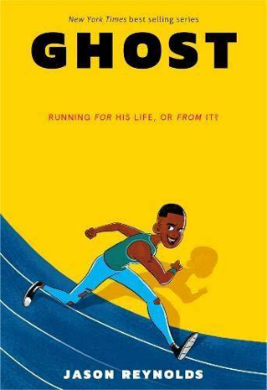 | Ghost by Jason Reynolds | Use inspirational quotes from the story to help you write a poem, make a running log and try out different exercises for wellbeing or research the history of world records using these eight cross-curricular activities. This is part of our Read Woke South Ayrshire resource, which empowers learners to engage with social justice issues.
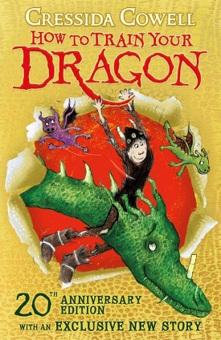 | How to Train Your Dragon by Cressida Cowell | Design your own dragon, reinvent the game ‘bashyball’, and write your own training manual! This resource also includes fun and engaging cross-curricular activities to use in response to the film adaptation.
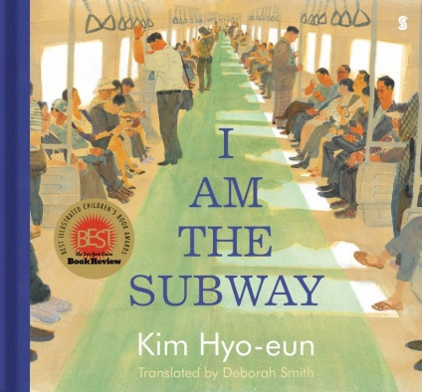 | I Am the Subway by Kim Hyo-eun | Use the picture book to spot moments of kindness, plan a trip to Seoul, and play with percussion to explore a train’s rhythm with these eight cross-curricular activities suitable for first and second level. This is part of our Read Woke South Ayrshire resource, which empowers learners to engage with social justice issues.
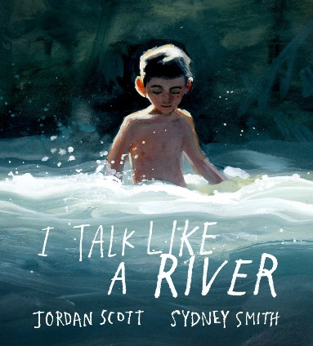 | I Talk Like a River by Jordan Scott and Sydney Smith | Use this picture book about a boy who stutters as inspiration to write your own similes, make a rain garden and explore the sounds of a river. These eight cross-curricular activities are suitable for first and second level and are part of our Read Woke South Ayrshire resource, which empowers learners to engage with social justice issues.
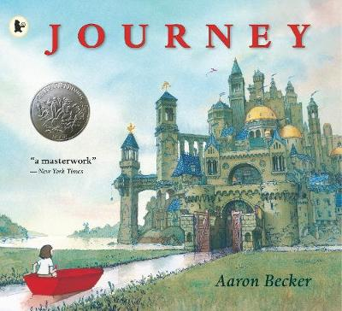 | Journey by Aaron Becker | Explore where your magical crayon might take you, create a journey stick and use mime to reflect different emotions using these cross-curricular activities. This resource can be used as a whole school core book project.
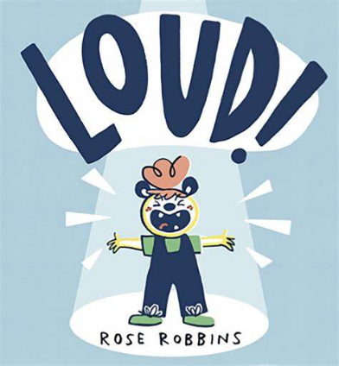 | LOUD! by Rose Robbins | LOUD! is a picture-book full of sounds and textures, making it perfect for sensory-storytelling. The recommended props and actions described in this resource will bring the book to life for all ages and abilities. Suitable for first to fourth level.
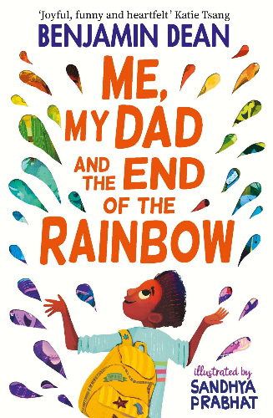 | Me, My Dad and the End of the Rainbow by Benjamin Dean | Learn about the history of Pride then research a cause you’re passionate about, design your own Pride event flyer, and write a short story about a time you were lost using these cross-curricular activities. These eight cross-curricular activities are suitable for first and second level and are part of our Read Woke South Ayrshire resource, which empowers learners to engage with social justice issues.
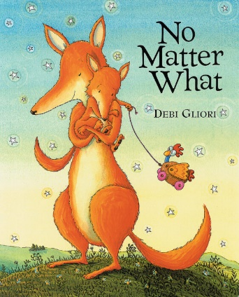 | No Matter What by Debi Gliori | Explore body language connected to different emotions and practise being a good listener using this picture book as a prompt. These health and wellbeing activities are part of a resource to support children through grief and loss. Suitable for early to third level.
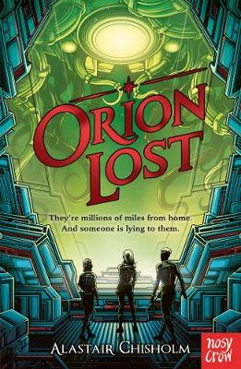 | Orion Lost by Alastair Chisholm | Design and make your own robot out of recycled material. Write a fact-file for it and display your robot in a space museum exhibition.
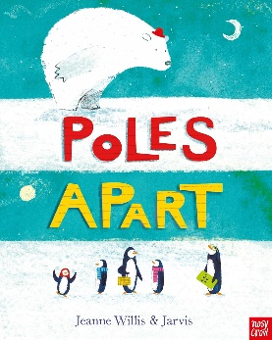 | Poles Apart by Jeanne Willis and Jarvis | Inspired by this picture book, research penguins and find out more about where they live, what they eat and how they communicate.
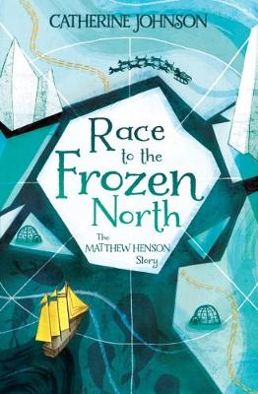 | Race to the Frozen North: The Matthew Henson Story by Catherine Johnson | Plan an expedition, research unrecognised heroes, and build your own shelter using these cross-curricular activities which will spark discussions around exploration and discrimination in this remarkable true story. This is part of our Read Woke South Ayrshire resource, which empowers learners to engage with social justice issues.
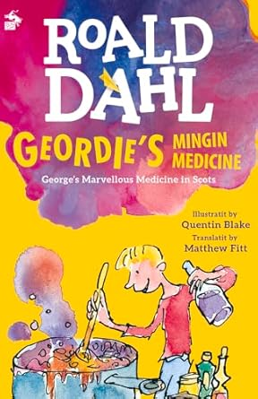 | Roald Dahl’s Geordie’s Mingin Medicine by Matthew Fitt | Start your own dictionary of your favourite Scots words, write your own Scots recipe and get dramatic with the hilarious scene “Grannie Taks the Medicine”. These cross-curricular activities are designed for a project on Scots language and can be used with other Scots language translations of Roald Dahl books.
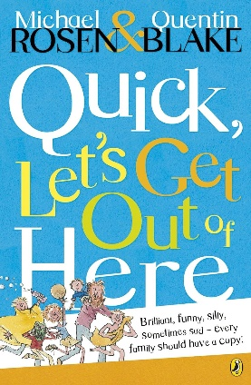 | Selection of Poems by Michael Rosen | Build confidence discussing, writing and performing poetry using these fun cross-curricular activities. These activities have been designed to be used with five poems by Michael Rosen which are included in the resource.
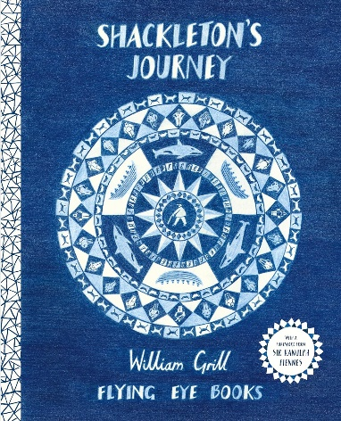 | Shackleton’s Journey by William Grill | Learn about Ernest Shackleton’s expedition to the Antarctic on the ship Endurance in this informative picture book, count the number of provisions the crew took with them and get inspired to build your own boat.
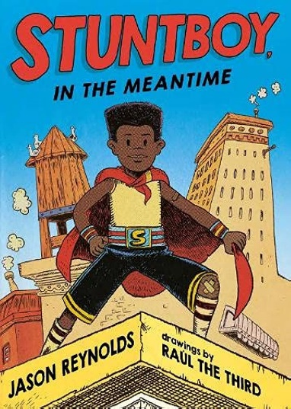 | Stuntboy, in the Meantime by Jason Reynolds | Write a poem about a special object, play around with compound words and make an advert for a new friend using these eight cross-curricular activities. This resource explores how we deal with our emotions, how we navigate conflict, and where to find support amongst friends and community. It is part of our Read Woke South Ayrshire resource, which empowers learners to engage with social justice issues.
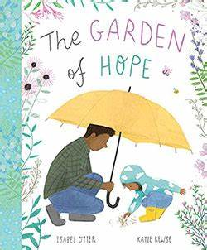 | The Garden of Hope by Isabel Otter and Katie Rewse | Using this picture book, explore how worries feel and make your own worry doll. These health and wellbeing activities are part of a resource to support children through grief and loss. Suitable for early to third level.
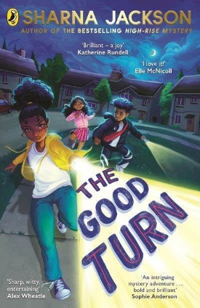 | The Good Turn by Sharna Jackson | Come up with a group name and your key values then design your own badge and uniform like the Copseys in The Good Turn. Trace the route the HMT Windrush took to the UK and learn about the experiences of the Windrush generation using these eight cross-curricular activities. This is part of our Read Woke South Ayrshire resource, which empowers learners to engage with social justice issues.
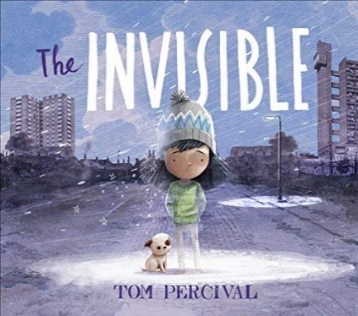 | The Invisible by Tom Percival | In The Invisible, themes of homelessness and poverty are central to the story. Explore these themes using our activities – you could choose an invisible character and write a story about them or make a home for a class teddy bear. These activities are part of our Read Woke South Ayrshire resource, which empowers learners to engage with social justice issues, and are suitable for first and second level.
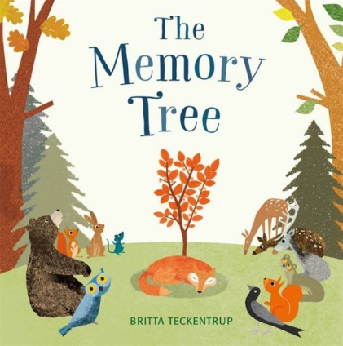 | The Memory Tree by Britta Teckentrup | Explore how memories make us feel and make a memory box for Fox using these health and wellbeing activities. This resource can be used to support children through grief and loss. Suitable for early to third level.
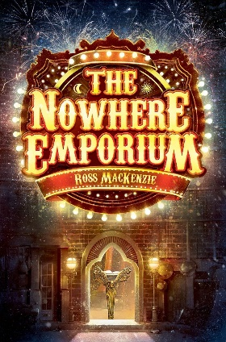 | The Nowhere Emporium by Ross Mackenzie | Make your own book of wonders, research a city and create a snow globe from a jam jar using these four cross-curricular activities.
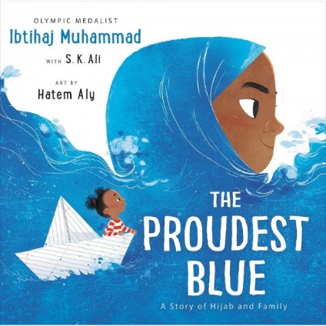 | The Proudest Blue by Ibtihaj Muhammad, with S.K Ali, and Hatem Aly | This picture book explores sibling bonds and explains the importance of hijab within the Muslim faith. Learn about Islamic beliefs, make your own similes, design a paper boat and practise cartwheels using these 11 cross-curricular activities. These activities are part of our Read Woke South Ayrshire resource, which empowers learners to engage with social justice issues, and are suitable for first and second level.
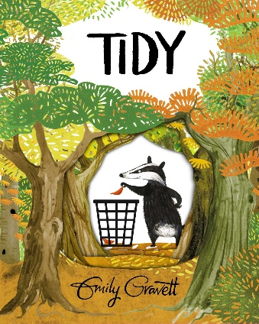 | Tidy by Emily Gravett | Design a tool to help keep your playground tidy, research different kinds of leaves and draw your own badger with these cross-curricular activities. This resource can be used as a whole school core book project.
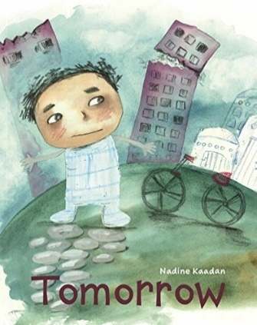 | Tomorrow by Nadine Kaadan | This picture book is about experiences of Syrians living through war. Using these cross-curricular activities, you could write a letter to a refugee, make a pledge for peace and learn about Syrian culture. These activities are suitable for first and second level and are part of our Read Woke South Ayrshire resource, which empowers learners to engage with social justice issues.
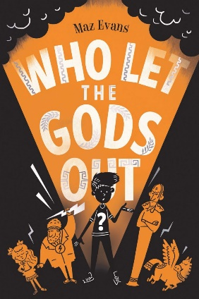 | Who Let the Gods Out? by Maz Evans | Retell your own Greek myths, record a news broadcast, and create a comic book using these five cross-curricular activities.
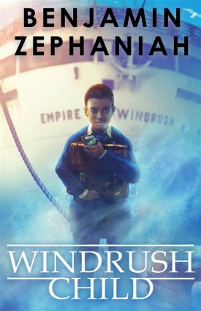 | Windrush Child by Benjamin Zephaniah | Make your own joy journal, experiment with trying to heat your classroom room, explore children’s rights and cook some Jamaican recipes using these eight cross-curricular activities. This resource is part of our Read Woke South Ayrshire resource, which empowers learners to engage with social justice issues.
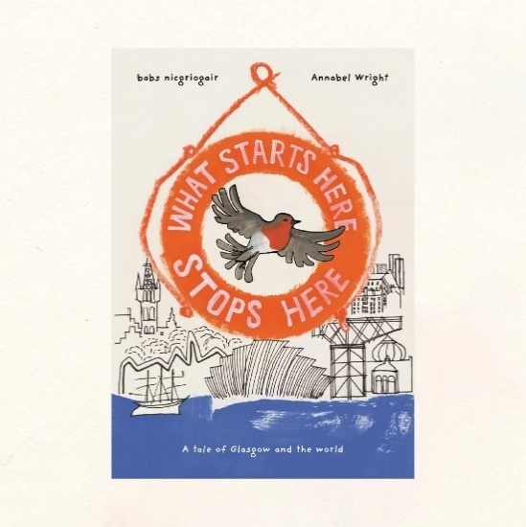 | What Starts Here Stops Here by Hope Street Collective | The book follows a robin who is blown off course by a gale, and journeys back in time through the history of Glasgow. It focuses on the connection between colonialism and climate change. This resource will help you create your own version of the book to reflect on your local area. Each activity is designed to help you gather material for the book and learn more about colonialism, protest and climate change.

