Our learning resources for specific books

About this resource
You can search this resource for specific titles or authors. Each title is linked to the resource page on our website where you can download the activity pack for each book in different formats. You can also find all of our resources by visiting the Learning and resources section of the Scottish Book Trust website.

First Level texts
Cover image | Title and author | Themes
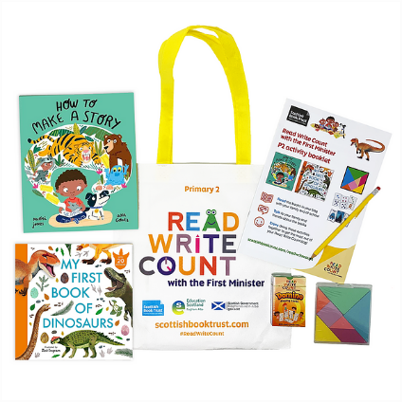 | Read Write Count books | Each year, we gift picture books to P1, P2 and P3 children across Scotland. Each book comes with fun and inclusive cross-curricular activities and games. Visit our website to find the resources for the books this year.
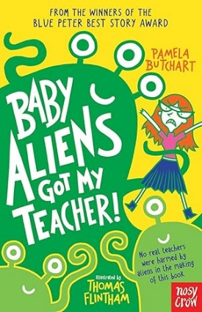 | Baby Aliens Got My Teacher by Pamela Butchart | Produce a TV news broadcast, build your own campaign and design an alien awareness poster using this cross-curricular resource.
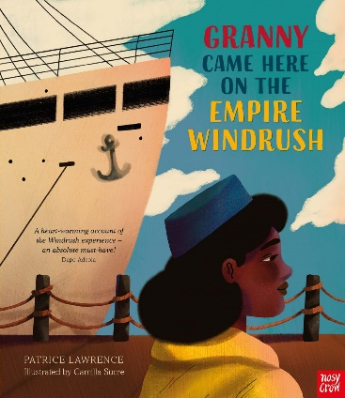 | Granny came here on the Empire Windrush by Patrice Lawrence | Make a storyboard, cook Carribean food, design a suitcase, and talk about what you would take with you if you were moving to another country using these seven cross-curricular activities. This is part of our Read Woke South Ayrshire resource, which empowers learners to engage with social justice issues.
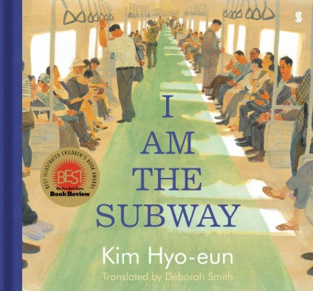 | I Am the Subway by Kim Hyo-eun | Use the picture book to spot moments of kindness, plan a trip to Seoul, and play with percussion to explore a train’s rhythm with these eight cross-curricular activities suitable for first and second level. This is part of our Read Woke South Ayrshire resource, which empowers learners to engage with social justice issues.
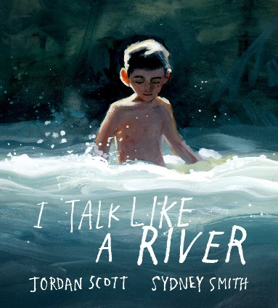 | I Talk Like a River by Jordan Scott and Sydney Smith | Use this picture book about a boy who stutters as inspiration to write your own similes, make a rain garden and explore the sounds of a river. These eight cross-curricular activities are suitable for first and second level and are part of our Read Woke South Ayrshire resource, which empowers learners to engage with social justice issues.
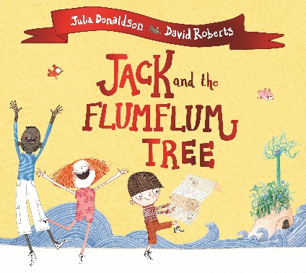 | Jack and the Flumflum Tree by Julia Donaldson and David Roberts | Make your own patchwork sack, play a memory game and experiment with floating and sinking using these eight cross-curricular activities suitable for early and first level.
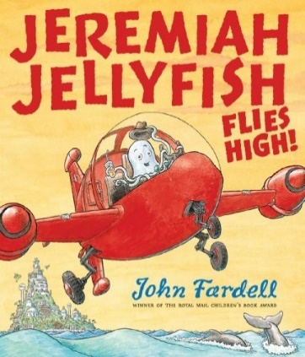 | Jeremiah Jellyfish Fies High by John Fardell | Explore the world of work, create your own job advert and write a letter to a rocket manufacturer using these fun cross-curricular activities.
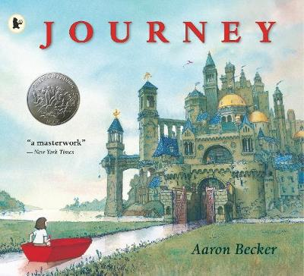 | Journey by Aaron Becker | Explore where your magical crayon might take you, create a journey stick and use mime to reflect different emotions using these cross-curricular activities. This resource can be used as a whole school core book project.
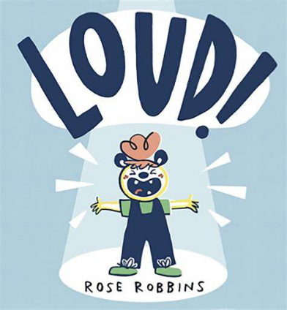 | LOUD! by Rose Robbins | LOUD! is a picture-book full of sounds and textures, making it perfect for sensory-storytelling. The recommended props and actions described in this resource will bring the book to life for all ages and abilities. Suitable for first to fourth level.
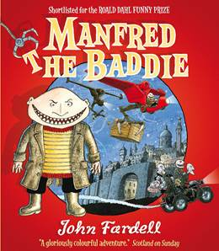 | Manfred the Baddie by John Fardell | Design your own invention, write a poem about your favourite comfort food and create a hideout with these cross-curricular activities.
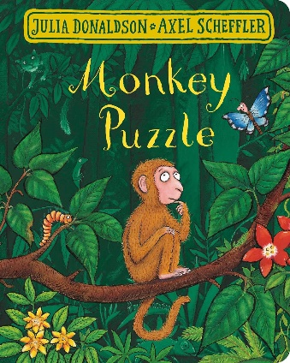 | Monkey Puzzle by Julia Donaldson and Axel Scheffler | Roleplay different animals, go for a nature walk and make your own symmetrical butterflies using these nine cross-curricular activities suitable for early and first level.
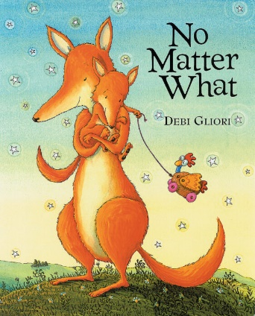 | No Matter What by Debi Gliori | Explore body language connected to different emotions and practise being a good listener using this picture book as a prompt. These health and wellbeing activities are part of a resource to support children through grief and loss. Suitable for early to third level.
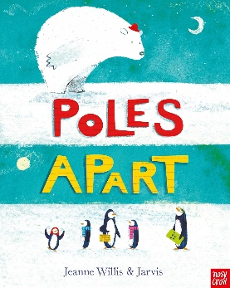 | Poles Apart by Jeanne Willis and Jarvis | Inspired by this picture book, research penguins and find out more about where they live, what they eat and how they communicate.
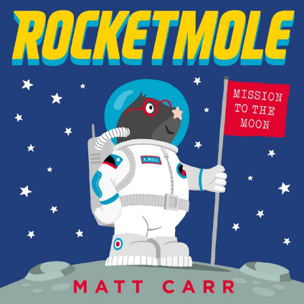 | Rocketmole by Matt Carr | Get space-inspired by this picture book! Design your own spaceship and explore what home comforts you’d like to take with you.
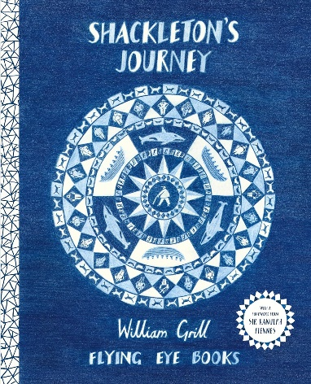 | Shackleton’s Journey by William Grill | Learn about Ernest Shackleton’s expedition to the Antarctic on the ship Endurance in this informative picture book, count the number of provisions the crew took with them and get inspired to build your own boat.
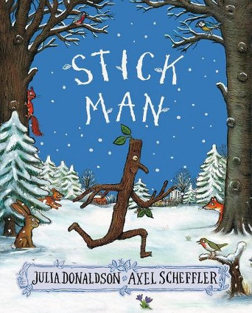 | Stick Man by Julia Donaldson and Axel Scheffler | Create a class story, play pooh sticks and design your own stick man with these seven cross-curricular activities suitable for early and first level.
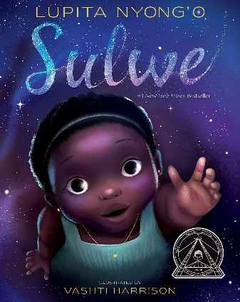 | Sulwe by Lupita Nyong’o and Vashti Harrison | Make a human sundial, explore your unique skin tone, and play with rhyming words using these eight cross-curricular activities suitable for early and first level. This is part of our Read Woke South Ayrshire resource, which empowers learners to engage with social justice issues.
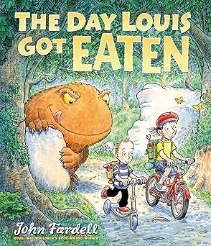 | The Day Louis Got Eaten by John Fardell | Make your own origami frog, explore food chains and plan a healthy menu for the monsters in the story using these six cross-curricular activities.
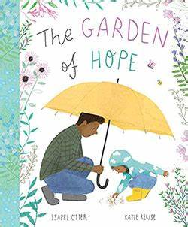 | The Garden of Hope by Isabel Otter and Katie Rewse | Using this picture book, explore how worries feel and make your own worry doll. These health and wellbeing activities are part of a resource to support children through grief and loss. Suitable for early to third level.
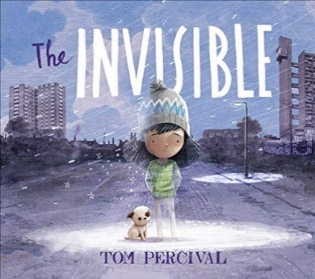 | The Invisible by Tom Percival | In The Invisible, themes of homelessness and poverty are central to the story. Explore these themes using our cross-curricular activities – you could choose an invisible character and write a story about them or make a home for a class teddy bear. These activities are part of our Read Woke South Ayrshire resource, which empowers learners to engage with social justice issues, and are suitable for first and second level.
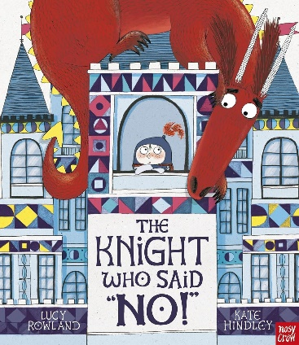 | The Knight who said “No!” by Lucy Rowland and Kate Hinley | Make a sensory castle corner, act out different jobs and use drama to role-play having a ‘yes’ then a ‘no’ day using these inclusive activities suitable for early and first level. You could then have a go at making your own dragon using our sensory art project resource.
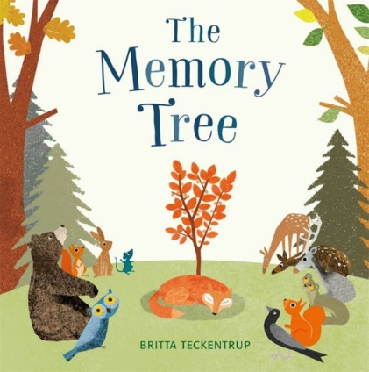 | The Memory Tree by Britta Teckentrup | Explore how memories make us feel and make a memory box for Fox using these health and wellbeing activities. This resource can be used to support children through grief and loss. Suitable for early to third level.
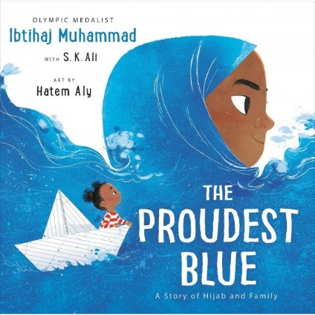 | The Proudest Blue by Ibtihaj Muhammad, with S.K Ali, and Hatem Aly | This picture book explores sibling bonds and explains the importance of hijab within the Muslim faith. Learn about Islamic beliefs, make your own similes, design a paper boat and practise cartwheels using these 11 cross-curricular activities. These activities are part of our Read Woke South Ayrshire resource, which empowers learners to engage with social justice issues, and are suitable for first and second level.
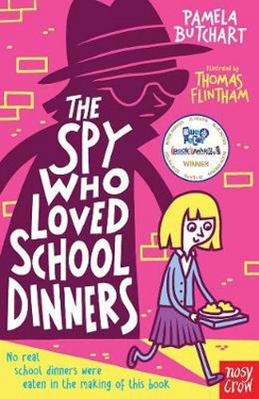 | The Spy Who Loved School Dinners by Pamela Butchart | Plan an exchange visit to Paris, design your dream library and write a new story about Izzy and her friends using these three cross-curricular activities.
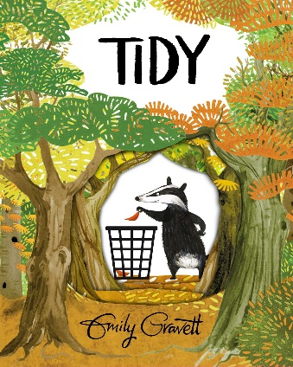 | Tidy by Emily Gravett | Design a tool to help keep your playground tidy, research different kinds of leaves and draw your own badger with these cross-curricular activities. This resource can be used as a whole school core book project.
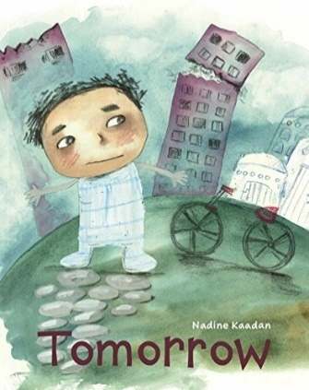 | Tomorrow by Nadine Kaadan | This picture book is about experiences of Syrians living through war. Using these cross-curricular activities, you could write a letter to a refugee, make a pledge for peace and learn about Syrian culture. These activities are suitable for first and second level and are part of our Read Woke South Ayrshire resource, which empowers learners to engage with social justice issues.
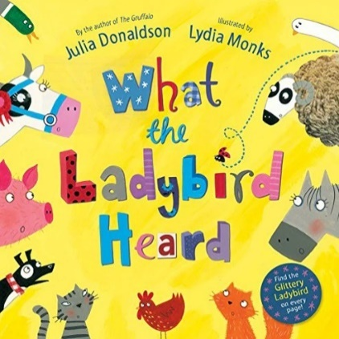 | What the Ladybird Heard by Julia Donaldson and Lydia Monks | Create a farmyard scene, throw a party or make a news report using these cross-curricular activities suitable for early and first level.

