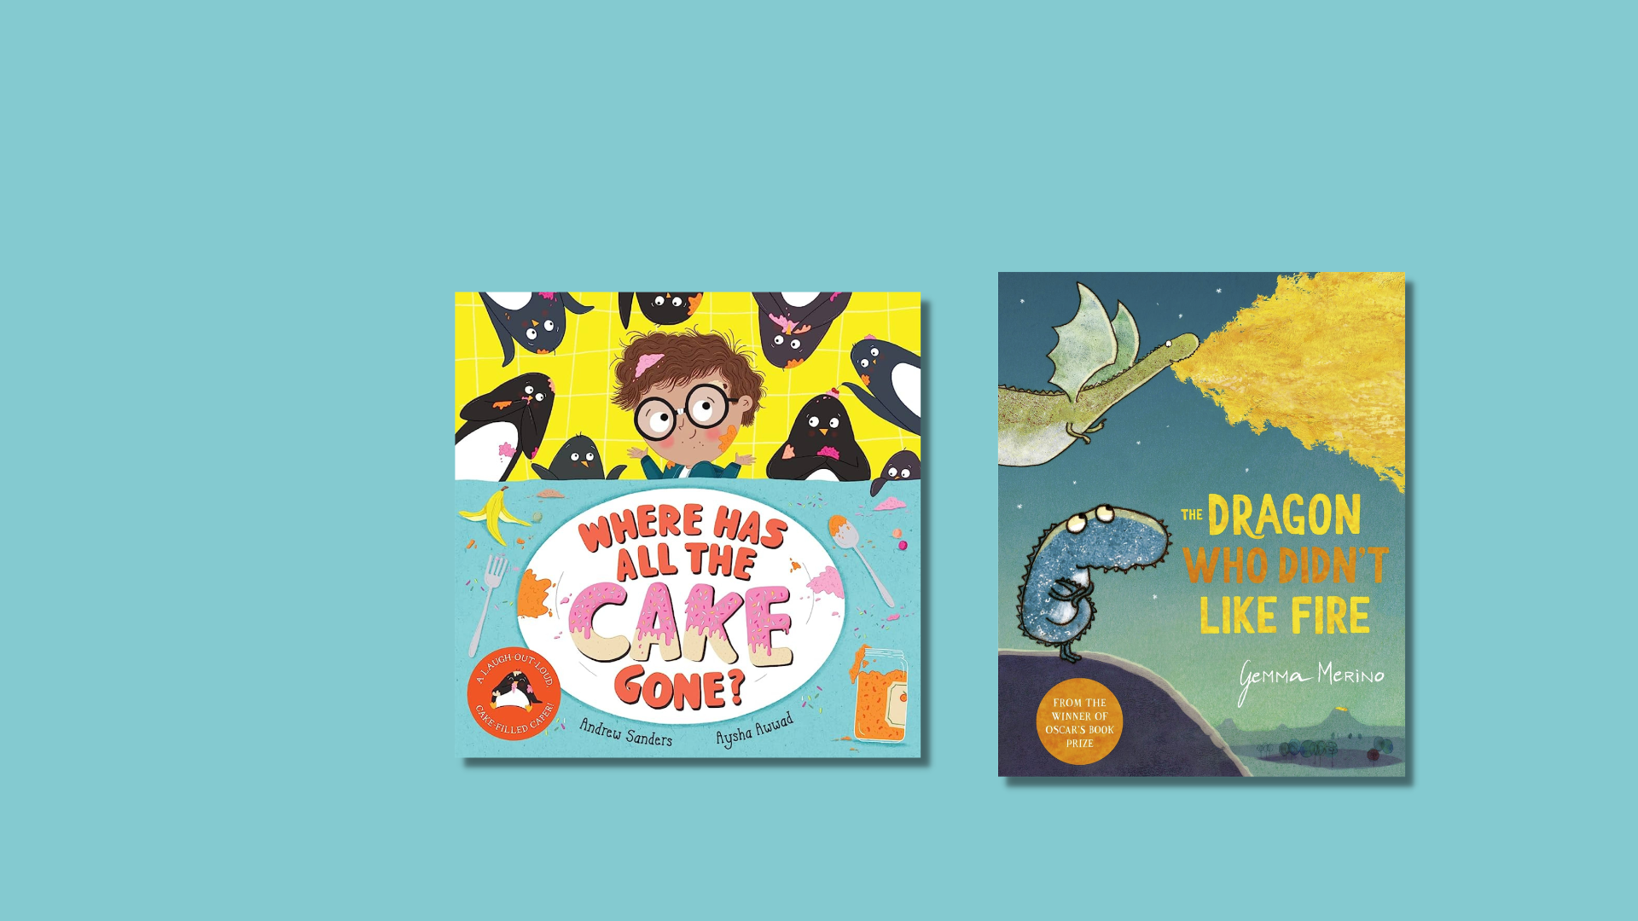

Read Write Count P2 inclusive activities
Activities for the Read Write Count P2 bag, designed for children with additional support needs.

Resource created by Ailie Finlay

scottishbooktrust.com
Scottish Book Trust is a registered company (SC184248)
and a Scottish charity (SC027669).

Contents
About this resource 2
Where Has All the Cake Gone? activities 2
The Dragon Who Didn’t Like Fire activities 4
Tangram activities 6
Shape Shuffle card activities 6
Act It Out card activities 7
Talk It Out cards activities 7
Further resources 8

About this resource
The aim of this resource is to make the items in the Read Write Count P2 bag accessible to all. The activities can be used with pupils with a variety of needs, including additional support needs, English as an additional language or those who are disengaged from or struggle with reading.
These activities are flexible and we encourage you to adapt them, whether in school, community groups or at home.

Where Has All the Cake Gone? activities

Activity 1: Simple sensory story with smells
Your child may enjoy a simpler version of the story – try missing out the middle section (where Albert explains what has happened to the cake) and create a simple story about the cake disappearing and being replaced.
You could add in some smells and props. Start with the title page – show your child the picture of the cake and say: ‘Dad made a cake! The cake smelt of vanilla!’
Use a mixing bowl and a wooden spoon to make some mixing noises and actions. You could use some vanilla essence if you have some to make a nice cake smell.
Turn to the third last double page in the book and share the picture of the penguins and the mess. Make the noises of penguins eating and running around (stamp your feet). Say:
‘The penguins at the cake.
The penguins ran all about.
The penguins made a mess.’
Use scrubbing brushes, dusters and cloths – or just mime the cleaning actions. You could have some soap to smell as well. ‘Dad cleaned up.’
Share the picture of Albert and his dad making the cake. ‘And we made a new cake!’
Use the mixing bowl and spoon again to finish off the story (and the vanilla essence if you have it).

Activity 2: Make a cake hand rhyme
Use your fist to make a “layer of cake” by placing it on the table in front of you with your thumb on top – then your child can add a layer by putting their fist on top of yours. Then you add a layer on top of that – and so on, until you have a four-layer cake with all your fists on top of each other. Try naming the cake layers as you go, e.g.: Chocolate, butter icing, ice cream, sprinkles…
You could finish it with “candles” then blow them out together!
See the “One Potato, Two Potato” song on the Bookbug Song and Rhyme Library for insight into how to do the rhythm.

Activity 3: Spot the difference
Try carefully holding the book so you can see the title page and the last double page at the same time – now you can see the first cake and the second cake together. What is different about them? What is the same?

Activity 4: Steal the cake game
Use an object for the “cake” – anything will do! Put the “cake” at your feet and close your eyes. Your child then quietly steals the cake and hides it somewhere not too far away. Count to ten then open your eyes – ‘Oh no the cake has gone!’ – hunt for it and once you’ve found it, try switching roles.

The Dragon Who Didn’t Like Fire activities

Activity 1: Make a sensory dragon
Share the picture of the dad dragon with the children. Make a multi-sensory version of the dragon! Here are some suggestions:
- ‘I am a dragon. I have sharp teeth.’: Try cutting sharp teeth out of a yoghurt pot.
- ‘I am a dragon. I have little hands.’: Put on washing up gloves and clap them together!
- ‘I’m a dragon. I have flappy wings.’: Flap a pillowcase, or something similar.
- ‘I’m a dragon. I like to puff.’: Use the book as a fan to make some dragon’s breath.

Try creating your own sensory dragon. Maybe your dragon has stretchy antennae, a furry tummy or bumpy scales? For more inspiration see our Let there be dragons: a tactile and sensory art project, where you can create your own dragon together as a class.

Activity 2: Underwater dragon
Cut a small dragon or crocodile shape out of something that will be okay in water (e.g. an empty juice carton or an old sponge). Don’t worry too much about the colour or shape – your child will use their imagination!
Then give your child a washing up bowl (or something similar) full of water and let them play out the scene in the book where the dragon goes under the water. You could put some stones or small toys in the water or cut a “door” in an old yoghurt pot to make a cave home for the dragon/crocodile. You could add ice cubes for little icebergs or slices of oranges or lemon to make the water smell nice!
Encourage your child to tell you what their dragon can see, hear and feel under the water.

Activity 3: Scribble trees
The illustrator has drawn some lovely simple trees in the background. Can you and your child draw some trees like these? Or maybe your child can start with a scribble and you can turn it into a tree (or something else)?

Activity 4: Five little dragons
Maybe your child would like to hear a familiar rhyme… turn to the page where the Daddy Dragon is flying over the sea. Share the picture and this rhyme with your child:
Six little ducks went swimming one day
Over the hills and far away
Mama duck said, "Quack, quack, quack, quack!"
And all those little ducks came back…
Then turn the page where five of the dragons are flying a loop-the-loop:
Five little dragons went flying one day
Over the hills and far away
Papa Dragon said, "Puff, puff, puff, puff!"
And all the little dragons came back…
Then turn the page where the dragon finds the water is “amazing”:
Lots and lots of fish went swimming one day
Over the waves and far away
Mama fish said, "Blub, blub, blub, blub!"
And all the little fish came back…

Tangram activities

Activity 1: Fit the shape
On a sheet of paper draw round the individual tangram shapes. Then help your child to fit the right wooden shape into the right drawn shape. You could make it trickier by drawing round two shapes together.

Activity 2: Tangram cakes and biscuits
Pile up the tangram pieces to make a multi-layered cake (like the one in Where Has All The Cake Gone) or some pretend sandwiches or cakes. Have some pretend cups of tea with your pretend picnic!

Shape Shuffle card activities

Activity 1: How many?
Using one type of small object (such as Lego bricks, teaspoons or sweets) put them into groups with a different number in each group. Then ask your child to match the number cards to the number in the group. For example, put down one piece of Lego, two pieces of Lego and three pieces of Lego in separate groups. Give your child the cards with 1, 2 and 3 on them and ask them to put the card down next to the correct number of Lego pieces.

Activity 2: Hat count
For a slightly sillier game, gather together all the hats you have in your house (sun hats, winter hats, baby hats etc.). Let your child choose a random number card and then attempt to balance that number of hats on your head, counting as you do so.

Act It Out card activities

Activity 1: Activity actions
Take it in turns to act out the activities for each other – can the other person guess what you are doing? To make it simpler you can choose three cards, lay them out, mime one of the activities and then the other person guesses which of the three actions it is.

Activity 2: Guess who?
Take out the animal cards (and maybe the ghost card as well) – choose three or four of these and lay them in front of your child. Make the noise of one of the animals and see if your child can guess which one. Take it in turns to make animal noises and guess. Try making some extra animal cards to add to the different noises! (You could use the templates in the activity booklet for this).

Talk It Out cards activities

Activity 1: This or that
Try offering your child two choices to make things simpler when using these cards. For example, for the describe your perfect day card you might say: ‘Tell me about your perfect day. Would you go swimming or would you go to the park?’
Or, instead: ‘If you were an animal what would you be you might ask: Would you rather be a cat or a dog?’
You could use the activity cards to help your child with describe your perfect day and tell me about the things that make you happy. They can choose from the activities in the cards. You could also make some extra cards for them to choose from showing things that you know they enjoy.

Activity 2: Guided drawing
Another option for the Talk It Out cards is to draw an answer for your child – but let them guide you as you draw. For example, in answer to describe your dream dinner you might start drawing chips, then check with your child: would you want chips – if they say no rub out the chips and start again!

Activity 3: Diary question
If your child has a home-school diary jotter you could tape one of the question cards about their day into the diary. (For example, what cool thing happened today). You can then read or listen to the answer with your child at the end of their day.

Further resources
- For further resources to support children with additional support needs, see the Disability and Neurodiversity section of our website including our Make your own sensory story resource, created by Ailie Finlay.
- For further resources to support use of the Read Write, Count bags see the Read Write Count section of our website.
- You can find more of Ailie Finlay’s work on the Flotsam and Jetsam and My Kind of Book websites.

