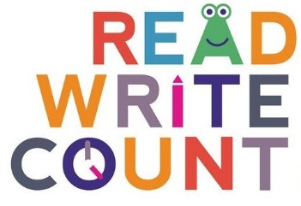
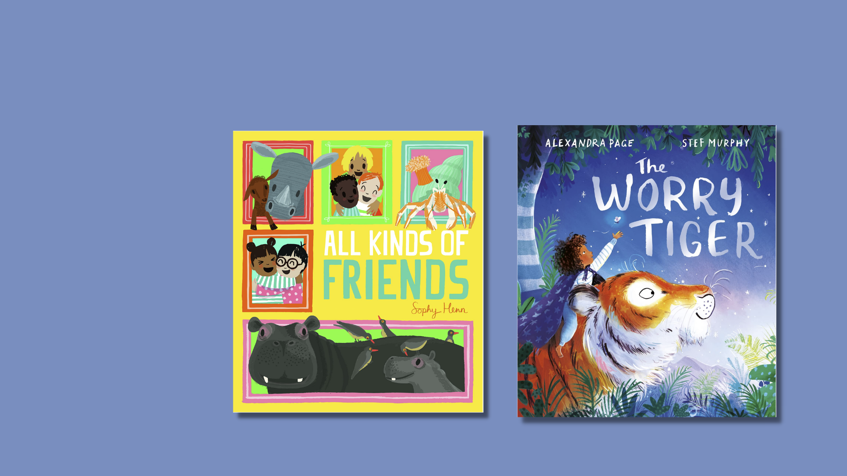

Read Write Count library session: P3 Bag
A library session for the Read Write Count P3 bag including songs, crafts and worksheets and printables

scottishbooktrust.com
Scottish Book Trust is a registered company (SC184248)
and a Scottish charity (SC027669).

Contents
About this resource 2
Welcome to the session 3
Reading the books 3
Songs and rhymes 3
Main activity 4
Goodbye and finding books to take home 4
Printable 1: What to read after your P3 Read, Write, Count books 6

About this resource
We’ve put together a session for each of this year’s Read, Write, Count bags so you can run interactive family sessions in your library. These can be adapted to suit the duration of storytelling sessions in your library.
Each session includes:
- Reading the book together
- Choices of songs to sing together
- Choices for a main activity or arts and crafts
- Suggestions to help families find their next read
Whilst Read, Write, Count gifts bags to children in P2 and P3, you can keep these sessions open to all families and they don’t rely upon the families having prior knowledge of the books. The contents of this year’s bags are as follows:

P2
- Where Has All the Cake Gone? by Andrew Sanders
- The Dragon Who Didn’t Like Fire by Gemma Merino
- A tangram
- A pack of cards containing the games Shape Shuffle, Act it Out and Talk it Out

P3
- All Kinds of Friends by Sophy Henn
- The Worry Tiger by Alexandra Page and Stef Murphy
- A tape measure
- A pack of cards containing the games Beastie Battle, Story Cards and Dominoes

Welcome to the session
Welcome everyone to the session, saying hello to all the adults and children in turn. You could use “The Hello Song” from the Bookbug Song and Rhyme Library or Bookbug app to warm the group up.

Reading the books
Read All Kinds of Friends aloud to the group, making sure everyone can see the pages and hear you. Allow the children to stop and ask questions or take time to look at the illustrations. Now, read The Worry Tiger aloud to the group. Afterwards, you could ask the children to talk about which of the books they liked more.

Songs and rhymes
For singing together, you could choose between:
- “If You’re Happy and You Know It” – you could replace “happy” with “friendly” to talk about the different friends in All Kinds of Friends
- “A Leopard Has Lots of Spots” – explore being a leopard or tiger!

If You’re Happy and You Know It (via the Bookbug Song and Rhyme Library)
If you’re happy and you know it, clap your hands
If you’re happy and you know it, clap your hands
If you’re happy and you know it,
And you really want to show it
If you’re happy and you know it, clap your hands

A Leopard Has Lots of Spots (via the Bookbug Song and Rhyme Library)
A leopard has lots of spots
What a lot of spots he’s got!
A tiger has stripes
Like long, thin pipes
But a leopard has lots of spots, spots, spots, spots, spots…

Main activity

Option 1: Arts and crafts
In The Worry Tiger, Rory and the tiger explore a rainforest together. Make your own tree out of handprints. Make one big tree that you display in your library by asking each child create a leaf for the tree by printing their hand using paint, or draw around it with pens. Make sure you have enough materials that children can also make one to take home.

Option 2: Musical statues
Play a game of animal musical statues. Play some music – you could use the Bookbug Song and Rhyme Library or the Bookbug app. Before you pause the music, call out an animal that everyone has to pretend to be.

Goodbye and finding books to take home
At the end of your sessions, you can explore some books that are similar to All Kinds of Friends and The Worry Tiger in theme or topic. Explain to the children they can borrow them and take them home. See page 6 for a printable collection of books we’d recommend as next reads.

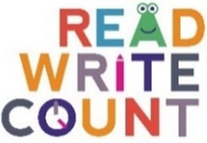

Printable 1: What to read after your P3 Read, Write, Count books
If you enjoyed All Kinds of Friends by Sophy Henn, we think you might like:
- We Are Family, Patricia Hegarty
- Frank and Bert by Chris Naylor-Ballesteros
- Five Bears by Catherine Raynor

If you enjoyed The Worry Tiger by Alexandra Page and Stef Murphy, we think you might like:
- The Worrysaurus, Rachel Bright and Chris Chatterton
- Ruby’s Worry by Tom Percival
- Mr. Tiger Goes Wild by Peter Brown

And here’s some space for you, your librarian or your family to write down some books you might like:

