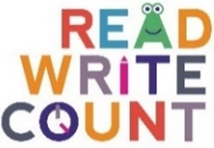

Penguin cake scavenger hunt
Cut out the penguins and cakes and hide them throughout your library. Ask the families to try and find them together. Once they’ve found them all, see if they can match the penguins to the same coloured cake!
