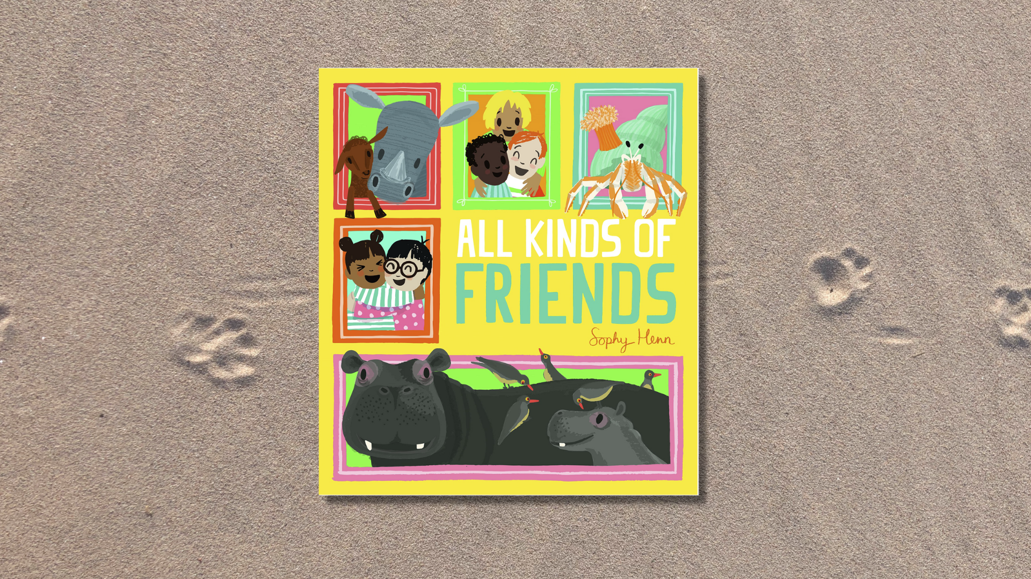

Read, Write, Count: All Kinds of Friends STEM learning activities
STEM learning activities based on All Kinds of Friends by Sophy Henn

Age 6-8

CFE First Level

Resource created by Raising Aspirations in Science Education (RAiSE)

scottishbooktrust.com
Scottish Book Trust is a registered company (SC184248)
and a Scottish charity (SC027669).

Contents
About this resource 2
Learning activities 2
Further resources 4

About this resource
This resource was developed by Raising Aspirations in Science Education (RAiSE) and provides links to some suggestions for further STEM learning activities to complement and enhance children’s learning from one of the books included in this year’s Primary 3 Read, Write, Count bag. The key themes explored in these activities are: food chains, interdependence, senses, and biodiversity.

Learning activities

Activity 1: Venn diagrams
MNU 1-20a
Explore what is the same and what is different between you and your friends. Make links to maths skills using a Venn diagram to sort information. You can find an example Venn Diagram template on Twinkl.

Activity 2: Hermit crabs and dependence
SCN 0-01a/1-01a, SCN 1-02a
Watch the clip from the BBC (2 minutes, 5 seconds) to find out about hermit crabs and how they depend on each other.

Activity 3: Hermit crabs and anemones
SCN 0-01a/1-01a, SCN 1-02a,
When hermit crabs change shells, they often take their anemone with them! Watch this clip from BlueWorld TV on YouTube (2 minutes, 39 seconds) to find out more.

Activity 4: Forest bathing
SCN 1-12b, SOC 0-08a, SOC 1-07a
In the book we learned that langur monkeys have excellent eyesight and zebras have an excellent sense of smell. Use all of your senses outdoors in this Forest Bathing activity from Learning through Landscapes – simply spending time in and with nature, letting it invade our being using all of our senses.

Activity 5: Smell that!
HWB 1-15a, SCN 1-12b
Zebras have excellent sense of smell! Explore the sense of smell by covering some plastic bottles using a sock and identifying what is inside from the smell alone, use this Activity on page 11 from this year’s British Science Week activity packs.

Activity 6: Food chains
SCN 1-02a
Oxpecker birds eat ticks, and the wren was helping to feed the bluetits. Support learning about food chains using the resource from BBC Bitesize.

Activity 7: Biodiversity and interdependence
SCN 1-02a
This Interdependence in Food Webs activity from Learning through Landscapes helps children to visualise the concept of biodiversity interdependence. It can support work on food chains.

Activity 8: Camouflage catepillars
MTH 1-13a
In the book, the wren was fetching food for the blue tit chicks. Use the Learning Through Landscapes active game “Camouflage Caterpillars” to develop understanding of adaptation, food chains and encourages number process work through play.

Activity 9: Bird feeders
TCH 1-01a, SOC 1-08a
Use the RSPB Wild Challenge website to plan, or build, your own bird feeder.

Activity 10: Endangered species
SCN 1-02a
Use the WWF’s teaching resources to learn more about endangered species. The Dundee Science Centre website contains information about endangered species within Scotland.

Further resources
- Find more learning activities for all the books and resources included in the Read, Write, Count bags on our website:
  - Learning resources for the P2 bags
  - Learning resources for the P3 bags
- Find out more about RAiSE on the Education Scotland website

