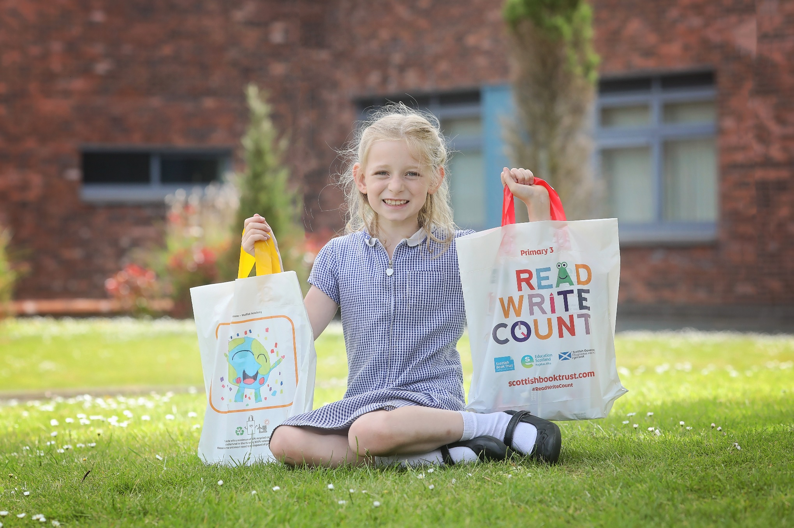

Read Write Count worksheet tasks
Task instructions from our printable PDF worksheets in an accessible format

Resource created by Scottish Book Trust

scottishbooktrust.com
Scottish Book Trust is a registered company (SC184248)
and a Scottish charity (SC027669).

Contents
Make a story map for Where Has All The Cake Gone? 2
Draw yourself for All Kinds of Friends 2
Design your own pair of socks for The Dragon Who Didn't Like Fire 2
Design your own butterfly for The Worry Tiger 3
Bingo – ‘Find someone who…’ 3
Measuring using the tape measure 4
Design your own dream cake 5
Draw your own postcard 5
Window view 5
Animal fact file 5
Create a comic strip 6

Make a story map for Where Has All The Cake Gone?
Create your own story map to retell the events of the story in sequence. In three boxes, draw what happens in the story and write a few sentences beside each panel to explain what happened, ‘first’, ‘next’ and ‘finally’.

Draw yourself for All Kinds of Friends
In a frame outline, draw a picture of yourself with your friends, family or loved ones. Add labels to describe what makes these relationships special. Design a pattern for your frame. Cut out your picture frame for a class gallery of your artwork.

Design your own pair of socks for The Dragon Who Didn't Like Fire
Draw or print the outline of a pair of socks. What colours would you use, what materials would you make them from and what patterns would add?
Colour, paint, or stick fabric, wool or paper to the socks below. If you want, you can label your picture to explain your design.

Design your own butterfly for The Worry Tiger
Draw or print the outline of a butterfly. Can you make its wings symmetrical?

Bingo – ‘Find someone who…’
Answer the questions below, then try to find someone in your class or group who has the same answers as you.

Questions about you
- What colour is your hair?
- What is your favourite food?
- How many brothers and sisters do you have?
- What colour are your eyes?
- What is your favourite book?

Find someone
- Find someone who has the same hair colour as you. Write down their name.
- Find someone who likes your favourite food. Write down their name.
- Find someone who has the same number of brothers and sisters as you have. Write down their name.
- Find someone who has the same colour of eyes as you. Write down their name.
- Find someone who likes your favourite book. Write down their name.

Measuring using the tape measure

My record sheet
Draw or print a table with two columns. In the first column, write down the name or sketch objects you will measure with your tape measure. In the other column, write down the measurement in centimetres.

Estimating and checking
Can you estimate how long an object is then measure the item to see if you are correct?
Draw or print a table with three columns. In the first column, write down the name of the item you will measure. In the second column, write down how long you think the item will be in centimetres. Then measure the item using your measuring tape. In the third column, write down the object’s actual measurement in centimetres.
Examples for objects you could measure:
- A ball point pen
- The spine of a jotter
- The height of a chair seat
- Width of the classroom door
- The circumference of an apple
- Other items you find in the classroom or playground
How many did you estimate correctly? Were your estimates too big or too small?

Measuring circumferences
The circumference is the measurement around an object. Measure around the following objects, then find some more different objects you can measure around.
Draw or print a table with two columns. In the first column, write the name of the item or sketch it. In the second column, write the object’s circumference in centimetres.
Examples of objects you could measure:
- Pencil tub
- Cup

Design your own dream cake
Think of all the things you’d most like to include in a cake. They can be real or imaginary. Make a list of them, then draw a picture of your cake and give it a special name.

Draw your own postcard
Think of a place you have been or a place you would like to visit. Draw a picture of this special place.
Turn over your drawing to the blank side of the paper and draw a line down the middle. On the left, write a special message for the person who will receive your postcard. On the right, write the name and address of the person to whom you will send your postcard.

Window view
Draw a box shape and inside, draw what you can see from your window.

Animal fact file
Choose one of the animals from the book and create your own fact file. Write down the name of the animal you have chosen and draw a picture of it.
Underneath, write down if it is a bird, insect, fish or mammal. Write down its size and what it eats (diet).
Write down where they live (their habitat). Do they live on land, in water or in the sky? Is the climate in their habitat hot or cold? What temperature is it? How much rainfall is there? Which other animals live in the same habitat?
Lastly, write down an interesting fact about your animal.

Create a comic strip
Draw or print the comic strip template to tell a story you have created using the Talk it Out cards as inspiration. For example, ‘if you were an animal what would you be and why?’ could lead to you imagining yourself turning into an animal. What would you do with your day if this happened?

