Make your own paper dragon

*(Instructions on next page or watch our online video for how to fold)*

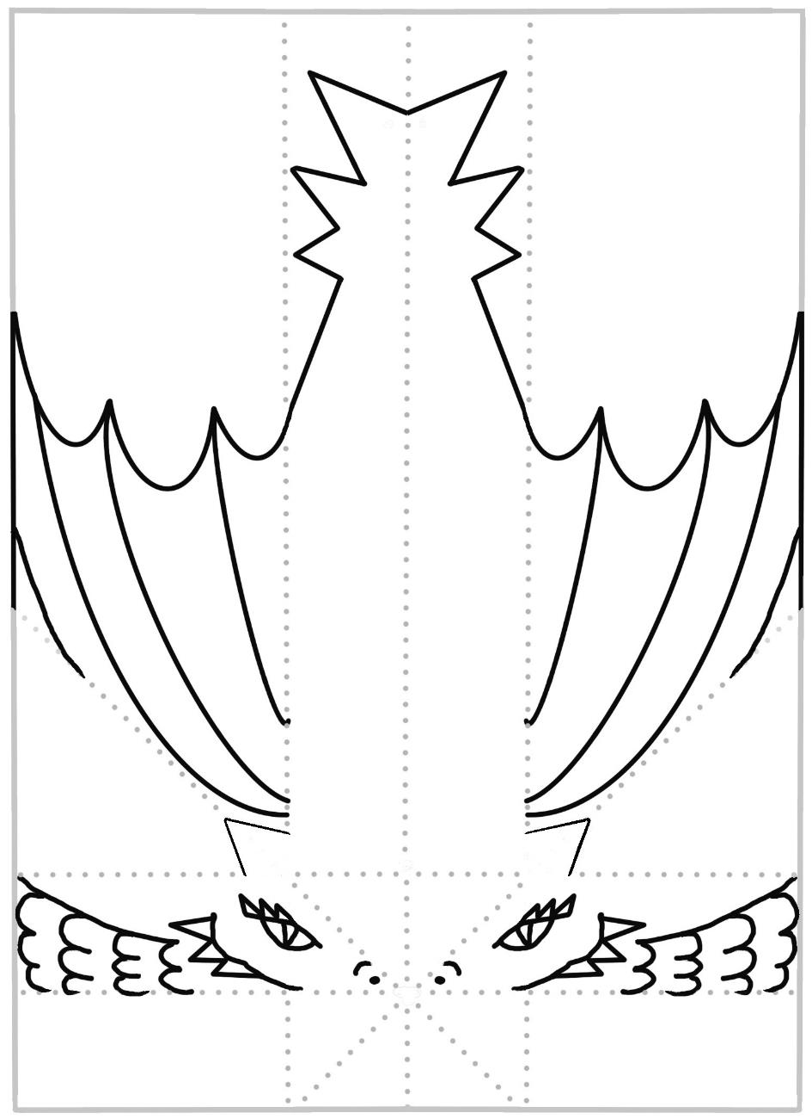

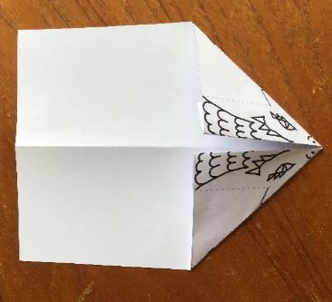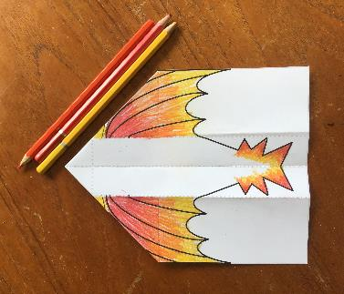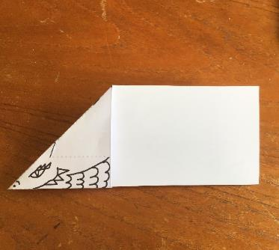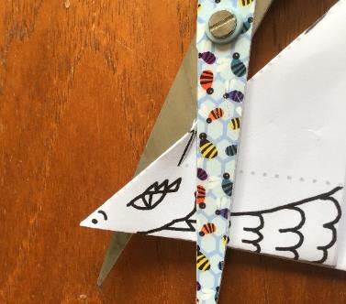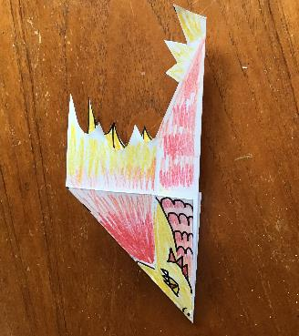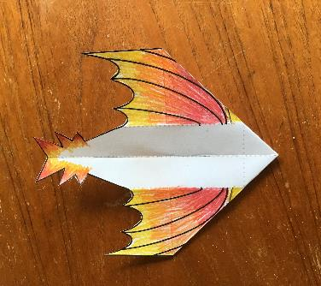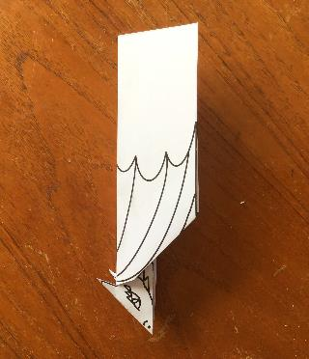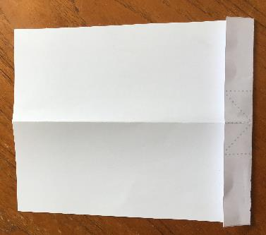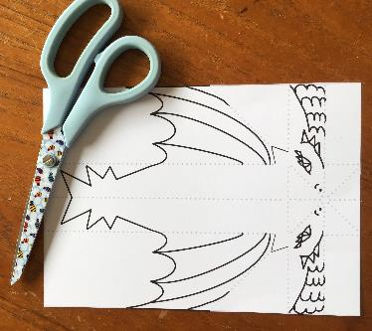

**9.** Fold in half again and colour underwings, body and dragon’s face (both sides)

**5.** Carefully cut down the black line to make ears. Stop at dotted line!

**7.** Open up and colour in the wings, ears and tail points.

**3.** On the same side, fold the two triangles to the centre along dotted line.

**8.** Cut around the wings and tail.

**4.** Fold the whole thing in half.

**6.** Fold down the wings along the dotted line, leaving the ears up.

**1.** Cut out template.

**2.** Turn over and fold up along the first dotted line.

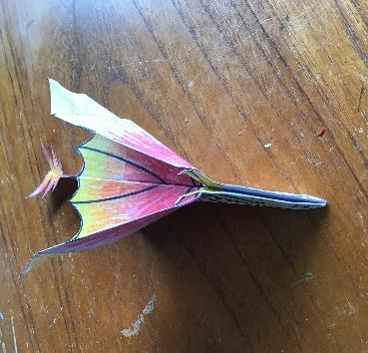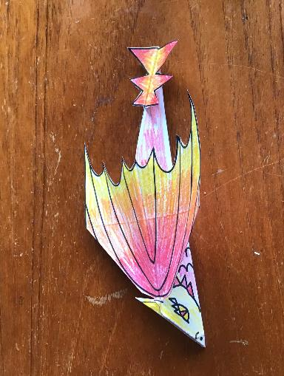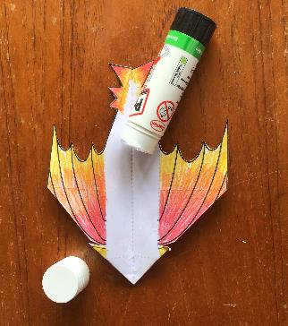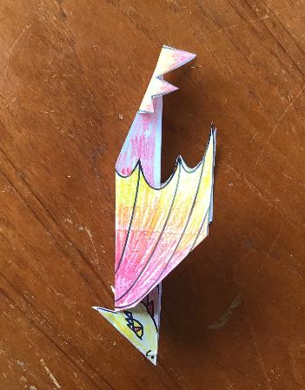

Extra wing fold?

**11.** Congratulations you now have a paper dragon. Have a go at flying it and see how far it goes

**Try experimenting**

You might want to experiment to get the best flight. Try folding the outer edges of the wings upwards, or weighing down parts of the body with a paper clip and see what happens.

You could also try sticking on some cut out claws, or even designing your own dragon plane with different wings or tail?

**10.** Fold down the wings and the tail spikes

**11.** (Optional) If you want to, you can also glue the white centre of the body together