Suggested learning opportunities for The Worry Tiger by Alexandra Page and Stef Murphy

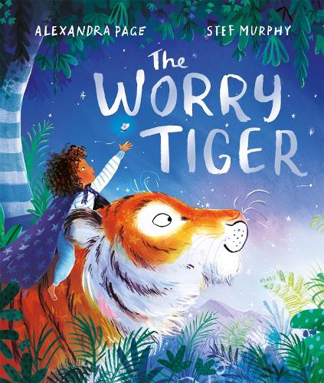
- Science, technology, numeracy and mathematics
- Literacy and English
- Health and wellbeing, and social studies
- Expressive arts

Mathematics and numeracy
- At the end of the book we can see the pose “stretch like a tiger”, look up how tall a tiger would be when it stretches, then measure yourself to create a height chart for the whole class. (MTH 1-21a)
- The book is set at night. Look up what hour the sun will set today. What does this look like on a clock? Repeat this idea over several weeks to look at the changing time of sunset or how the hours of sunlight get shorter or longer at certain times of year. (MNU 1-10a)

Sciences
- There are loads of different plants in the jungle. Look up some of the different plants you can find in a jungle and what they need to live. Use what you learn to look at how you could look after your own plants in the classroom. (SCN 1-03a)

- Why do plants thrive in the rainforest? Research rainforests, including their climate and what living and non-living things you can find there. How does the climate effect the plants? (SCN 1-02a, SOC 1-12b)

Technology
- In the story Rory has a den in their room. What your dream den look like? Draw a plan of your den and
what you’d have inside it.
(TCH 1-11a)
- Rory has a patchwork quilt on their bed. Make your own patchwork quilt as a class, using different fabrics and tools. (TCH 1-04b, EXA 1-03a)

- Make a den for your classroom with a jungle theme. Think about what decorations you could add to make a space in your classroom look like a jungle. Create a plan together to see what materials you’ll need, and work together to build it! (TCH 1-04c,
TCH 1-04d, TCH 1-11a)

Literacy and English
- The author uses lots of onomatopoeia to describe the sounds of the jungle. Try to find as many as you can and create a word display which you can use to describe the sounds in your own stories. (LIT 1-14a)
- At the end of the story there are some instructions on how to tiptoe like a tiger. Write your own instructions for moving like another animal. Swap with a partner and see if they can guess what animal you’ve written about! (LIT 1-09a)

- Write a story about travelling to a jungle or rainforest. Make sure you include all five senses – what can you hear, smell, see, taste and feel? (LIT 1-20a)

- Rory draws a picture to help them tell a story at school. Draw a picture that you can use to tell a story. Take it in turns sharing and listening to each other’s stories, using the pictures to help you. (LIT 1-10a, EXA 1-13a)

Health and wellbeing
- Write a list, or draw a picture, of all the people who can help you when you feel worried. (HWB 1-03a)
- Find all the words that the author uses to tell us how Rory is feeling. Write some words that describe how you’re feeling and use them to create a story or poem. (HWB 1-01a,
LIT 1-20a)

Social studies
- Using catalogues look at the different costs of furnishings, toys, technology and explore how much it would cost to create your dream den.
(SOC 1-21a, MNU 1-09a)

- Rory magically travels from his bedroom in a city to the jungle! Look up the jungle and compare it with where you live. How is it different? What different plants or animals live in the jungle versus your local area?
(SOC 1-12b)

Art
- Rory and the tiger see fireflies, butterflies and crickets. Design and draw your own insect. Can you make their wings symmetrical? (EXA 1-04a, EXA 1-05a, MTH 1-19a)
- The tiger helped Rory overcome their worries. What would your worry animal be? Draw a picture of it and write your worries inside.
(EXA 1-05a, HWB 1-01a)

Music
- Use the BBC Sound Effects Archive to create your own soundscape for the book. Explore different sounds including rain, forest ambience, or animal noises.
(EXA 1-18a, TCH 1-01a)

Drama
- Use the movement guides at the end of the book to move like a tiger. What different things do you see, hear or feel in the different poses?
(EXA 1-12a, EXA 1-13a)

- Look for the words in the book that describe how Rory and the tiger move. Use these to help you act out the story. (EXA 1-13a)

- Decorate a hula hoop or large box with vines and leaves. When children step or crawl through they have to pretend they’ve been transported to the rainforest. What’s the first thing they do? (EXA 1-14a)

