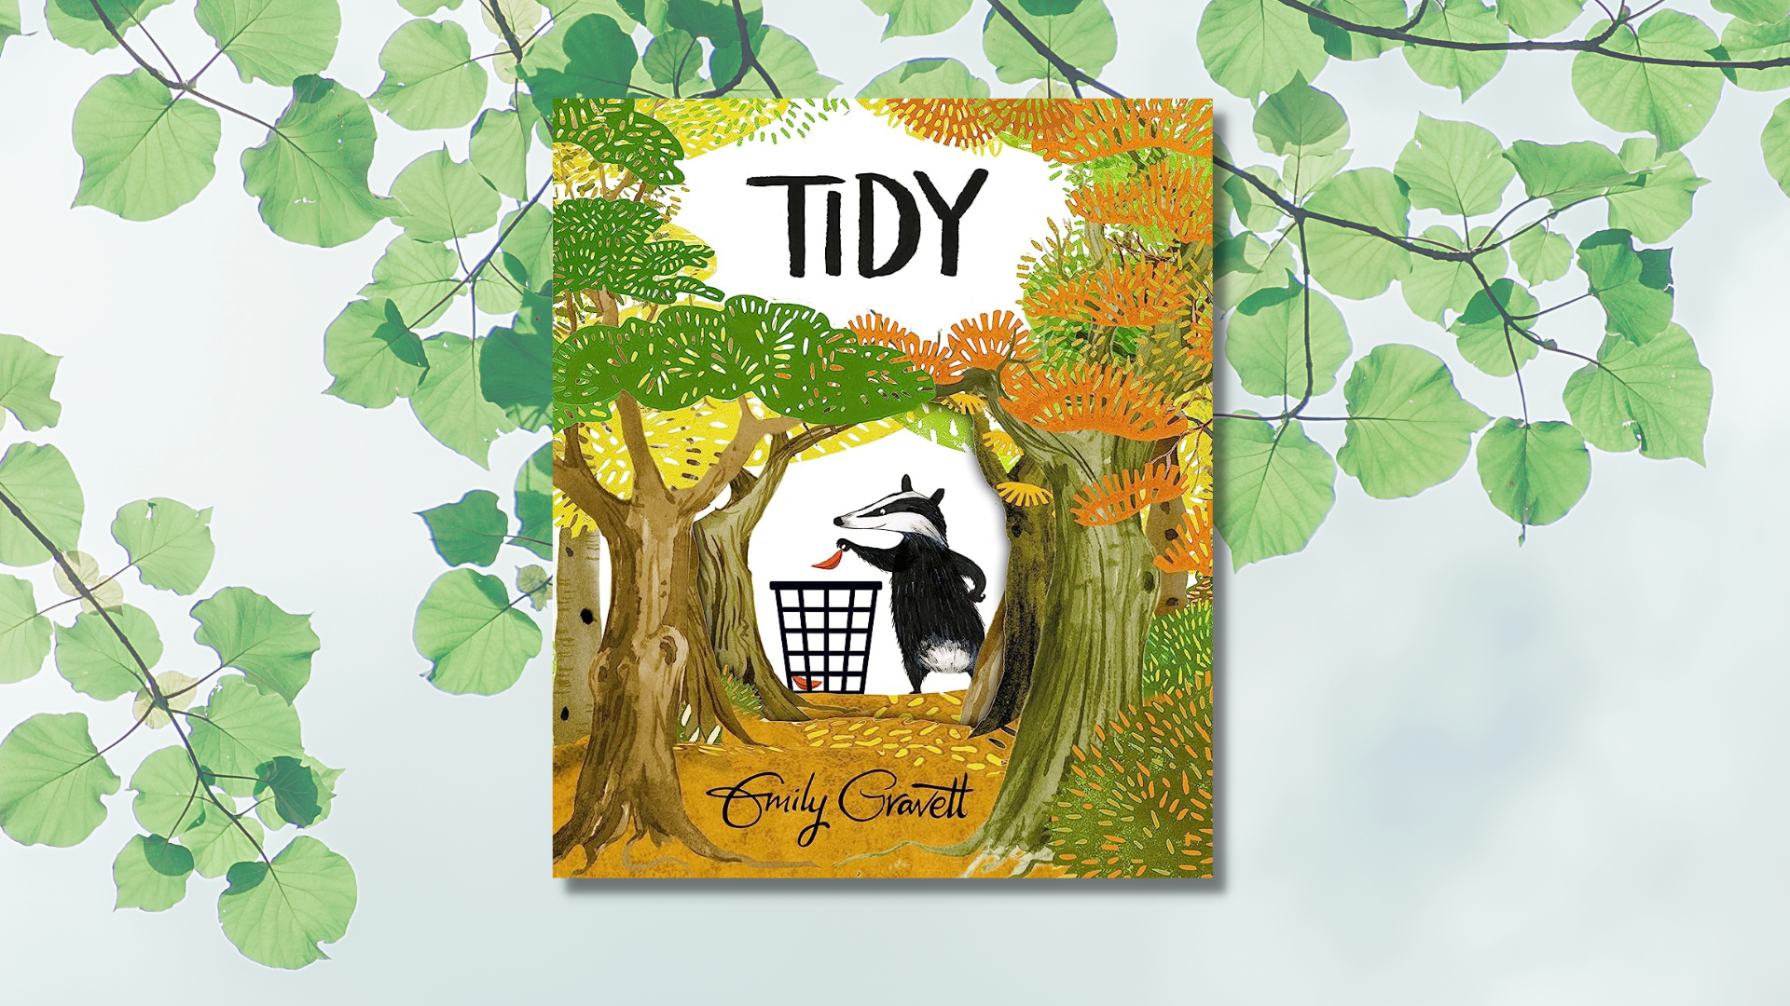

Using Tidy by Emily Gravett for a cross-curricular book project
Whole school activities inspired by Emily Gravett’s Tidy

Age 5–12

CFE Levels Early, First and Second

Resource created by Scottish Book Trust

scottishbooktrust.com
Scottish Book Trust is a registered company (SC184248)
and a Scottish charity (SC027669).

Contents
About this resource 2
About Tidy 3
Introducing the book to your class or school 3
Literacy and English activities 4
Health and wellbeing activities 5
Modern languages and Gaelic activities 6
Expressive arts activities 7
Science activities 7
Mathematics and numeracy activities 8
Technology activities 9
Social studies activities 9
Religious and moral education activities 10
Further resources 10

About this resource
The resource contains differentiated cross-curricular activities for Early, First and Second levels, adaptable to use as part of a whole school core book project involving ideas to support:
- Literacy
- Health and Well-being
- Modern Languages (French & Gaelic)
- Expressive Arts
- Sciences
- Maths
- Technologies
- Social Studies
- Religious and Moral Education
If you are taking part in Reading Schools, you can use this resource as part of the delivery of Key Area 2.2.2 of the framework on interdisciplinary book projects.

About Tidy
Tidy follows Pete the Badger, who is on a mission to tidy up all of nature in the forest – leaving everything neat and clean. Eventually, Pete’s quest for cleanliness goes too far and he lays concrete over the whole forest. Only then does he realise his mistake, and sets out to restore the forest to its more messy, natural state, with the help of all of his animal friends.

Introducing the book to your class or school
To introduce the book, we recommend holding a book launch with either your class or whole school. You could do this by:
- Hide the book and the printed letters of the word “TIDY” around your classroom/school and ask the children to find them and make the word.
- Set up reading groups where older children read the book to younger children.
- Hold a school assembly where you read through Tidy together. Afterwards, ask each class to come up with a way they could improve the environment in their class, the school or your local community.
- Create a recycling station in your cafeteria or classrooms with pictures of Pete the Badger.

Literacy and English activities

Early and First Level
LIT 0-01c/LIT 0-02a/LIT 1-02a/LIT 1-04a
Clearly display the front cover, have younger children sitting around you or display the picture on a larger screen. Older pupils could have a copy of the cover in pairs or groups. Children need time to look at the image and process their observations.
Using open questions begin to gather their initial ideas:
- Let the children think about the one-word title: Tidy
- What do they think the story might be about based on the cover alone?
- Are there any clues to help and do they hint at what might happen in the story?

As the story unfolds, begin to establish basic questions to use with each page. Allow the children time to study each picture and practise looking for clues.
- What do you see? Look again, what else do you see?
- Are there any clues showing what the story might be about?
- Is there anything different or unusual?
Turning each page, discuss what they see. Encourage them to become picture detectives who need to look carefully at the pages. If new words are offered, record them for a word wall to support writing later. Include deeper questioning during discussion:
- How do you think Pete’s friends are feeling?
- What makes you think this?
- What do you think they could have said to Pete?

First and Second Level
LIT 1-02a/LIT 1-04a/LIT 2-02a/LIT 2-04a
Consider the story in pairs or groups:
- Do you think this book has a message for us? If so, what do you think it is?
Findings can then be shared and the different ideas discussed.
Encourage deeper questioning and discussion, sharing knowledge, understanding, building confidence, vocabulary and scaffolding pupils who require more support.
- How does the tidying of the forest make you feel?
- How do you think Pete’s friends are feeling? What makes you think this?
- Why do you think the illustrator filled the front and back outside and inside covers with pictures of trees?
- What sounds might you hear in a forest?

Health and wellbeing activities

Early Level
HWB 0-01a/HWB 0-13a
As a class, discuss how you think Pete felt at the beginning of the book. How did he then feel once everything in the forest had been made tidy? What would you have done? Would you have done the same as Pete?
What could you do to make your school a happy, healthy and welcoming place for everyone? Think about the dining area, the play area, your classroom and the corridors.
First Level
HWB 1-01a/HWB 1-13a
The Sustainable Development Goals offer a shared blueprint to create a fairer, more sustainable world for everyone. Talk about how Pete sought to make the world better. Did he succeed in his goal? What can you do to bring positive change to your school and community?
There are 17 goals in total and The World’s Largest Lesson website has lots of ideas for learning about: Goal 3 – Good Health & Wellbeing

Second Level
HWB 2-05a/HWB 2-13a
Goal 13 of the Sustainable Development Goals is about Climate Action. What did Pete do to the forest? What were the consequences of his actions for our health and wellbeing? What can we do to protect our environment from harm? Find out more with the World’s Largest Lesson activities for Climate Action.

Modern languages and Gaelic activities

Early, First and Second Levels
Watch Emily’s draw along of Pete the Badger (6 minutes, 24 seconds) so that children can draw their own version of a badger. They can then add their own trees, flowers and leaves to create a forest background, inspired by the pictures in Tidy.
Once pupils have drawn their own pictures, they can talk about them and then label them in the modern languages or Gaelic. They could add short phrases to describe what is happening. See the below example in French:
- Pete – Pierre
- The badger – Le blaireau
- The bird - L’oiseau
- The flower – La fleur
- The tree – l’arbre
Pupils of all ages can create a collage of the forest using recycled materials and label the trees, leaves, animals etc. in Gaelic.

Expressive arts activities

Early, First and Second Levels
EXA 0-01a/EXA 1-01a/EXA 2-01a
At a whole school assembly, first level pupils can narrate the story of Tidy which could be acted out by the younger children. This performance could be shared with pupils or the local community. You can get tips for performing picture books our Quick activities for performing picture books resource.
Second level pupils could then share a drama-inspired presentation, showing how the school has developed the theme of working with nature and responding to the climate emergency. The presentation could offer ideas and suggestions to take action at home and in school to protect the planet for future generations. Pupils could use any medium they liked – PowerPoint, digital storytelling or display boards.

Science activities

Early and First Level
SCN 0-01a/SCN 1-01a/SCN 1-03a
For English and Gaelic learners you can use the Mission Explore: John Muir activities to follow in the footsteps of John Muir and connect with nature in simple ways.
Pupils could explore the differences between living and non-living things and sort living things into groups, explaining how they have sorted them. This could be done as a class activity and then children could create a list of living and non-living things they can find at home. You could discuss what living things need to survive – light, water, space – and what was happening to the forest as Pete covered it with concrete.
You could then grow plants in class or in containers in the playground and have a rota so that the plants could be watered regularly by different pupils. If there are any untended planting areas around the school, you could create seed bombs and have fun dispersing them to grow wildflowers and make good use of these areas as natural habitats for bees and insects. The Wildlife Trust has this great resource on how to make a seed bomb.

Mathematics and numeracy activities

Early, First and Second Level
MNU 0-20a, MNU 0-11a, MNU 1-20b/MNU 2-20b
We use Maths in myriad ways in our daily lives and we can identify where it features beyond the walls of the classroom – in patterns, measurement, making calculations, sorting etc.
You could chalk numbers 1–20 on the playground and then the children can find different items to symbolically represent each of these numbers, e.g. 1 stick, 2 stones, 3 leaves etc. They may wish to discuss which items the can find most of before they begin.
Children could also try to find as many different kinds of leaves as possible and research them to identify the names of the trees from which they have fallen. They could then create a chart showing leaf, naming it and including its measurement – length and breadth – to show which tree has the largest/smallest leaf.
Give the children a picture of half of a flower or tree and ask them to fill in the missing half to show how symmetry occurs in nature. They could also fold a piece of paper in half, paint half of a tree or flower on one half of the paper and then fold over the clean half so that the wet paint will print the missing section to create a complete picture. Creative Star has many great ideas for all stages for exploring Maths outdoors.

Technology activities

Early and First Levels
TCH 0-05a, TCH 0-09a/TCH 1-09a
Consider the tools and equipment that Pete used to tidy up the forest. Design a tool/machine that would help to keep your playground tidy. Can you think of a way in which litter could be reduced, re-used or recycled in your playground and school?

Second Level
TCH 2-01a
Create a simple book trailer to inspire others to read the book. You can use our Book reviews and trailers on film resource to support this. Think about what Tidy teaches us about nature and our relationship with it.

Social studies activities
Tidy is open to individual teacher/pupil interpretation and has endless possibilities for further learning about Rethinking, Reducing, Recycling and Re-using waste.

First and Second Levels
SOC 0-18a/SOC 1-18a, SOC 2-16c
The Practical Action resources set a challenge for school pupils to consider what we can do with plastics that can cause so much harm to creatures on land and in the seas.
Stay At Home! published by Cranachan is a book designed to give children the opportunity to reflect on their experience of lockdown and to consider what that has meant for different people, places and communities and the wider world. You could use Stay At Home! alongside Tidy to think about the environmental impact of lockdown.

Religious and moral education activities

Early, First and Second Levels
RME 0-04a/RME 1-04a/RME 2-04a, RME 0-05a/RME 1-05a/RME 2-05a
Many religions have a concept of “stewardship”, meaning they believe looking after the planet and their God or Gods creations is an important part of their faith. You could look at one of the following examples together as a class:
- Christianity: Green Bible Stories for Children or A video introduction to Rocha UK (1 minute, 51 seconds)
- Islam: The Story of the Crying Camel
- Judaism: The BBC guide to mitzvot, the Jewish concept of looking after the world
- Hinduism: The BBC guide to how karma and ahimsa tie into caring for the planet
- Sikhism: Discover Guru Nanak’s “Respecting the Earth” webpage lists examples of action Sikhs have taken to care for the planet

Then as a class explore the following questions:
- Why is caring for the planet important?
- What religious beliefs are there about looking after the planet?
- How does looking after the planet promote values such as fairness, caring and community?

Further resources
- Our resource on 10 things to do with any book or 10 things to do with any book outdoors could be used to extend some of the learning opportunities and activities in this resource
- Our book lists contain suggestions for books for exploring nature, learning about the environment, developing an understanding of climate change and environmental responsibility and books to support outdoor learning
- We have other cross-curricular book project resources, including:
  - Journey by Aaron Becker (recommended for 6–11 year olds)
  - Arrival by Shaun Tan (recommended for 12–18 year olds)
  - The Hunger Games by Suzanne Collins (recommended for 12–18 year olds)

