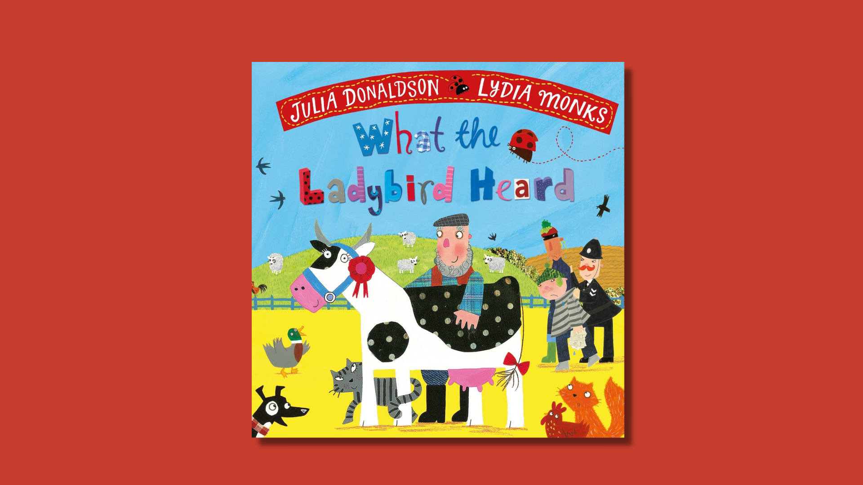

What the Ladybird Heard learning activities
Ideas and activities to support using Julia Donaldson’s book in class

Age 3–8

CFE Levels Early to First

Resource created by Scottish Book Trust
scottishbooktrust.com
Scottish Book Trust is a registered company (SC184248)
and a Scottish charity (SC027669).

Contents
About this resource 2
Learning activities 2
Further resources 7

About this resource
This resource contains learning activities for class use of the book What the Ladybird Heard which can be adapted to suit the children you work with. For further ideas to use with this book, see:
- 10 things to do with any book (primary)
- 10 things to do with any book outdoors

Learning activities

Activity 1: Learning to look
ENG 1-17a
Read the book together as a class. This activity will take you through the book, its cover and pages, to prompt discussion about the story and artwork. We’ve broken down the book into different sections with questions for you to use –

Cover
- How does the cover show us what the book is about?
- What kind of animals can you see on the cover?
- What do you think the animals are up to?
- There are two names on the cover – one is an author, one is an illustrator. Does anyone know the difference?

Endpapers
- What do you notice about the leaves?
- Can you spot the collaged artwork?
- Who can you see on the farm? Who is in the trailer?

Title page
- There are some dedications at the start of the book. Does anyone know what those are?
- Can anyone find where the book was printed?

Pages 1 and 2
- Talk about the fact that the story involves rhyming.
- Can anyone find the ladybird?
- Does anyone know why the cow is wearing a rosette?

Pages 3 and 4
- Which animal says which animal noise?
- Why is the text not in a straight line?
- Why are the sounds in capital letters?

Pages 5 and 6
- Why do all of the animals seem much bigger?
- Why are they staring at the ladybird?
- What do you think they might be thinking about?

Pages 7 and 8
- What time of day is it? How can you tell?
- Who’s in the van? What do they have in front of them?
- Discuss nocturnal animals. Does anyone know what “nocturnal” means, or know of any nocturnal animals?

Pages 9 and 10
- Discuss the map and directions. Which animal is asleep on the map? How can you tell? What are the brown marks?
- Where’s the ladybird? What do you think he might be doing?
- Why is there a big red cross above the cow?

Pages 11 and 12
- What do you think the ladybird is doing? What are the lines around its head for?
- What do you think the other animals are thinking?
- Why is the phrase “being careful not to wake the dog” in brackets?

Pages 13 and 14
- Why are the animals all “talking” on this page?
- Who else is in the picture?
- Which other animals can you spot?

Pages 15 and 16
- What does the dotty, sparkly red line represent?
- What do you notice about the animals?

Pages 17 and 18
- What’s happening in these pictures?
- What has Hefty Hugh stood on?
- Who’s keeping watch?
- Where’s the ladybird?
- What are Lanky Len and Hefty Hugh holding?

Pages 19 and 20
- How are the animals managing to trick the two men?
- Where’s the ladybird?
- What is Lanky Len standing in?

Pages 21 and 22
- Oh no! What’s happened? What’s the ladybird doing?
- Look at the fish – how do you think they are feeling?
- What’s Lanky Len got his head into?
- How is the farmer feeling? How are Lanky Len and Hefty Hugh feeling?

Pages 23 and 24
- What is everyone doing?
- How do they feel?

Endpapers
- How does this endpaper compare with the one at the beginning of the book?
- Can you spot the differences?

Activity 2: What the Ladybird Heard party
TCH 0-14a, TCH 1-04b, EXA 0-02a, EXA 1-02a
Throw a party based on the book, putting the pupils in charge of preparation. Start by reading the book together and asking the children for their party ideas. You could also:
- Make ladybird posters and invitations to the event
- Make ladybird biscuits by baking or buying biscuits then decorating them with red icing and raisins or chocolate chips
- Make antennae with hair bands and pipe cleaners
On the day, why not:
- Have a picnic! (See our 10 things to do with any book outdoors resource for inspiration)
- Dress up as different animals, insects or farmers or do face painting
- Make and decorate different animals masks
- Make a playlist and dance the jitter bug
- Play a ladybird drive
- Play games like “The Farmers in the Den”, “Duck, Duck, Goose” or “Moosical Statues”
- Play stick the antennae and spots on the ladybird (Pin the Tail on the Donkey)!

Activity 3: Wall display
EXA 0-02, EXA 1-02a
Make a farmyard scene on your classroom wall – use the book as a guide for creating your farm. Use different collage materials to make the animals hairy, woolly etc.

Activity 4: News reader
EXA 0-12a, EXA 1-14a
Work with the pupils to write a news report of the events, then film the child reading it behind a mock news desk. You could interview the farmer and the police, perhaps even Hugh and Len from behind bars. You could even interview the animals, and decide whether they can talk or not, perhaps explore using gestures to convey what happened.

Activity 5: Criminal mastermind!
MTH 1-17a
Use the map and farmyard in What the Ladybird Heard to map out your own. Use coordinates and square paper to draw a map using the robber’s plan. Now use the map to write clearer instructions to give better directions to the robbers. Do you think your directions could outsmart the animals?

Activity 6: Morals of the story
HWB 0-14a, HWB 1-14b
Discuss:
- Does a hero need to be big?
- What would happen if you always make a noise and never listen?
- Complete the sentence: So, the moral of the story is. . .

Further resources
- You can filter all our Learning resources by topic, including animals and nature as well as our Authors Live on Demand broadcasts
- Our book lists suggest more picture books that celebrate friendship, explore animals and our environment and books for outdoor learning
- Visit Julia Donaldson’s website to learn more about her other books, songs and plays

