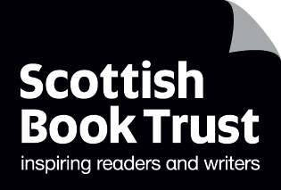
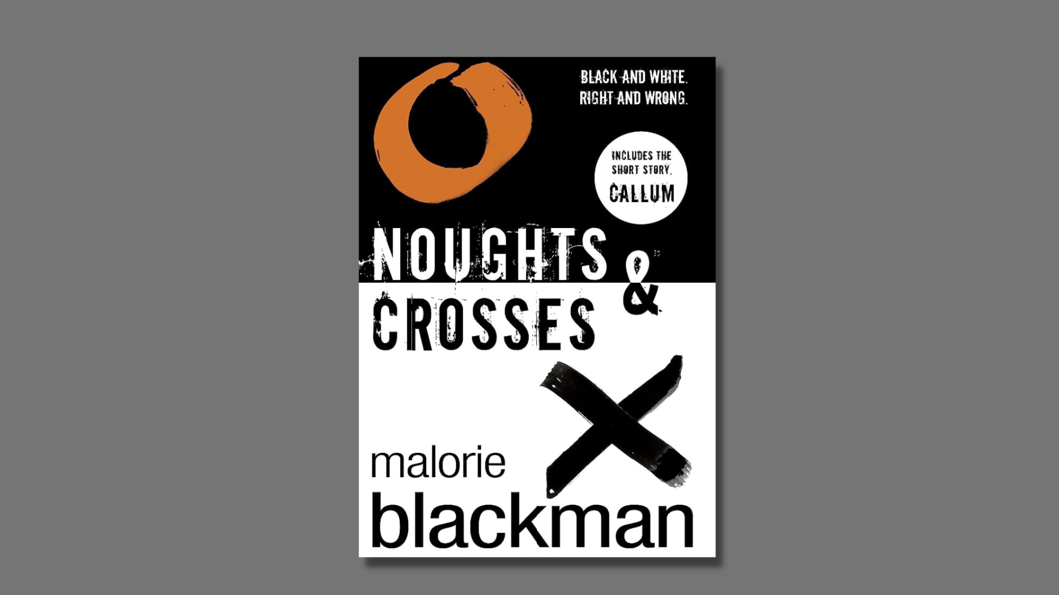

Noughts and Crosses learning activities
Ideas and activities to support using Malorie Blackman’s book in class

Age 12–18

CFE Levels Third, Fourth and Senior Phase

Resource created by Scottish Book Trust

scottishbooktrust.com
Scottish Book Trust is a registered company (SC184248)
and a Scottish charity (SC027669).

Contents
About this resource 2
Learning activities 2
Further resources 6

About this resource
This resource will help you explore Noughts and Crosses by Malorie Blackman as a class. The book is set in an alternate universe, where power dynamics between races are reversed. The book does contain content including child and domestic abuse, alcoholism, suicide and murder and, as such, is not suitable for younger readers.
As with all our resources, we highly recommend that you read the book before using it with your class and use your own judgement about its suitability for the specific children you work with.

Learning activities

Activity 1: The newsroom
EXA 3-14a, SOC 3-15a, LIT 3-28a
Pupils work to create a television news broadcast on some of the key moments in the novel, for example the growing tensions and conflicts between Noughts and Crosses.
Roles for pupils who are confident in front of a camera include an anchor’s introduction, an on-the-scene reporter, an eyewitness and an expert’s account. Pupils who do not wish to be filmed could write a script, help with the filming, take pictures, or make set decorations.
This is also an opportunity to explain the importance of the "behind the scene" production crew.
Stage 1: Discuss the following questions:
- What is a news report?
- What happens on a news report?
- Name some segments on the news you have seen.
- What is the difference between local, regional, national and international news?
- What is involved in news reports?
- How does the news affect everyone?
- How important are news reports?
- What kind of role do they play in our world?
- Can you name some local news reporters?
- What school news can you think of?
Stage 2: The class searches for information from the critical incident selected that needs to be included and who needs to be interviewed.
Stage 3: The pupils compile and create their news report and those with speaking parts can take home copies to practice.
Stage 4: The pupils act out the news report in front of an audience or alternatively film it to be viewed by parents and other stakeholders.

Activity 2: Civil rights and the Black power movement
SOC 3-01a, SOC 3-06a, SOC 3-06b, LIT 3-14a, LIT 3-25a
The noughts’ attendance at Heathcroft High School has parallels with the real life incidents involving the Little Rock Nine and Central High School in Little Rock, Arkansas in 1957, a significant aspect of the civil rights movement.
Ask pupils to research and write a report on some or all of the key aspects of the civil rights movement. Pupils should be given free choice as to which aspect they would like to cover. Some options are listed below.
This project can be displayed with a timeline charting the major events.
- Definition of civil rights
- Background including slavery
- Rosa Parks
- Desegregation of Little Rock High School
- Sit-ins
- Civil Rights act of 1964
- Race Riots
- Martin Luther King, the Nobel Peace Prize and his assassination
- Malcolm X
- Black Power

Activity 3: Writing a political speech
SOC 3-06b, ENG 3–27a
Start by watching Martin Luther King Jr.’s speech “I Have a Dream” (5 minutes, 17 seconds). What do you notice about the words he uses? Which words and phrases does he repeat?
Investigate the history of rhetoric and argument writing and discuss its purpose: who uses it, for what reasons and what are some of its techniques? The New York Times has an extensive resource on argument writing.
Discuss with pupils what they think would make your school, local community or wider community a better place. Ask each to write a list of five "dreams" they have.
Using the techniques they have learnt on rhetoric and argument writing, ask pupils to write a speech about how they will make the world a better place.

Activity 4: Page to stage
EXA 3-01a, EXA 3-14a, ENG 3-31a
Many of the key incidents in Noughts & Crosses offer a great basis for pupils to first of all write their own scripts and then to have them acted out in class or in front of a wider audience. The recent TV adaption of the novel by the BBC is one interpretation of the novel for the screen. Do pupils agree with this adaption? What would they write for their own script?
Pupils can be taught the familiar conventions of playwriting, particularly layout and stage directions, and should give their chosen incident or chapter a title.
In addition, writers should be encouraged to adapt Malorie Blackman’s dialogue as much as they see fit.
Chapter 36 could, for example, be split into three scenes and started and laid out as follows:
Goodbye, Everyone.
Scene 1: A dining room with the McGregor family eating. The atmosphere is tense, charged even. Mum is looking angry and dad is looking sad. Ryan is sullen and moody. Lynny seems distracted as if thinking deeply about something and Callum is watchful, taking everything in and aware of trouble brewing.
Mum: (throws her fork down angrily) I’ve had enough of this! Why can’t we just get on the way we used to?
Dad: Meggie. . .
Mum: (turns and scowls at Dad) Don’t you “Meggie” me. There’s been a funny atmosphere in this house for a while now. What’s going on?

Over now to the pupils to finish it off!

Activity 5: Write your own poem
ENG 3-23a, ENG 3-24a, ENG 3-27a, ENG 3-31a
Read the section of Chapter 50 where the bombing at Dundale shopping centre is described. Tell pupils they are going to write a poem to describe the incident.
Before writing, take your pupils through the following tasks:
- Before beginning, imagine you were really there. What would you see, hear, feel, taste, smell?
- What emotions would you be going through at each stage of the poem?
- Read the extract again and write down any striking words Malorie Blackman uses. Then add words that you can think of yourself. Next, use a thesaurus to find synonyms to make your poem richer in terms of the word choice.
- Write your first draft freely. After this go back cutting out any unnecessary words such as “the,” “an,” “a,” etc.
- Next, try to organise your poem into lines that create impact. Think about punctuation. Think about the difference in impact between long lines and short lines.

Further resources
For further ideas to use with this book see:
- Our Understanding and challenging racism resource, created with Show Racism the Red Card Scotland
- Our Read Woke learning resources, including learning activities to understand and challenge discrimination
- Our 10 things to do with any book (secondary) resource for adaptable ideas that can be used with any text

