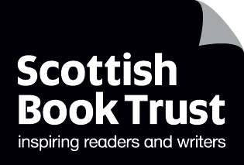
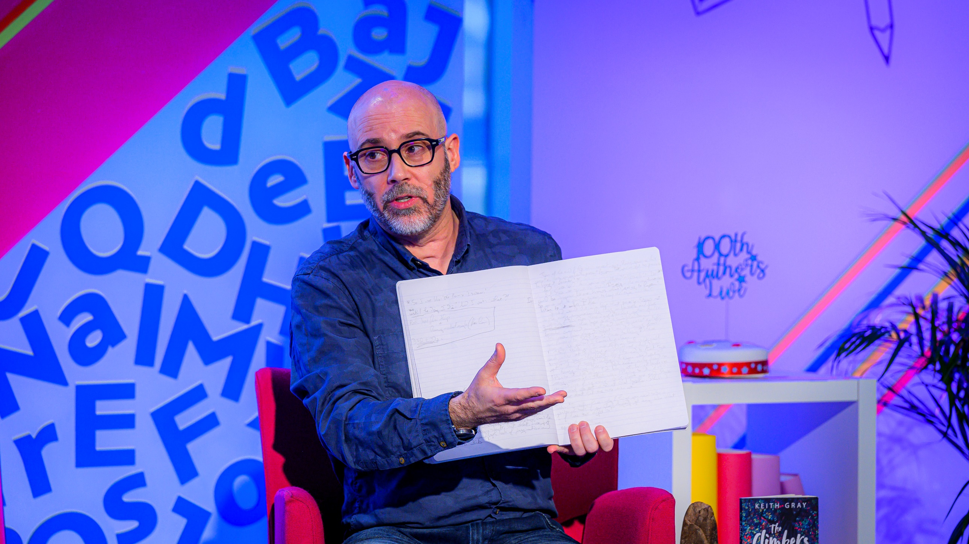

Making the most of Authors Live
How to get the most out of our digital events and on demand library

Age 5-18

CFE Levels Early to Senior Phase

Resource created by Scottish Book Trust

scottishbooktrust.com
Scottish Book Trust is a registered company (SC184248)
and a Scottish charity (SC027669).

Contents
About this resource 2
How to watch Authors Live 2
Before you watch 3
As you watch 4
After you watch 4
Support and FAQs 5

About this resource
Authors Live is a series of free events with children’s writers and illustrators, streamed live in partnership with BBC Scotland Digital Learning. Authors Live can be watched either live as it is broadcast, or streamed online afterwards through our Authors Live on Demand library on the Scottish Book Trust website.

How to watch Authors Live

Watching a broadcast live
- All live broadcasts are available to watch via the BBC Authors Live homepage. You can also use this page to check for any upcoming broadcasts.
- Before the broadcast, sign up for or log into BBC iPlayer.
- 15 minutes before the event starts, there is a test stream which you can use to check sound and video quality.
- If the video buffers during the broadcast don’t panic! This is perfectly normal, and the broadcast should continue after a couple of seconds.

Watching via our Authors Live on Demand library
- Visit our Authors Live on Demand library. You can search by curriculum areas, topics or look up a specific author.
- Click on the broadcast you wish to watch, then play the video. If you hover your mouse over the video, you’ll find additional settings such as enabling captions or making the video full screen.

Before you watch

Work with your library
If you’re not sure which Authors Live to pick, you could ask your librarian for some recommendations and see what books they have. You could also arrange a class trip to borrow some of the author’s books, or read them together.

“If you only do one thing”
For all Authors Live events there should be a “if you only do one thing” which will suggest a tie-in activity for the broadcast. You can read this in advance and use it to plan delivery after you’ve watched Authors Live together.

Make it an event
You can use Authors Live broadcasts to build some excitement around reading. Why not:
- Ask the pupils to put together a programme by picking a broadcast to watch each week. Draw the names out of a hat to see who gets to pick!
- Run a lunchtime club where pupils can watch broadcasts whilst drawing, or writing, along.
- Ask pupils to design posters advertising when, where and who you’ll be watching. You could use these to make a display in your hallways to encourage others to come along and watch!
- Screen in your library and invite parents and families.

As you watch

Join in on Twitter!
Use the hashtag #BBCAuthorsLive and tag us @scottishbktrust to join the conversation! You can tweet pictures of your class watching, the drawings they create, or any questions you’d like to ask the author or illustrator.

Draw along
Some of our events allow pupil to “draw along” following the illustrators lead. Get your pencils at the ready!

Think of questions to investigate afterwards
Set aside some time to discuss the broadcast with pupils. You could ask them to write down any books they’d like to read, or any questions they have. You could also ask them something interesting they learned, or their favourite part of the broadcast.

After you watch

Find some of the writer’s work
Look up the author online together and look at their books. You could ask them to pick or vote on a book they might like to read, either individually or in groups or a class. Contact your local library to see what books they have that pupils can borrow.

Adapt their work
If the author gave a reading, or described the books, ask the pupils to adapt it. This could be:
- Writing a poem
- Drawing a comic book panel or scene
- Creating a book trailer
- Rewriting it in a different genre or style

Project resources
Use the Scottish Book Trust website to search through our learning resources. These can also be searched by curriculum area or theme.
If you can’t find something to tie in, we have our “10 things to do with any book” resources which can be used with any text:
- Early level
- Primary
- Secondary
- For pupils with additional support needs
- Outdoor activities
- Expressive arts activities

For support with writing, you can also see our Creative writing resources or the Young writers section of our website.

Support and FAQs

How long are the broadcasts?
Usually 40 minutes, unless otherwise stated.

I have been trying to register our school for an Authors Live event, but have been unable to. What do I do?
Contact the Schools Communities Team on schools@scottishbooktrust.com

I can’t get the link to work
Check with the technical staff at your school to make sure the BBC link isn’t blocked. They may need to unblock it or speak to your local authority.

Can we ask the author questions?
To ask the author or illustrator questions, tweet the question using the hashtag #BBCAuthorsLive. Please keep in mind that thousands of children watch and may submit questions, and we only have a limited amount of time! If we don’t answer your question this time, please do keep submitting them.

