Read, Write Count Bags are coming to your school!
Read, Write, Count bags will be delivered to your school for every Primary 2 and Primary 3 pupil this term. These are fantastic bags filled with books and resources to inspire a lifelong love of reading, writing and counting.
This Teacher Pack will tell you what’s in the bags and how you can make the most of them using our free resources. We have also included the books from this year’s bags to help with your planning for next term, as well as example activities.
These bags are gifted by Scottish Book Trust through the Scottish Government’s Read, Write, Count campaign, and give you a great opportunity to build relationships with parents and strengthen links between home and school learning.

Read, Write, Count gifting
Step one: plan your parent event! Sign up to our Primary 1-3 Gifting CLPL on Thursday 7 September to hear tips and discussion on how to gift the Read, Write, Count bags to families without a large event. To book a bespoke online or in-person session, please get in touch at readwritecount@scottishbooktrust.com.
Step two: your school receives the Primary 2 and Primary 3 Read, Write, Count bags. Count them when they arrive and get in touch with your local Read, Write, Count Contact if you have any issues with delivery or need any additional bags.
Step three: get stuck into some fun creative learning with our free downloadable Learning Resources. There are quick worksheets, video recordings of the books being read and lots more. You could get older pupils involved by including them in parent events.
Step four: give the bags out to your families. If possible, do this during Book Week Scotland, our national celebration of books and reading (15-21 November 2023)! Don’t worry if this date isn’t possible – just be sure to give parents tips on how to explore the bags with their children to enjoy all the contents as a family.
You can also find lots of great activities and videos for families to enjoy on our Home Activities Hub.

Inside this year’s bags. . .

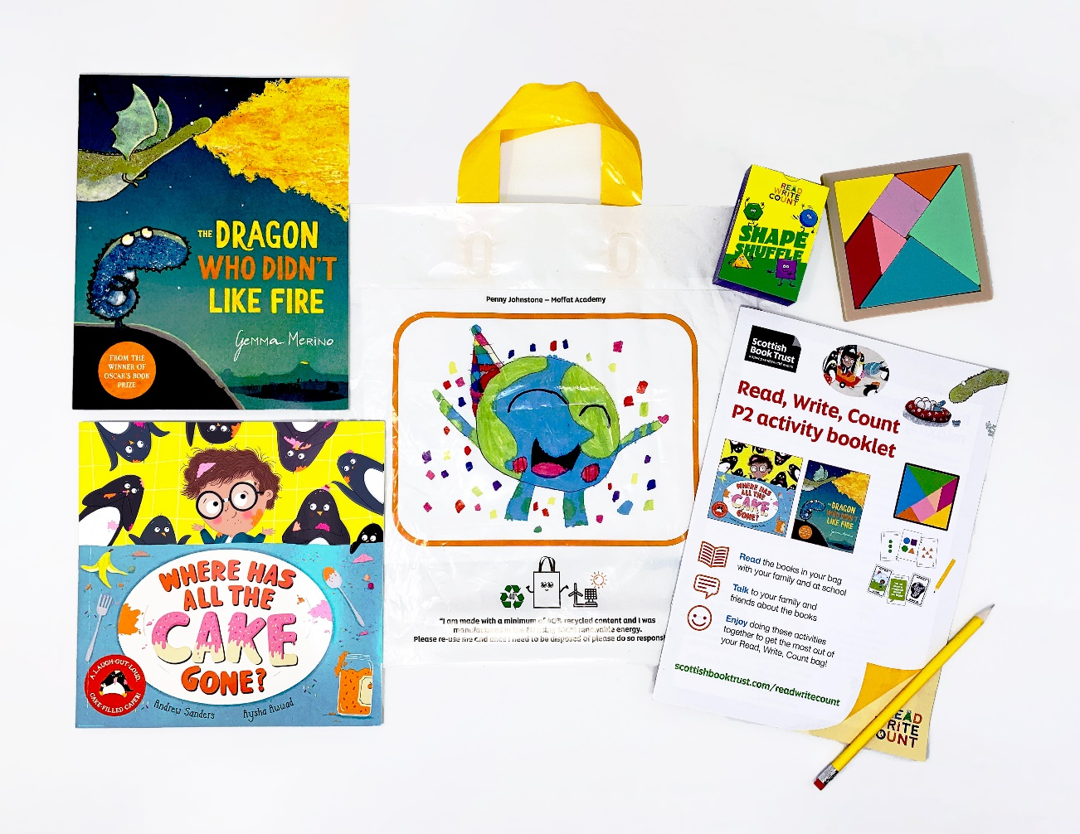

The Primary 2 Read, Write, Count bags contain:
- An activity booklet – a fun and interactive booklet with activities and blank pages for parents and children to enjoy together
- A yellow writing pencil
- The Dragon Who Didn’t Like Fire by Gemma Merino
- Where Has All the Cake Gone? by Andrew Sanders and Aysha Awwad
- A tangram
- Shape Shuffle cards with ‘Talk it Out’ and ‘Act it Out’ games on reverse
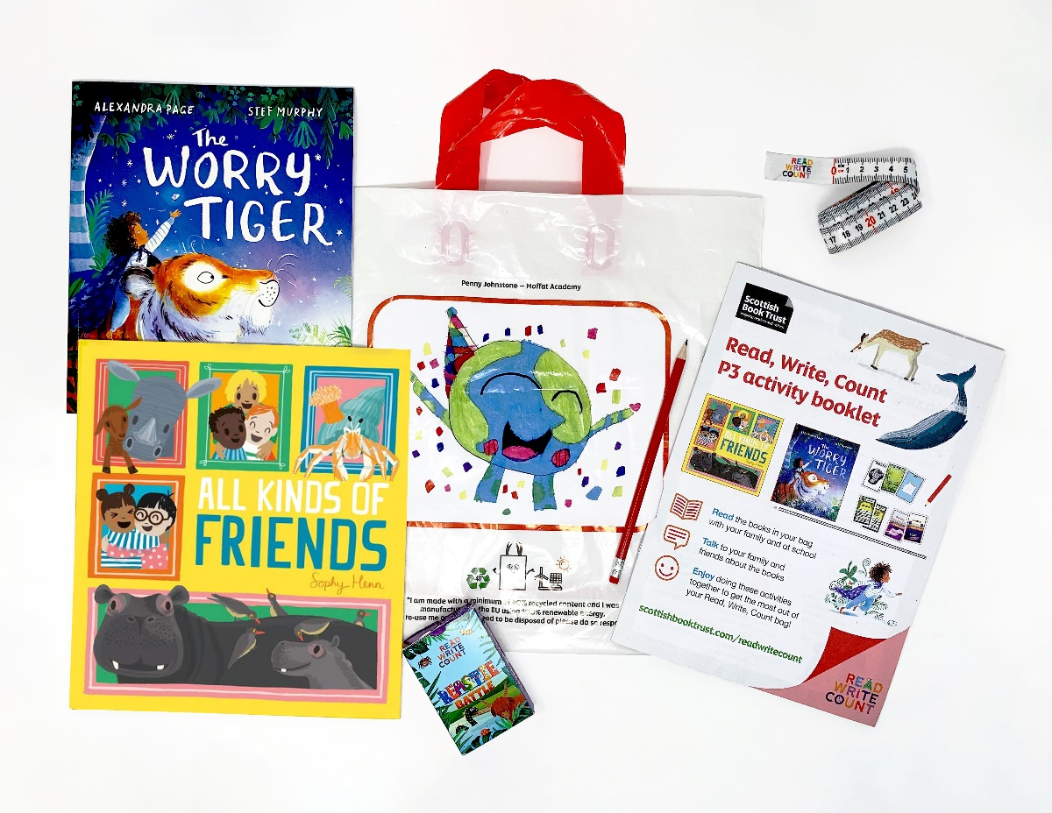

The Primary 3 Read, Write, Count bags contain:
- An activity booklet – a fun and interactive booklet with activities and blank pages for parents and children to enjoy together
- A yellow writing pencil
- All Kinds of Friends by Sophy Henn
- The Worry Tiger by Alexandra Page and Stef Murray
- A measuring tape – a meter long retractable measuring tape.
- Beastie Battle card game with reversible Domino and story cards

How to make the most of your bags

Resources

We have a full set of resources created in collaboration with Education Scotland for each Read Write Count bag which includes mind maps with suggested activities linked to CfE, printable worksheets, video readalongs and much more! These will be available on our website from August 2023.

Training sessions
We’ll be holding online CLPL for learning professionals that offers support on gifting the Bookbug Primary 1 Family Bag and Read, Write, Count bags to pupils, including how to use them to promote parental engagement. There will also be the opportunity to attend webinars that explore the accompanying resources for Primary 1-3 teachers. The training dates are as follows:
- Thursday 7 September, 16.00–17.30: Gifting the Bookbug Primary 1 Family Bag and Read, Write, Count bags
- Tuesday 26 September, 16.30–17.30: Make the most of the Bookbug Primary 1 Family bag
In addition, we offer bespoke training in-person and online. To request a session in your school or area, contact readwritecount@scottishbooktrust.com. Find our full list of CLPL on offer and details on how to register.
To help you make the most of the Read, Write, Count bags in your classroom we have lots of creative resources available on our website, available in August.

Holding a gifting party
Use our case studies and blog posts to prepare for your event! You can find out more about working across P1-3 to gift bags with lots of example events and activities. If you’d like some training or support on organising a parent event please get in touch at readwritecount@scottishbooktrust.com.

About Scottish Book Trust
Scottish Book Trust is a national charity that believes books, reading and writing have the power to change lives. A love of reading inspires creativity, improves employment opportunities, mental health and wellbeing and is one of the most effective ways to help break the poverty cycle. We work towards a Scotland where everyone has an equal opportunity to thrive through literacy.

