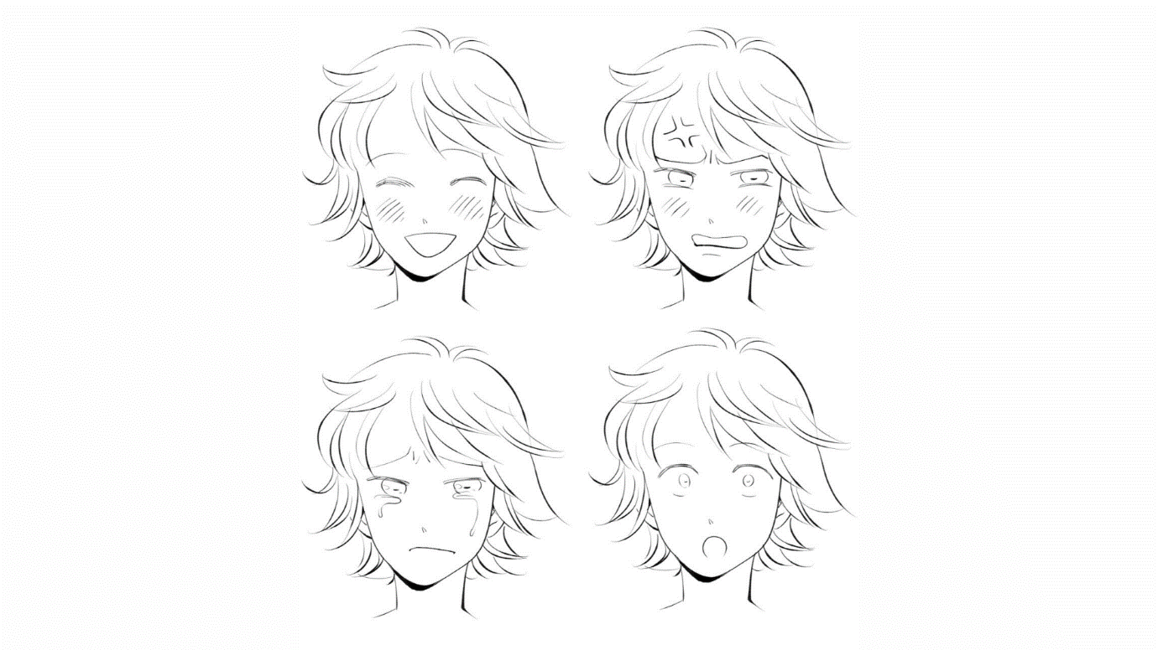
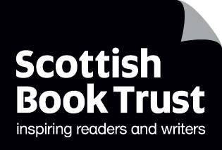

Creating a manga character
A guide to creating your own manga character, focusing on drawing faces, expressions and emotions

CFE Second and Third Level

Resource created by Chie Kutsuwada

scottishbooktrust.com
Scottish Book Trust is a registered company (SC184248)
and a Scottish charity (SC027669).

Contents
About this resource 2
Curriculum areas 2
Drawing a face step-by-step 3
Drawing facial expressions 9
Face template worksheet 14
Facial expression worksheet 15
How to draw eyes 16
How to draw noses and mouths 17
How to draw hair 18

About this resource
Manga is a Japanese word that means comics or graphic novels. It is one of the most popular and widely known pieces of Japanese culture. In Japan, almost 40% of publications are manga books and manga style drawings are very commonly used across design, including in advertisements and mascots.
This means it can be difficult to define what “manga style” is as it varies from artist to artist. That being said, manga style typically uses clean lines.
Please note, there is no such thing as the “ultimate” manga style, and the aim of this resource isn’t to limit any young person’s drawings or their own style. Hopefully, this resource should allow your pupils to explore new drawing techniques and find a style of their own!

Curriculum areas
This resource supports areas of Curriculum for Excellence in both Literacy and English and Expressive arts:

Literacy and English
LIT 2-20a/3-20a, LIT 2-24a/3-24a, ENG 2-27a/3-27a, ENG 2-31a/3-31a

Expressive Arts
EXA 2-02a/3-02a, EXA 2-03a/3-03a, EXA 2-04a/3-04a, EXA 2-07a/3-07a

Drawing a face step-by-step

What you need:
- A4 size plain paper
- Copies of the printed templates on page 14 and 15 (at least one per pupil)
- Pencils, ideally HB or slightly softer
- Erasers
- Optional – a fine point liner to finalise the drawing

Starting out
Please make sure pupils draw very softly for their draft sketches. This is because all the pencil lines will be erased when the image is finished. As they go, allow them time to adjust and redraw their rough sketches until they’re happy with their drawing.

Step 1
Start by drawing a circle. Make sure it is not too large or small. If it’s too large, there’ll be no space to add hair later, if it’s too small it’ll be difficult to add in facial features later.

Step 2
Divide the circle into four even sections with a vertical and horizontal line.

Step 3
Extend the vertical line to mark the end of the chin. A long line will create a longer face, and vice versa for a shorter face. In most manga, a longer face is usually used for characters who are mature, cool or sharp. Shorter faces are usually used for characters who are younger or cuter.
This is a good point to ask the pupils to think about what kind of character they want to create. Ask them to think of some adjectives to describe their character, and how they’ll convey that in their illustration. For example, an evil character may look angrier, or have a longer face with a “cooler” look. A young and more upbeat character might have a shorter face.
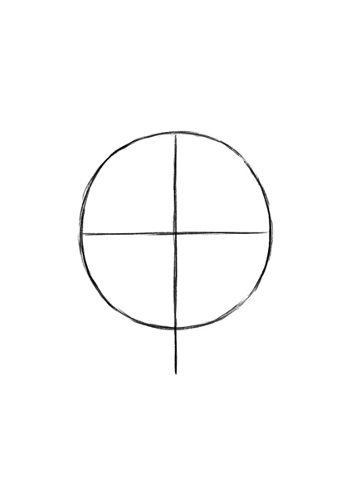

Step 4
Following the diagram, connect A, C and B with curved lines. It should almost look like an upside-down egg.
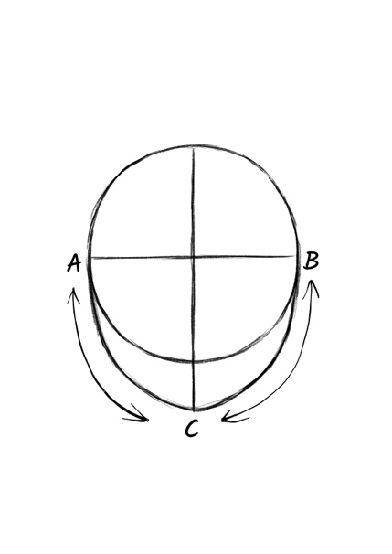

Step 5
Start adding marks to plan where to place facial features. I usually add eyes just under the horizontal line. It’s all about balance!
You can play around with where to place features. For example, placing the mouth higher will create a longer chin and placing the eyes above the horizontal line will create a longer face. The image on the right shows an average balancing of features.
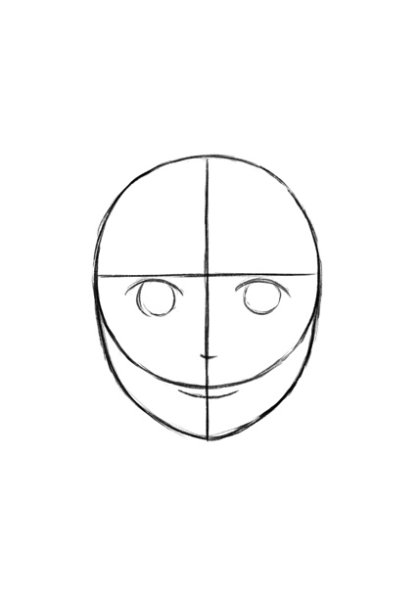

Step 6
This is where we add the ears and neck. Ears might be covered with hair later, but I recommend drawing them at rough sketch stage.
Knowing where the ears are affects how to add hair, especially volume of hair and hair style are affected by the existence of ears, for example, hair combed behind ears/ears partly covered with hair.
The position of base of ears is almost next to eyes. Usually, I ask pupils to think about the relation between temples of glasses and ears. 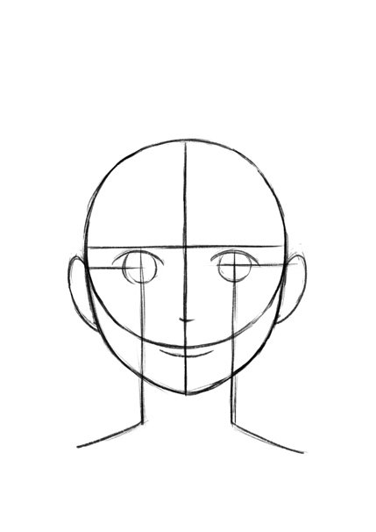

Step 7
Finally, adjust shapes of face and widths of face/neck accordingly. Please refer to the image below for some possibilities. For example, I sometimes trim the sides of the head to reduce its roundness.
As for neck, the wider neck as illustrated below immediately give the impression of a more muscular person. On the other hand, if neck is narrower, it might make the character look slim and/or sensitive.
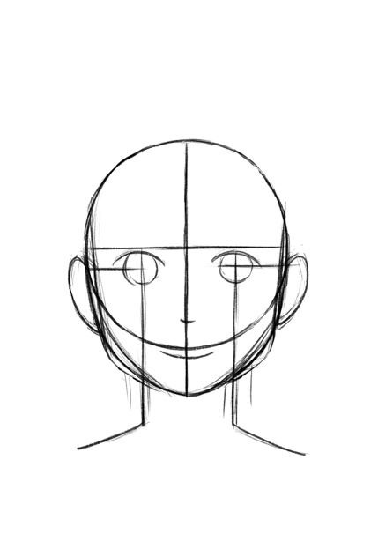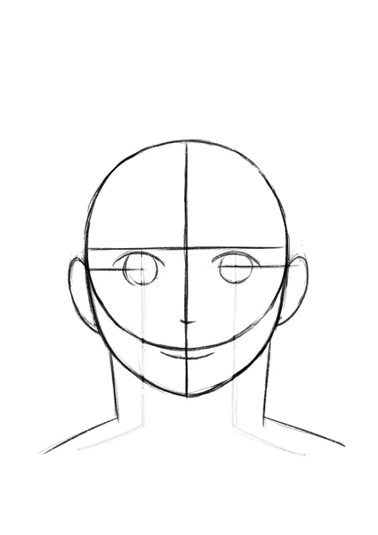

Step 8
Before finishing the drawing, it’s time to look at how to draw the different facial features and hair. Please refer to the further information on facial expressions on page 11, and the examples of different features and hair on pages 16, 17 and 18
.
Ask the pupils to think about:
- What expression is their character expressing? Do they have a backstory for why they’re feeling this way?
- How can you show this character’s personality through their features? (e.g. hair, eyes, nose, mouth). You could show some examples of manga characters on the board, asking the pupils to describe the character’s personality based on how they’re drawn, paying attention to expression, pose, facial features and so on.
- What will their character be wearing? What background is behind them?

Step 9
Time to add all the facial features and hair. Please make sure pupils are still drawing softly. Ask them to think about how each facial feature and hairstyle, etc., best suits their character. Make sure they keep think about balance – paying attention to the size and position of each feature.

Step 10
Once the pupils are satisfied with their sketch, it’s time to finalise the image! Use proper pressure on a pencil to finalise it – drawing over the best lines from the draft to make the lines clearer. Then erase all unnecessary lines.
If you want to use a fine point liner to complete the image, then make sure they use a lighter pressure throughout the drawing process, including any definition. Then ink over the lines. Make sure the ink is completely dry before using erasers.
You can use a fine liner for details and a thicker pen for the face and hair’s outline.

Drawing facial expressions
Most manga works are character driven and a lot of the story is told through the character’s emotions. This means capturing different emotions is crucial. Here are my top tips for capturing different facial expressions:

Act it out!
Knowing how the face moves is key to understanding different expressions. Ask the pupils to spend some time acting out facial expressions in pairs, or with a mirror.

Look at the details
Focus on how parts of the face interact – for example eyebrows, eyes, mouth and cheek. If you move one part of your face, notice how other parts of the face also move. If you smile, for example, your cheekbones rise and eyes close, or half-close. This means drawing a smiling character with their eyes wide open won’t look quite right.

Use manga marks
Manga has some unique markings for specific emotions. For example, the “anger mark” or ikari maaku is used to show a character is angry or irritated and represents a bulging vein. Paired with a downturned mouth and eyebrows, you can create a character who is visibly angry. Or, paired with a smiling face, it represents a character who is secretly angry but pretending to be happy. See examples of these on page 11.
You can also see diagonal lines are used across the cheeks, and sometimes nose, to show a character is blushing.

How does this character express their feelings?
Think about how the character is feeling – you can search for images to look at the interactions of different feelings. Try mixing and matching different feelings, for example, smiling sadly, crying happily or frowning angrily versus sadly.
Also think about how their personality will impact how different emotions might look on their face. For example, someone who is shy might not have a big wide grin, instead they might smile with their mouth closed.
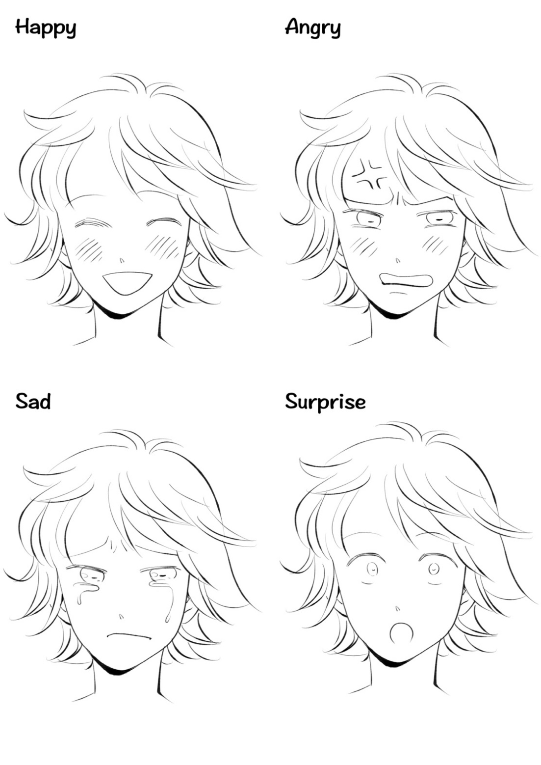

Happy
The most obvious happy face is smiling or laughing. In this image, you can see the eyebrows are relaxed, the eyes are closed and the diagonal lines are used to show rosy cheeks.

Angry
Drawing the tension is the key. Most distinctive feature of angry face might be eyebrows. Try to add lines between eyebrows and shape the eyebrow sharp arch to realise the angry frown. The angry mark is added to visually show the anger. But overusing some of the manga iconography, such as the angry mark, will make artwork look slightly comedic, so I’d advise to use them sparingly!
Differs from the Happy face, those diagonal lines here are added to show boil over emotion.

Sad
When one is sad, the whole face goes down. Both side of mouth go down and the outer edge of the eyebrows go down. Drawing some teardrops might be a good addition.

Surprise
All the facial features look as if they are exploding. Eyebrows rise, eyes wide open, and mouth wide open too. If you keep the wide opened eyes but match them with the angry eyebrows (and angry mouth maybe), the character looks unpleasantly surprised or shocked. But with smiling mouth, it looks happily surprised.

Further resources

Chie Kutsuwada and Scottish Book Trust
- Find out more about Chie Kutsuwada on her website, including her Drawing Manga video workshops
- For more creative writing, including illustration, see our creative writing for schools and young writers resources
- Read our article on Journaling for wellbeing from illustrator Candice Purwin

Using manga in schools
- “Manga, graphic novels, and comics in Higher Education?”, University of West London (though this article is looking at higher education, it looks at how readers learn when reading manga, and suggests possible teaching activities)
- Webinars from Manga in Libraries on topics including disability visibility, teaching with manga, supporting learners, BIPOC representation and more
- “Manga Belongs in School Libraries”, Journal Quest from the American Association of School Librarians
- “Manga and anime declared good study tools for kids”, Japan Today

Face template worksheet
Print this page

Facial expression worksheet
Print this page
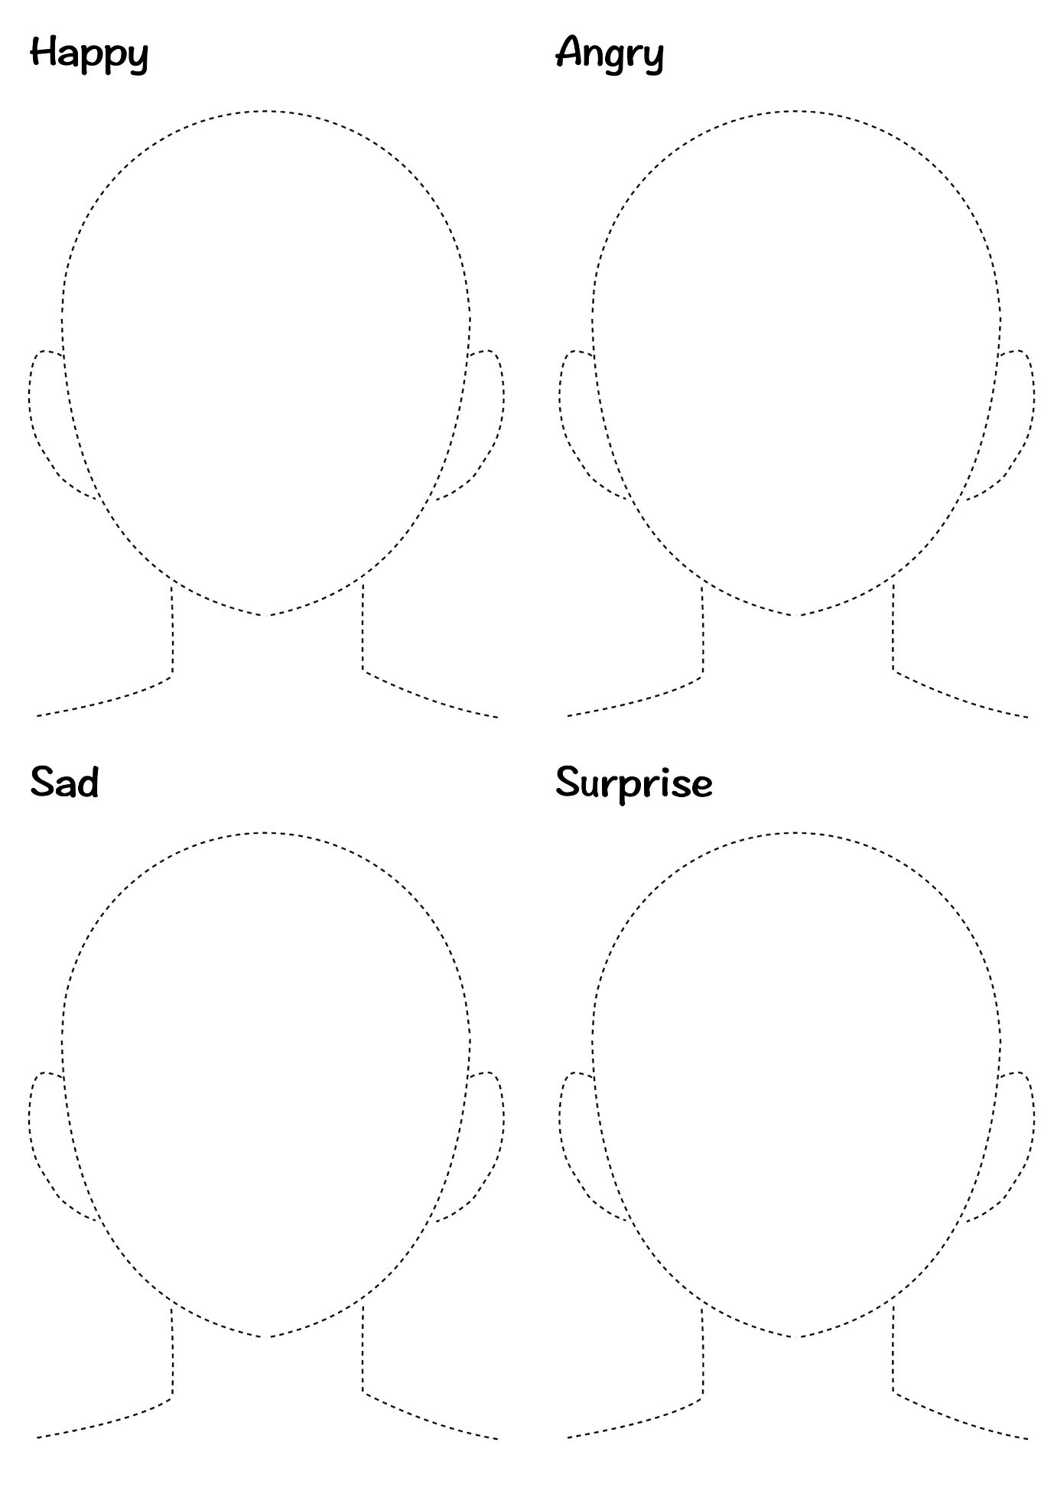

How to draw eyes
Print this page
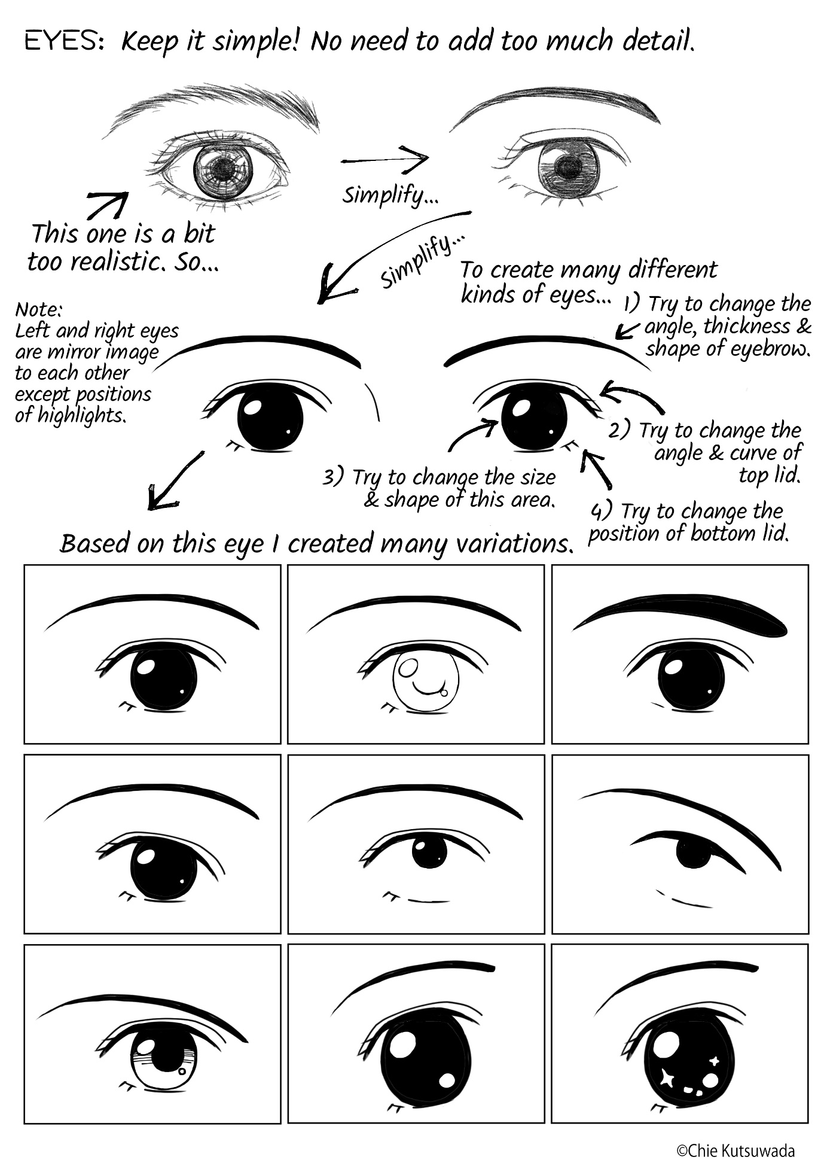

How to draw noses and mouths
Print this page
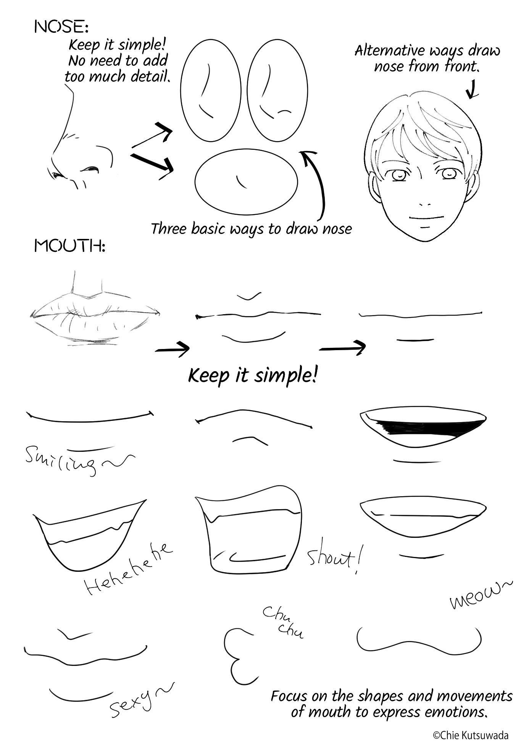

How to draw hair
Print this page
