First Minister’s Reading Challenge Reflection Report – Executive summary
The First Minister's Reading Challenge (FMRC) run by Scottish Book Trust (SBT), has been a positive, high-profile programme since 2016. It offered resources and opportunities for primary and secondary schools, libraries, and community groups to implement ways to develop a reading culture and increase levels of reading for pleasure.
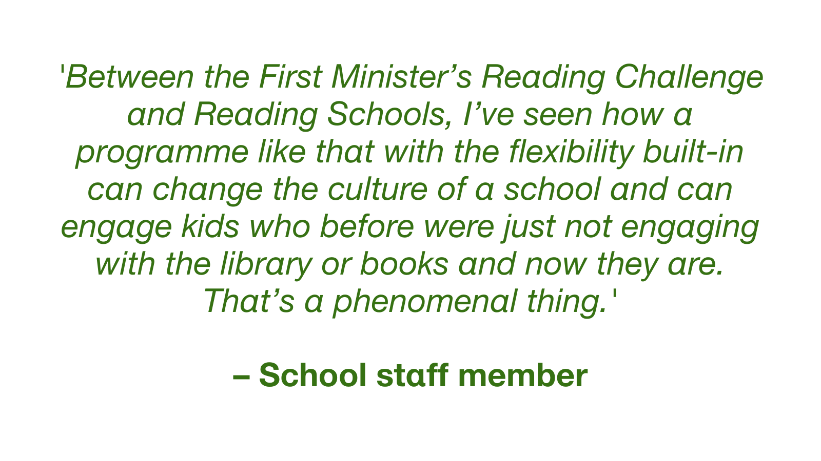

Background
FMRC has made significant progress in establishing a reading culture for Scotland's young people, with transformational change being described for schools, staff and pupils. The programme achieved a high level of engagement with schools, especially primary schools with 1,665 schools registering to take part in at least one year since 2016.
Scottish Book Trust managed a range of challenges in implementing FMRC, from promoting the concept of developing a reading culture in the first place, to the annual management of a national awards programme. An initially high level of uptake in Year 1 reduced in subsequent years, with the programme heavily affected by the COVID-19 pandemic as schools closed for two periods in 2020 and 2021. While some found ways to continue literacy activities, many FMRC activities were put on hold because of changed priorities or practicalities.
The evaluation found examples of:
- Schools which made significant progress in establishing a reading culture, with transformational change identified for schools, individual staff and pupils. This includes adopting daily working practices to incorporate reading into school life;
- Teaching and librarian staff changing their view on their roles and the contribution of reading to attainment across the curriculum, and
- Young people who have increased or developed a new love of reading.
There are challenges in attributing changes in attainment specifically to FMRC, however the qualitative evidence is strong about its contribution to an improved reading culture in a learning environment and the positive atmosphere and focus this brings. Crucially, the evaluation established a clear link between FMRC and pupils enjoying discovering and sharing a knowledge and love of books.
An increase in reading for pleasure and an improved reading culture was reported by 97% of schools which participated in the evaluation, with 18% attributing this fully, and 71% partially to FMRC.
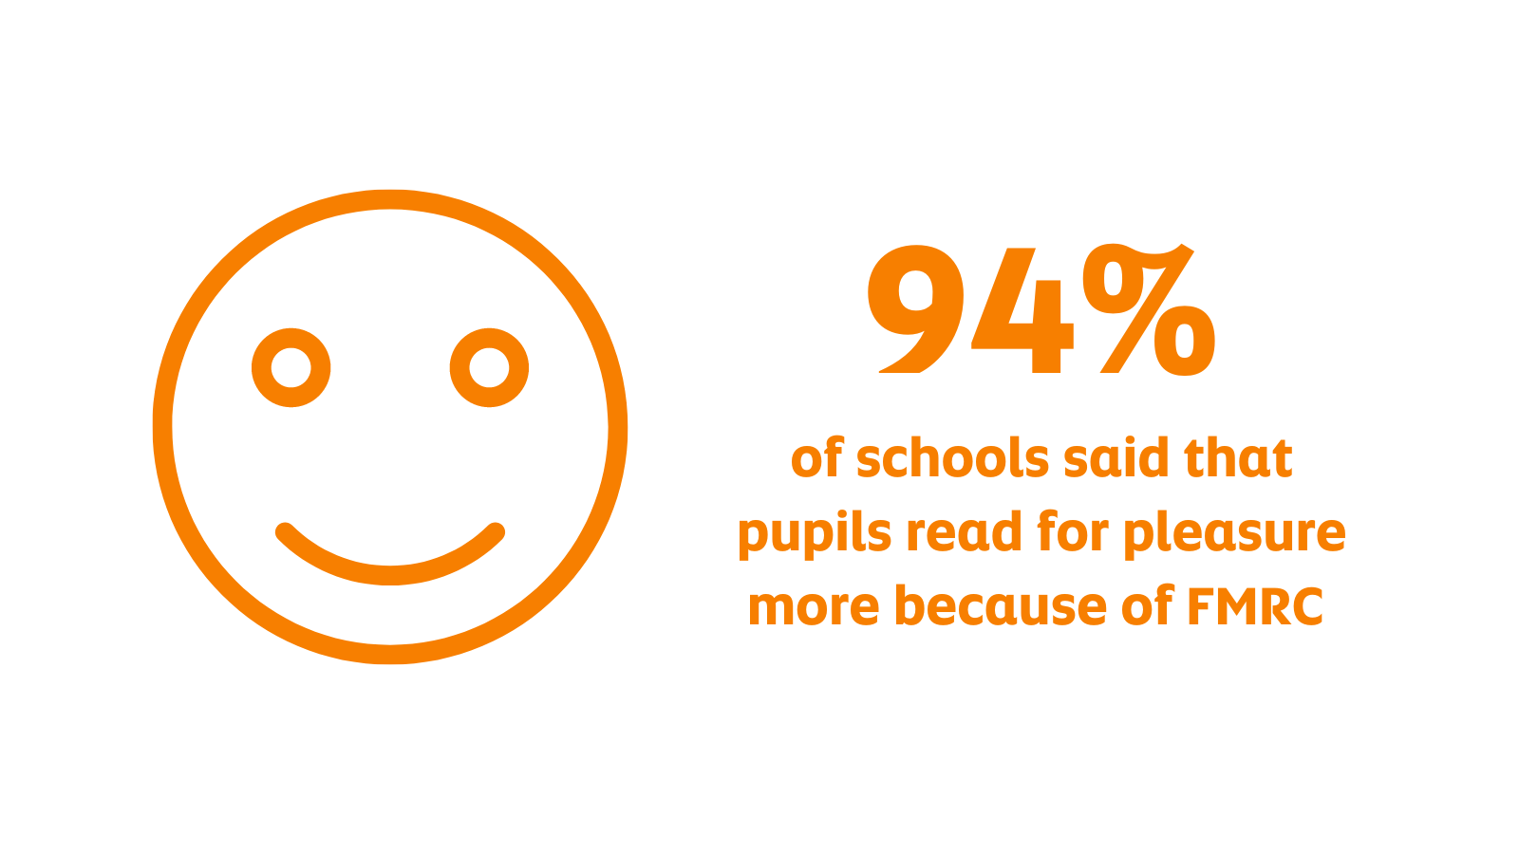
As First Minister's Reading Challenge approached its original planned ending in June 2022, a successor programme called Reading Schools was launched, following a two-year pilot.
However, following consultation with Scottish Government, FMRC and Reading Schools will both continue to be delivered. Reading Schools is an accreditation scheme offering schools the opportunity to achieve bronze, silver or gold status for their work in developing reading for pleasure. Schools which engaged in the FMRC appear well-informed and equipped to take part in this new programme.
Resources and support have been key to the implementation of FMRC in schools. The continuation of similar encouragement and practical help for school staff through Reading Schools, will help to ensure that FMRC’s achievements in developing reading for pleasure in schools and communities around Scotland are likely to be sustained and further developed.

Key findings
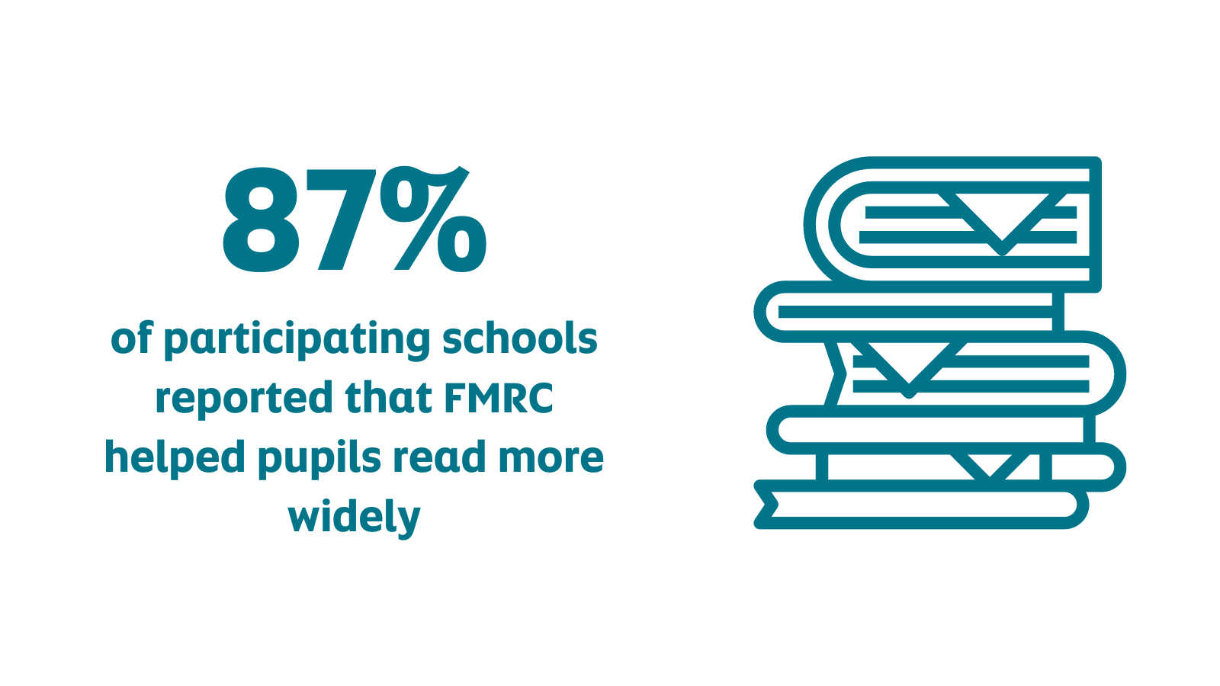
- Scottish Book Trust took the vision of developing a reading culture in schools, and created and resourced a national programme which gained significant school involvement. Latterly this took place during a challenging period which included school lockdowns during the COVID-19 pandemic. FMRC supported schools to embed reading in their daily life, to celebrate a love of reading and for schools around Scotland to develop and share examples of good practice.
  - A large number of schools in Scotland took part in the First Minister's Reading Challenge at some point during the programme, with a particularly high level of interest right at the start.
    - Sustaining that interest has been a challenge for the programme. While the numbers achieved in Year 1 were not repeated, and have decreased over time, a good level of engagement from schools remains.
      - FMRC is seen as a flexible and accessible programme and school staff value the support from Scottish Book Trust resources, and the opportunity to link FMRC with other SBT initiatives.
        - Schools which engaged fully with the concept offer strong examples of how reading culture can be developed in schools and how reading for pleasure can be stimulated. There is evidence of transformative change in working practice, shifts in staff attitudes and increases in young people’s enthusiasm for reading. However, with participation levels reducing over time, it can be assumed that a decreasing number of schools have experienced sustained culture change towards the end of the life of the programme.
          - Learning from FMRC has informed the development of a follow-up programme which offers a way of sustaining a focus on reading for pleasure in the future. Reading Schools, FMRC's successor, is now in place and offers all schools the opportunity to gain accreditation for their efforts in developing reading for pleasure. This ensures the continuation of an accessible framework to support reading for pleasure in schools, with an awards scheme which every school can achieve. Many of the resources and forms of support which have been at the heart of FMRC are seen by schools as being valuable to continue, for their work in the development of reading culture.
