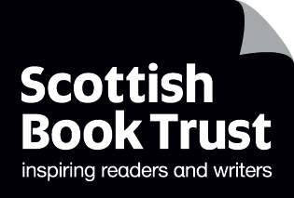
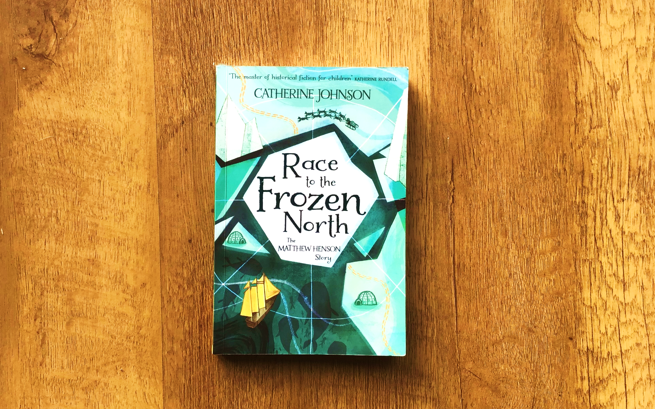

Read Woke: Race to the Frozen North
Activity ideas to support classroom use of the book Race to the Frozen North: The Matthew Henson Story by Catherine Johnson.

Second level
Resource created by Scottish Book Trust

scottishbooktrust.com
Scottish Book Trust is a registered company (SC184248)
and a Scottish charity (SC027669).

Contents
Scottish Book Trust 2
Read Woke 2
Read Woke South Ayrshire 3
How to use this resource 3
Learning activities 4
Further resources 9

Scottish Book Trust
Scottish Book Trust is a national charity that believes everyone living in Scotland should have equal access to books. Our work provides opportunities to improve life chances through books and the fundamental skills of reading and writing. Access to books and a love of books bring many important benefits from family bonding and advancing children’s learning, to unlocking creativity, helping employability and improving mental health and wellbeing. Scottish Book Trust aims to support all communities across Scotland, with particular focus on those who are vulnerable and under-represented.

Read Woke
‘Read Woke is a movement. It is a feeling. It is a style. It is a form of education. It is a call to action; it is our right as lifelong learners. It means arming yourself with knowledge in order to better protect your rights.’
– Cicely Lewis, Founder of Read Woke
The Read Woke challenge was developed by Cicely Lewis in Georgia, USA in 2017. Motivated by the political climate and seeing students grapple with issues of social injustice daily, Cicely realised the need to empower them with knowledge. Knowledge about the issues they (and others) face and knowledge about their own rights. The aim is to educate children and young people through reading. Find out more on the Read Woke website.
Read Woke South Ayrshire
The Read Woke challenge was brought to Scotland in 2020 via the School Library Improvement Fund. A collaboration of South Ayrshire secondary schools created a book list and incentivised reading programme for S1–6 students with the aim of improving representation within library collections, celebrating diversity and encouraging students to be socially aware. Further backing from the Scottish Library and Information Council has allowed this work to be expanded into a primary school setting with Read Woke South Ayrshire Primaries launched in February 2022.
Providing carefully chosen books to schools – along with tailor-made resources and activities through the year – is allowing us to educate and empower students to engage with social justice issues and stand up for the rights of themselves and others. The resources produced will help schools embed themes of equality, diversity, social justice, and human rights throughout their curriculum from P1–7. Learn more on the Read Woke South Ayrshire website.

How to use this resource
The aim of this resource is to support the use Race to the Frozen North: The Matthew Henson Story by Catherine Johnson in a classroom setting. Activities reflect some of the central book themes and scenes and cover a range of curriculum areas at second level.
Race to the Frozen North is a remarkable true story full of thrilling adventure, Arctic exploration, and historical detail. But it is also a moving first-person narrative that touches on the historical racism and discrimination in America and the treatment of Inuit peoples by early explorers. Activities within this resource aim to reflect this broad scope, covering both the exploration and discrimination elements.
With all Read Woke resources, we highly recommend that you read the book before using it with your class. Whilst this book does not contain any upsetting or graphic content, it’s worth being familiar with the text before you use it with your class.
There are a couple of aspects that teachers may wish to be mindful of before working on this book with pupils. The author Catherine Johnson has written the story as if it is being told to us by Matthew himself in the 1900s and has used language that would have been appropriate at that time, but that would not be appropriate today. In particular, Matthew often uses the term ‘coloured’ to speak about himself and the black individuals he encounters. You may wish to speak to pupils about the use of this term in the Jim Crow era and explain how describing someone as ‘coloured’ places the emphasis on humans being white and suggests that anyone else has been ‘coloured’ to another tone. This racist emphasis and the era in which it was used, mean that although Matthew would have used this word, it is now considered offensive. In this resource Activity 6: ‘Don’t call me “boy”!’ can also be used to explore how language can be discriminatory and hurtful. For further information on speaking to young people about racism and racist language, teachers may wish to explore the NSPCC website.
Teachers should also avoid referring to the Inuit people as “Eskimos”. While this term is not used within the book, it is still occasionally used in schools and is widely regarded as a slur by the Inuit and Yupik peoples. For more information on the importance of not using the term “eskimo”, we recommend this article from the Sinchi Foundation.
If, as part of exploring this book with your class, you choose to research Matthew Henson’s real life, you’ll find evidence of how explorers, including his party, treated the Inuit people. This could lead into a conversation about the nuances of colonialism and racism – including that those who experience racism can still perpetuate racist systems themselves. For more information on the impact of colonialism on indigenous people, we recommend this article from the Indigenous Peoples of Canada Atlas. The Inuit Cultural Online Resource also has some great teaching resources and worksheets on Inuit history, life and culture.

Learning activities

Activity 1: Plan an expedition.
LIT 2-02a, SOC 2-09a, SOC 2-04a
Any expedition requires lots of planning and organisation. For their trip to the North Pole, Matthew and his colleagues also had to consider that everything brought with them had to be carried or transported by sled.
Split into groups and ask pupils to work together to plan a modern expedition, being mindful to only list what they think would be essential. You might vary the places each group are going, for example: trekking across the jungle, heading over the Himalayas, crossing the Atlantic in a small boat, or traversing a desert.
Ask groups to consider how they would survive, how they would travel, the kind of dangers they might face, and what they would do in an emergency.
As an extension activity, you could then ask the groups to cross off anything they think that people would not have had in 1909. Discuss what the alternatives might have been back then, and the additional problems this might have raised.
You might also discuss if any group had considered asking for the help of a local guide or someone who had done this before. One of Matthew’s strengths was that he reached out to the Inuit people, unlike others in his team, and in doing so learned many skills that were vital to the survival of the expedition.

Activity 2: Useful phrases in other languages
MLAN 2-11c, MLAN 2-02a, LIT 2-03a
Although Matthew was unable to read or write until he was 11 years old, by the time he was 16 he could speak a bit of Chinese, Japanese, Russian and Spanish. When he journeyed to the Arctic, he took the time to learn the Inuit language as well. This enabled him to learn essential skills such as hunting, fishing and how to drive a dog sled from Ikwah and Ahnalka.
Ask pupils to work in groups and come up with a list of useful phrases or words that they think would be important to learn if you were visiting a new country. Each group can use online tools to translate some of them into a language of their choice.
Finally ask a member of each group to speak a phrase in the new language and see if the rest of the class can work out what they are saying. How much does body language help to convey the meaning of the phrase?

Activity 3: Unrecognised heroes
SOC 2-01a, SOC 2-16b, LIT 2-24a
In Race to the Frozen North we discover that in 1910 when the American government finally recognised their expedition to the North Pole, the white members of the team were given medals and promotions. Sadly, because he was black, Matthew’s accomplishments were ignored. Throughout history there have been many amazing men and women whose achievements have been largely ignored during their lifetime due to the colour of their skin, their gender, or their sexuality.
Ask pupils to research someone connected to Scotland or the UK who was overlooked in this way and create a brochure or poster that celebrates their work.
You might consider people like: Andrew Watson (footballer), James McCune Smith (doctor, writer, activist), John Edmonstone (taxidermist), Edith Hughes (architect), Lady Carolina Nairne (songwriter) or Kaichi Watanabe (engineer).
Useful black history resources and films on some of these individuals can be found on the BBC and Historic Environment Scotland websites.

Activity 4: Build a shelter
TCH 2-09a, TCH 2-10a
An important skill for any adventurer is the ability to create a shelter from the materials they have at hand. This could be wood, metal or even, in the case of the Arctic explorers, ice.
Offer a range of craft materials and loose parts; boxes, tubes, sticks, straws, tape, tubes, netting, fabric, pegs, string (etc.) and ask pupils to create a strong shelter. These could be tiny individual shelters (say for a Lego person or a doll) or, if you have space in the classroom or playground, this could be a life-size creation big enough for a person.
If you wish to extend this activity, you could ask that the shelter be waterproof or windproof (then test its effectiveness!).

Activity 5: Tall tales
EXA 2-01a, EXA 2-13a, HWB 2-23a
Baltimore Jack was known for telling amazing stories to Matthew. These tales were so exciting and enticing that he ended leaving his job and seeking passage on a sailing ship to explore the world. Ask pupils if they felt these stories were true or did Jack exaggerate or make them up? What was it about the stories and the way they were told that was so exciting? Could they tell a tale so good that it would make someone want to run away and go there?
In this drama and storytelling activity, split pupils into small groups and ask them to come up with a 3-minute tale of somewhere so amazing that everyone else in the class would want to go there, or the story of an adventure they had that everyone would wish to experience.
One person in the group can then be Baltimore Jack and read or tell the story aloud, and the rest of the group can act out scenes from his tale (a bit like an advert for an amazing adventure). Think about how tone of voice, persuasive language and dramatic scene setting can influence an audience. Finally, ask the class to vote on how compelling the place or adventure sounded and looked. Would they want to go there?

Activity 6: Don’t call me “boy”!
SOC 2-16b, LIT 2-26a, ENG 2-31a, HWB 2-04a
In the book (page 61) Matthew talks about how uncomfortable he is when people call him “boy” even though he is a grown man. Ask pupils to consider why Mr Sam used this term and explore how this ties to slavery and how black men were viewed in America at the time.
Discuss how the choice of words we use, even ones that are not obvious slurs, can make others feel. If you referred to one of the pupils as “little girl/boy”, “troublemaker” or called them “this child” in front of another person, how would they feel? What does that say about how you view them? Can pupils think of other everyday words or ways of speaking that can feel hurtful? Words like; silly, childish, mean, stuck-up, horrible, selfish, boring, weak or foolish. Write some of these out on the board and consider how these words can make us feel and why people use them.
Ask pupils to write a poem about how words can hurt or belittle someone. Be aware that this activity may be upsetting for some pupils, so consider framing it as seeing the world through someone else’s eyes, rather than their own.
The poem could start with the words the person used “You called them. . .” , then show how this made them feel. Then an answer with all of the positive things they are instead “But they are…”

Activity 7: Letters
SOC 2-19a, SOC 2-16c, LIT 2-26a
When Matthew finally left the Arctic, Ootah was surprised to hear that, after everything they had been through together, Matthew would not be coming back. For Ootah it seemed very strange that people would travel all this way, spend so many years and such effort just to stand on a lonely piece of ice, one that looked much like all the rest.
Ask pupils to imagine what it was like for Matthew to come home after living with the Inuit people for so long. What might he miss about the Arctic, what was being home in America like, and did he think about his friends who he would never see again.
Write an imaginary letter from Matthew to Ootah, exploring their time together, discussing what he misses, what being home is like, and explaining why he left.
As an extension activity you could ask pupils to imagine a letter that Ootah might write back to Matthew.

Activity 8: Animals that help us
EXA 2-03, EXA 2-04a, SOC 2-16c
Sled dogs are a vital part of both Arctic exploration and the Inuit culture, even today. They are perfectly designed for the climate, are intelligent, hardy and do not require petrol to run! Research Greenland sled dogs or watch this short film about sled dogs with your class (3 minutes, 1 second).
Ask pupils if they can think of any other ways dogs or other animals help us? You might consider; guide dogs, sheep dogs, mountain dogs, sniffer dogs, therapeutic animals, horse loggers, or even carrier pigeons.
Give pupils a sheet of paper with a circle on it and ask them to design a medal for one of these animals, rewarding them for their achievements. Ask them to consider what symbols and words should appear in the design to show what it was awarded for and what animal it was given to.
You may like to follow this up by reading a book like Scotland’s Animal Superstars by Kimberlie Hamilton, or by learning about a real animal who was awarded a medal e.g. the Dickin medal, or had a statue made in their honour, like Greyfriars Bobby or Tombili.

Further resources

Read Woke
- Read Work South Ayrshire website
- Read Woke resources on the Scottish Book Trust website

Scottish Book Trust
- Scottish Book Trust Polar adventures book list
- Scottish Book Trust Black history book list
- Watch Catherine Johnson discuss Race to the Frozen North on our Authors Live on Demand library

Other useful links
- Explore inspirational black historical figures on the Black History Month website.
- Find more learning resources to explore racism on The Black Curriculum website.
- Find out more about the Arctic and the North Pole with the Royal Geographical Society.

