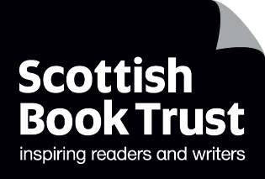
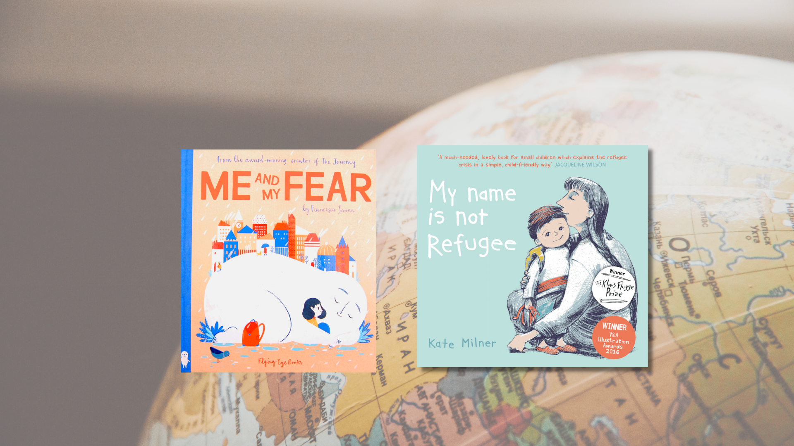

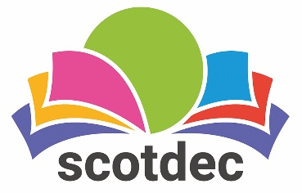

Taking a rights-based approach to fiction in primary schools: Early Level
A guide to using picture books to teach about, through and for children’s rights and UNCRC. This resource contains all Early Level activities.

CFE Early Level

Resource created by Scottish Book Trust and Scotdec
scottishbooktrust.com
scotdec.org
Scottish Book Trust is a registered company (SC184248)
and a Scottish charity (SC027669).

Contents
About this resource 2
Early level learning activities 4
Me and My Fear, Francesca Sanna (Article 31) 4
My Name is Not Refugee, Kate Milner (Article 22) 7
Other texts 9
Further resources 10

About this resource
This resource aims to support teachers of early level to explore children’s rights through fiction in the classroom. The first section of the resource explores questions and discussion points which could be used and adapted in relation to any primary text. The resource then examines two picture books in detail, with suggested activities and questions for each. The aim is to provide teachers with confidence, motivation and understanding of how to take a rights-based approach when reading fiction with children.

Taking a rights-based approach
Taking a rights-based approach means that the articles of the convention in the UNCRC underpin the ethos and life of the classroom. For a simplified child-friendly version of the UNCRC to use with children, visit the UNICEF website. This approach involves teaching about, through and for rights which are explained in more depth in this resource.

Texts as mirrors, windows and doors
The metaphor of texts as mirrors, windows and doors is often used when exploring children’s literature. As a mirror, texts and images can give opportunities for children to see their own realities, cultures and identities. As windows, literature can enable children to view someone else’s world, exploring ideas and cultures that are new and realising that multiple perspectives exist. As a door, texts help children to develop as critical thinkers who can respond actively, making links between the texts and taking social action.

About rights
Learning about the different rights in the UNCRC includes looking at characters’ needs and wants, relating their needs to the rights in the articles of the UNCRC and asking pupils to reflect on the rights in their own life. Example questions include:
- What is the difference between what a character wants and needs?
- Which rights are, or are not, being upheld in the story?
- How are these rights upheld in your life? Are there individuals or groups who do not have these rights? Why not?

Through rights
For children to understand their rights, they also need to experience a rights-based approach in the classroom, where teachers:
- Demonstrate a commitment to human rights through relationships based on equality and mutual respect
- Put dignity at the heart of classroom principles and promoting and demonstrating cooperation, kindness, empathy and trust
- Use creative and active learning to encourage all children to engage in learning opportunities
- Equally recognise all children’s achievements
- Ensure children are supported to understand the consequences of their behaviour through nurturing relationships with each other and adults
- Recognise that behaviour is a form of communication
- Create a democratic culture where all children have a voice and believe adults will take them seriously
- Enable all children to directly influence their learning
- Teach children their rights in relation to their own daily lived experiences

For rights
This focuses on equipping children to advocate and take action for their own, and others’ rights. Texts offer chances for children to learn about systems of support, how their choices matter, the impact of their voice and participation and practical ways to take action. Example questions include:
- Can you engage in action or campaigns relating to the text?
- What can you do when you want to raise an issue? Who can you go to? Are there groups or people who will listen? Are there ways to improve the system?
- What choices does the character have/make in the text? What choices do you have? When should you be able to make your own choices?
With all the texts mentioned in this resource, we highly recommend that you read the book before using it with your class and use your best judgement about whether that specific text, or topic, is appropriate for the children in your class. There may be children in the class with a range of backgrounds and lived experiences: children should only talk about or share these if they wish to. Teachers may wish to send a copy of the book home to share with parents in advance or to talk about it with the child before reading it with the class.

Early level learning activities

Me and My Fear, Francesca Sanna (Article 31)
‘Every child has the right to relax, play and take part in a wide range of cultural and artistic activities.’ – Article 31: The right to leisure, play and culture.
This book follows a young girl who is followed by a secret friend called Fear. Fear has always kept her safe, but they also hold her back from making friends or exploring.

Teaching about rights
Discuss the following:
- When the little girl starts to make friends with the boy, they draw, paint and play outside. What do you do to make friends?
- What do you like to do to relax and play?
Put two signs at either end of the classroom – one with the word “want” and the other “need”. Tell children they’re going to think about what they want to have and what they really need. What is the difference?
Either show pictures of, or write on a piece of A4, and ask the children to stand beside “want” or “need”:
- TV
- Shoes
- Clean water
- A bed
- A pet
- Time to play and relax
- A name
- An adult to take care of them
- Sweets
- School
- Medicine
Leave the picture, or piece of paper, with the most popular vote so you can reflect on them afterwards. Go through them together, and explain that things we need are our rights. These are things that all children should have to be happy and healthy – including being able to play and relax. Having a right to something means the adults who look after us and the government of our country should make sure that we have access to it.

Teaching through rights
HWB 0-02a, HWB 0-04a
At the beginning of the book, the girl tells us that Fear kept her safe and helped her explore new things before she moved. Talk about the following as a class or in groups:
- When and where do we sometimes feel afraid?
- When might feeling afraid help to keep us safe?
- What rules and strategies do we have to stop us being afraid and help keep us safe? (e.g. road safety)
- What happens to the girl in the story when Fear grows too big?

Look at how Fear appears in the book – similar to an imaginary friend. Take a piece of paper and draw what your Fear might look like. Cut out your image and stick it onto a head and shoulders photograph of yourself so that it’s sitting on your shoulder. Ask your pupils to create their own, asking them to think about what fear looks like to them.
Use these to create a class display, and revisit them throughout the year and think about how your fears might change, or you may overcome a fear.

Teaching for rights
HWB 0-01a
We’ve all experienced being new to a situation, whether it was joining school, a new club or group, or moving to a new town or country. Discuss:
- How did you feel when you were new to a place or situation?
- Are there any similar feelings to the girl in the book?
Imagine a new child arrives in your class from another country. Draw a large outline of a schoolbag on the board for all the pupils to see. Ask them for ideas of what they would give or say to that person to welcome them and help them not feel afraid. Write/draw their suggestions, or ask them to come and write/draw it for you.

My Name is Not Refugee, Kate Milner (Article 22)
‘Refugee children have the right to special protection and help.’ – Article 22: The right to special protection and assistance to enjoy all the UNCRC rights from governments, if they are a child seeking refuge or have refugee status.
My Name is Not Refugee is a moving story about a young boy and his mother who have to leave their home as it’s no longer safe. The picture book invites the reader to follow their journey. When the boy has found a new home he is reminded that being a refugee does not define him.

Teaching about rights
Ask the children what they understand by the word “refugee”. Where have they seen or heard this word before?
Watch the YouTube video “What is a refugee?” from Save the Children (3 minutes, 43 seconds). Afterwards discuss:
- Is there anything that surprised them?
- What have they learned that they didn’t know before?
- Children who are refugees have the same rights as the children who live in the new country they have moved to. Which rights were shown in the clip?
Now read My Name is Not Refugee together, looking at the illustrations as well as the text. Which rights can you see?

Teaching through rights
LIT 0-09a
Read the story to the children without discussing the questions provided throughout the text. Now read it a second time, exploring the questions and allowing them time to share their ideas. You could do this as a class or in groups or pairs.
Throughout the text, different words are used to describe the character’s experience as he travels to a new country. Find these in the story (sad, exciting, boring, interesting, strange, new, safe). Discuss:
- When have you had experiences you would describe as sad, exciting, boring, interesting, strange, new and safe?
- Which words would you choose to describe the different experiences of the character?
- Look at the character’s face in different situations. Can you describe how he is feeling by looking at his expressions?
- What would you want to say to him to reassure and welcome him?
- How do his expressions make you feel?
Near the beginning of the book, the child is told that he can pack his own bag but to only bring what he can carry. Ask children to point out the things they can see that he has chosen to bring (special soft toy, photographs, a toothbrush).
Ask them if the mother has packed anything? Encourage them to look out for these objects throughout the book. When they reach their safe place, ask them if they can you notice any of these things. Ask what things might remind them of their old home?
Create a suitcase using construction paper or card which can be folded and unfolded to reveal the contents inside. Ask children to bring a photo from home of an item(s) they would pack in their suitcase, or they could draw a picture of the object (s). Children can share the stories of their chosen items with the class. Questions that might facilitate sharing these stories include:
- What is the object used for?
- Who would use the object?
- Why is it important to you?
Bear in mind, some children in your class may have an experience of leaving important items behind.

Teaching for rights
Show children the front cover of the book. Discuss:
- Why has the book been given this title?
- What does it mean?
- Is it surprising/confusing/clever?
- Can you think of another title you would give the book?
Now read the last page of the story. Explain that the word refugee describes the character’s status, in the same way as you may be described as an adult. His actual name is part of his identity as a person and the word refugee is not part of his name. Ask children why this is such an important title for the book and what we have learnt by talking about it.
Tell children that there are refugees in countries all over the world, and while the word refugee tells us that they have made a difficult journey to leave a home country, we must remember that they will have their own story to tell, and that they have the right to all of the same rights that we have, including that of a name and an identity.

Other texts
- We All Play, Julie Flett (Article 31)
- Susan Laughs, Jeanne Willis (Article 23)
- Talking is Not My Thing, Rose Robbins (Article 29)

Further resources

UNCRC and children’s rights
- UNICEF: UNCRC summary and full versions
- Amnesty International: Human rights education
- Children’s Parliament: resources
- Article 8: “Why Getting Someone’s Name Right Matters” from Ascend
- Article 30: “Why we have the right to an identity” from Amnesty International

Scottish Book Trust
- For more resources exploring reading and social justice, see our Read Woke resources and our Understanding and challenging racism resource.
- Our Read Woke resource on The Proudest Blue can be used to explore Article 14: freedom of thought, belief and religion.
- Use our book lists to find more picture books or children’s books exploring migrant and refugee experiences.

Scotdec
- For a curated list of high quality teaching and learning resources about rights see Scotdec’s Signpost Series
- For a range of educational resources exploring children’s rights in different contexts, see Scotdec’s Signpost for Global Citizenship
- For steps designed to support young people to create their own campaigns and lead the learning on issues including children’s rights see Scotdec’s Active Global Citizens resource

