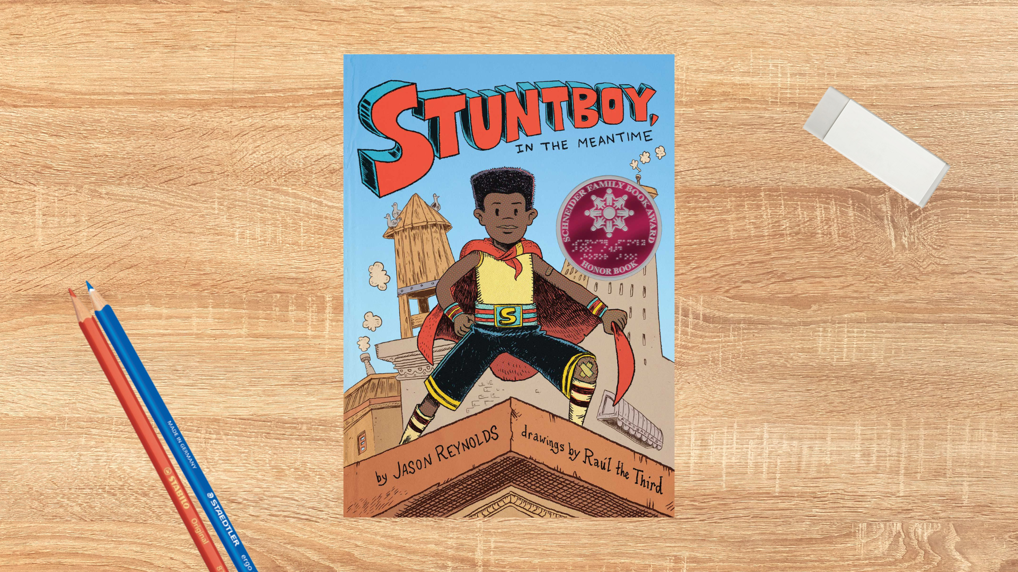

Read Woke: Stuntboy, In the Meantime
Activity ideas to support classroom use of the book Stuntboy, In the Meantime by Jason Reynolds with illustrations by Raúl the Third.

Second level
Resource created by Scottish Book Trust

scottishbooktrust.com
Scottish Book Trust is a registered company (SC184248)
and a Scottish charity (SC027669).

Contents
Scottish Book Trust 2
Read Woke 2
Read Woke South Ayrshire 3
How to use this resource 3
Learning activities 4
Further resources 9

Scottish Book Trust
Scottish Book Trust is a national charity that believes everyone living in Scotland should have equal access to books. Our work provides opportunities to improve life chances through books and the fundamental skills of reading and writing. Access to books and a love of books bring many important benefits from family bonding and advancing children’s learning, to unlocking creativity, helping employability and improving mental health and wellbeing. Scottish Book Trust aims to support all communities across Scotland, with particular focus on those who are vulnerable and under-represented.

Read Woke
‘Read Woke is a movement. It is a feeling. It is a style. It is a form of education. It is a call to action; it is our right as lifelong learners. It means arming yourself with knowledge in order to better protect your rights.’
– Cicely Lewis, Founder of Read Woke
The Read Woke challenge was developed by Cicely Lewis in Georgia, USA in 2017. Motivated by the political climate and seeing students grapple with issues of social injustice daily, Cicely realised the need to empower them with knowledge. Knowledge about the issues they (and others) face and knowledge about their own rights. The aim is to educate children and young people through reading. Find out more on the Read Woke website.

Read Woke South Ayrshire
The Read Woke challenge was brought to Scotland in 2020 via the School Library Improvement Fund. A collaboration of South Ayrshire secondary schools created a book list and incentivised reading programme for S1–6 students with the aim of improving representation within library collections, celebrating diversity and encouraging students to be socially aware. Further backing from the Scottish Library and Information Council has allowed this work to be expanded into a primary school setting with Read Woke South Ayrshire Primaries launched in February 2022.
Providing carefully chosen books to schools – along with tailor-made resources and activities through the year – is allowing us to educate and empower students to engage with social justice issues and stand up for the rights of themselves and others. The resources produced will help schools embed themes of equality, diversity, social justice, and human rights throughout their curriculum from P1–7. Learn more on the Read Woke South Ayrshire website.

How to use this resource
The aim of this resource is to support the use of Stuntboy, In the Meantime by Jason Reynolds in a classroom setting. Activities reflect some of the central book themes and scenes and cover a range of curriculum areas at second level.
Stuntboy, In the Meantime is a dynamic and funny story about a young boy who creates a new superhero persona to help him deal with the stresses in his life. While the book is full of friendship and fun, it also touches on some serious topics such as bullying, anxiety and the separation of the main protagonist’s parents.
Some activities within this resource discuss how we deal with our emotions, how we navigate conflict, and where to find support amongst friends and community. The aim is to let pupils explore the main protagonist’s feelings, without focussing on the divorce itself, in a way that helps them become more resilient and emotionally literate.
However, it is important that teachers are mindful that many young people in Scotland are likely to have experience of family conflict, separation or divorce, and may find parts of the story difficult. With all Read Woke resources, we highly recommend that you read the book before using it with your class and use your best judgement about whether teaching about this topic is appropriate for the children in your class. You may also want to explore further resources on how to support children dealing with divorce, which are listed at the end of this resource. You can also highlight organisations such as Childline and Gingerbread which are full of advice written specifically for children.

Learning activities

Activity 1: The Frets
HWB 2-01a, HWB 2-02a, HWB 2-04a
When Portico is anxious or upset he feels his body developing ‘The Frets’. He feels like he can’t sit still, his brain is churning and his insides feel mixed up. Look at how this is described at the bottom of page 15:
“[…] his heart dropped to where his stomach was. And his stomach jumped up to his heart space, which meant his stomach started beating and his heart started growling.”
Have a discussion about how our emotions impact how our body feels physically. Where do we feel sadness in our body, or anger, or happiness? How does this actually feel? Does our heart pound, do we get a headache, do we feel sweaty or have shaky hands? Do we think this is the same for everyone?
Follow this exercise up by thinking about the techniques that we can use to calm these emotions down and make our bodies feel more balanced again. In the book, Zola’s mum suggests they try meditation to calm down. Do they think this would work? What other things might help?

Activity 2: Precious objects
LIT 2-20a, LIT 2-26a, ENG 2-31a
In the book Portico’s parents spend a lot of time fighting over ordinary objects that hold meaning for them. One of the first things they fight over is an old chair that nobody sits on anymore but that they both love because of the happy memories associated with it.
Ask pupils to think about an object that holds meaning or memories for them. Something that isn’t precious in a monetary sense, but precious to them in other ways. Something they would be sad to lose.
Challenge them to write a poem about this object, with a focus in how it makes them feel and the memories that are linked to it. For inspiration you might show the poem “Lucky Pebble” by Amy Ludwig VanDerwater. If you need any resources to support writing, you can visit the Creative Writing for Schools section of the Scottish Book Trust website.

Activity 3: Word play
ENG 2-27a, LIT 2-28a
Author Jason Reynolds enjoys playing with words throughout the book, giving them new, unexpected meanings and interpretations. Meantime doesn’t mean “a time to wait before something happens”, it means “the time when Portico’s parents are being mean to each other”. Super means both the “supervisor of the building” and “a superhero”.
Offer pupils some of the closed compound words below and get them to discuss what they mean. Then ask them to come up with one or two new definitions. E.g.: an armchair is obviously a nice chair with arms in your sitting room, but could it also be a small chair that you rest your arm on, or a chair made out of arms, or a tiny chair you strap on your arm for your pet hamster to sit on!
Potential closed compound words to use:
- aircraft
- armchair
- beachcomb
- bedrock
- bodyguard
- clockwise
- daybreak
- eardrum
- firefighter
- football
- forklift
- grandfather
- indoors
- jellyfish
- moonlight
- nightfall
- spearmint
- watchdog

Activity 4: Commercial break
LIT 2-24a, TCH 2-11a
Many chapters in the book are broken by commercial break boxes. Ask pupils to look through the book and find out what happens in each commercial break. Look at how each box contains graphics and text laid out in a different way to the main body of the story. Why do they think the author has added them? What kind of information do these boxes contain?
Ask pupils to choose a classic fairy tale or a book they love and design their own commercial break to fit with the story at an appropriate point.

Activity 5: Looking for a friend
HWB 2-44b, HWB 2-45a
Discuss why Zola Brawner is Portico’s best friend. Ask pupils to look through the book and try to understand why they get on so well. Are there times that she showed friendship to Portico? What did she do? What kinds of things do they enjoy doing together and why do they think she likes him in return? Discuss how friendship is a two-way street.
Get pupils to create an advert for a new friend, listing the qualities would they look for in a good friend and what could they offer them in return.

Activity 6: Allegory
LIT 2-16a, LIT 2-24a, ENG 2-31a
The sci-fi TV show Super Space Warriors features in every chapter. The two main characters in the show are Mater and Pater who are trying to save the sun from disaster, but they always seem to end up fighting instead. Ask your pupils to look up the names Mater and Pater online, and then discuss how they think the TV episodes relate to what is happening in the story.
Introduce the concept of an allegory and ask pupils if they can think of any other stories that have moral lessons or ideas in them. Discuss how fairy tales and fables often have allegorical elements, eg: the three little pigs is actually about how hard work and perseverance help us in the long run. Aesop’s Fables are also good examples of allegories.
If they were directing an episode of Super Space Warriors that had a moral lesson in it for the bully Herbert Singletory the Worst, what would happen? Ask them to plan out the episode in the same comic book style that is in the book.

Activity 7: Community event
SOC 2-16a, HWB 2-08a, HWB 2-10a
In Stuntboy, In the Meantime, the community who live in Skylight Gardens all know each other well, they chat, gossip and help each other out. Every year they hold a block party, full of great music, food, dancing and entertainment. Everyone, young and old, gets involved and there is something for everyone to enjoy. It is a really fun way to bring community together.
Think about the communities around you, the street you live on, the village, the block of flats or even the school community. If you had to design an event for your chosen community, that had something that everyone would enjoy, what would it look like? What food would you serve, what would everyone do for fun, how would you decorate and what kind of music would make everyone feel good?
Split into groups and plan a community event. Try to make sure your event has things that would appeal to lots of different people. Focus on things that bring the community together, rather than separate activities for different ages or abilities.
Activity 8: Stuntboy says
HWB 2-21a, HWB 2-23a
In Stuntboy, In the Meantime, Portico has created all sorts of physical stunts like Plaster Blaster, Truck wheel, and the Jumbo Jump. In your gym hall or PE space, split your class into groups and ask them to come up with some new stunt moves to deal with potential superhero dangers such as ‘crocodile attack’, ‘meteor impact’, ‘evil lasers’, ‘sinking sand’ or ‘an explosion of great magnitude!’. Each group then teaches their move to the whole class.
Play a game of ‘Stuntboy says…’ calling out each move in turn. Everyone performs the correct action when it is called out, but they have to sit out if they do the wrong action, are last to complete it or if they do it when it is not prefixed with ‘Stuntboy says’. The last person standing is crowned Stuntperson Extraordinaire.

Further resources

Read Woke
- Read Work South Ayrshire website
- Read Woke resources on the Scottish Book Trust website
- Scottish Book Trust book lists on books to encourage empathy and children’s books to save the world.

Supporting children with divorce
- The Conversation: How teachers can help support children during their parents’ divorce
- Childline: Divorce and seperation
- Gingerbread: Supporting your child through your separation

Emotional literacy and wellbeing
- Scottish Book Trust: Discussing and drawing emotions with Tom Percival
- Scottish Book Trust: 12 books that help children explore emotions
- Scottish Book Trust: Mental wellbeing books for teens
- Empathy Lab: Resources

