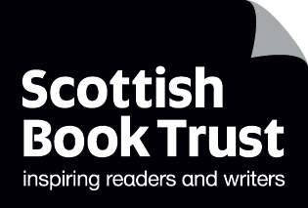
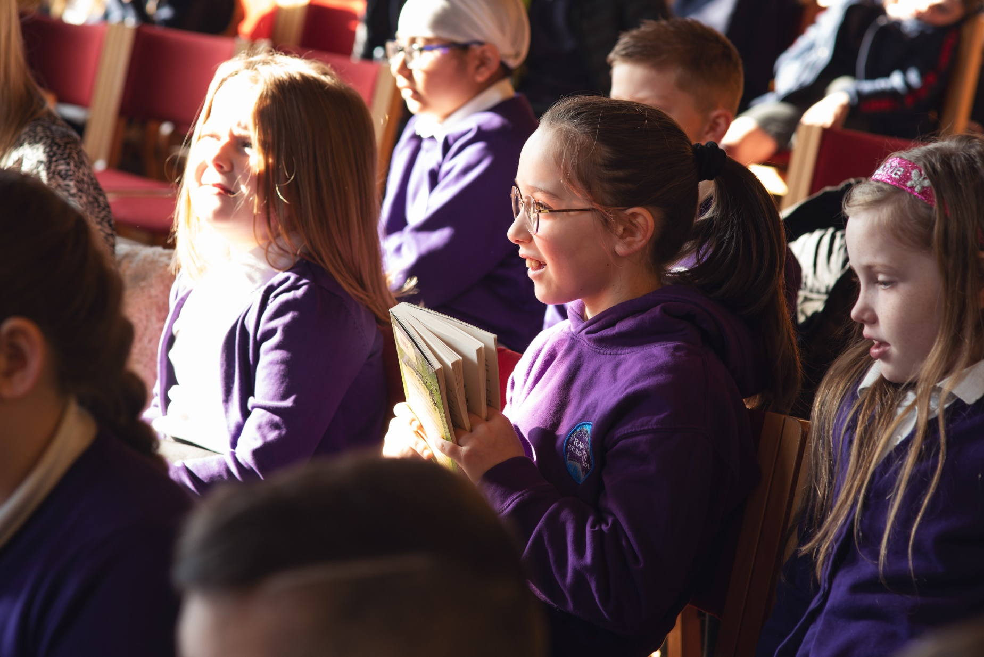

Mental health and wellbeing learning activities
This resource contains learning activities you can use with any book to explore mental health, wellbeing and emotional literacy

Age 5 to 13
CFE First to Fourth Level

Resource created by Scottish Book Trust

scottishbooktrust.com
Scottish Book Trust is a registered company (SC184248)
and a Scottish charity (SC027669).

Contents
About this resource 2
How reading improves mental health 2
Primary learning activities 3
Secondary learning activities 5
Further resources 7

About this resource
This resource has been designed so you can use these activities with any book. Giving children the opportunity to read for pleasure is a great way to support their mental health and wellbeing. The activities in this resource are designed to help children identify specific emotions and feelings, including vocabulary development and improve their own empathy skills.

How reading improves mental health
Reading and listening to stories have been shown to benefit your health, including your mental health. Research has shown that reading for just six minutes a day can reduce stress levels by 60%.
Reading as a habit can also help children:
- Develop their social and emotional skills including empathy and identifying their own feelings
- Reduce stress, including lowering heart rate and blood pressure
- Find a source of fun and escapism
- Develop friendships and connect with other readers
- Improve sleep, especially when used as part of a night-time routine

Books and stories also give us a way to talk about mental health without having to be direct. By asking questions like ‘why do you think that character acted that way?’ or ‘can you relate to how they felt?’ you can use the book as a separate safe space where they can discuss mental health and wellbeing without putting pupils on the spot or asking them to disclose their own experiences.

Primary learning activities

Activity 1: Pre-reading bingo
HWB 1-02a/2-02a, LIT 1-04a/2-04a, LIT 1-16a/2-16a
Before you read the book, let all the pupils have a look at the book’s cover. Ask them what emotions or feelings might show up in the book. You can give them some further clues by reading out the book’s blurb.
Ask everyone to write down three emotions they think will show up in the story. Read through the story together and then reflect together:
- How many people correctly identified an emotion that showed up?
- What gave them the clues that emotion would be in the book?
- How easy is it to guess how someone might react to a situation? Have a discussion about how we can’t always predict how someone else might feel.
- How much did they think about how they would feel when they heard the blurb?

Activity 2: Emotion synonyms
LIT 1-10a, LIT 1-14a/2-14a
Read the book together. Ask pupils to keep a note of any feelings, or words the characters use to describe how they feel. Pick some of the words that come up and use a dictionary to look up any synonyms, for example:
Word | Synonym
Angry | Mad, annoyed, irritated, infuriated
Happy | Joyful, cheerful, merry, jolly, content
Sleepy | Tired, exhausted, drowsy

Pick some words to compare. Though “annoyed” and “infuriated” both describe states of being angry, they’re used in different situations – or might feel different in our bodies!

Activity 3: Who can help?
HWB 1-03a/2-03a, EXA 1-05a/2-05a, EXA 1-06a/2-06a
If you’ve identified some of the feelings or emotions that show up in the book, have a discussion about who you can go to if you’re feeling the same. Ask them to draw themselves in the centre of their page and then, around them, list some of the people they can talk to about how they feel. This doesn’t just have to be difficult feelings – you can also get them to reflect on who they like to talk to when they’re feeling excited or happy!

Activity 4: Show me!
HWB 1-02a, EXA 1-13a
Once you’ve read through the book together, explain that you’re going to ask the pupils how they’d feel if they were the main character. Have the pupils cover their face and countdown from three to one – once you say one, they have to reveal their face!
For example, if you were reading The Gruffalo together, you could say:
- “Show me. . . your ‘I’m out for a walk in the woods’ face!”
- “Show me. . . your ‘I just saw a Gruffalo!’ face!”
- “Show me. . . your ‘I just found a nut to eat!’ face!”
The point of this activity isn’t to identify how a specific character felt in the book but to express how they would feel. So, for example, whilst the mouse in the Gruffalo is delighted to eat a nut – one pupil might hate nuts, and so pull a disgusted face!
After they reveal each emotion, make sure you take some time to identify some of the faces you can see. Asking questions like “Are you showing me a scared face?” can allow children to define what they were trying to act out. It also means you can show the children that people can have different reactions, or feel differently, about the same situation.

Secondary learning activities

Activity 1: Mental health book group
LIT 3-01a/4-01a
All books contain emotions, feelings and ways to explore emotional literacy, but reading with older children and teenagers offers the opportunity to look at books which specifically address mental health, including specific experiences such as depression or anxiety. This can be a really unique way for a pupil to feel “seen” in a way they might not have been before.
On our website we have book lists for children and teenagers containing our top recommendations for books about mental health and wellbeing. You could run a Mental Health Book Club where you read the same book, or pupils each bring a book to chat about.
You could also spend some time discussing what everyone at school can do to help people who are struggling with their mental health, using the characters in the books as a jumping off point.

Activity 2: Journaling
HWB 3-02a/4-02a, HWB 3-06a/4-06a, HWB 3-07a/4-07a
On our website you can find an article on journaling for wellbeing from Candice Purwin which takes you through creating a character, doodling and keeping a regular journal. You could use this to help pupils create a mental health journal, reflect on what they’ve read and how it made them feel, or keep a list of things (no matter how small!) that help them feel better when struggling with mental health.

Activity 3: Perspective taking
LIT 3-02a/4-02a, LIT 3-07a/4-07a, HWB 3-02a/4-02a, RME 3-09c
Pick a point of conflict in the book put the pupils into groups or pairs, and assign each person a character to embody. They now have to take it in turns arguing their point of view and what led them to make the decision that caused the conflict. When arguing their case, they can think about:
- The characters’ personal motivations – what memories, experiences or feelings might cause them to act like this?
- The characters’ beliefs – do they have religious, spiritual or political beliefs that may shape how they act or what they would find hurtful from someone else?
- The books’ setting – does where and when these characters live influence how they behave or what they find hurtful or immoral? Does it differ from the readers beliefs?
- The relationship between the characters – are they friends, old enemies, family? How does that effect how they treat each other?

After ten minutes, make them swap and try and argue the other character’s point of view.
A variation of this is to ask each pupil to vote for which character they agreed with and then assign them the other character – so they have to see it from another perspective.
Have a discussion afterwards:
- Do you still believe one character or group is ultimately morally correct?
- Who acted morally and who acted immorally?
- Whose side was easier to argue?

Activity 4: What would you do?
LIT 3-10a/4-10a, LIT 3-28a/4-28a, LIT 3-29a/4-29a, HWB 3-02a/4-02a
Ask the pupils to rewrite the story of the book with what they would do if faced with the main conflict. Encourage them to think about their own actions, as well what would be different. For example, if the book is historical or fantasy fiction, how would their context change what they do?

Further resources
- Scottish Book Trust’s webpage of Mental health awareness resources
- Our book lists of picture books, as well as books for children and teens on mental health and wellbeing
- Mental Health Foundation: Mental Health Awareness Week
- Anna Freud Centre: Mentally Healthy Schools resource library
- Young Minds: Mental health resources and advice
- Empathy Lab has book collections and resources to help pupils develop empathy skills

