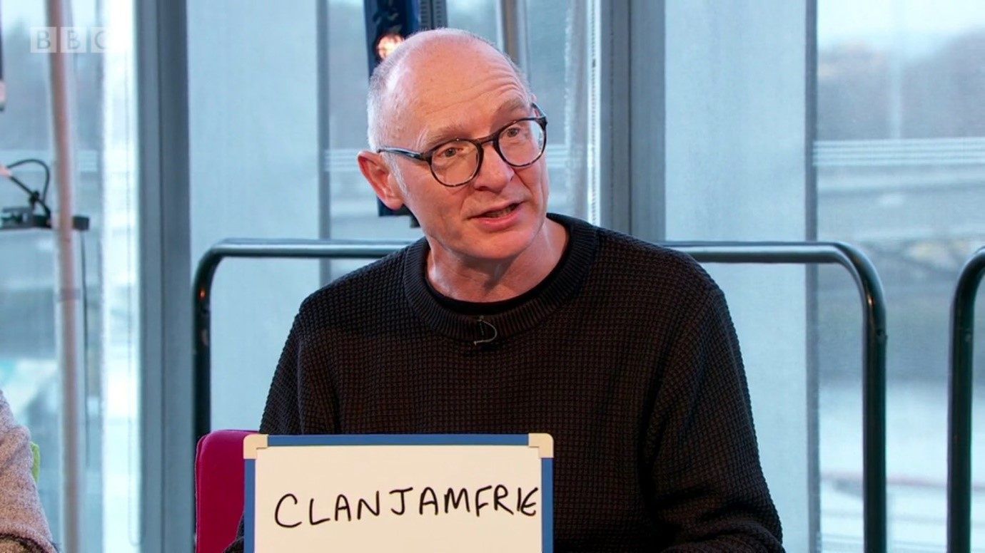

Using Scots in school
Discover how using Scots can support learning in literacy and across the curriculum.

Age: 3-18

CFE Levels: Early to Senior Phase

Resource created by Scottish Book Trust

scottishbooktrust.com
Scottish Book Trust is a registered company (SC184248)
and a Scottish charity (SC027669).

Contents
About this resource 2
Reasons to teach Scots in schools 3
Introducing Scots in the classroom 5
Scots writing activities 6
Teaching different Scots dialects 8
Worksheet: Body Parts 10

About this resource
The activities in this resource have been designed to support the use of Scots in the classroom with ideas for reading, writing, listening and talking as well as suggestions for including Scots in your interdisciplinary learning. The resource is designed to be adaptable to individual needs. Pick and choose from a range of ideas and differentiate as you see fit.
The resource has several aims:
- To show how Scots can enrich the language of the classroom.
- To encourage the use of Scots in literacy programmes
- To support cross curricular planning, involving fun activities
- Suggest useful links to support Scots learning
There is much more to Scots language activities than reciting poetry aloud once a year. Introduce Scots into your classroom today. It his an afa lot gaan fir it!

These resources include a compilation of information contributed by teacher Katrina Lucas, Education Scotland Scots Language Coordinators Diane Anderson and Bruce Eunsen.

Reasons to teach Scots in schools
Curriculum for Excellence states clearly that all learners should have the opportunity to study Scotland’s languages and culture. Using Scots language in classroom activities can add breadth and depth to the Curriculum for Excellence. Some reasons to teach Scots are:
- It develops transferrable skills in language learning
- It gives pupils the confidence to contribute and express themselves
- It helps pupils to appreciate Scotland’s heritage
- It helps create effective contributors
- It helps create links between school and home
- It’s fun!

Transferrable skills
Research has shown that pupils will be more successful in the acquisition and correct use of English if they are secure in the use of their first language. Scots language is used in everyday experiences at home, in the playground, with family and friends. By valuing the language skills that children bring to school, we provide the learner with a transferrable set of linguistic skills which can be adapted to studying English and other languages.

Confidence
Scots is an expressive language, studying Scots develops linguistic confidence, providing learners with the opportunity to freely express themselves in their mother tongue. It also helps pupil develop their identity, a sense of self-worth and citizenship can be fostered for both speakers and learners alike.

Heritage
Schools can acknowledge and celebrate the linguistic and cultural heritage of their pupils and the land in which they are growing up.
The European Charter for Regional or Minority Languages (1992) has been ratified by the U.K. Government, Scots is therefore afforded special protection and promotion within the United Kingdom.
The Scottish Government has stated categorically that all dialects of Scots are equally valid and that each needs to be preserved along with its distinctive identity. We are responsible for protecting our native language.

Effective contributors
Tourism and the creative industries could benefit from Scots language learning in schools. Scots is currently recognised and used in the Scottish parliament, including the Scottish Government website and swearing in procedures. There is a growing call for Scots to once again feature in a more prominent way in Scotland’s other institutions.
Teaching Scots provides the opportunity for Scotland to produce confident players on the world stage, secure in their linguistic and cultural heritage, and aware of their place in Europe and beyond.

Links between school and home
It can help motivate some learners and their families by showing them that the language they use at home is valued in school and allow them to participate in tasks together.

Fun
Learners love lessons that feature Scots. It is different, unexpected and can feel challenging but exciting.
It can help those with English as a second language to feel more valued, with all languages spoken in the class being considered together.
It can be a way back in for those who have felt alienated in school – the reluctant learners who have felt that literacy is not really for them.

Introducing Scots in the classroom
This section will help you to introduce simple activities for use in the classroom. The following activities are designed to give a starting point for those keen to try out Scots with their class while building on their own skills and confidence in the process.

Action songs
You can use well-known songs in Scots as a way to introduce pupils to vocabulary and Scots language. For example “Heid, Shooders, Knaps and Taes”.
Identify the various parts of the body with the pupils and through singing the song become familiar with the Scots words for each.
For a writing activity that leads on from singing, draw around one pupil to create a body shape on a large piece of paper which can be used for a wall display. Label each of the body parts in Scots. New words can also be added. See worksheet 1 at the end of this resource for an individual activity for pupils around body parts and new words to learn. You can extend this activity by adding labels in another language as part of the 1+2 language strategy.
To finish, you could play the game “Simon Says” in Scots. Play the game as usual but using Scots version of words and actions.

Daily routines
A simple way of introducing Scots initially is using Scots language in daily routines.
Think about using greetings at the beginning and end of the day, create class and school rules in Scots, a weather chart with Scots words like dreich and snaw, haar. You could add messages and labels around school buildings. Some schools have recorded their telephone welcome in Scots! Older pupils can make a recording of a weather report and create their own newsroom with bulletins about current or local affairs.

Scots word mats or word wall
Creating Scots word-mats can help learners to create their own simple texts in Scots while reinforcing features of language and can support dictionary skills.
Take this idea to a wider context and create a Scots graffiti wall that can be added to regularly as learning progresses.

Scots writing activities
We hope the activities in this section will inspire you to introduce your learners to try writing Scots in the classroom. We want future generations of Scots people to appreciate the literature of their native country. Use these writing ideas either as a stand-alone activity or as part of an interdisciplinary approach.
Scots stottin sentences
A great five-minute warm up to any literacy lesson is the Scots stottin sentences activity. Make up a selection of basic Scots sentences for the class, and type each one at the top of their own sheet of A4 paper. Laminate the sheets to make reusable, wipe-clean resources and distribute to pairs or trios.
Ask the learners to improve or ‘up-level’ the sentences – and be prepared to be amazed at the creativity and engagement that ensues!
One example could be: A daft dug.
Possibly expanded to: A daft dauncin dug.
Further improved by: A daft drookit dauncin dug.
Alternatively, even: A daft drookit dug dauncin in a dub.
This activity is great fun and it does not have to be limited to alliteration. You can also adapt these to different Scots dialects to learn about either your local area, or how dialects are different – but similar – across Scotland.

Cinquin poetry
This type of poetry is great fun and addictive. It suits Scots language work and can easily be adapted to most topics while reinforcing vocabulary and grammar points. This example is straight forward and the best bit is that it’s a five-line poem that doesn’t have to rhyme! This shouldn’t be too daunting for pupils.
Line 1: one noun/one word title
Line 2: two adjectives to describe the noun
Line 3: three present participles to describe the noun (remember in Scots they will end –in)
Line 4: four word phrase about the noun
Line 5: one synonym for the noun
You will end up with something like this:

Tod
sleekit gleg
lowpin rinnin howkin
gallus tousie wee beastie reiver
Ask pupils to have a go and see what they can come up with! Other poetry ideas you might use are creating an acrostic poem using your favourite Scots word.

Writing instructions in Scots
Write a set of instructions in Scots for others to follow. You might want to work as a class or in pairs to begin with.
Early level: How to play a favourite game, make a model out of recycling
First level: How to make a sandwich, a recipe, play a favourite sport
Second: how to conduct an experiment, bake a cake

Writing using a familiar book written in Scots
Watch our Authors Live Gruffalo in Scots together on our On Demand library. Using the Gruffalo in Scots as your stimulus, ask learners to make a list of all the Scots adjectives used in the book, then find and record their English definitions. Encourage learners to compare their list with the rest of the class to create a joint adjective list. This could then be used to create a ‘Wanted’ poster for the Gruffalo, using as many Scots adjectives as possible. You can extend this activity by creating a storyboard activity where the characters use Scots words inside speech bubbles.
This is just one example of using a book and the activities can be adapted for any of the books which have now been translated into Scots.
Early years will find suggestions in Scots Books for Bairns in Bookbug resources.
Teachers may find other useful resources on the Scots Language Centre and Scots Education websites. They are both good starting points for information about what is current and can help you get started.

Comics
Older pupils may enjoy creating a piece of writing using Scots in comic style and can create their own superheroes to use in their work. Famous characters like Oor Wullie and the Broons can be used to model Scots in comics and provide the pupils with ideas to create their own versions.

Writing competitions
Keep an eye out for competitions that might engage your pupils to write in their mither tongue. Use the Scottish Book Trust website to find out more about opportunities for young writers, including the Young Scots Writer O the Year Award.

Teaching different Scots dialects
The Scottish Government has stated that all Scots dialects are equally valid and that each individual dialect and its distinctive identity needs to be preserved. Celebrating the use of individual dialects can add richness to any classroom activities.
SQA have included a Scots Language Award which is tailor made for schools and learners studying their local dialect and excelling in their specific regional variety.
By valuing each dialect equally, we can help our young people to respect the way other people in Scotland speak and learn about their own and other cultures and communities.
There are many interesting regional variations of Scots language. Dialects from Shetland and Orkney, Dundee, North East, Glasgow and Edinburgh often have their own specific pronunciations of the most common words and are rich in new and unique vocabulary which is sometimes specific to that one region or area.

List of local words
A good place to start is asking pupils to create a list of words that they and their families use which will probably link to the history of their local area. Many words will be derived from industries such as farming, fishing, crofting and weaving and were an important part of daily life. Grandparents can often support with this activity!

Explore media
Old photographs and film clips can be useful to spark up conversations and discover words used to describe items. A visit to the local library will be able to help with sourcing materials for this activity and librarians are a font of local knowledge!
Scots language has been used in major film productions like Disney’s Lady and the Tramp and by Disney & Pixar in the computer animation Brave.
Children will be familiar with the characters and using clips from films can model developing character traits that they can then use in stories of their own.

Explore local songs and stories
Many of these words can be found in stories, songs and poems celebrated by local Heritage societies who are striving to keep the language alive. It is worth checking for societies in your area as they usually hold competitions for writing poetry and prose with a school and children’s section that may inspire your pupils.

Digital storytelling
Digital storytelling is another useful way of embedding the pupil’s knowledge of Scots while developing technology skills. Pupils can investigate a topic, include some intergenerational interviews and learn more about the area they live in. Participation in this type of activity allows parents and community to become involved. Find out more about digital storytelling in the resource available on our website.

Worksheet: Body Parts
Print this page
Label the figure with the correct word, draw on facial features and add in new words as you learn them.
Heid | Een
Shooders | Lugs
Knaps | Mooth
Taes | Neb

