
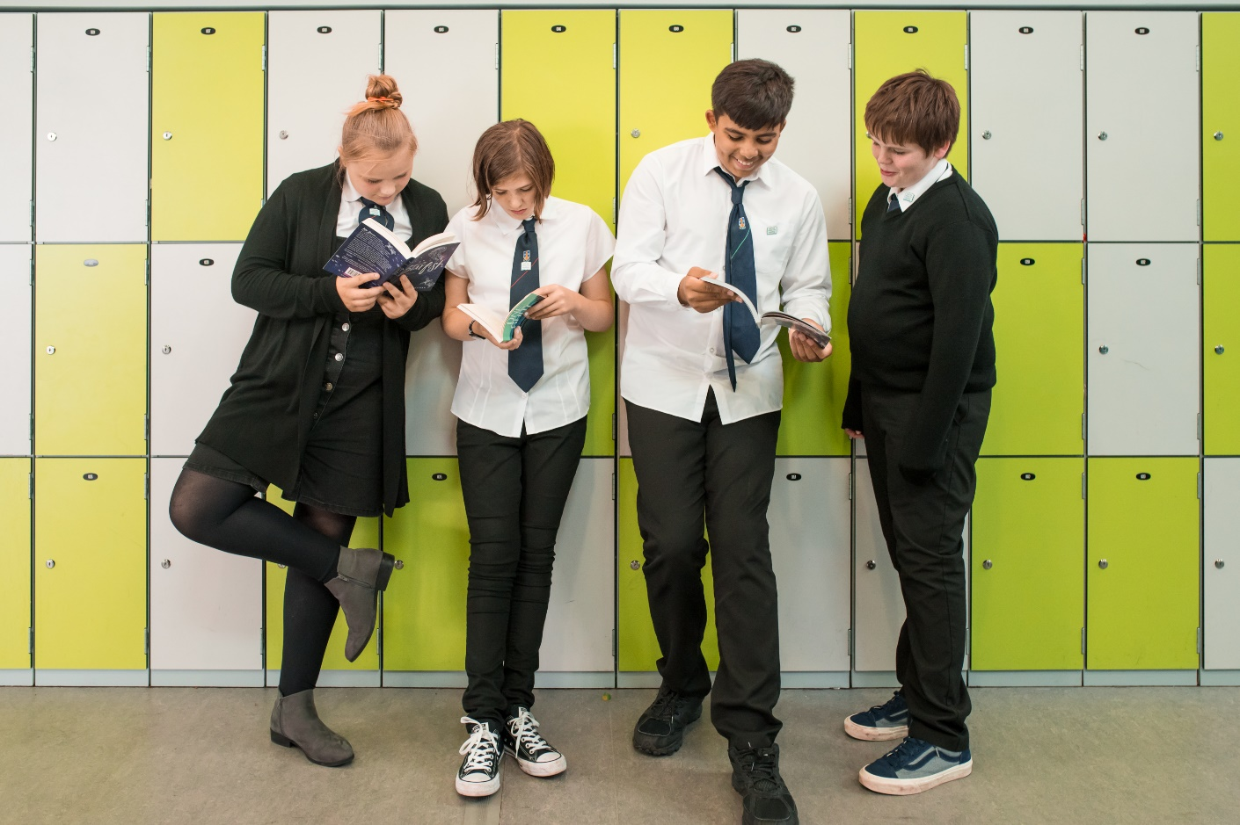

#ReadScottishTeenBooks
A list of nine of the finest new teen books written by Scottish authors or featuring Scotland as a setting, accompanied by summaries and book group questions.


Ideal for sharing in school libraries and classrooms, or for starting a book group

scottishbooktrust.com

Scottish Book Trust is a registered company (SC184248)
and a Scottish charity (SC027669).

Contents
About this resource 2
The Climbers by Keith Gray (Barrington Stoke) 3
Hide and Seek by Robin Scott-Elliot (Everything with Words) 4
The Summer We Turned Green by William Sutcliffe (Bloomsbury) 5
Keep Dancing, Lizzie Chu by Maisie Chan (Piccadilly Press) 6
Cardboard Cowboys by Brian Conaghan (Bloomsbury) 7
The Rewilders by Lindsay Littleson (Cranachan) 8
Only on the Weekends by Dean Atta (Harper Collins) 9
Know My Place by Eve Ainsworth (Barrington Stoke) 10
Talking History by Joan Haigh and Joan Lennon (Templar Books) 11

About this resource
We want teenagers in Scotland to discover the very best homegrown books. In this list we’ve got something for everyone, whether you’re into comedy, romance, historical fiction, or non-fiction.
In this document you will find our book list along with some book group questions which you might like to consider on your own after reading or discuss with your book group.
Tell us which books you have enjoyed the most by sharing your thoughts on social media using #ReadScottishTeenBooks

The Climbers by Keith Gray (Barrington Stoke)

The Climbers is a moving and highly original story of rivalry and friendship.
Sully is the best tree climber in the village. He can scale Twister Sister’s tangled branches and clamber up Double Trunker with ease. But when a new kid, Nottingham, shows up and astonishes everyone with his climbing skills, Sully’s status is under threat and there is only one way to prove who’s best.
Keith Gray is a master of finding extraordinary stories in ordinary places and The Climbers is one of his greatest books. The relationships between the characters and their internal battles with themselves are so rich, you’re left thinking about Sully and Nottingham long after you’ve finished reading.

Book group questions
Why is Sully threatened by Nottingham?
Climbing is a huge part of the youth culture in Sully’s village. Are there special places in your community that mean a lot to teenagers?
Did the ending surprise you in any way? Was it where you thought Keith Gray was taking the story?
Themes: Friendship, Rivalry, Climbing

Hide and Seek by Robin Scott-Elliot (Everything with Words)

Hide and Seek is a gripping, fast-paced wartime spy story which begins in Paris in 1942.
When Amelie Dreyfus hides in her mother’s cupboard, it’s a game. When she comes out, it’s a matter of life and death. Amelie soon finds herself involved in the resistance, running messages, and hiding from the enemy. It’s a dangerous job that will take her out of Paris and away from her innocent childhood.
Robin Scott-Elliot has created a brilliantly tense and thrilling story which you won’t be able to put down. The world of spies and the resistance is endlessly fascinating and having a wartime thriller told from the perspective of a teenage girl is incredibly refreshing.

Book group questions
What did you learn about French resistance fighters in the Second World War?
How does Robin Scott-Elliot create suspense throughout the story?
Where does Amelie get her bravery from? Do you think she’s driven by fear, hope or something else?
Themes: Second World War, Spies, Bravery

The Summer We Turned Green by William Sutcliffe (Bloomsbury)

The Summer We Turned Green is the laugh-out-loud tale of a family that has been split down the middle by an environmental protest going on across the road.
The plan for a new airport runway to be built nearby has attracted a commune of protesters, who are now living in one of the soon-to-be-demolished houses opposite 13-year-old Luke’s family home. The neighbours could not be more horrified. When Luke’s older sister Rose moves to join them, the rest of the family has some tough decisions to make!
A life of being a nuclear family, working in the insurance industry, going on holiday to the same resort in Spain every year, and dutifully obeying the status-quo might just be about to get shaken up – in a big way.
William Sutcliffe has created a family of totally believable characters grappling with a serious issue that has affected all of us in one way or another, but with a healthy dose of wit, playfulness, and charm.

Book group questions
What kind of stereotypes are explored with regards to the climate protesters at the start of the book? Does this view of the protesters change?
Do you think it is important for us to be able to think about serious issues like the climate crisis through a humorous lens? Why or why not?
Why do you think Luke’s Dad is so interested in life in the commune?
Have you ever been to a protest? Why did you go? If you haven’t, what kind of issues would you choose to protest about?
Themes: Family, Climate crisis, Humour, Activism

Keep Dancing, Lizzie Chu by Maisie Chan (Piccadilly Press)

Keep Dancing, Lizzie Chu follows the warm-hearted tale of 12-year-old Lizzie as she tries to get her beloved Grandad from their Glasgow home, to the Tower Ballroom in Blackpool to attend the tea dance. She’s really hoping that the trip will help to snap her Wai Gong out of the funk he seems to be in. Lizzie and her grandparents used to never miss an episode of their favourite show, Strictly Come Dancing – but since Lizzie’s Grandma Kam passed away, things have been slowly changing...
Maisie Chan has crafted a funny, poignant story of perseverance and love that will have you cheering for Lizzie and her Wai Gong through the pages and feeling jealous of some truly fabulous costumes.
Keep Dancing, Lizzie Chu offers a tender, uplifting look at familial bonds and close friendships after grief, reminding us all to keep dancing through life.

Book group questions
How did Lizzie’s relationship with her Wai Gong change throughout the course of the book?
What is the significance of the goddess Guan Yin for Lizzie’s Wai Gong?
How do Lizzie’s friends support her throughout the story? Would you have done anything differently if Lizzie was your friend?
Themes: Family, Friendship, Young carers, Ballroom dancing, Chinese culture

Cardboard Cowboys by Brian Conaghan (Bloomsbury)

Cardboard Cowboys is the story of twelve-year-old Glaswegian boy, Lenny Lambert. Lenny chooses to spend most of his days plonked down on a green bench by the canal instead of going to school. It’s not that he isn’t clever; it’s just that, on his bench, he can dream up haikus, sing songs, and think in peace - without the almost relentless taunts of his schoolmates reminding him of his size.
One day, an errant Irn Bru can, flung down into the water, sparks an unlikely friendship between Lenny and Bruce - a man living in a cardboard shelter on the canal’s edge.
Full of sparkling dialogue and Glaswegian humour, Cardboard Cowboys follows this peculiar duo on their life-changing quest to visit Lenny’s older brother in Aberdeen. The physical journey prompts an emotional journey for Lenny, who is learning how to acknowledge his own worth in a world that often seems to dismiss it.
Brian Conaghan’s charming narrative will have you hee-hawing with laughter and then blinking back tears from one page to the next. It reminds readers that, in a world that can seem cruel, there’s always kindness and connection to be found.

Book group questions
How does Lenny view his relationship with his parents? Why do you think this is?
What qualities make someone a good friend? Is Bruce a good friend to Lenny?
How is homelessness represented in Cardboard Cowboys?
Themes: Family, Friendship, Homelessness, Bullying, Body image

The Rewilders by Lindsay Littleson (Cranachan)

Set against the backdrop of the Scottish Highlands, The Rewilders follows the adventures of Esme, as a ‘boring’ trip to her Nan’s house turns into a high-stakes, dangerous mission to reintroduce a wildcat to its natural home. Cora, the wild lynx kitten, had been found and taken in by Esme’s unsuspecting Nan – but now it’s up to Esme to make things right. She must get Cora back to the wildlife park that she was born in, as part of an effort to reintroduce wildcats and wolves to Scotland.
The trouble is, the only people around to help are Esme’s sworn enemy, Callum, and Shug, the worst guard dog in the history of the world. When Esme and Callum start to hear wolves howling outside of their tent, things look like they might go from bad to worse...
Lindsay Littleson takes the somewhat contentious topic of reintroducing apex predators into Scotland’s landscape and handles it with sensitivity and balance. The Rewilders is a truly gripping tale that will have readers on the edge of their seats, as well as encouraging them to think carefully about all sides of the rewilding debate.

Book group questions
What do you think about the project to reintroduce wolves and wildcats to the Scottish Highlands?
Callum is seen as the school ‘bad boy’ at the start of the book. Does this view of him change? Why?
How does Lindsay Littleson create a sense of menace and tension during the adventure?
Themes: Adventure, Environmental conservation, Bullying, Friendship, Nature

Only on the Weekends by Dean Atta (Harper Collins)

Written entirely in verse, Only on the Weekends is the artfully told story of fifteen-year-old hopeless romantic, Mack. Mack has had a serious crush on Karim, the most gorgeous, popular boy in school, for years now – and he can’t believe his luck when Karim seems to reciprocate his feelings. The only trouble is, Karim is not ready to come out as gay, and Mack isn’t keen on being anybody’s secret.
When Mack’s Dad moves the family to Scotland for work, Mack is devastated to be leaving Karim behind. A few weeks into his new life in Scotland, Mack meets Fin. Fin seems totally fearless; he’s confident in his sexuality, outspoken about being transgender, and a talented actor to boot. In short, he’s thoroughly intoxicating. Which could be a problem for Mack and Karim...
Dean Atta has created a cast of fresh, believable characters with layers and flaws, who exemplify the highs, lows, and messy moments of first love – particularly through the lens of being both queer and Black. Only on the Weekends is a lyrical exploration of self-discovery that will have you gripped from start to finish.

Book group questions
What did you think about the story being written in verse? Did it influence the way you read the book and understood the story?
How does Dean Atta portray toxic masculinity and internalised homophobia?
None of the characters in Only on the Weekends are perfect – many of them make mistakes that hurt people around them. What impact does this have on the reader?
Themes: Poetry, LGBTQIA+ relationships, Romance, Friendship, Homophobia

Know My Place by Eve Ainsworth (Barrington Stoke)

Amy has been in the foster care system since her grandmother passed away when Amy was six years old. She’s lived in multiple houses with multiple families over the years, and her most recent and longest stay was with the Gibsons. But that’s over now, and Amy knows there’s no going back.
When Amy is placed with a new family, the Dawsons, she is initially reluctant to trust them. Their big, spotless house with carpets that your feet sink into is not exactly what she’s used to. She knows that they have good intentions but can’t understand why she should try to ‘settle in’ when there’s every chance she will have to move again. When she finally begins to let her guard down, a conversation overheard through a doorway throws Amy’s whole world back into question.
Throughout Know My Place, Eve Ainsworth handles complex themes with sensitivity and realism. She offers a heartfelt and ultimately uplifting insight into the life of a teenager in foster care, in a dyslexia-friendly read that nurtures empathy and understanding.

Book group questions
Why do you think Stephanie treated Amy the way she did?
How would you welcome a child who had been in foster care into your family?
Amy says ‘I was like a jigsaw piece in the wrong place. I wouldn’t fit, no matter how much you tried to ram me into the space.’ Why do you think she feels this way?
Themes: Foster care, Family, Belonging

Talking History by Joan Haigh and Joan Lennon (Templar Books)

Talking History is a beautifully illustrated non-fiction book, filled with profiles on some of the most influential activists and speakers that modern world history has to offer. For each of the sixteen featured people, Joan Haig, Joan Lennon, and illustrator André Ducci have created two double page spreads filled with details about their lives, what they stood for, an influential speech that they made, and some contextual historical information.
Readers will find themselves both fascinated and inspired by the lives and words of prominent figures such as Emmeline Pankhurst, Harvey Milk, and Malala Yousafzai, among many others. This book covers a myriad of issues, from colonialism, racism and women’s rights to space travel, climate change and world health.
Joan Haig and Joan Lennon also make sure to point out some of the literary devices that have been used in these memorable speeches, which encourages the reader to try their hand at writing their own. Talking History is an immersive book that will inspire a new generation of thinkers and speakers.

Book group questions
What impact can a very powerful speech have on a community? Can things really be changed just through the power of words?
Why do you think people still remember the speeches that are featured in this book, even though some of them happened over 100 years ago?
What did you learn from this book that surprised you?
If you were going to make a recipe for the perfect speech, what ingredients would you add?
Themes: Social justice, History, Activism, Politics

