The Wild Man Who Changed the World: Discover national parks
Before you begin, look through the John Muir graphic novel and read the section The Wild Man Who Changed the World, which shows why John Muir became known as ‘the founding father of National Parks’.
“John Muir: Four days we camped in the Yosemite. Me, John Muir from Dunbar, and President Roosevelt! We climbed to Glacier Point and I showed him all the glories of my beloved wilderness. We talked about protecting the forests and nature.
President Roosevelt: I’ll preserve 148 million acres of forest and create many new national parks!
John Muir: Hurrah! We mustn’t waste the wilderness. It’s a necessity – not just as fountains of timber, but as fountains of life itself.”
The aim of this lesson is to find out:
- Why John Muir became one of Scotland’s most famous and influential conservationists and is considered today to be the 'founding father of National Parks’.
- Where the National Parks, Sites of Special Scientific Interest and public walkways are located in Scotland.
- What the challenges around creating a National Park are.
- What the benefits of having protected land are.

Background
Dunbar-born John Muir at the age of eleven immigrated with his family to the America where he later helped to establish the world’s first National Park system.
In 1893, John Muir returned to his home in Scotland and set out to walk across the land he loved. Some of the places he visited during this trip have since become protected.
It has been reported that John Muir said: “Happy will be the men who, having the power and the love and the benevolent forecast to [create a park], will do it. They will not be forgotten. The trees and their lovers will sing their praises, and generations yet unborn will rise up and call them blessed.”
At the time of John Muir’s death in 1914, the United States government had designated 230 million acres of land as protected national parks, as a direct result of John’s conservation work. Other countries around the world have since followed the same format, designating areas of land to be protected for future generations.
Although the protection of so much land is an important achievement for future generations, it is important to remember that this land was not a “wilderness” and was already being managed and protected by Native American communities. Before progressing in this activity, if you haven’t already done so, complete our Native American History activity LINK, then return to this activity.

Activity
You will now be shown some photographs (as a slide show) of America and Scotland’s National Parks. Then, using arrows, draw and write onto the map below where you think the following protected areas in Scotland are located.

The Scottish national parks:
- Cairngorms National Park Loch Lomond
- The Trossachs National Park

The long distance pathways
- The John Muir Way
- The West Highland Way
Also write onto the map where the following towns and cities are located:
- Edinburgh
- Glasgow
- Berwick-upon-Tweed
- Hawick
- Perth
- Dumfries
- Aberdeen
- Stirling
- Inverness
- Fort William
- Wick
- Portree
And the following protected parkland/nature reserve:
- Holyrood Park
And Sites of Special Scientific Interest:
- John Muir Country park
- River Tweed
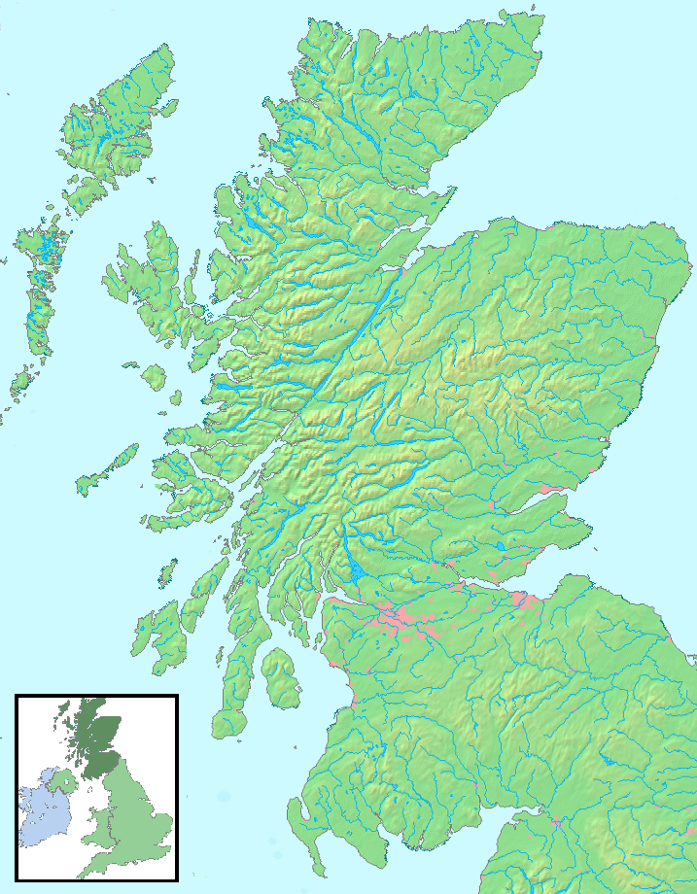

In pairs, write a list of the advantages and disadvantages of setting up a new national park in Scotland. The benefits of having a new national park (protected land) include:

The challenges around creating a national park due to conflicting land use demands include:

Contemporary link for today
John Muir helped to create the first national parks in the United States, bringing many benefits. However, today it has been recognised that these parks have also created wildlife boundaries due to being separated by roads and traffic, which is detrimental to wildlife. So ‘wildlife corridors’ between areas that have been specially protected are being created. This has been recognised in Scotland too; for example, the red squirrel (a protected species) requires corridors to be created between beech forests, to aid in its continued survival.
John Muir, Earth - Planet, Universe: Pupil Activity Support Notes created by Koren Calder © Copyright 2014 Scottish Book Trust. Permission to reprint for school purposes is granted to all public and private school teachers. All other rights reserved.

