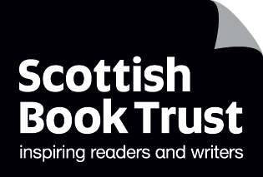
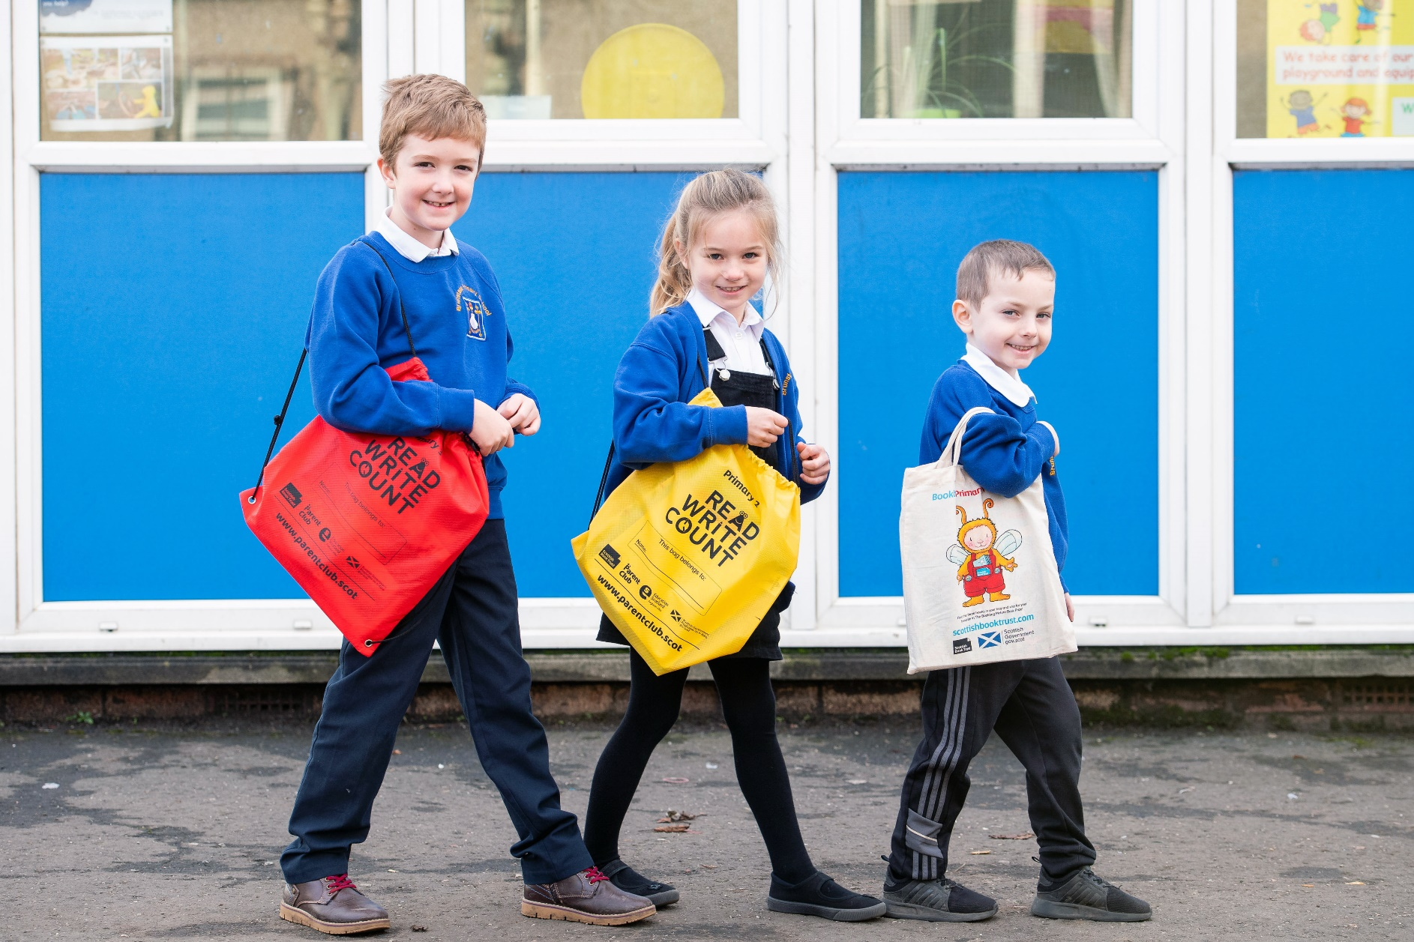

Read, Write, Count Evaluation 2020–21
An evaluation of the reading and numeracy resources gifted to every P2–3 child in Scotland, along with the supporting CLPL and resources.

Evaluation report

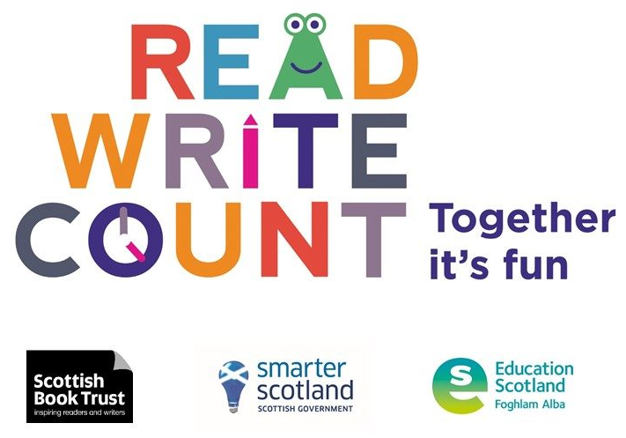
October 2021

scottishbooktrust.com
Scottish Book Trust is a registered company (SC184248)
and a Scottish charity (SC027669).

Introduction
Read, Write, Count (RWC) is a national campaign to improve the literacy and numeracy skills of Scotland's children. The campaign is delivered by Scottish Government, Scottish Book Trust and Education Scotland. It is a key part of the Scottish Government's commitment to raise attainment for all. As part of the campaign, every child in primary 2 and 3 receives a free bag with books and activities to support their learning. In addition, the campaign provides advice and support for learning professionals and families from SBT and Parent Club through training events, online resources and targeted programmes of activity in areas of high deprivation.

Programme outcomes
The gifting of the P2 and P3 bags is intended to support the overarching RWC programme aims:

- Contribute to the joint aims of raising attainment for all and closing the attainment gap, with the focus on the latter
- Provide resources and advice to parents and children to support fun and accessible home-based learning (incorporating growth mindset principles, particularly in relation to numeracy)
- Ensure good integration between the bags and the wider social marketing campaign (in line with the strategic approach of belief, competency and behaviours)
- Secure buy-in and support from teachers and other practitioners, such as library staff and family/community learning

Highlights
- 77% of learning professionals felt the pupils were more enthusiastic about books and reading since receiving the bags
- 43% of learning professionals found the bags useful for their parental engagement work
- 95% parents/carer respondents liked all the items in their bag
- 97% of the parents/carer respondents read the books together with their child
- 79% of parents/carer respondents said the bags made them more confident engaging with their child’s learning
- 'They were fantastic and the resources were of extremely good quality- the children loved received them and still talk of using them at home.' (Learning professional survey)
- 'It is always interesting to see that if we ask pupils to bring in a book from home a few bring in a book they had in one of their bags. For some I know this is probably the only way they have access to books.' (Learning professional survey)
- 'Love the bags, Congratulations on doing this for our country.' (Learning professional survey)
- 'These resources were used as the primary focus to support and engage families during lockdown. These were very successfully deployed. The suggested tasks were great to help us get started and generate some of our own ideas.' (Learning professional survey)
- 'I think the bags are fantastic and I also find they encourage my child to read more with me and they encourage him to suggest new games/activities.' (Parent/carer survey)
- 'I think the book bags are great! They give every child the opportunity to read and help to close the socio-economic gap as they are inclusive and meet the needs of all children' (Learning professional survey)

Methods
The evaluation of the 2020–21 Read, Write, Count bag gifting programme was undertaken in-house by Scottish Book Trust and comprised four feedback surveys of key stakeholders. Respondents to the parent/carer and learning professional surveys submitted responses voluntarily and the surveys were circulated through Scottish Book Trust channels. The findings should not be considered entirely representative as many respondents were already engaged with Scottish Book Trust, though the feedback gathered still provides a valuable insight into the reception and impact of the programme.

Learning professional survey
In February 2021 Scottish Book Trust circulated a survey to learning professionals who gifted the P2/3 bags. The survey was incentivised with respondents having the option to enter a prize draw to win a selection of books and learning resources. The purpose of this survey was to gain feedback on the bag contents and information on how the bags were gifted in different areas, as well as to gather evidence on the impact of the programme.
The survey was circulated through Scottish Book Trust social media channels and newsletters. There were 306 responses. 68% of respondents gifted P2 bags and 63% P3 bags. The majority of respondents were class teachers and came from a variety of local authorities. Some local authorities were not represented and the respondents are not representative of learning professionals as a whole.

Local authority survey
RWC has a contact in each local authority through which the bag numbers, school communications and distribution is organised. In 2021 these contacts were surveyed for the purposes of internal learning and distribution improvement.

Initial parent and carer survey
In February 2021 Scottish Book Trust circulated a survey to parents and carers of pupils who received the P2/3 bags. 1560 responses were received from parents and carers. 548 agreed to be contacted for further research, leaving the door open for a strong follow-up survey to find out how the bags were used later in the year. 63% (833) of respondents received a P2 bag and 37% (497) received a P3 bag. Some local authorities (like Aberdeenshire) were over-represented while others (Scottish Borders, Shetland Islands, Stirling, West Dunbartonshire) were not represented at all. The survey was incentivised, with respondents given the option to enter a prize draw to win a bag of games, books and activities for home learning.

Follow-up parent and carer survey
The yearly Read, Write, Count gifting survey is circulated to parents and carers at the beginning of the year (January to March) shortly after the bags have been gifted (November to January). This allows feedback on the initial impressions of the bags to be gathered ; the follow-up survey is designed to produce data on how the bags have been used since they were first gifted. 548 respondents to the initial parent/carer survey consented to participate in further research. They were contacted in June with an online follow-up survey which gained 112 responses (20%) and was incentivised with a book voucher prize draw. 73% of the respondents received the P2 bag and 36% received the P3 bag.

Read, Write, Count at home: parent/carer surveys
The general feedback on the bags from parents and carers was overwhelmingly positive. Most respondents were enthusiastic about the bags and their contents, and strongly supported the programme:

- 'Every year the bags get better and better.' (Parent/carer survey)
- 'I feel so lucky that we're in a community/country that provides this support to children and tries hard to reinforce the importance of parents getting involved in their child's learning and development. The bag is always a reminder to me to try some new things and finding quality time for reading and chatting (even when it feels free time is scarce).' (Parent/carer survey)

Feedback from parents/carers of reluctant readers and parents from households struggling to make ends meet was positive. The bags introduced new activity ideas and resources and boosted the confidence of families and their children. Families found the resources useful for entertainment as well as learning, and there were more comments about their use as home learning tools this year due to the 2021 lockdown.

Receiving the Read, Write, Count bags
Most respondents to the initial parent/carer survey remembered receiving the bags in November (38%) or October (37%) 2020. Quite a few respondents mentioned that their memories of getting the bag were hazy due to lockdown. 87% said the school sent the child home with the bag and 9% said the bag was sent home with the child with additional information. A couple said the school or teacher dropped the bag off at their home while they were in lockdown.
Parents and carers were positive about the bags. 93% said they liked the bag (65% liked it very much) and 94% said that their child liked the bag (67% very much). 95% of respondents liked all the individual items in their bag. Those who disliked an item in the bag were most likely to say that they did not need any parent/carer guidance or that they would prefer an extra book to the other items. Negative feedback on the bags generally centred around parents not needing or not wanting support:

- 'I appreciate the idea and i know how important it is for parents to engage in their kids learning and education but do not feel that i gain anything from the bag. we read with our children a lot and are pretty confident helping them with their school work.' (Parent/carer survey)

Other parents said they valued the support:

- 'It was something I didn’t have to think about, but which took our learning & communication skills deeper - so it was outside of my box, but fun and enjoyable and gave me insights into how to do more -especially the parent booklet (single mom, no family in the area to share their experience).' (Parent/carer survey)

A number of respondents highlighted that the children having their own books and resources gave them a sense of ownership and increased their enjoyment of them:

- 'She is very pleased especially as she feels it is 'hers'.' (Parent/carer survey)
- 'My kids absolutely love getting these bags. They are avid readers but this helps promote reading for enjoyment.' (Parent/carer survey)

Feedback was positive from parents/carers of reluctant readers or writers:

- 'We will use the story cubes, my son is a reluctant writer but we like the concept and will be doing this as a family now we don't have to homeschool (this proved enough and the rest of the time our son preferred to be outside or play with his toys).' (Parent/carer survey)
- 'My daughter was enthralled & spent ages looking through her bag & trying out different activities with me. The dice really help if she is struggling to write a few sentences.' (Parent/carer survey)

As in previous evaluations, some respondents appreciated the bags themselves as storage items and others did not want or need them:

- 'Personally don’t think the bag and all the extras are necessary (or good for the environment). 2-3 books are great on their own.' (Parent/carer survey)
- 'We are still playing the games that it came with. I love these bags we then use the bag to get our books from the library every week.' (Parent/carer survey)

Only 26 of respondents reported that their child received a Gaelic RWC bag. Whether or not the adults in the household read Gaelic, they appreciated having Gaelic books in the house:

- 'We believe strongly that Gaelic books and resources are important to supply and so are very glad to see these being supplied. These are very important, especially as many homes won't have a lot of Gaelic books.' (Parent/carer survey)

P2 bag contents
63% of respondents to the initial parent/carer survey received a P2 bag. Each bag contained:
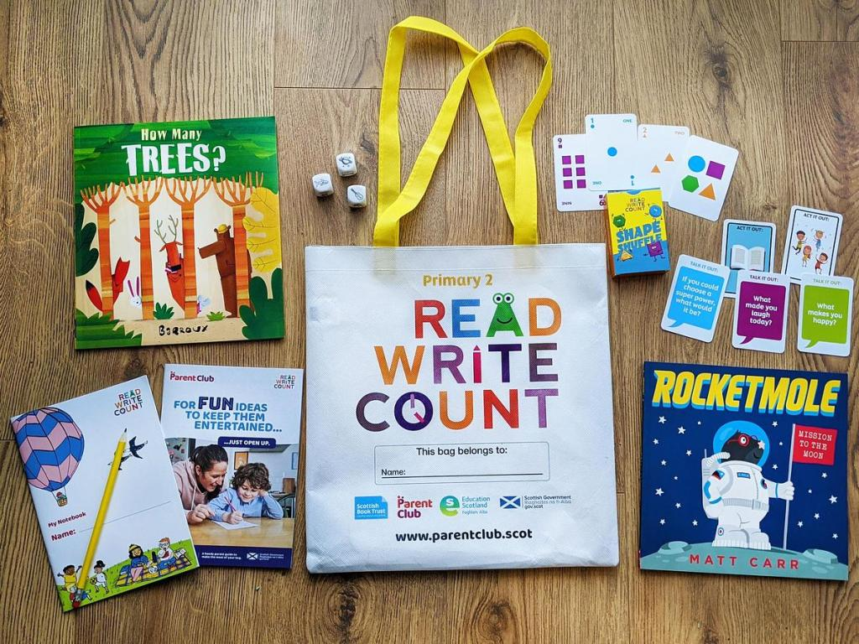
- How Many Trees? by Barroux
- Rocketmole by Matt Carr
- Story cubes with characters, places, and objects to inspire writing and storytelling
- A notebook and writing pencil
- Shape Shuffle card game with Talk It Out/Act It Out prompts on the reverse side
- An activity booklet for parents including information and inspiration for using the items at home

The bags, books, and additional activities were well received with parents/carers of P2 pupils. Respondents were positive about the quality and balance of the items chosen:

- 'I love the bag and think it's amazing that these are provided to the children free of charge. The dice are great for getting us talking, as are the cards, and provide a lovely break from the usual chat about getting ready for dinner or tidying up! We also read the books which are fun and colourful.' (Parent/carer survey)

Confirming the findings of previous evaluations, the books were the most valued items in the bags. Rocketmole was a particular favourite this year:

- 'All of my children enjoyed the books, especially Rocketmole. It lead to interesting discussions about moles (I had to look up some facts as I didn't know much about them myself!), space, supporting other people, and loneliness.' (Parent/carer survey)

How Many Trees? was also popular with pupils and families:

- 'How many trees is still a bedtime choice of reading. I think the pack was educational for us parents, guiding us in different ways to spend time together and how to make it fun.' (Parent/carer survey)

As in previous evaluations, respondents had a mixed response to the reading level of the books. A few mentioned the books were too easy for their children, most were satisfied that the reading age was appropriate, and a couple mentioned their children were able to start to read the books on their own.
The bag itself and the additional items were also generally well received. While respondents described different favourites, the story cubes seemed particularly useful for engaging children and encouraging imaginative play. Others reported that their children were attached to the cards or writing materials:

- 'The story cubes were magical! They really helped me as a mother, engage with my daughter to get into story telling.' (Parent/carer survey)
- 'We love the story cubes and the cards as there are three different activities on them my child loves playing charades on the cards it is so much fun and the other side of the cards.' (Parent/carer survey)

P3 bag contents
37% of respondents received a P3 bag. Each bag included:
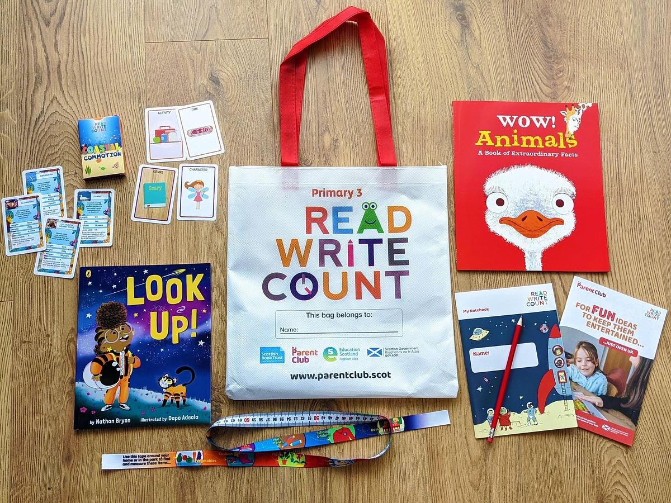
- Look Up! by Nathan Bryon and Dapo Adeola
- Wow! Animals: A Book of Extraordinary Facts by Jacqueline McCann and Emma Dods
- One metre long measuring tape
- A notebook and writing pencil
- Coastal Commotion card game with story and routine cards on the reverse side
- An activity booklet for parents including information and inspiration for using the items at home

Both books were popular with families. Some noted the books gifted helped to encourage an enthusiasm for reading and others focused on their child’s enjoyment of these particular stories:

- 'The books are lovely - so much in them. The animal book especially has been picked up and flicked through at random. We have all enjoyed playing card games and learning interesting facts.' (Parent/carer survey)
- 'It was great to hear my son reading the books and getting so animated.' (Parent/carer survey)
- 'We loved Look Up! already and so happy to see a book with diverse characters given out to all primary 3 children.' (Parent/carer survey)

The factual elements of the books were appealing to some children and less to the tastes of others

- 'My daughter enjoyed reading this story, and will also read it to her younger sister. She also enjoyed wow animals but as it’s a more factual book it’s not something that’s read repeatedly in the same way.' (Parent/carer survey)
- 'A lovely informative book about world wildlife helping children to learn about and connect with nature.' (Parent/carer survey)

Some respondents felt the reading level of the books was too easy for their children while others thought the level was right:

- 'The books are lovely but perhaps a bit young for my P3 who is a confident reader. He LOVED the tape measure though!' (Parent/carer survey)
- 'I loved reading the books. The words were easy for me to read and the stories were fun. I loved that they came all together in a bag and my very own measuring tape. I’ve been measuring everything.' (P3 pupil, parent/carer survey)

This included children who were not normally enthusiastic about reading:

- 'My son doesn’t normally sit to read a book but he actually sat and read these book to see what happens would definitely recommend.' (Parent/carer survey)

All the items in the bag were generally well received by parents/carers and children. The measuring tape was extremely popular with children and parents described using it for home learning activities. Respondents noted that the measuring tape doubled as a toy and a learning tool, as well as mentioning they liked the soft material it was made from:

- 'Our daughter loved playing the card game, and learnt some interesting facts about the sea creatures (as did l). She also loved the measuring tape, and took it out on walks to measure the girth of trees etc!!' (Parent/carer survey)
- 'The measuring tape has been so popular with both my children. It's so soft and my son who has autism just adores it' (Parent/carer survey)
- 'Son still using the measuring tape, love that it's soft material. I even reach for it often, love its bright colours and soft feel. Story books are always well received. So amazed this stuff is provided to all kids as part of their schooling' (Parent/carer survey)

As in previous evaluations, notebooks and writing materials were appreciated by some respondents though others already had access to these materials.

- 'It’s a delightful bag and the kids were glad to receive it. We have lots of paper and pencils at home so we didn't need these but I appreciate the need for them to be included as not all kids will have these.' (Parent/carer survey)

Family activities
A recurring theme in the parent/carer responses was accounts of families using the bags as a family. Most respondents used the bag with their child in some way. 97% of the respondents read the books together with their child. Some described using the bag to connect with their child individually:

- 'My daughter loves playing with mum, and this bag provided us lots of options to connect with.' (Parent/carer survey)

Many described sharing the bag with other siblings or using it together as a whole family. The games were particularly popular for family activities:

- 'My older child (P5) has enjoyed the stories just as much as his P2 sister. They’ve both used the shape shuffle cards together which was lovely to see older sibling helping younger sister' (Parent/carer survey)
- 'We enjoyed the whole bag as a family. Each item involved a different way for us to share stories' (Parent/carer survey)
- 'I measured things around the house with my big sister. I also love the story activity cards, these helped me to think up some interesting stories which I shared with my sister' (P3 pupil, parent/carer survey)

70% reported using the bag with their child either ‘a lot’ or a ‘fair bit’. A few respondents mentioned that they found the parent activity booklet useful for engaging with their child’s learning or for getting new ideas:

- 'I like the additional activities to show parents how to extend their child's reading and listening and talking skills.' (Parent/carer survey)
- 'We enjoyed using the story cards and the parent activity book it allowed me to be involved in making reading a lot more fun and exciting.' (Parent/carer survey)

52% told us that they either tried out a new idea or did something new after receiving the bag. Respondents who did not try anything new reported that they did not feel they needed to:

- 'We have done some but it hasn't changed how I do things as have a good interaction with my daughter anyway but the bag does give us something extra to do.' (Parent/carer survey)

Other respondents who were heavily engaged in their child’s learning still found the bag and resources valuable for supporting learning:

- 'I am already active in encouraging my children to read/ write but admit that this can go through peaks and troughs, where the value of such time with children can be easily over shadowed by other priorities. The bag is a fun way of bringing that priority back to the fore.' (Parent/carer survey)

While many highlighted using the bags to engage with their child’s learning, others described using the resources for entertainment and family bonding during the lockdown:

- 'During the post Christmas lockdown, the cards were a great activity we played together as a family.' (Parent/carer survey)
- 'I think it is a fantastic initiative and has been very helpful during lockdown to keep us entertained.' (Parent/carer survey)

Learning at home
79% of respondents said the bags made them more confident engaging with their child’s learning. While many were already confident about home learning, this confidence may have been valuable during the period of home schooling experienced at the end of 2020 and beginning of 2021. Respondents said that they used the books and numeracy items were particularly useful resources for supporting home learning. The numeracy items featured prominently in these resources:
- 'The resources were particularly helpful during lockdown and remote learning as we could use them to do fun literacy and numeracy activities together' (Parent/carer survey)
- 'The books and activities helped me learn my child different ways to read and count and made it fun they also helped me encourage my child to read out loud and understand what she was reading they also helped with adding and subtracting it was a great help' (Parent/carer survey)

Respondents described how they used the Read, Write, Count items to complete home learning activities set by their schools:

- 'My daughter loved writing notes and commentary on the books provided. This coincided with work tasks given from the school, as did the measuring tape which helped to embed maths elements the P3s were working on. She was delighted with the pack and I also saw it as high value' (Parent/carer survey)
- 'The measuring tape proved very handy in lock down learning as we were doing measurement' (Parent/carer survey)

Families also used the items for educational play to boost their child’s imagination and confidence in a more informal way:

- 'Story cubes have been a lot of fun during lockdown. A good way to build imagination and have fun whilst also building confidence' (Parent/carer survey)
- 'I loved the story activity cards. They helped with my daughters sentences and writing her own story's. They were very useful during the home schooling and getting her to use her imagination' (Parent/carer survey)
- 'My son loves using the measuring tape around the house. The story cards were a great idea. They gave us something when we needed a break during homeschooling! Kept the imagination churning!' (Parent/carer survey)

While most of the feedback related to home learning and lockdown indicated that the bags were useful, a few mentioned that they were too overwhelmed by the situation to make much use of the bags:

- 'Great initiative but the timing was way off this year. We were already overwhelmed so unfortunately the bag hasn't been used much other than to read the books' (Parent/carer survey)

Challenges
As previously noted, the majority of feedback from parents and carers was positive aside from a minority who felt the reading age of the books did not suit their child or told us that they had the resources to purchase similar items. Parents and carers of children with additional support needs noted that the measuring tape was popular but that many of the other items were not suited to their child. This suggests a need for accessible resources tailored to this group of pupils:
- 'Measuring tape was such a great hit with my autistic child.' (Parent/carer survey)
- 'Story cubes and some activities are too abstract an idea for my son who has additional needs.' (Parent/carer survey)
- 'Although the bag was great, having a child with additional Needs it wasn’t really suitable.' (Parent/carer survey)

Some respondents requested bags for older children:

- 'Maybe they could do would for older primary pupils as parents are often unsure how to best support them when they are older. Maybe include learning support things like times table squares, common spelling errors, grammar resources, books aimed at older children with short stories in.' (Parent/carer survey)
- 'The bags are brilliant! Please keep providing them. Would be great for P4-7 too and school library collection of books for secondary schools would be amazing!' (Parent/carer survey)
- 'I think the bags should continue through primary school, my daughter is sad that this is the last one she will get as she’s in P3.' (Parent/carer survey)

Suggestions for additional items for inclusion in future bags included more books, games, or toys. They also suggested things that would be useful for parents to support their children including guides to phonics, links to online resources or copies of the activities would be useful for children who want to repeat the activities:
- 'We would enjoy more maths, as a parent maths doesn’t come easy to me so it’s hard to then engage with my daughter but activities would help.' (Parent/carer survey)
- 'It would be great to get an electronic copy of the children's activity booklet. My son wanted to do it again, but on the website I could only find pdf files of the parent or teacher resources.' (Parent/carer survey)

Read, Write, Count in the long-term: follow-up parent/carer survey

In the initial parent and carer survey 78% said they thought they would use the bag and its contents for more than a few months. A follow-up survey was conducted to find out whether the bags were still being used 6–9 months after the initial excitement of gifting. In the follow-up survey 61% of respondents told us they had used the items in the bags for longer than they initially thought they would:

- 'My child was delighted with the bag and is still actively using the contents of the bag.' (Follow-up parent/carer survey)

A few noted that the items were not used as much recently, or that some items were still in use but others were not:

- 'The stories are still very much in use and they are great stories but the other items held interest for a month or two then we’re not used anymore.' (Follow-up parent/carer survey)

The initial parent/carer survey found that 52% used the bags to try out new ideas with their child. In the follow-up survey this rose to 77%. The survey also gathered feedback that included descriptions of the books becoming favourite stories, reigniting interests in other subjects, or engaging reluctant readers:

- We read the books every night and also the bag when we go out picnics or to the park, day out.' (Follow-up parent/carer survey)
- 'I think reading the book inspired him to use his telescope again.' (Follow-up parent/carer survey)
- 'How many trees is one of the few books my daughter will read by herself besides the school reading homework.' (Follow-up parent/carer survey)

Evidence of the impact of the bags can be seen from reports of an increase in parent/carer confidence and child enthusiasm or engagement. A number of respondents told us that they used the bag resources together as a family:

- 'All the items in the bag have been used regularly since we were given the bag. My younger daughter (who is age 4) also enjoys the stories and the story cubes which has been great as it is always nice when the whole family can take part and enjoy it.' (Follow-up parent/carer survey)
- 'Loved the bag, especially the story cubes and cards, we play them as a family including 4 year old brother.' (Follow-up parent/carer survey)
- 'My child loved the story cubes. It allowed all of the family to take it in turns making up stories.' (Follow-up parent/carer survey)

Others described their children taking the initiative to use the items on their own. These accounts suggest the books and items are pitched at a level which allows some children to read the books and play the games unassisted:

- 'My son read the books himself.' (Follow-up parent/carer survey)
- 'My children love reading these books to me now.' (Follow-up parent/carer survey)

Respondents were asked about whether their opinions of the bags changed since they first received them. Most reported that their attitude towards the bags was initially positive and had not changed over time:

- 'I still would highly recommend these bags. It’s full of great ideas, games, and builds confidence in parents towards helping their child learn.' (Follow-up parent/carer survey)

The one respondent whose attitude had changed since the initial gifting reported that they felt more positive:

- 'Yes, I think it's a fantastic thing to do for our kids - I'm even more impressed than I was. Well done and thank you!' (Follow-up parent/carer survey)

Suggestions for improvements and alternative or additional items that the respondents would like to see were also solicited. The most popular items respondents suggested would be helpful for home learning were white boards, measuring tapes (for respondents who did not receive a P3 bag), and additional books. Other suggestions for items to assist with home learning included stationary, soft toys, clocks, and craft items. These suggestions are not too different from those gathered in the first round of surveys but are worth considering as the respondents have had time with the bags to think of ways to improve them.

There were accounts of the bags and their contents being used for a longer period of time than initially anticipated in the first survey of parents and carers as well. While gathering feedback about the 2020–21 bags in the initial parent/carer survey, a number of unprompted responses about how families were still using bags and contents gifted as part of this programme a number of years ago were received:

- 'We will actually use the contents of the bags longer than a few months, with both my P2 and his 4 year old sister. They love stories and my son loved the number element of the how many trees book. Even though he now prefers chapter books he still enjoy enjoys picture books and they are something we can enjoy as a family with younger children too'. (Parent/carer survey)
- 'Past bags my children have enjoyed and still have books as we use for younger sister, or any other little people that comes to house.' (Parent/carer survey)
- 'Love the bags, the new books inspire the kids to read more. The counting resources from past bags (magnetic ones) are still on our fridge from about 5 years ago and our younger children still use all of it.' (Parent/carer survey)

Read, Write, Count in schools: learning professional survey

Overall feedback on the bag contents was extremely positive, with the learning professional respondents being particularly enthusiastic about the choice of books. They found them useful for engaging pupils and families, particularly for low-income families and those without access to books. Most respondents thought the bags increased pupil enthusiasm for reading and books, with many also noting an increase in enthusiasm for numeracy or writing.

Lockdown restrictions disrupted gifting plans and deliveries in 2020–21. A few teachers stressed that the way in which the bags are gifted is key to their impact and that this depends on work from the teachers as well as access to the families. Some found innovative ways to engage families with the bags by setting home learning activities and many found it useful to know that all their pupils had access to a matching set of books, numeracy, and writing resources at home during lockdown classes.

- 'The content of the Read, Write Count bags are amazing with a range of literacy and numeracy resources available for children and families to engage in. The feedback from staff, children and families is always positive.' (Learning professional survey)

Gifting in schools
64% of respondents were given information about the bag delivery by their school or local authority in advance and 82% had time to familiarise themselves with the bag contents before gifting. Those who had not were either not allowed to touch the contents for hygiene reasons or did not want to delay gifting them to the children. More than half of the respondents (62%) gifted the bags in November (Book Week Scotland), with others choosing to gift as the bags were delivered. A few were unsure when they had received or gifted the bags, and others waited for a specific event (e.g. World Book Day). 38% gifted the Read, Write, Count bags at the same time as the P1 Bookbug bags. Some of the respondents told us about the innovative ways they held gifting events or other activities within lockdown restrictions:
- 'A virtual message was sent to each P2/3 child. We created home learning packs for the whole school and included cosy socks and hot chocolate to add to the fun experience of reading the gifted books.' (Learning professional survey)
- 'The pandemic changed the activities slightly as in normal circumstances as a school we would usually invite parents in and have an afternoon focusing on the sharing and explanation of these book bags. However, it meant we could spend the whole week in class focusing on these which was great!' (Learning professional survey)

Others described how they built up anticipation to the bags in advance of the gifting:

- 'We had a focus week in class looking at the books and completing activities and games and then they were sent home with children alongside additional information for parents.' (Learning professional survey)
- 'I wrapped the boxes up and had them displayed in the class for a week beforehand. The pupils were so excited to see their own bag. I kept one bag out and we showed/used a different resource each day to familiarise them with it so them knew how to use it. I wrote their names on each bag in permanent marker which helped their sense of ownership over the contents.' (Learning professional survey)

The respondents were enthusiastic about the diverse themes of the books and the linked resources. They also reported using the numeracy activities in class:

- 'I really liked the tape measure this year. We were able to use this with remote learning in January/February. I also loved that there was a nonfiction and a fiction book. The children loved both books. We were able to do lots of activities based on them on the run up to gifting them. I also liked that the main character was a girl with ambitions to go to space. The pupils also really enjoyed the game. The pencil and notebook were loved too and lots of pupils went home to use them.' (Learning professional survey)
- 'The tape measure was a real hit with pupils. It was something I think few had at home. We used in in the class and for outdoor learning. So useful and helped them understand the social distancing requirement.' (Learning professional survey)

Less than 2% of respondents received Gaelic bags for their classes. Those who did stressed the importance of receiving both Gaelic and English versions of the books:

- 'Essential for in-class work as we are a GM class. The parents like to have the English options though.' (Learning professional survey)

Impact in school: pupil attitudes
The learning professionals who engaged with the evaluation noted that the bags had an impact on their pupils, their families, and their communities:

- 'Gets better every year and has a big impact in our community.' (Learning professional survey)
- 'Thanks for providing children with book bags. It’s and important campaign that sends a good message to parents about early literacy skills.' (Learning professional survey)

Respondents said that the books were particularly valuable for low-income households or families without books in their homes. Some noted that the books were sometimes the only books their pupils had access to:

- 'I think the initiative should continue as there will always be a child somewhere who does not have books at home or who has ever received a book as a gift.' (Learning professional survey)
- 'Some parents can struggle financially to buy books and by knowing their children are receiving them as a free gift gives them a sense of relief. Also by seeing the teachers read the stories and see how engaged the children are they may feel more willing to read in a more engaging way i.e. using voices.' (Learning professional survey)
- 'It is always interesting to see that if we ask pupils to bring in a book from home a few bring in a book they had in one of their bags. For some I know this is probably the only way they have access to books.' (Learning professional survey)

77% felt the pupils were more enthusiastic about books and reading since receiving the bags:

- 'They enjoyed getting the bags and were came back to school with enthusiastic reports on how well they enjoyed the stories at home.' (Learning professional survey)
- 'The activities and suggested learning makes them excited to read the books. Knowing their friends have the same books encourages them too.' (Learning professional survey)
- 'The books make the children feel so special and as a teacher I loved seeing their faces when they realise EVERYONE is getting a bag. Not everyone values reading but it is reassuring to know the children have access to a few new books for the first years of their education.' (Learning professional survey)

A few said it was difficult to judge this year due to lockdowns. Some noted that it was hard to pinpoint an increase in enthusiasm just to the bags but that these were a contributing factor along with other initiatives:

- 'Since returning to school in class, I have included daily storytelling in my class routine. This has encouraged reading in class. As a result, when the book bags were sent home, pupils were more enthusiastic to read them and use them.' (Learning professional survey)
- 'Our children are very enthusiastic about reading anyway but some don’t own as many books as each other so this was exciting for them.' (Learning professional survey)

45% felt the pupils were more enthusiastic about writing since receiving the bags. Some felt the story cubes and writing materials increased enthusiasm for writing but others did not see a change or had their writing activities disrupted by lockdown:

- 'I love teaching writing and always find ways to engage and motivate my classes to feel enthusiastic about it too. I would say the bags enhance their interest in reading and storytelling which obviously impacts on writing, I regard them as valuable resources.' (Learning professional survey)
- 'My class LOVE the story cubes and we often use them as a warm up activity (verbally) before a writing task. We haven't done as much writing (in jotters) this year due to the disruptions caused by COVID but we do enjoy using them for storytelling.' (Learning professional survey)

47% felt the pupils were more enthusiastic about numeracy and mathematics since receiving the bags. Others reported that their pupils were already enthusiastic about maths. The measuring tape was particularly popular with learning professionals who had noted an increase in enthusiasm:

- 'The numeracy resources give the children the opportunity to work on their skills at home.' (Learning professional survey)
- 'I kept the tape measures till later in the session so that the children could use them in their measure work. They were a great resource, the children really enjoyed using them as they were much more attractive than the school tape measures!' (Learning professional survey)

Remote learning
During periods of remote learning, teachers were reassured to know that all their pupils had access to the same set of books, numeracy, and writing resources at home during lockdown classes. A number of respondents reported relying on the resources and contents during lockdown. Their comments indicate that the bags had an impact on learning under lockdown for these pupils:
- 'We actually saved them and worked with them in the class more thoroughly this year with our own activities and then gifted them later to go home at the end of the Christmas term just in case of lockdown so that our first week of activities for children were shared with parents from the parent booklet - enough for a whole first week of lovely maths and literacy activities which has been fabulous. we usually have a big breakfast gifting party but because of covid this year couldn't do that - but glad we did what we did as having all the stuff in one bag has been brilliant for our families to receive and use in their first week of home learning and also the children were really confident as we had done our own activities in class (so as not to intrude on the activities that were designed for parents to support at home).' (Learning professional survey)
- 'They loved the books this time and we got lots of great feedback from completion of the notebook activities for learning at home with parents.' (Learning professional survey)

Some described using additional home learning activities as an alternative to running a gifting event:

- 'We normally do a shared event with parents, but this year it was gifted in class and then used as part of the home learning.' (Learning professional survey)

Forging home-learning links
41% of learning professionals felt that the bags helped parents to be more engaged and confident about being involved in their child’s learning. 43% found the bags useful for their parental engagement work. Others were unsure or found that being unable to hold events with the parents made it difficult to involve the parents in the gifting:

- 'The learning experiences with the bags are a significant part of our school calendar.' (Learning professional survey)
- 'We like to encourage parents in at every opportunity and this helps and is not a time consuming commitment for parent/ carers but also a bonding experience for both adult and child.' (Learning professional survey)
- 'Under normal circumstances, absolutely, much harder just now as parents are not allowed in school.' (Learning professional survey)
- 'Parents would normally be invited into class to work with their child on the contents of the bags so I know from experience how positive the bags are in promoting parental involvement. However, this year the pandemic did not allow this to happen.' (Learning professional survey)

Despite the disruption of lockdowns in 2020–21, a number of learning professionals believed that the bags had helped them engage with parents and carers. 27% of respondents thought the bags helped build better links with parents and carers:

- 'Our parents and carers are grateful for the resources and we have used these to develop family learning links.' (Learning professional survey)
- 'Whole families became more involved in learning and shared this online.' (Learning professional survey)
- 'Asking parents in to complete play based activities around the books is a great way to get them to understand how they can engage in similar play activities at home.' (Learning professional survey)
- 'As a Library department in a small all through school, we would say that it is a great way to help build relationships with parents, and help create links in learning alongside promoting the benefits of reading for pleasure and purpose.' (Learning professional survey)

This year many respondents noted that the pandemic interrupted links with parents and carers, or that it made it difficult to judge whether links had improved:

- 'We are a small rural school so already have good links with parents. Usually we would invite them in and that is a great bonding session between school and home but this year we couldn't. If I can't again this November I would consider a virtual get-together so we can invite parents.' (Learning professional survey)
- 'Previously (pre-pandemic) the parents coming in with the children made for a lovely well attended afternoon.' (Learning professional survey)

Respondents were more confident that the bags helped parents become more engaged and confident getting involved with their child’s learning. 41% agreed that it had:

- 'The book bags make reading and writing fun. They provide parents and children with lots of fun, creative ideas to support their learning.' (Learning professional survey)
- 'I think this may have given some families the opportunity to read with their children.' (Learning professional survey)

Learning professional resources and training
Alongside CLPL sessions for learning professionals, Scottish Book Trust produces activity ideas and plans for use alongside the bags and makes these available online. 52% of respondents were aware of the Scottish Book Trust resources and used them. Comments on the quality and content of the resources were favourable:

- 'The curriculum linked resources were fab - easy to use, well planned and very supportive documents.' (Learning professional survey)
- 'Useful. Often go back to them as the year progresses in class and children are familiar with stories and materials.' (Learning professional survey)
- 'The learning resources were useful and could easily be adapted to meet different needs.' (Learning professional survey)

15% of respondents had attended a Read, Write, Count CLPL session and 62% had not attended but would consider going to a future session. Respondents who were not interested in attending a CLPL session felt that advice on making the most of the bag gifting was not needed or involved common sense.

72% of those who did attend a session found it useful. Feedback from those who did attend was generally positive. They found sharing good practice and seeing the bag contents in advance especially helpful:

- 'I had no knowledge of Read, Write, Count bags before so it was useful in explaining what they are, and how I could use them in class/home.' (Learning professional survey)

Challenges and suggestions
Respondents detailed additional challenges engaging with Read, Write, Count this year with lockdowns and restrictions negatively impacting their bag gifting and parental engagement plans. Covid-19 limited how comfortable some learning professionals felt using the bags in class:

- 'We did not use the books in class to avoid spread of Covid. We did not receive the teacher copies so we could not read the books in school this year, before gifting or since then.' (Learning professional survey)

Social distancing restrictions meant that teachers were sometimes unable to demonstrate using the bags at all in 2020–21. This led to an increase in respondents requesting teacher copies of the bags:

- 'It would be nice to have a copy of all the resources gifted in the bag to have in class to model how to use so children can then do same with parents at home.' (Learning professional survey)

Delays to bag deliveries, uncertainty over school opening times, and social distancing restrictions disrupted planned events and activities, particularly those involving parents visiting the school:

- 'It has been a real pity that lockdown happened. We normally pair the children up with older children and we do a lot of Buddy work around the materials. We also invited parents in, which was successful. We were not that confident at holding online training etc away back in Nov/Dec. A pity really.' (Learning professional survey)
- 'We hope that this will change soon and we will be able to get back to engaging more fully with the pupils about their enthusiasm for reading. In more normal circumstances our pupils are enthusiastic about the book bags and we are able to continue the links/reminders etc about the books. Pupils often remember the book bag they received even when in secondary school.' (Learning professional survey)

There were requests for the programme to be expanded to other year groups. One small school mentioned purchasing books for the other year groups to gift alongside the bags:

- 'We are a small school and bought books in to be able to gift a new book to the p4-7's so that all children were accessing a new book' (Learning professional)

Other suggestions for improvements included additional items or resources to accompany the bags. A couple of respondents suggested that the bags should be gifted according to reading level rather than age. One respondent suggested a calendar of resources or events to help teachers space out the activities after the gifting.

Conclusion
The 2020–21 Read, Write, Count bags were well received by learning professionals who responded to the survey, with 77% noting an increase in pupil confidence and enthusiasm for books and reading following the gifting. They supported the book and numeracy item choice and, despite the challenges of teaching during the pandemic, found innovative ways to link the gifting with class activities:

- 'The contents are excellent and I think by continuing to be creative with additional resources such as the measuring tapes, pupils will remain motivated and excited to receive the bags.' (Learning professional survey)

Learning professionals were supportive of the universal gifting model and described using the bags during periods of lockdown as they knew all their pupils had access to the same learning resources at home. There was compelling evidence from learning professionals that the bags are particularly important for households without access to books:

- 'It is always interesting to see that if we ask pupils to bring in a book from home a few bring in a book they had in one of their bags. For some I know this is probably the only way they have access to books.' (Learning professional survey)

Parents and carers were enthusiastic about the quality and diversity of the bags, books, and numeracy activities. They described using the contents for bonding and home learning activities with their children:

- 'I think the bags are fantastic and I also find they encourage my child to read more with me and they encourage him to suggest new games/activities.' (Parent/carer survey)

While the majority of feedback gathered in both the parent/carer surveys was positive, a minority of parent/carer respondents expressed ambivalence towards elements of the bags. This mainly centred on the reading age of the books not suiting individual children, though concerns about ASN and P4+ pupils not having access to bags were raised as issues. The follow-up survey confirmed that the Read, Write, Count bags were still well used by the respondents at home over six months after gifting. 97% read the books with their child and 77% used the numeracy items with their child.

Appendix: outcome-based evidence

Outcome 1: attainment
Outcome 1: contribute to the joint aims of raising attainment for all and closing the attainment gap, with the focus on the latter

Findings indicate that the bags promote enthusiasm and confidence for learning in pupils and carers. 77% of learning professionals felt the pupils were more enthusiastic about books and reading since receiving the bags. Learning professionals highlighted that the universal gifting model meant that every child had access to learning resources:

- 'I think the book bags are great! They give every child the opportunity to read and help to close the socio-economic gap as they are inclusive and meet the needs of all children' (Learning professional survey)
- 'It was nice to have the resources in the bag from school to share to focus some activities that are desirable for the education of a child at their particular stage. It makes a nice opportunity for the child to experience the excitement and opportunity to share and learn' (Parent/carer survey)

47% of learning professionals felt the pupils were more enthusiastic about numeracy and mathematics since receiving the bags. Parents and carers reported finding the numeracy items useful for supporting their child’s learning:

- 'The measuring tape was great for homeschooling when they were doing measurement - much easier to use than metallic tape measure we have. I just love knowing that all children get it. The numeracy cards help me support the kids with maths at home but it seems like a game which is a good approach' (Parent/carer survey)
A number of parents and carers found that the activities in the bags helped encourage literacy and numeracy activities where their child was experiencing difficulties:

- 'As an avid reader I have always encouraged my daughter to read but she has struggled with literacy and numeracy, whilst we receive help from the school's SFL team these packs encourage us to try different methods e.g. story cubes instead of reading' (Parent/carer survey)

There was feedback from both P2 and P3 bag recipients that the contents were received positively by children with Additional Support Needs, encouraging engagement with learning resources:

- 'This bag was useful for us because my son have a problem can talk very well and he get help from school with speech and language therapy and my son like the bag because he had the cards for playing.' (Follow up parent/carer survey)
- 'The tape measure was a good gift for my autistic child.' (Follow up parent/carer survey)

Outcome 2: home resources
Outcome 2: provide resources and advice to parents and children to support fun and accessible home-based learning (incorporating growth mindset principles, particularly in relation to numeracy)

79% of respondents to the initial parent/carer survey said the bags made them more confident engaging with their child’s learning. Learning professionals told us that the sense of ownership the pupils have over the gifted books made them feel special, particularly if the child did not have access to a range of books at home:

- 'They were choosing to read their books together even the less confident children. Parents said the children wanted to read the books to them rather than be read to. I think the children that do not have a lot of books at home felt a sort of invested ownership if that makes sense.' (Learning professional survey)

41% of learning professionals felt that the bags helped parents to be more engaged and confident about being involved in their child’s learning. The impact of the bags as home learning tools is described by respondents who used them to engage pupils and families during periods of lockdown:

- 'The children really liked that they had the same books as they did in class. It was a great resource to have at home when the schools were closed.' (Learning professional survey)
- 'These resources were used as the primary focus to support and engage families during lockdown. These were very successfully deployed. The suggested tasks were great to help us get started and generate some of our own ideas.' (Learning professional survey)
- 'Notebook to practice my words. Measuring tape was so handy ... cause that was the maths subject we were doing n class' (P3 pupil, parent/carer survey)
- 'I feel that these resources have been very well received by both parents and children especially during the period of home learning, we’ve really tried to concentrate on reading during lockdown and the books came in very handy! My child also felt very happy to be able to run out of school and tell me that they had received a 'gift' from school, sometimes it’s just those little things that make a big difference to a child’s day if you know what I mean!' (Parent/carer survey)

Parents, carers, and pupils told us that they used the bags for learning at home, but also for playing, reading, and bonding together:

- 'Loved the notebook to practice my writing Cards were great to play at home with mum, Dad and wee brother.' (P2 pupil, parent/carer survey)
- 'Think they have been a something that the kids have enjoyed. With the current lockdown this has given kids and parents something to do when they have had limited access to any other activities' (Parent/carer survey)
- 'The story cubes have been great for helping my daughter with writing her own stories and helping her work on literacy and spelling.' (Follow-up parent/carer survey)

Outcome 3: integration
Outcome 3: ensure good integration between the bags and the wider social marketing campaign (in line with the strategic approach of belief, competency and behaviours)

While the evaluation focused on the bag gifting element of the Read, Write, Count programme, some evidence that the bags were integrated into the wider campaign was received. Half of the respondents to the initial parent/carer survey told us that they consulted the parent guide provided with the bag which signposted them to new learning resources. Learning professionals also reported using the bags to integrate into curriculum activities:

- 'They are enthusiastic because we link it into the activities planned in school and keeps momentum going' (Learning professional survey)
- 'I work within a childcare setting so the parent guide was lovely to see and used within my workplace, can be tailored to all children.' (Follow-up parent/carer survey)

Some respondents to the follow-up parent/carer survey that they visited the Scottish Book Trust (24%) or Parent Club (16%) websites for learning or play ideas while 43% tried an idea from the parent activity guide. Some specified they used the activity guide in lockdown and found it helpful:

- 'It was a nice resource of ideas during lockdown' (Follow-up parent/carer survey)
- 'I used these so that I knew how to help and educate my child.' (Follow-up parent/carer survey)

Outcome 4: support from professionals
Outcome 4: secure buy-in and support from teachers and other practitioners, such as library staff and family/community learning

Feedback on the bags and their contents from learning professionals was extremely positive. The books from both packs were particularly well received by learning professionals:

- 'I think the books are the heart and soul of the bags. Good books make a good bag, regardless of the extras which come with them.' (Learning professional survey)

Most reported reading the P2 (72%) or P3 (65%) books in class. Respondents used the books to spark learning activities for their classes and to encourage enthusiasm for learning:

- 'The Look Up! book had a great positive role model for girls regarding STEM subjects. It would be fantastic to see this continue as a theme!' (Learning professional survey)
- 'The book 'Trees' was very adaptable for outdoor learning for example, going on a leaf hunt, creating leaf prints and matching different leaves with the trees they have fallen from. This encouraged using the outdoors due to the pandemic.' (Learning professional survey)
- 'I thought the books were excellent. In class, we read the Rocketmole story and made our own rockets out of junk for a STEM activity which the class loved!' (Learning professional survey)

Learning professionals whose children received the bags told us that they appreciated the additional resources for parents from a professional perspective:

- 'As I work as a primary teacher, I have a good idea of what activities to try out and so don't use the activity booklet although I think it is a great idea to support parents in engaging with their children.' (Follow-up parent/carer survey)

