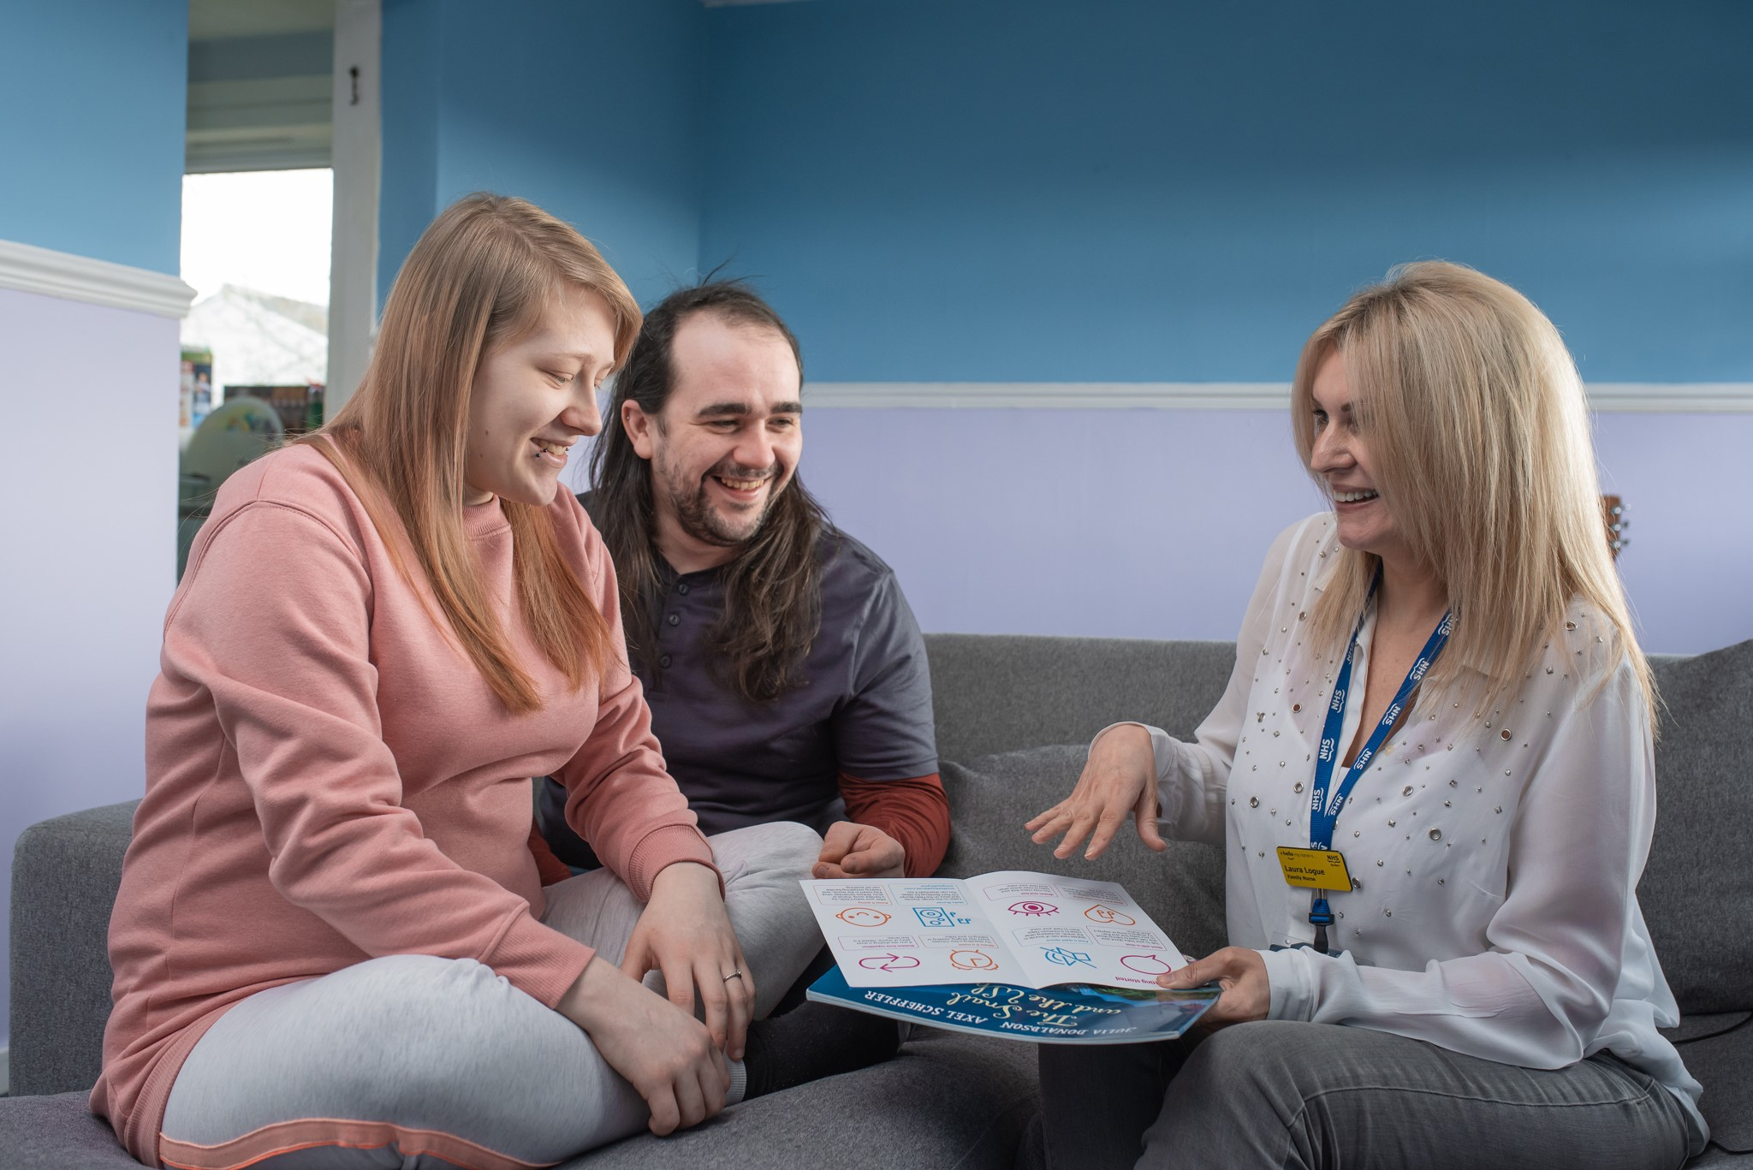
Survey summary
Bookbug Before Birth – encouraging singing, rhyming and reading in pregnancy
With the Family Nurse Partnership

October 2021
Summary presented by Scottish Book Trust
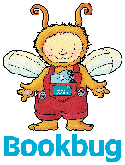
scottishbooktrust.com
Scottish Book Trust is a registered company (SC184248)
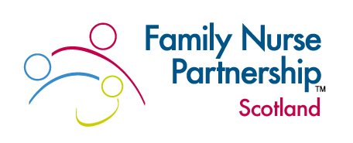
and a Scottish charity (SC027669).

Contents
Background 3
Feedback survey 4
Response and feedback 5
Challenges and improvements 9
Impact 12

Background

Bookbug

Bookbug aims to inspire a love of books and reading in every child across Scotland. Bookbug is an evidence-informed programme, underpinned by research and directly linked to the Universal Health Visiting Pathway and the Scottish Government's parenting and early years policies. Early book sharing promotes attachment, speech and language development and infant mental health. Find out more at scottishbooktrust.com/our-impact

Family Nurse Partnership

Family Nurse Partnership (FNP) is a licenced, evidence-based programme, developed over the past 40+ years. It has been successfully delivered and received in Scotland since 2010. The programme is delivered by specially-trained nurses or midwives to first time mothers under the age of 20 years, (in some areas under the age of 24 years) from early pregnancy until the child is 2 years old. FNP is fundamentally a change programme, focusing on reducing inequality and delivering on social justice using a public health approach, with three main aims:

- Improving maternal and birth outcomes
- Improving child health and development
- Improving economic self-sufficiency of the family

Further information regarding the evidence base, theories, models and fidelity measures can be found on the Scottish Government website and the international website.

There is a strong body of evidence to support the importance and benefits of talking, reading and singing to babies both pre-birth and in the early post-natal period. Babies can hear external sounds from around 22 weeks gestation and studies have shown that babies remember and respond to music, songs and stories heard regularly during pregnancy. Reading, singing and rhyming in pregnancy is also a great way to develop the parent-baby relationship.

Bookbug Before Birth

In 2019, Scottish Book Trust (SBT) worked with practitioners (including FNP teams) in three regions of Scotland to gift additional Bookbug resources to around 385 families. The aim of the pilot was to encourage parents to sing, rhyme and talk to their babies before birth. Feedback from families and practitioners indicated that this:

- Supported and reinforced health professionals' key messages for families
- Encouraged parents to get started and provided new ideas for those already singing and rhyming
- Built parents' confidence and encouraged a sense of connection to baby

Following a fundraising campaign, SBT were then able to offer all FNP teams across Scotland a picture book (The Snail and the Whale by Julia Donaldson and Axel Scheffler) and the Bookbug Before Birth leaflet to gift to families during pregnancy. The launch of this project was delayed due to Covid-19 restrictions but got underway in January 2021.

To build a picture of the nature of this project, here is a memorable moment that one of the Family Nurses described when surveyed. It begins to highlight the benefit of reading and singing to babies pre-birth and in the early post-natal period.

'My memorable moment is in regards to a lovely couple who were not keen to read or sing to their unborn baby when this conversation took place in pregnancy. Eventually Mum advised [the] Family Nurse that dad did start singing to her bump when she was around 20.0 Gestation but asked her not to tell anyone as he felt embarrassed. [The] Family Nurse visited the family in hospital at the parent's request when their baby was born. The baby was a day old and when she became unsettled dad lifted her and sang the same song he had sang to his partner's bump for 20 weeks and very quickly she settled into her dad's chest. Dad was very proud and advised [the] Family Nurse that he had sang this song to her throughout pregnancy. I share this story with all my clients as I also seen the benefits of reading/singing to unborn baby that day.' – Family Nurse

Feedback survey

A feedback survey was circulated to practitioners in June 2021 with 92 out of a possible 240 responses to the survey. However, it should be noted that not all nurses and supervisors had clients that were pregnant and therefore would not have had the opportunity to gift the book.

Response and feedback

The book and information leaflet were well received by the Family Nurses and their clients. As detailed in the chart below, 91% of the Family Nurses surveyed reported that their clients responded positively to the gifting of the book and leaflet.

The comments reported by the Family Nurses show that many clients where delighted and enthusiastic about receiving the book and information about the benefits of reading to 'bump':

- 'Brought joy into the visit, helped client to be more confident to sing to her child.'
- 'All clients have been delighted to have the bag.'
- 'Surprised about the value of reading to baby in pregnancy, but happy to have a go.'
- 'The client identified that she loves reading and learning, she enjoys talking to her baby and it would be nice to read the book. She also commented her grandmother would be pleased as she is the person who encouraged the client to read as a child.'
- 'Clients' are delighted to receive the book and are excited when information is shared about baby hearing your voice and that sharing stories can be a way of bonding with baby.'
- 'They thought it was a lovely idea, and often the dads were most excited as they have likely already started talking to bump.'
- 'Clients showed interest and enthusiasm. For one client whose first language isn't English they were also keen to use this to practice language skills by reading to baby.'

Of the clients that did not initially respond positively to the gifting (9%), three quarters (74%) of the Family Nurses revisited the discussion at a later date. Of all the respondents, Only 5% reported their clients would not engage with the materials at all. Mixed or challenging responses to the gifting were reported by some Family Nurses and one noted a client with undisclosed dyslexia who became upset. Mixed responses were mainly due to lack of confidence, language barriers or information overload:

- 'Some felt self-conscious reading to bump and are not comfortable reading books due to their own literacy skills.'
- 'Embarrassing. Both girls I gifted to were concealed pregnancies and just coming to terms with pregnancy. I was giving a lot of information in one day!'
- 'Some clients were unsure and felt it was not for them. These are the clients where the drip drip effect is important to get message across in a gentle way.'

Covid-19 restrictions also meant that Family Nurses had to move quickly to deliver parts of the programme via telehealth, with the number of face-to-face visits greatly reduced. There was therefore a significant amount of content to be discussed when there was a face-to-face visit, making it more challenging to spend time discussing the gifted items:

- 'It was just difficult. For most part we were gifting when we seen client and that was usually for recruitment (on to the programme) or (discussion regarding) Intimate Partner Violence (IPV) or other data collection so it felt like an add on.'

Most Family Nurses responding to the survey reported undertaking additional activities with the client when they gifted the book and leaflet, demonstrated in the graph below. The most common activities were talking to the client about the benefits of songs, rhymes and stories, either in pregnancy (94%) or after birth (93%), encouraging attachment behaviours (88%) and encouraging partners to sing or read to the bump (85%).

Comments suggested that the way the Family Nurses prepared the client and introduced the books were both key to achieving a positive response:

- 'At first – thought it was unusual as they were still in the antenatal period, however [the] Family Nurse had prepared them for the book being gifted and the importance of their baby hearing them whilst in utero – pleased to talk, touch and read to their baby.'

The Snail and the Whale was a popular book choice with nurses and clients. Most respondents (75%) reported that it was an engaging story commenting on the bright and colourful illustrations:

- 'Lovely colours and illustrations.'
- 'Enthusiastic about the particular book – 'The Snail and the Whale' and it seemed to make them feel more able to read to their baby during pregnancy.
- 'Bright and colourful for more visual people.'
- 'Many clients reminisced about their enjoyment of the other books by the author – specifically The Gruffalo.'

There was some discussion of the suitability of the book for clients, with 19% of Family Nurses citing literacy skills, client engagement or English language skills as key barriers:

- 'It's not accessible for non-English speaking clients.'
- 'It may be quite a difficult book for some of the clients with literacy difficulties.'

Some clients reported using the gifted book to set up a regular reading routine with their baby or bump:

- 'Most of my clients have set reading into their bed time routine with their babies.'
- 'One client in particular was excited to be given the book and when asked a few weeks later if she had been reading the book she had said that she had been every day.'
- 'For one client she now reads this story every night to her bump and plans to use it as a bedtime story for when her baby arrives.'
- 'Clients read other books to their baby both antenatally and postnatally.'

Reflecting on the pilot overall, respondents were very positive and noted that the gifting provided valuable resources and reinforced crucial messages around attachment and the importance of songs, stories and rhymes:

- 'This is a "must" project for all new first time parents as it fits beautifully with FNP programme materials.'
- 'Clients were smiling they appeared happy to be communicating with their babies especially when one client had movement from baby in response to talking and reading.'
- 'I think the resource is fabulous and is well received by parents. It introduces – very early in the mum's first pregnancy the benefits of reading, rhyme and baby development.'
- 'Valuable additional resource which links perfectly with building baby's brain materials and reinforces the concept of bonding/attachment.'
- 'Encouraged positive attachment antenatally and informed wider family unit of importance of reading, rhyme and song to developing babies.'

Challenges and improvements

Challenges to making the most of the gifting project included clients who were unwilling to engage with the resources, social distancing and not having clients to gift the resources to. A couple of respondents reported gifting the book but not having received the accompanying leaflet.

Respondents also indicated that the project highlighted a number of challenges their clients faced. More than half of the Family Nurses surveyed said that some of their clients felt silly reading or singing to 'bump' and almost half said that the project highlighted some of their clients' lack of confidence in reading. This suggests that self-consciousness and lack of confidence are key barriers for clients engaging with their bumps and that the Family Nurse has a central role to play in building their confidence.

However, a number reported that clients were more receptive after the idea had been broached a few times or that they began to feel more comfortable talking to their bump later in pregnancy:

- 'By revisiting the conversation several times the client was able to understand the importance of talking, reading, singing and interacting with their baby.'
- 'Opened conversation around connection with bump and what client or others around them were doing.'
- 'Clients who initially lacked confidence felt silly appeared to recognise the benefits of reading/speaking to their baby as pregnancy continued.'
- 'I found that they were more receptive to reading to bump when they had a more noticeable bump and feeling baby more.'

Family Nurses were asked about individual parts of the pilot to understand which elements of the intervention are most likely to influence behaviour change and encourage clients to sing, read and rhyme both during pregnancy and afterwards. Overall, as summarised in the graph below, the Family Nurses felt the most important things were the conversations they had with their clients, followed by providing a book and signposting to other Bookbug resources.

Suggestions for improvements to the project included resources (information leaflets, downloadable songs and rhymes and videos modelling reading to bumps) which are already available for free from SBT, suggesting that more signposting for Family Nurses may be beneficial. Other suggestions included books about pregnancy, toys, more books and books with different or visual languages.

Impact
81% of Family Nurses thought the project encouraged clients to read aloud during pregnancy and 74% thought it encouraged clients to try singing or rhyming during pregnancy. Many (57%) observed that the provision reinforced what clients were already doing with their bump.

Responses to the survey suggest that the impacts of this project were not limited to clients understanding the benefits of reading to 'bump', there is also good evidence that the book gifting built confidence, conversations and relationships between the clients and the Family Nurses and was a good way to promote early attachment for partners/other family members during pregnancy. These wider impacts are discussed further below.

Access

A key impact of the project for many respondents was that it provided access to books for families who might not have had access to them otherwise:

- 'Giving books to clients who had never grown up with such lovely books or in fact had no memories of being read to as a child .They were so appreciative, one in particular who loves reading to her baby.'
- 'One of my low income families was very excited about buying books to read to her bump and loves Julia Donaldson. When I gave them the Bookbug they were delighted about it.'
- 'I had a client that didn't have any books to read to bump and was so grateful for the book. She shared that she now knows the book off by heart.'
- 'It is such a worthwhile project and benefits lots of young families. Books can be expensive even children's books which excludes a lot of low income families from sharing this joy and helping their unborn and young children from developing. With most libraries still closed during covid restrictions borrowing books is not an option.'

Confidence

Respondents said that the project helped them to boost their clients' confidence:

- 'Clients laughing at [the] Family Nurse reading the book but saying they will do it when no one is watching.'
- 'One teenage mum was brave enough to disclose that her literacy skills were poor so we 'learnt' a book together for her to read to her unborn baby.'
- 'They helped my clients where English is not their first language to practise reading. Encouraged my shy clients to speak to their baby by reading to them.'
- 'I think the clients felt cared for themselves receiving something for them to share with their baby.'

Signposting

Many mentioned that the gifting facilitated conversations or signposting to introduce or cement an understanding of the benefits of reading, rhyming or singing to their bump or baby:

- 'I always enjoy the parents response of delight when gifting the book and the following conversations about gestational and early years development and bonding – for some parents you get to see their 'light bulb moment' – which is very special.'
- 'It encouraged a lot of discussion around attachment which I had concerns around with both girls. It was an ice breaker and allowed a lot more discussion.'
- 'Opened up conversation re attachment, responsive care giving and brain development. Normalised talking, reading and singing to baby in pregnancy.'
- 'By gifting the book, opened up discussion about baby brain development, bonding with baby and gestational and early years development. Parents were also enthusiastic to access the other Bookbug resources – such as the online materials.'

Conversation

Respondents were enthusiastic about the benefits of the conversations sparked by the gifting, noting that it introduced new ideas to clients:

- 'Some clients were unaware of the benefits and were responded positively to this information.'
- 'Clients that were not read to were interested and curious about the benefits to their baby.'
- 'This book has been gifted to my pregnant clients when exploring "building a baby's brain" facilitators and has been welcomed by mums, dads and family members who are all keen to build their baby's brain in utero. Lots of mums unaware that reading to their baby in utero has an impact on their baby's development and have welcomed the offer of this lovely book.'

Therapeutic relationship

The book gifting and subsequent conversations also helped Family Nurses to build or strengthen a therapeutic relationship with their clients:

- 'As mentioned above she has been ambivalent about the uptake of FNP programme – gifting the Bookbug at our initial visit really helped the conversation around the benefits of the programme in relation to attachment and connecting with baby. It was a positive interaction. The project is well received.'
- 'Encouraged wider discussion between myself and client in the early period when trying to build a therapeutic relationship with them.'
- 'It was an added bonus to strengthening the therapeutic relationship it was some nice 'soft' but equally important material.'

Memories of childhood

Memories of childhood was a recurring theme in responses to the survey and may have played a part in facilitating the therapeutic relationship between practitioner and client. Whether the memories involved The Snail and the Whale, being read to as a child or not having access to books, these memories gave the practitioner more information about the client:

- 'It was another good way to get information about a client's childhood experiences as it opened up a discussion around if they were read to as a child etc.'
- 'It made some clients reflect on stories by the same author that they were familiar with from their childhood. It felt like it helped with engagement as is such a positive topic to discuss and a lovely book to be able to give to clients.'
- 'She talked of how her dad read books to her when she was younger and sees the value in connecting with her "bump" at an early stage.'
- 'They remembered how they felt when they were read to.'

Attachment

Most respondents (82%) agreed that the project helped clients and partners to form secure attachments with their baby. Themes of attachment and bonding appeared in a number of responses:

- 'Helped them to bond with their baby during pregnancy and envisage what it would be like reading to their baby after birth.'
- 'Dads have started reading to their unborn baby.'
- 'Client was surprised about how her baby responded with a big smile to hearing Mums voice when she sang to her.'
- 'One of my clients partner read the book while her partner was in labour. She also read the book to the baby within the first hour of birth she thought the baby remember it as the settled.'
- 'Showing to family. Younger sibling reading to bump.'
- 'I had a lovely conversation with a client who was feeling frustrated about her partner not spending as much time with her as she would like. When we tried to think of some positive behaviours he was carrying out – she told me that he liked reading the book to her bump! She said he wasn't very good at reading, but was still able to talk through the pictures.'
- 'Clients who feel their baby is now 'real'.'
- 'A client who loves the book bought a baby grow with the same pattern on it so her baby could wear it from birth. Parents who say their baby moves when they read the story. One dad cried when he got the book.'

The below graph summarises the wider impacts that the intervention encouraged:

Conclusion and next steps

The overall reaction to the Family Nurse Partnership from the Family Nurses and their clients has been positive. For example, one Family Nurse talking about a client's mother said, 'she was wondering who the client was talking to in her room and then she realised she was talking and reading to her baby, this was wonderful'.

Most respondents (82%) agreed that the project helped clients and partners to form secure attachments with their baby. Respondents thought the intervention encouraged:

- Clients to sing or rhyme with their baby (78%)
- Clients to read to their baby (77%)
- Nurses to discuss the importance of early language development (79%)
- Clients to understand more about early language development (80%)
- Clients to form secure attachments with their baby (82%)
- Discussion between nurses and clients about the benefits of songs, rhymes and reading (81%)

Given the impact of the project on both Family Nurses and on their clients, Scottish Book Trust's aim is to sustain the provision of books and leaflets to Family Nurse clients next year and in future years. This report will be used to share learnings with colleagues and funders.

Coronavirus (COVID-19) Family Nurse Partnership insights: evaluation report - gov.scot (www.gov.scot)

