Child Protection Policy
Wellbeing Concern Form

This form should be completed by whoever is raising the concern.
Once completed, this information must be passed to Scottish Book Trust’s Designated Child Protection Officer and Deputy DCPO for action and filing.
This form has been adapted from the GIRFEC Wellbeing Concern Form. The GIRFEC framework provides opportunities to work with other agencies to report any issues or concerns we might have to the child’s named person using the GIRFEC Wellbeing Concern Form.
Each child in Scotland has a named person. If it is deemed necessary to report this wellbeing concern to the Child’s named person, Scottish Book Trust will pass the information on as appropriate. As each child grows up, their contact will change, with support usually provided by:
- A health visitor from birth to school age
- A head teacher or deputy head teacher during primary school years
- A head teacher, deputy head teacher or guidance teacher during secondary school years
In case it is necessary, here is a link to Social Work Departments Contact Information provided by Social Work Scotland https://socialworkscotland.org/wp-content/uploads/2018/06/ScottishCouncilsSocialWorkContactSheet.pdf

Child/Young Person’s Details
Name:
Date of Birth:

Person Recording Details:
Name:
Agency/Establishment:
Position:
Area of Concern
Please refer to the ‘Wellbeing Wheel’ (below) to identify the SHANARRI area which your concern belongs to and use the headings to record the details below.

e.g. Healthy

child seemed to be hungry every morning and unable to concentrate

Wellbeing Wheel

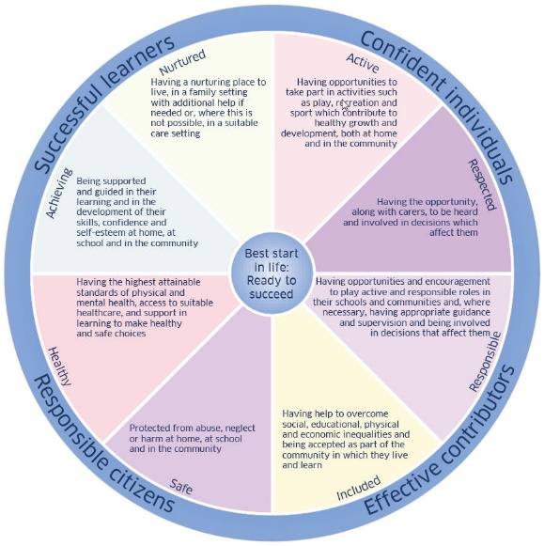
Description of Concern(s)
If appropriate include strategies to address the issue and/or any actions taken. Please also summarise any previous concerns.

Signature:
Date:

It does not have to be the recorder who discusses the concern with the parent or carer. Please speak to the DCPO and/or Deputy DCPO about who is the best person to do this and record the parent/carer/s views here (if appropriate).

Has the concern been shared with the parent/carer? | Yes  No
What did the parent/carer say about the concern?

Has the concern been shared with the young person? | Yes  No
What did the child/young person say about the concern?

ONLY COMPLETE THIS SECTION IF RELEVANT TO AGENCY STRUCTURE
Has the concern been shared with anyone else? | Yes  No
Please specify who:

Comments/Action:

Signature of person completing the form:

Signature of Designated Child Protection Officer (on receipt of the information):

