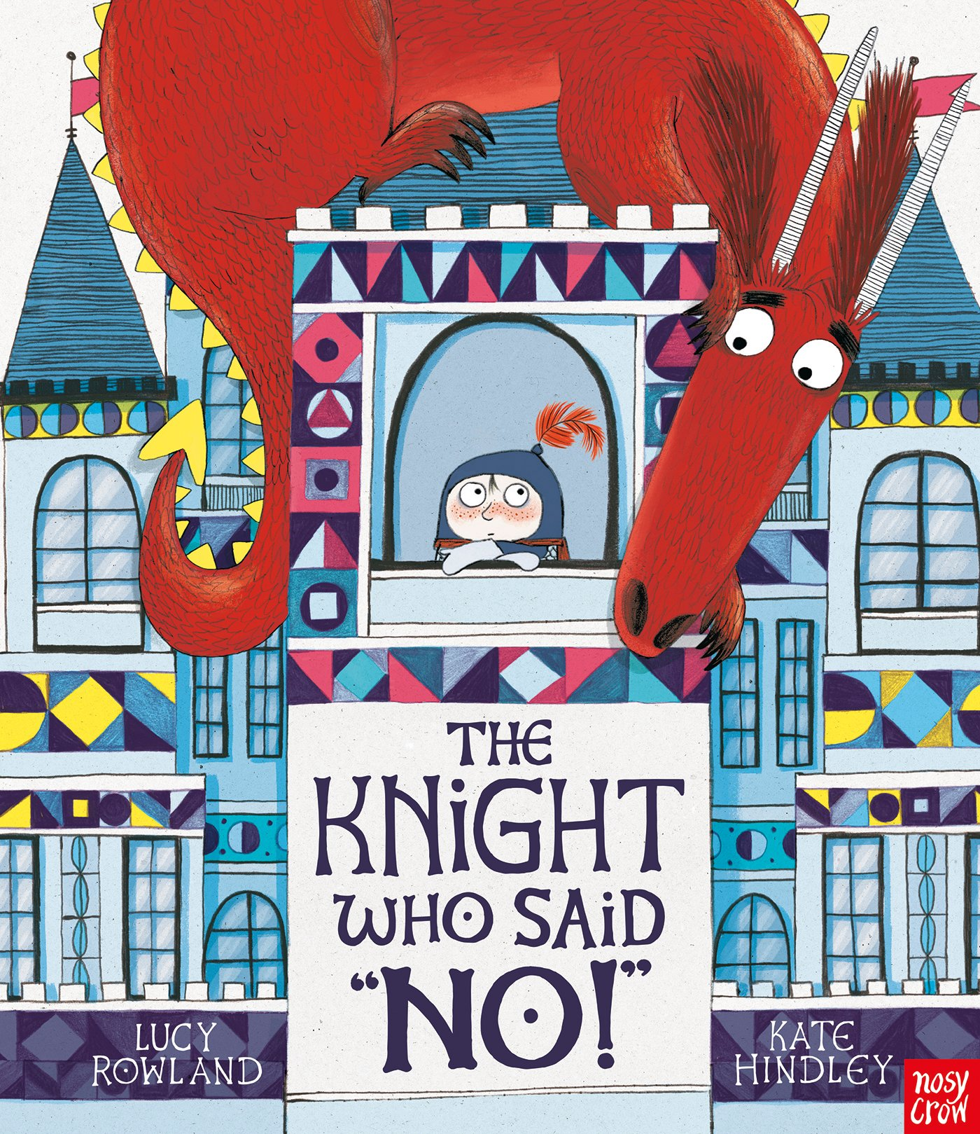

The Knight Who Said ‘NO!’ activities
CFE Levels Early and First

Resource created by Ailie Finlay

scottishbooktrust.com

/scottishbktrust

@scottishbktrust

A castle for Ned
Ned lives in a big castle. Make a castle for Ned out of old boxes and cereal packets. You could use other play items such as Lego too. Add a little Ned character at the top of the castle, a mum and dad in the middle of the castle and some soldiers and villagers all around. The characters can be cut out of card or paper, and then stuck to the castle with blue tac or a loop of tape (or use Lego or Playmobil figures). You can then re-tell the story using the little figures.

What is that job?
Ned does many different jobs. Can you act out some of the jobs and see if people can guess what you are doing? What other jobs might he have to do in a castle? Think of some jobs that are not in the book and act these ones out as well. Can anyone guess what you are doing?

Yes and no!
Read through the book looking carefully at the pictures, but this time only read the words ‘yes’ and ‘no’! Try to make them full of expression!
Role-play having a ‘yes’ day. One person asks the other to do many jobs. They reply ‘yes’ to everything and mime the actions.
Then role-play a ‘no’ day. This time say ‘no’ to everything!
Which do you think is more fun?

Make a sensory castle corner
Gather together props and objects for a castle corner. Do not worry too much about historical accuracy! These might include:
- Special ‘royal’ fabric
- Rugs or rough blankets
- Toy spiders and cobwebs
- A ‘throne’ (made from a chair draped in fabric)
- A fan (to make draughts!)
- Costumes and crowns (but best not include any swords etc.)
- Drums
- Soft toys (cats, dogs, chickens)
- If possible, a dragon!

