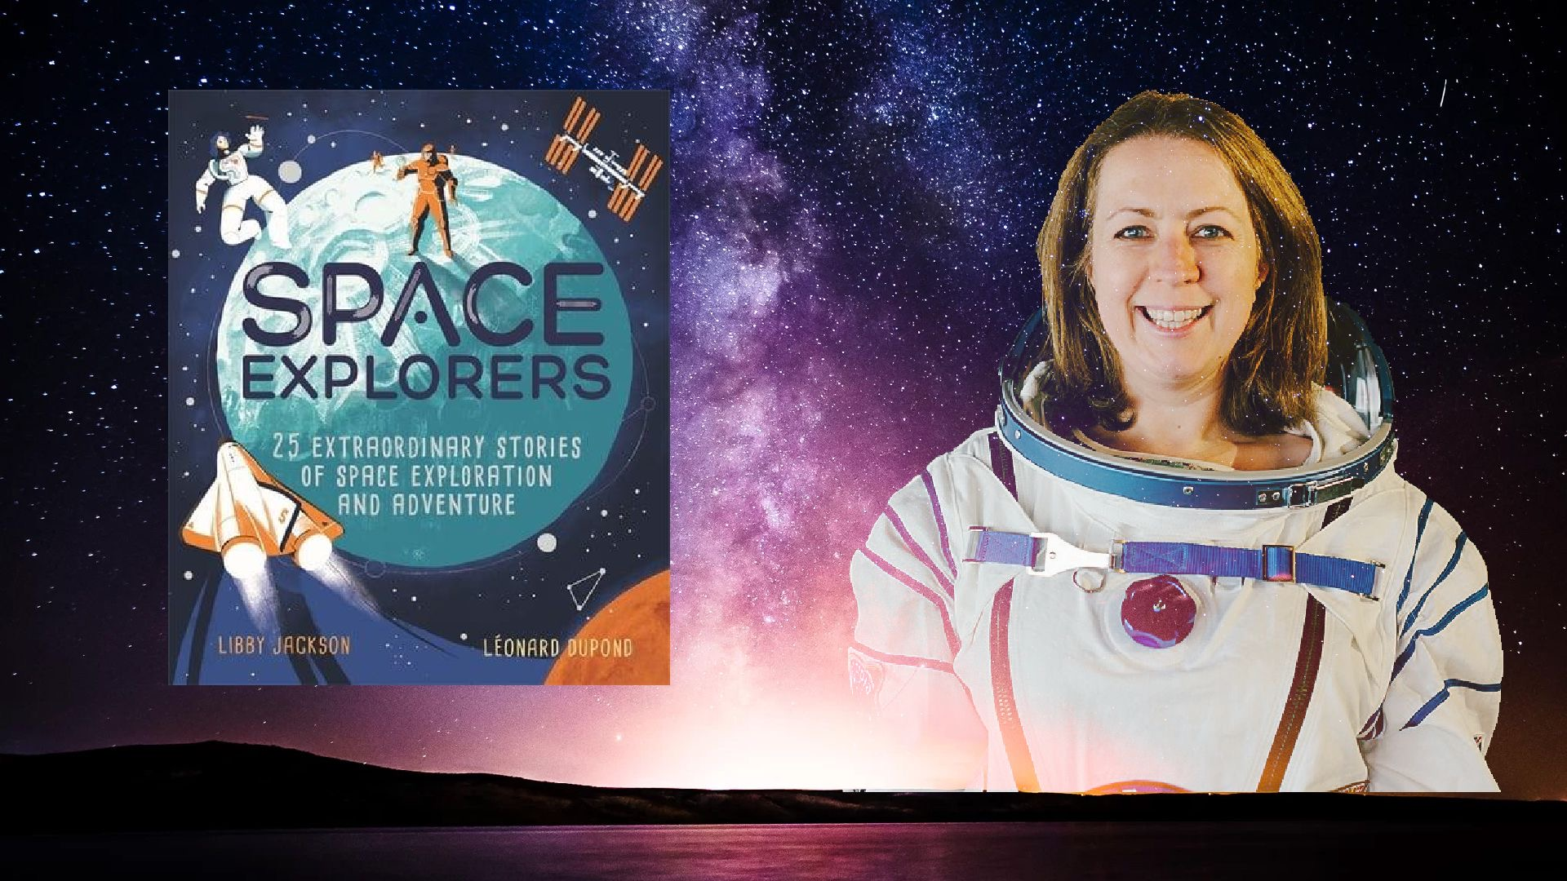
Resource created by Scottish Book Trust

Space Explorers learning activity

Age 8-12

CFE Level 2

Creative activity inspired by Libby Jackson‘s anthology Space Explorers

scottishbooktrust.com

/scottishbktrust

@scottishbktrust

About this resource
This resource features a Literacy & English activity to help you explore Space Explorers with your students. Adapt and use as you see fit!

Introducing Space Explorers
A collection of amazing real-life stories about space exploration and adventure.
Do you know the true story of...
- The first astronauts to land on the moon and were nearly stranded there for ever, if it hadn't been for a felt tip pen that saved them?
- The 'human computers' that launched NASA's first rockets into space?
- The astronaut that trained to go to space by living in underground caves and completing underwater missions?
Humans have always been fascinated by the universe, but only a few have been daring enough to travel beyond the Earth.
From venturing into space for the first time to building the International Space Station in orbit, the history of space exploration is filled with peril, bravery and strokes of genius.
In this beautifully illustrated anthology, spaceflight expert, Libby Jackson, reveals the very best true stories of humankind's thrilling journey to the stars.

Rewriting History
LIT 2-14a, LIT 2-28a
Space Explorers reveals the best true stories of humankind’s thrilling journey to the stars.
Ask your pupils to each select their favourite of the 25 extraordinary stories. They must then write the story in their own words within the following parameters:
- Tell the real-life story accurately
- Add dialogue between the real people in the story
- Introduce one or more fictional characters
Pupils can share their stories with their peers, either in class or through online learning platforms. Ask each pupil to explain why their chosen story was their favourite.
The class can have fun guessing who the fictional characters are and who are the real life individuals. This works especially well if not all pupils are familiar with all 25 stories in Space Explorers. Writers can even research real people to mention in their stories as red herrings to confound their classmates! By re-telling the stories accurately, your pupils benefit from hearing these amazing historical accounts of space exploration.

