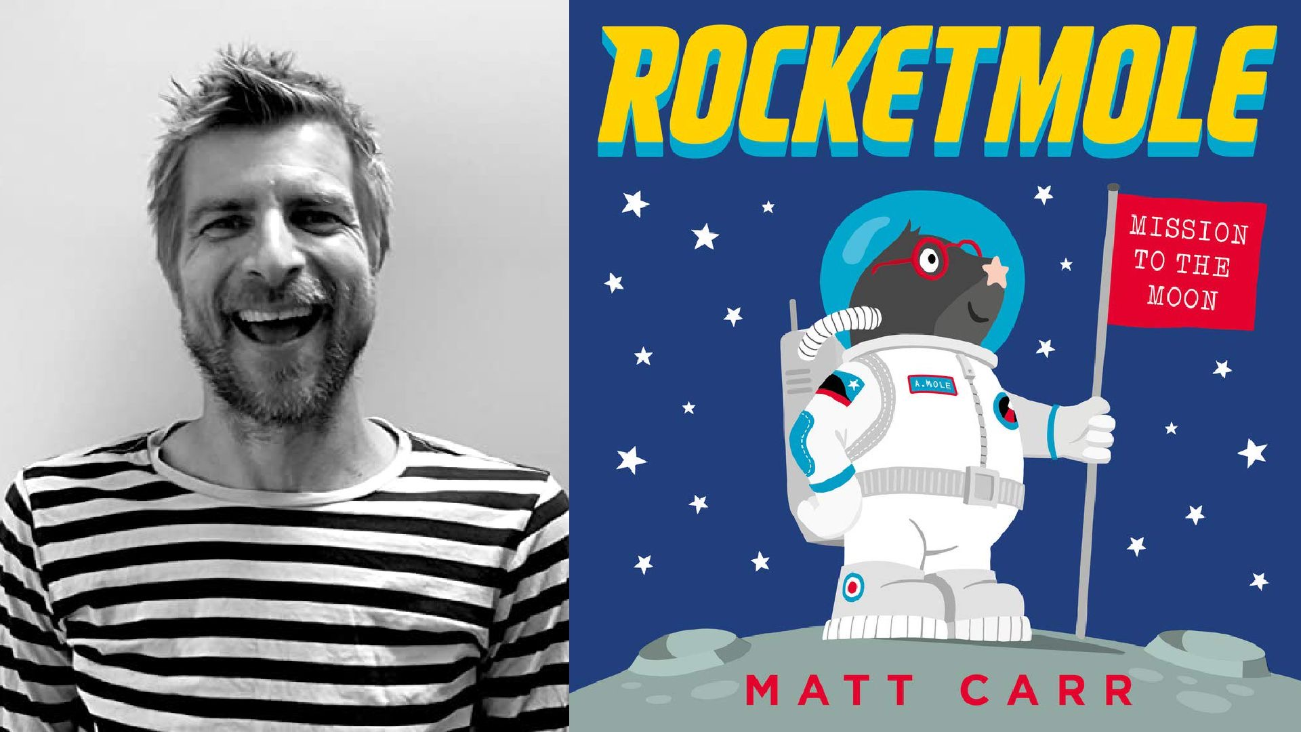
Resource created by Scottish Book Trust

Rocketmole learning activity
Age 4-7

CFE First level

Creative activity inspired by Matt Carr’s picture book Rocketmole

scottishbooktrust.com

/scottishbktrust

@scottishbktrust

About this resource
This resource features a STEM activity to help you explore Rocketmole with your students. Adapt and use as you see fit!
Introducing Rocketmole

Armstrong the star-nosed mole doesn't dig living underground. His friends think building a rocket to go to the moon, alone, is an astronomically bad idea, but Armstrong is determined to boldly go where no mole has gone before. On the moon, Armstrong bounces around in his space suit, but soon starts to miss his cautious mole mates.
How can a mole with big dreams have it all: adventure AND friendship?
Fly me to the Moon
TCH 1-10a, TCH 1-11a, TCH 1-12a, LIT 1-09a, LIT 1-10a
Armstrong builds his own rocket and boring machine, he even experiments with different ways to travel to the moon.
You can design and draw a spaceship that you would use to travel to the moon. You could use an idea from the story or create your own.
Think about what it would be like in space. What home comforts might you like to take with you?
Tell a family member or friend about your spaceship. If you are in school, then talk about your spaceship/s in class;
- Name
- Mission objective
- Fuel type
- Top speed
- Gadgets onboard
- Meet the Crew

