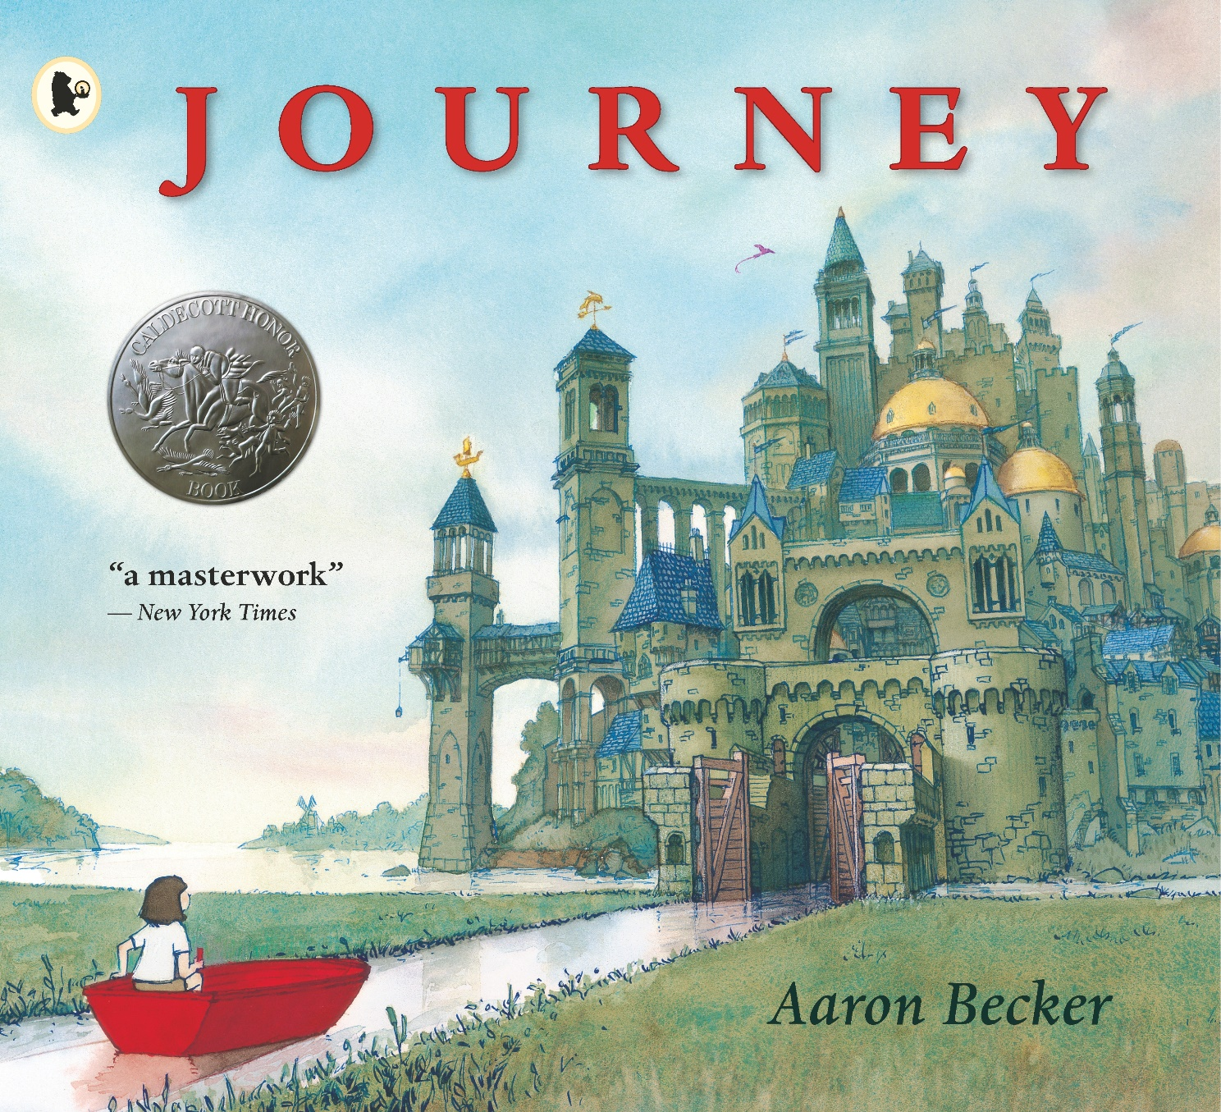

Journey
multi-disciplinary
project

activities
Age 5 -12

CFE Levels Early, First, Second

Resource created by Scottish Book Trust

Whole school activities inspired by the picture book Journey by Aaron Becker

scottishbooktrust.com

Contents
About this resource 1
Journey/Book launch 2
Getting started 3
Creative writing 5
Health and wellbeing 6
Expressive arts 6
Technologies 8
Social sciences 9
Additional information 9
About this resource
The resource contains differentiated cross-curricular activities for Early, First and Second levels, adaptable to use as part of a whole school core book project involving ideas to support:
- Creative writing
- Expressive arts: art, drama and music
- Health and wellbeing
- Critical thinking and problem solving
- Digital technology
- Skills for learning: visual literacy
Images are now used to quickly convey meaning, persuade and manipulate emotions and having the skills to interpret, negotiate and make meaning from information presented is an essential part of learning. Wordless picture books support visual learning by:
- Exploring how pictures can tell a story and images communicate meaning.
- Developing listening and talking skills within literacy, involving a rich variety of vocabulary and oral storytelling.
- Providing an effective bridge for EAL pupils within the learning process.
- Engaging young and reluctant readers.
- Raising awareness of author techniques when engaging readers in a book.
Journey by Aaron Becker
With a background in film artistry, Aaron Becker has produced an engaging picture book which can be read on many levels. It involves a young girl encountering danger and friendship in a different world. Underlying themes of loneliness, determination, problem solving and friendship are evident as the visual narrative takes the reader along on her adventure.
When the girl picks up a red crayon and draws a door on the wall, the reader now follows her journey through muted scenes where dilemmas are faced by using the crayon to control her destiny.
Teachers wishing to explore how using visuals can develop understanding and enjoyment of books will find Journey an excellent place to start. Picture books can be challenging so ensuring preparation and familiarity with content is important.
Information on sharing picture books can be found:
- Advice for sharing wordless picture books
- Using wordless picture books in schools and libraries

Book launch
When using the book as a whole school resource, it’s important to create an initial buzz, setting foundations for all to engage in the exciting activities. Think about holding an assembly or whole school event such as World Book Day to introduce the book.
- Explain that a book has arrived in the post or has been found near the school. (Have the book wrapped and select a pupil to uncover and reveal what it is).
- Introduce ‘Every picture tells a story’ or ‘A picture paints 1000 words’ and have pupils consider what these might mean, followed by an introduction to wordless books and Journey.
- Create a red door on the wall and ask them where it might lead. Explain that they are going to go through a red door in a book and each class will take part in the adventure.
- Link to learning about journeys, a power-point or pictures with refugees, evacuees or space travel and discuss journeys into the unknown. (Pupils could also be given envelopes with one of these pictures to contribute ideas)
Now explain that you are going to be reading a wordless picture book where they will all be involved in telling the story rather than being read to. You will be creating a story together and every class has a part to play.

Getting started
The book can be shared as a whole school or individual class resource as suits. However, there are key points to remember when sharing Journey and other wordless picture books:
- Teacher knowledge and preparation of the resource is vital to initiate learning
- Establishing pupil prior knowledge of wordless books can be helpful.
- It is important that pupils can see the images clearly.
- Allow time for them to process what they see and accept suggestions offered.

Title activity LIT 0/1/2-02a, LIT 0/1/2-07a
Clearly display the front cover, have younger children sitting around you or airdrop the picture onto a larger screen. Older pupils could have a copy of the cover in pairs or groups. Children need time to look and process their observations.
Early/First Using open questions, begin to gather their initial ideas:
- Let the children think about the one word title: Journey
- What do they think it means?
- What do they think the story might be about based on the cover alone?
- Are there any clues to help and do they hint at what might happen?
First/Second: discuss collaboratively:
- Where they think this is.
- Who the girl might be.
- What they think is about to happen.
(Findings can then be shared and different ideas discussed).
Without any reading, they should already be starting to engage with the book and will offer suggestions from their own experiences about where the story might be headed (make a note of any suggestions as these could support writing later).

Storyline activity LIT 0/1/2-07a
As the story unfolds, begin to establish basic questions to use with each page. Allow the children time to study each picture and practice looking for clues.
(Questions could already be written on fans or cards to support using the book, possibly handed out to pupils across year groups at the assembly).
- What do you see? Look again, what else do you see?
- Are there any clues showing what the story might be about?
- Is there anything different or unusual?
- Are there any characters? Who do you think they might be?
Early/First Turning each page, discuss what they see. Encourage them to become picture detectives who need to look carefully at the pages. If new words are offered, record for a word wall to support writing later. Include deeper questioning during discussion:
- How do you think the girl is feeling? How do you know this?
- Do you ever feel this way?
(Emotion cards would support younger pupils and can be used later in the book)
Second The whole book could be looked through, with time to discuss and note observations as you go.
(Smartboard display would enlarge the pictures to discuss in class).
- Groups/pairs could be given different frames with space to record observations for reporting to the class when ready.

Class thinking activity
Second Encourage deeper questioning and discussion, sharing knowledge, understanding, building confidence, vocabulary and scaffolding pupils who require more support.
(Prompt cards could be used or a sheet with questions for them to think about).
- How does the lack of colour in the pictures make you feel?
- How do you think the girl is feeling? How do you know?
- Why do you think the author chose red for the crayon?
- What do we usually associate with the colour red? Examples?
- Can you imagine what sounds there might be in these places? Explain.

Storytelling activity LIT 0/1/2-09a, LIT 0/1/2-10a
Wordless picture books are ideal for developing oral storytelling skills.
Early Using pictures as prompts, have pupils retell the story in their own words. This could be recorded and shared with other classes, at assembly or with parents.
First/Second
- Retell the story in their own words, adding detail from their observations.
- Paired reading activity with younger pupils.
- Different groups or pairs could record individual spreads from the book and add to QR readers for others to listen to.
- Digital storytelling, pupils create video with audio and music to retell the story.
Further information on digital storytelling can be found in our How to create digital stories resource.

Creative Writing
LIT 0/1/2-13a, LIT 0/1/2-20a, LIT 0/1/2- 26a, ENG 0/1/2-19a, ENG 0/1/2-31a
Now familiar with the story and format, pupils can develop their creative writing skills. Writing prompts/planning frames will stimulate imagination and scaffold ideas.

Whole school/stage partners
Create an adventure starting in Nursery/P1. Complete a page of a story using pupil ideas. Include a link to be followed by the next class (just like the book) and have each class add their own piece to continue the story. This could be displayed around the school, on classroom doors or on walls around the hall.
Early
- Have pupils draw or model their own doors first, or use a door drawn on the wall to stimulate their imagination of travelling to a special place.
- Bring in a magic (red) carpet as a special prompt to engage pupils in talking about where they might like to travel on a magical journey.
- Story cubes and objects e.g a hat, can stimulate ideas for writing
  - Who might it belong to and where did it have come from?
  - What if it came to life and had magic powers?
  - Read Write Count provides activity ideas for using story cubes which are inclusive and support creative writing
- A familiar journey, e.g: their journey to school be used. Create a journey stick with items they find to support a story map and writing activity.
First
- Have a collection of photos and pictures showing unusual doors:
  - Where do they lead you to?
  - What kind of world would you be in?
  - What happens there?
- What would it be like to travel somewhere different on a magic carpet or in a balloon?
  - Where would you go?
  - What might you see from above?
  - Who would you meet?
  - Is anyone with you?
- Create another scene from the story, would you introduce another colour and what would it be?
- Write a character profile for the girl in the story. What do you know about her?

Second
- Write a narrative version of the story and give the characters names.
- With a partner or in a small group, begin to imagine dialogue or speech bubbles for the characters. What do you imagine they said? Use a comic style storyboard to create the story involving this speech.
- Script: turn your dialogue writing into a piece of script, involving stage directions and performance for a drama activity.
- Using photos, models or their own drawings of doorways, imagine a world beyond the door and create a new adventure there.
- Write a newspaper report about the girl going missing or being captured.
- Create a poem that leads the reader through the adventure.
  - This could also be created from early to upper stages as a follow on activity.

Health and Wellbeing
HWB 0/1/2-01a, HWB 0/1/2-04a
With themes of loneliness, confidence and friendship, Journey is an excellent resource to approach wellbeing issues and links closely to experiences of refugees.

Early Circle time- using emotion cards, take turns to think of a time when they might have felt like this
Choose an item from the book (a boat, magic carpet), take turns to talk about the special places they would like to travel to.
First/Second Discuss different emotions, making a collection of words that can describe these emotions. Talk about how body language (posture and gestures) can be used to express feelings and the impression they can give. Have the children offer examples of when different emotions are often used.

Expressive arts
Using a wordless picture book provides endless opportunities to develop art and performance skills. Journey is an ideal resource for this.

Art EXA 0/1/2-02a, EXA 0/1/2-05a
Whole school a display could be created with classes adding to the collage or each class could create a frame from the book to reflect the girl’s journey as you travel round school. Hold an exhibition of the artwork at the end.
Classroom doors could be designed to show where the girl went and inspire an exciting adventure behind them.
Early
- If you had a magic crayon, what would you draw with it? Create a picture using a computer programme then label or write a sentence about it.
- Create a model door to display in class and use in a writing activity.
- Working with a partner, take turns to draw a circle or squiggle and let the other complete the shape.
- Read The Pencil by Allan Ahlberg and imagine where your pencil might take you if it came to life? (This could also be done outdoors with chalk).
First
- Design or make a model door that will lead you into a world of adventure.
- Using 2 pieces of A4 paper, draw a background picture of an imaginary place or somewhere special on one piece and create a door on the other to attach on top. Where do you go when you open the door?
- Using watercolour techniques, create your own pictures. Watch Aaron Becker for ideas.
- Explore drawing small or large circles and turning them into something new.
- Paint/stick some different circles on paper or go outdoors and draw some chalk circles. Use a magic crayon to travel in and around the circles, connecting them with a line in one colour. Take photos to display in class.
Second
- 3D models: (these could be displayed on a background from the book).
  - Create your own version of a bird the girl might meet
  - Design your own hot air balloon using paper and junk to create.
- Use watercolour to create an imaginary world or background beyond the door.
- Research watercolour artists and their techniques. Create a display of their work or paint your own picture in a similar style.
- Photograph different backdrops, print in sepia and add a coloured object to the picture just like the book.
- Computer drawing programmes can be used to support less confident pupils in drawing activities and can add to engagement for others.
Drama EXA 0/1/2-13a
Early
- Emotions: change face and body position to reflect the different emotions portrayed in the story. (Music could be added to create effect).
- Recreate the story through mime. Perform the actions of the girl in the story, e.g. drawing the door, rowing the boat, falling through the air, riding the bike.
- Create a special area in the classroom with different props to support imagination and allow the pupils to create an imaginary world to travel to.
First
- In pairs, mime drawing an object with a magic crayon and make it ‘come to life’. Perform the mime for the rest of the class to guess what it is.
- Create different scenes from the book with a character in action, for example the bird flying free or trapped. Extend by creating a sequence of actions.
Second
- Using props, e.g. a ladder or stepping stones, develop a mime incorporating the prop to enter another world.
- Statues, recreate scenes from the story that demonstrate character actions and emotion e.g. the girl stealing the bird. Others can guess the scene.
- Practise the motions of the flying machine parts. Create a moving sequence.

Technologies
TCH 0/1/2-01a, TCH 0/1/2-09a
Journey offers great opportunities to explore themes relating to technology, including transport, power, design and digital skills.
Early Consider the different forms of transport used by the girl on her journey.
- How many are there and can you think of others that sail, fly, use wheels?
- Make sets with those that move in the same way, create a display and write about how they move.
First
- Design one of the vehicles used by the girl and write about how it works.
- Invent your own flying machine. Think about how it will move and label the parts.
Second
- The Emperor had an elaborate flying machine, can you identify the different methods of powering it? Make a list of movement words with their definitions. Create your own machine with at least one working part using construction materials and junk and draw a cross section of your machine like the one in the book.
- Create a book trailer to inspire others to read the book. You can find out more in our book trailer learning resource.
- In small groups, make a short video with narration based on Journey. Little Boat, an animation of a small boat making a journey.

Social Sciences
SOC 1/2-06a
The book is open to individual teacher interpretation and has endless possibilities for further learning about People in Society and History:
- Discussions around refugees and children being uprooted from their homeland to live in a new country.
- Research about: space, religious or historical journeys.

Additional information
If you enjoyed reading Journey you may also like read other wordless books on our 10 wordless wonders booklist.

More wordless book suggestions
The Red Wheelbarrow by Briony Stewart
Wonder Bear by Tao Nveu
Tuesday by David Weisner, contrast/colourful
Arrival by Shaun Tan
Quest by Aaron Becker

Further reading:
Mr Ben by David Mckee
Paddington by Michael Bond
Nowhere Emporium by Ross Mackenzie
Swimming Against the Storm by Jess Butterworth
The Explorer by Katherine Rundell
I am Malala by Malala Yousef
The Colour of Home by Mary Hoffman
No Ballet Shoes in Syria by Catherine Bruton

Check out:
Kate Greenaway awards for suggestions with additional visual literacy resources.

